
Project Report – Appendix

These documents are included in the order in which they are mentioned in the body of the report. Some documents have been converted from other formats and may thus be less than optimally reproduced due to the limitations of the process.

Index
Battlefield Registration Report Page 1
Initial Archaeological Scoping Report Page 13
Final Heritage Lottery Fund Submission Page 39
Primary Source Research Protocol Page 52
Volunteers’ Primary Source Summary Page 57
Volunteers’ Secondary Source Reading List Page 63
Landscape Archaeology Report Page 65
Routes To and From Otterburn Page 96
Field Archaeology Report Page 107
John Sadler’s Account of the Battle Page 202
Elsdon Burials : The Berwick Naturalists Society Page 214

Otterburn – Battlefield Registration Report

English Heritage Battlefield Report: Otterburn 1388

Otterburn or Chevy Chase (19 August 1388)

Parish: Otterburn

District: Tynedale

County: Northumberland

Grid Ref:NY 877936 (centred on Percy's Cross)

Historical Context

The instability caused by Richard II's struggle with the lords appellant extended to all corners of the Kingdom. In the north of England the Neville family was stripped of its official positions and the rival Percys placed in the ascendant. The Scots were aware of the disunity caused by the power struggle and decided to take advantage. In the summer of 1388 an army estimated at 40,000 by contemporary chroniclers invaded northern England. By far the greater number struck west towards Carlisle under the Earl of Fife; a smaller force around 6,000 strong, commanded by James, Earl Douglas headed for Durham.

To counter the threat posed by Douglas's expedition the head of the Percy family, the Earl of Northumberland, sent his sons, Henry and Ralph, to Newcastle. During one of the skirmishes that occurred outside the walls of the City, Douglas snatched the silk pennon from the end of Henry Percy's lance. Percy, whose impetuosity had earned him the sobriquet 'Harry Hotspur', vowed to recover the pennon and Douglas, who was equally chivalric, promised to give him the opportunity to do so. Thus, in the course of their retirement to Scotland, Douglas prevailed on his colleagues to wait for their pursuers at Otterburn, 32 miles northwest of Newcastle. The Scots busied themselves in an unsuccessful attempt to capture Otterburn Tower. Meanwhile the English, who by now realised that with the bulk of the Scottish army operating near Carlisle they outnumbered their opponents, were prepared to allow Hotspur to fulfil his vow. During the course of 19 August Hotspur drove on his army of approximately 8,000 men and they arrived at Otterburn at nightfall.

Location and Description of the Battlefield

Although, thanks to Froissart¹ and other chroniclers, a good description of the course of the Battle of Otterburn has come down to us, none of the accounts are sufficiently precise in their topographical references to enable the battlefield to be unhesitatingly identified. This has meant that in the past a number of alternative locations for the battlefield have been proposed. At one time the camp on the hill above Overacres, a little over a mile to the east of Otterburn, had its supporters². More recently Sir James Ramsay has argued in favour of the river flats around Otterburn Mill and the hill at Castle Rigg³. The consensus that has emerged, however, is that the fighting took place to the west of Otterburn, extending as far as the hillside above Greenchesters. In justification of this view, the location of the battlefield monument, Percy's Cross, is cited⁴. The monument was already ancient when it was moved a short distance in 1777 and the tradition has long been that its siting was associated with an event in the battle, possibly marking the spot where the Earl of Douglas was killed. Locating a battlefield in the vicinity of a monument is one method of proceeding when documentary sources fail to provide firm guidance; thereafter all that is possible is to attempt to match what topographical references there are in the written sources to the landscape as it is today.

Otterburn battlefield lies to the north of the River Rede at a place where the valley broadens to a width of about 1,000 yards. The gradient of the hillside on which the battle was fought is relatively gentle, sloping down not only southwards to the River Rede but eastwards towards the Otter Burn, which flows into the Rede at Otterburn village. Land use is primarily agricultural. Tree plantations of varying sizes cluster near the crest of the ridge, which reaches a maximum height of 700 feet behind the Cross Plantation.

Landscape Evolution

In 1388 the battlefield comprised marshes near the River Rede (mentioned by Froissart) and light woodland on the firmer ground elsewhere. The Scotichronicon⁵ alludes to the role played by 'thickets and thorn brakes' in the battle and Andrew of Wyntoun⁶ refers to 'buskis' (bushes). Although the bottom of the valley is now much better drained, marshy ground is still indicated in places on the Ordnance Survey map.

The earliest maps show fields on the battlefield called Townhead Common Land and, next to the present school, Townhead Ancient Land. The common land would probably have been rough grazing, whilst "Ancient Land" indicates old enclosed land. Whether this was pasture or down to grain is impossible to tell, but there is no documentary or field evidence for medieval open field arable agriculture in the battlefield area, nor any old hedgerows. What evidence there is suggests the battle was fought on valley-bottom pasture land.

The battlefield area has been enclosed by the current field system in stages from the 1770s until the 1860s. Some field lines may pre-date 1779. Holt Wood may have been continuously wooded, having been spared from more general clearance, but the current woodland there is not ancient. Cross Plantation was planted after 1860, Long Plantation was planted between 1840 and 1860.

The Otterburn Road and Dere Street were mapped in 1779. The A696(T) road which runs through Otterburn to Scotland follows the route of the eighteenth-century turnpike, which in turn follows the route of the mediaeval road to the border at Carter Bar. It was when the turnpike was being constructed that Percy's Cross was moved. The then Duke of Northumberland wished to commemorate the part played in the Battle of Otterburn by his illustrious Percy ancestor. The local landowner however refused him permission to erect a monument, offering instead to do so himself. To that end he dug up the ancient stone and used the socket for a new monument, which the landowner sited 180 paces to the west so that it could be seen from the new road. Robert White, who published the first substantial work on the battle in 1857, was a local and in his youth walked with a man who pointed out to him the Stone's original position⁷.

As the information panel which Northumberland County Council has provided alongside Percy's Cross explains, a lintel from the kitchen fireplace at Otterburn Tower was placed in the original socket and became the new monument. The Tower Hotel in Otterburn was built on the site of the mediaeval fortification.

The pastoral landscape of the battlefield has not been greatly altered since the enclosed fields were built across it, probably from the late eighteenth century. Some of these boundaries have disappeared since 1860 but those remaining do not interfere with the open views across the Rede Valley and to the fells. Holt Wood, Cross and Long Plantations do not extend beyond the fringes of the battlefield area. Only the school, the small woodland planted around the Percy's Cross and Greenchesters Farm provide any focal points in the flat pastureland.

The Sources

There are a number of written sources for the Battle of Otterburn. Pre-eminent amongst them is the account of the battle penned by Jean Froissart⁸. Although by this stage Froissart had returned to his native Low Countries he had earlier, as a member of the entourage of Edward III's Queen, Philippa of Hainault, travelled widely in Britain: as Froissart remarks, he had met Douglas, the Scottish commander at Otterburn, when the future captain was but a youth. Afterwards, within the year, he spoke to men of the rival armies who had fought in the battle. Froissart may have been a foreigner writing about events at some distance but he understood the culture of the men involved and his telling of the battle possesses authentic touches. Indeed the fame of the Battle of Otterburn is largely due to him. Deeply impressed as Froissart was by examples of chivalric endeavour the occasion brought out the best in his writing.

As the victors at Otterburn, the Scottish accounts of the battle tend to go into greater detail than the English versions. Both the Scotichronicon⁹ of Walter Bower (abbot of Inchcolm 1418; died 1445) and the Orygynale Cronykil of Scotland by Andrew of Wyntoun¹⁰ (prior of Lochleven 1395-1413; completed his chronicle in retirement 1420-24) give full descriptions of the fighting. They are, moreover, in close agreement on the course of events. It is reassuring that some of their detail corroborates references found in Froissart. However, the case of the Latin poem written c.1418 by the Glasgow canon of Bothwile, Thomas de Barry, is problematical¹¹. As Colonel A H Burne recognised when he wrote an account of the Battle of Otterburn in one of his battlefield guides, 'the poet seems more intent on his rhymes and puns than on presenting a straightforward historical account'¹². Little of independent value can be derived from Barry's poem.

The perception of English chroniclers of the battle varies. John Harding, who joined Sir Henry Percy's household as a boy two years after the battle, many years later recorded the version of the battle that he had been told. In Harding's account the English effectively won the battle; unfortunately the Scots captured Sir Henry Percy¹³. While the continuator of Henry Knighton's chronicle (writing at Leicester Abbey)¹⁴ and Thomas Walsingham¹⁵, at the time of the battle a monk at St. Albans, both record Percy's capture, this only occurs after he has killed the Earl of Douglas with his own hand. Walsingham acknowledges that during the Scottish counterattack - when Percy was captured - the English suffered heavy losses, but the Scots too were so battered that they fled the kingdom and did not dare return. In this way the English defeat is cast in a favourable light. The Polychronicon, a continuation of the work begun by Ranulph Higden at St. Werberg's Abbey in Chester in the early fourteenth century, is the only contemporary English source to adopt a critical stance, enumerating the reasons for Percy's lack of success¹⁶.

The Battle

Froissart's description of the battle begins once Douglas has prevailed on his colleagues to remain at Otterburn and make another attempt on the castle.

[The Scots] settled down comfortably and peacefully, no one hindering them, and built a large number of shelters from trees and leaves. They protected themselves by making skilful use of some big marshes which are there. On the way in between these marshes, on the Newcastle side, they quartered their serving-men and foragers. They placed all their cattle in the marshland. Then they made great preparations to assault the castle again on the next day, for such was their intention.

What Froissart writes suggests that at least part of the Scottish camp was sited amidst the marshy ground at the bottom of the valley. His observation that the Scots made shelters from trees and leaves hints at the wooded nature of the landscape.

Yet it appears strange that the Scots, who were after all awaiting the arrival of the English, should have relaxed to the extent that they did. When Henry Percy, as the Scotichronicon explains, approached 'to attack the army of the Earl of Douglas, then in pitched camp at Otterburn in Redesdale', we are assured that

The Earl of Douglas did not suspect any evil from his foes, so with the Earls of March and Moray, his two brothers, and many other knights and nobles, he and they were dressed, unarmed, in gowns and long robes, ready for feasting on the day of St Oswald. As they reclined at table a certain Scot came to them, sitting on a saddled horse, calling frantically to all to fly to arms, 'because our enemies are speeding upon us'. At his voice all jumped up from their supper, and flew to put on their armour.

Wyntoun agrees and describes a scene of some panic. Douglas and his party, because of the heat, had put on their gowns (for the hete tuk on syd gownys) when suddenly a rider appears shouting a warning. The Scots don their armour: 'But that was done with great speed, That many failed in that need.' Douglas 'reckless he of his arming was'; the Earl of Moray forgot his basinet.

During the course of the day Percy had hurried on from Newcastle. The distance to Otterburn is actually 32 miles but Froissart believed it to have been as few as eight, an instance where either his sources or his own recollections failed him. Arriving near Otterburn at nightfall, Percy, perhaps uncharacteristically, paused to take stock of the situation and decided to send a force round the enemy flank to attack their rear. Command of this flanking attack is ascribed by the chroniclers to a variety of men: Sir Matthew Redman's name is mentioned most often. The Polychronicon approves the strategy: it was set to deliver victory. Andrew of Wyntoun too was aware of the English plan. Sir Henry Percy was

To meet the Earl [of Douglas], to whom he would give fight:
The other body then ride to the right
Until the pavilions, and there When the main bodies fighting were, Destroy and slay all that they find.

Unfortunately, as far as the author of the Polychronicon is concerned, Percy throws away the opportunity by reverting to type and launching a rash attack. But this is not how the Scotichronicon sees it:

Henry Percy found that his men were crowded together, so he divided his army into two. He led one part himself, with Ralph Percy his brother; the other part he entrusted to the lords Maurice [?Matthew] Redmane and Robert Ogyl, to destroy pavilions and tents; he himself hastened to the field. The arrival of the English increased the hubbub amongst the Scots, who took to flight, keenly pursued by Redmayne and Ogyl. But when the part led by Percy was waiting for the fugitive Scots, and was rejoicing at the prospect of their flight, the Earl of Douglas got his best men to mount their horses and advance unseen through thickets and thorn brakes. They approached the field unseen by the English, and suddenly burst out near the English line, with twelve banners unfurled, and gleaming in the setting sun.

Douglas's manoeuvre would ultimately prove to be the battle-winning tactic. Wyntoun mentions it also:

With this the Earl James was passing
Towards his foes the nearest way,
Where bushes were, as I heard say,
Where Englishmen saw not his coming;
For they were more intent on beholding The Scottish commoners, that they saw fly.
And when they had a little way
Beholden the folk, that fleeing was,
Sir James then of Douglas
Was past the bushes, and suddenly
He bolted up close at hand to them [by] With twelve displayed banners, or more.

Froissart's account also recognises the importance of Douglas's counterstroke. Although his description of the battle does not take cognisance of Redman's flanking attack which, as has been seen, the partisan narratives of both English and Scots mention, the foresight of the Scots in planning how they should react to an enemy attack is given due prominence:

While the Scots were sitting over supper - though many had already gone to bed, for they had had a hard day attacking the castle and meant to get up early to assault it again in the cool of the morning - suddenly the English fell upon their encampment. When they first came to it, they mistook the quarters of the servants, near the entrance, for those of the masters. So they raised their cry of
'Percy! Percy!' and began to break into that part of the camp, which was quite strong. You know what a great commotion there is at such moments, and it was very fortunate for the Scots that the English made their first attack on the serving-men for, although these did not hold out long, it gave the rest of them good warning of what to expect. Their commanders therefore sent up a number of their strongest servants and foot-soldiers to keep the English busy, and meanwhile armed themselves and formed up, every knight and man-at-arms under the banner or pennon of their captains, and thence under the earls whom they were to follow, each of whom had his own command. Night was now falling fast, but there was a moon and it was fairly light. It was in August and fine and cloudless, and the air was calm and clear.

When the Scots had formed up noiselessly in the order I have described, they left their encampment. Instead of advancing directly ahead to meet the English face to face, they skirted round the marshes and a hill which was there. They enjoyed the great advantage of having prospected the terrain during the whole of the previous day, when the most experienced among them had discussed it and said: 'If the English tried to surprise us in our quarters, we would go that way, and do this and so on.' It was this that saved them, for it is a great thing for men-at-arms who are exposed to a night attack to know the ground round them thoroughly and to have already concerted their plans.

The English soon overcame the servants who had met their first onrush. But as they went farther into the encampment, they constantly ran into fresh men coming up to fight and hinder them. And suddenly there were Scots on their flank, having come round as I described, who charged down on the English like one man, shouting their battle-cries all together and taking them completely by surprise. The English rallied and closed up, seeking a position on firm ground and shouting 'Percy!' in reply to the 'Douglas!' of the Scots. A fierce battle began, with prodigious lance-thrusts and men on both sides hurtling to the ground in this first clash.

By this point in the battle each side had executed what it hoped would be a battle-winning manoeuvre. We now also possess virtually all the topographical references that the chroniclers are prepared to vouchsafe us. It seems appropriate, therefore, to attempt to relate both manoeuvres and topographical references to the terrain around Percy's Cross.

As already noted, Froissart's repeated mention of a marsh indicates that at least the servants' section of the Scots' camp was at the bottom of the valley. The servants, Froissart tells us, were placed at the entrance of the marsh on the Newcastle side, with the quarters of the men-at-arms and knights by definition further to the west. The tents of the knights were probably on the higher ground near Greenchesters, although whether any part of their camp really reached as far as the ancient settlement on the bluff above Greenchesters is open to question.

When Sir Henry Percy launched his flanking attack on the rear of the Scots' camp it was, according to Andrew of Wyntoun, sent to the right, which means that Sir Matthew Redman would have traversed the ground further up the hillside. A reference in a poem must always be treated with caution - 'right' is included to rhyme with 'fight' in the previous line - but the presence of the River Rede would preclude an outflanking move to the left. The comment appears sound.

But if the presence of the Rede dictates that Redman's thrust must have taken place to the right, so too must the Earl of Douglas's counterstroke. How did the two outflanking moves miss each other? The explanation favoured by Colonel Burne, and adopted by subsequent writers on the battle, is that Redman swung sufficiently far wide for his approach to be hidden by the crest of the ridge. If this were the case he would have had to march to the north-east of the present Cross Plantation. Douglas, meanwhile, is held to have manoeuvred within the arc of Redman's sweep.

If the testimony of the Scotichronicon and Andrew of Wyntoun alone were being considered it would be sufficient to attribute the surprise caused by Douglas's counterattack to the bushes and thickets that screened his approach. But Froissart claims that Douglas had to skirt round the marshes and a hill. The marsh creates no difficulty: if the Scots servants at the marsh's entrance were being attacked to their front, the knights and men-at-arms would have had to move round the edge of the marsh to get at the enemy without meeting them head-on. The 'hill' poses more of a problem. Burne, in his analysis of the battle, claims to have identified it, but in reality he is talking about folds in the ground. The extent to which these exist depend upon where one stands. A combination of the gathering gloom, the bushes and thickets which would flourish further up the slope away from the low-lying marshes, and the uneven nature of the ground, should be enough to explain the fact that Douglas's riposte came as a surprise to the English.

Froissart writes that when the Scots counterattacked, the English rallied, closed up and sought a position on firmer terrain. They may therefore have eventually stemmed the Scottish onrush somewhere near the old Battle Stone, which White informs us was 180 paces to the east (not north-east, as Burne insists) of Percy's Cross. It was here that the severest fighting occurred. The Scotichronicon has the English, who are claimed to be three times as numerous as the Scots, 'counterattacking manfully'. Froissart makes the same point:

Because the English were in great numbers and eager to beat the enemy, they stood their ground and pushed, driving back the Scots, who were very near to defeat. Earl Douglas, who was young, strong and spirited, and eager to win distinction in arms, ignored the knocks and the danger and had his banner brought forward, shouting 'Douglas! Douglas!' Sir Henry Percy and his brother Ralph, who were so angry with the Earl because of the loss of their pennon outside Newcastle, made towards him, shouting their own cry. Great feats of arms were performed when the two bannerets and their men found themselves face to face. As I said, the English were in such strength and fought so well at this first stage, that they drove the Scots back ... Earl James saw that his men were falling back, so, to recover the lost ground and show his warlike qualities, he took a two-handed axe and plunged into the thickest of the fight, clearing a way in front of him and breaking into the press. None was so well protected by helm or plate as not to fear the blows he dealt. He went so furiously forward, as though he was a Trojan Hector expecting to win the battle single-handed, that he ran into three lances which pierced him all at the same time, one in the shoulder, one in the chest just above the pit of the stomach, and one in the thigh. He could not avoid these thrusts or parry them and was borne to the ground, very badly wounded. Once down he did not get up again ... The English went on, paying little attention to him, merely supposing they had felled some man-at-arms...

Yet the tide of battle was set to turn again. The different narratives mention various Scottish knights whose endeavours affected the course of the fighting. Thomas Walsingham credits the intervention of the Earl of Dunbar. The Scotichronicon lauds 'a very experienced, strong, and brave Scot', John Swinton, who carved a path through the English: 'Because of this the Scots were able to penetrate the English line with their spears, so that the English were forced to give ground to this strong force'. Froissart commends the Earl of Moray, amongst others. One of Moray's household, Sir John Maxwell, captured Sir Ralph Percy. Froissart continues:

Such as were behind, hearing the shouts of 'Douglas!' so often repeated, ascended a small eminence, and pushed their lances with such courage that the English were repulsed, and many killed or struck to the ground. The fighting passed beyond where the Earl of Douglas was lying, now dead. Numbers were continually increasing, from the repeated shouts of 'Douglas!' and the greater part of the Scots knights and squires were now there. The Earls of Moray and March [Dunbar], with their banners and men, came thither also. When they were all thus collected, perceiving the
English retreat, they renewed the battle with greater vigour than before.

If this stage of the combat occurred in the vicinity of the Battle Stone, as has been argued, the 'small eminence' onto which the Scots pushed must have been the hump that extends westwards from West Townhead between 400-500 yards. This is the most significant feature of land below the crest of the ridge to the north; much more so than the almost non-existent swell in the ground that Colonel Burne dubs 'Percy's Cross Ridge'.

Froissart goes on to say that during the relentless fighting, which continued throughout the night, the English were handicapped by fatigue: their long march from Newcastle the previous day told upon them. Also, because the fighting was at such close quarters and because it was dark 'the archers' bows were useless': this deprived the English of an advantage.

In the final big clash, Sir Henry Percy came face to face with the Lord of Montgomery, a very gallant Scottish knight. They fought each other lustily, untroubled by any others, for every knight and squire on both sides was hotly engaged with an opponent. Sir Henry Percy was handled so severely that he surrendered and pledged himself to be the Lord of Montgomery's prisoner.

Victory now belonged to the Scots. But one loose end remains. What became of Sir Matthew Redman and his force? According to the Scotichronicon and the Polychronicon, Redman's flanking attack had successfully stormed the Scots camp. However, what these temporarily victorious Englishmen did next is not clear. Burne believes that hearing the sound of Douglas's and Percy's combat to the east Redman and his men would have hastened to join in. Certainly, Froissart recounts a lengthy tale of Redman's flight once he saw the battle was lost and his capture by Sir James Lindsey. Andrew of Wyntoun sheds further light on the fate of part of Redman's force by writing that the English who remained in the Scots camp were butchered when their foes returned.

The defeat of the English cost them between a 1,000 and 1,500 men killed and many more captured, including 21 knights. In turn 200 Scots who pressed their pursuit too closely were taken, including Sir James Lindsey, the captor of Sir Matthew Redman. There was a postscript to the battle the next day when English reinforcements under the Bishop of Durham arrived on the scene, but they showed no stomach for the fight and drew off.

Indication of Importance

If historical significance were the only criterion of importance the Battle of Otterburn's reputation would suffer. Although May McKisack¹⁷ concluded that the English defeat jeopardised the safety of the North for many years to come and forced England to accept a three year truce in its war with France, the more widely-held perception of the Battle of Otterburn is probably that of Colonel Burne: 'never was battle fought on English soil that had less effect on the fortunes of Old England'.

But historical significance is not the sole criterion. The battle testifies to Harry Hotspur's impetuosity. Documentation counts too, and this battle is exceptionally well-served. In addition to the usual raft of chroniclers Otterburn has Froissart. His description of it elevates the battle to another plane. Writing about men like the Earl of Douglas and Sir Henry Percy is what Froissart did best. For, as he commented, 'Of all the battles that have been described in this history, great and small, that of which I am now speaking was the best fought and the most severe'. The quality of the description of fourteenth century chivalric warfare is almost unparalleled.

Battlefield Area

The battlefield area boundary defines the outer reasonable limit of the battle, taking into account the positions of the combatants at the outset of fighting and the focal area of the battle itself. It does not include areas over which fighting took place subsequent to the main battle. Wherever possible, the boundary has been drawn so that it is easily appreciated on the ground.

The battlefield is bounded by the River Rede to the south, mostly by the Otter Burn to the east, by the dead ground beyond the Cross Plantation to the north, and the top of Holt Wood to the west. The battle took place north of the Rede so that boundary makes sense, even if the river does not follow exactly its course in 1388. Sir Henry Percy would have waited until he was across the Otter Burn before detaching Redman on his outflanking manoeuvre; that accounts for the second boundary. The dead ground beyond the crest of the ridge would have been necessary to hide Redman's progress, hence its inclusion in the battlefield area. Existing boundaries have been used for convenience around Holt Wood and Greenchesters to close the battlefield area.

Notes

- Froissart, Jean Chronicles. Selected, edited and translated by Geoffrey Brereton (Penguin Books, 1968) pp335-48.

- See comments of Robert White in his History of the Battle of Otterburn, fought in 1388 (London 1857) page xxvi.

- Ramsay, Sir James Genesis of Lancaster p260.

- See Burne, Lt.-Col. A H More Battlefields of England (London 1952) p133.

- The Scotichronicon 's description of the Battle of Otterburn is translated in English Historical Documents 1327-1485 ed. A R Myers (London 1969) pp163-4.

- The Orygynale Cronykil of Scotland by Andrew of Wyntoun ed. David Laing (Edinburgh 1872) iii 35-9.

- White op. cit.

- Froissart op. cit.

- Scotichronicon op. cit.

- Orygynale Cronykil op. cit.

- Printed in White op. cit.

- Burne op. cit.

- The Chronicle of John Harding (London 1812) p342.

- Chronicon Henrici Knighton ed. J R Lumby (London 1895; Rolls Series 92) ii 297-8.

- Walsingham, Thomas Historia Anglicana ed. H T Riley (London 1864) ii 176.

- Polychronicon Ranulphi Higden Monachi Cestrensis ed. J R Lumby (London 1886) ix 185-7.

- McKisack, May The Fourteenth Century 1307-1399 (Oxford History of England; 1959) pp146, 463.

Otterburn – Initial Archaeological Scoping Report

Otterburn battlefield pilot survey
March 2017
A pilot investigation of the 1388 battlefield at Otterburn was undertaken in March 2017 on behalf of the Battlefields Trust with resources from the HLF development funding for the Redesdale project. The work was directed by Dr Glenn Foard, assisted in the fieldwork by Sam Wilson and Bryn Gethin; with the historic landscape assessment/report by Dr Tracey Partida; the soil analysis/report by Samantha Rowe. In addition an assessment of the primary documentary evidence relating to the dead of the battle and a brief assessment of the antiquarian reports of the possible battle-related burials found at Elsdon has been provided by Sarah Taylor from her PhD research for the use of this pilot investigation only. The analysis of the results and the overall assessment of the potential of the battlefield was undertaken by Glenn Foard on behalf of the University of Huddersfield, in order to determine the potential for collaboration between the Trust and the University in a large scale survey on the site.
BACKGROUND
In the summer of 1388 the Scots launched a three-pronged attack against the English: in Ireland, the West March and the East March. The attack in the east was led by Earl Douglas with a force of some 6,000 troops which advanced as far as Durham, burning as they came. The son of the Earl of Northumberland, Henry ‘Hotspur’ Percy was despatched by his father to Newcastle to intercept the Scots’ route home. On the 19th August the Scots were camped near Otterburn, after attempting unsuccessfully to take Otterburn Tower. Douglas decided to remain there to await his enemy or possibly to make a further attempt on the castle the following day. However, the arrival of Percy’s forces in the early evening took them by surprise. The Scots were swift to respond to the surprise attack and the battle was a Scottish victory and Hotspur was captured. However it was not a resounding victory as their leader James, Earl Douglas was killed and the English were not routed as their capture of 200 Scots pursuing them from the field indicates.
While at least one alternative site for the battle to the east of Otterburn has been suggested, the traditional site lies approximately just over a kilometre to the north west of Otterburn Tower. The present project focussed principally on the traditional site of the battle, but also briefly assessed the evidence for the supposed battle-related burials found in the 19th century in Elsdon churchyard.

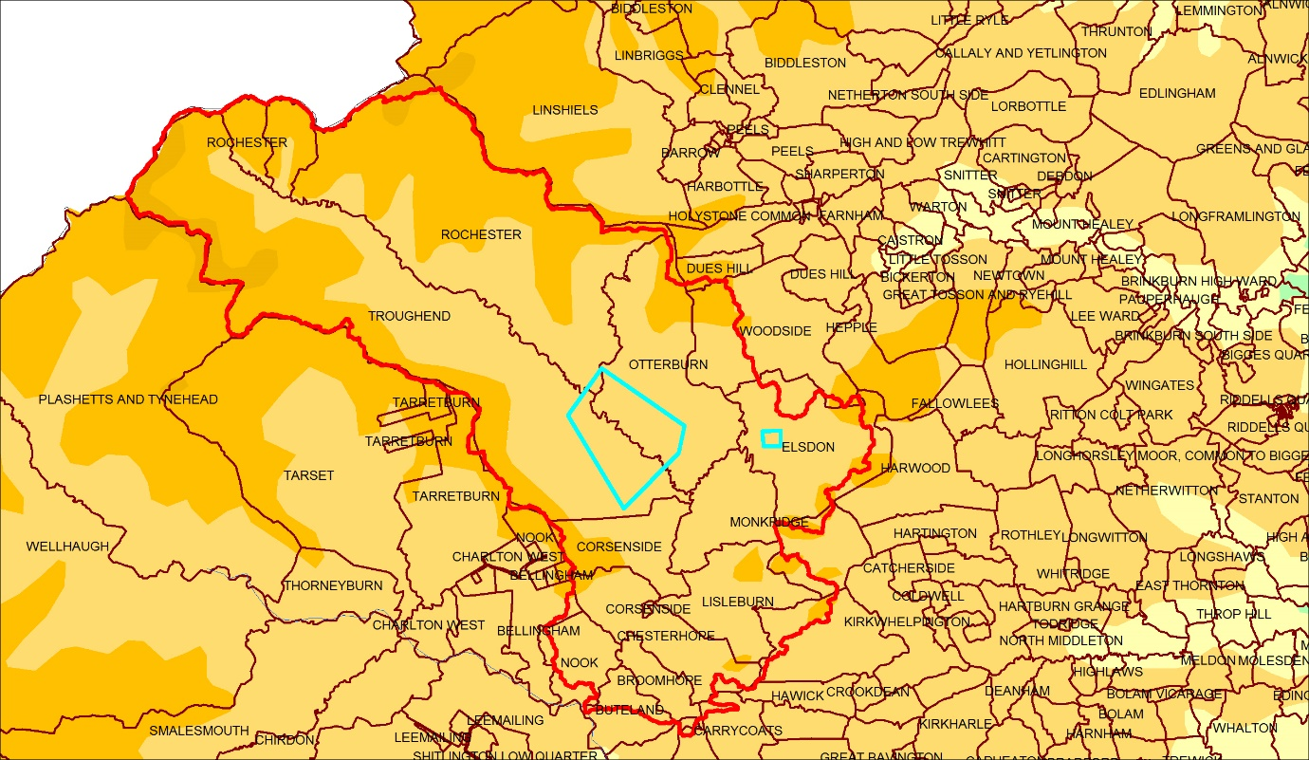
Figure 1: Location of Otterburn and the pilot study area within Redesdale, including the location of Elsdon church (Township boundaries from (Kain and Oliver 2001))

PRIMARY SOURCES FOR THE BATTLE
Detailed notes on information provided in the primary sources as regards the dead from the battle are given in appendix 4. Other than this, no attempt was made here to rework the primary sources. Instead only published extracts of the major accounts for the battle were reviewed. In this the most significant topographical detail relevant to the present assessment was found to be that provided by Froissart. He states that “They [the Scots] protected themselves [i.e. their camp] by making skilful use of some big marshes which are there. On the way in between these marshes, on the Newcastle side [of this main camp], they quartered their serving men and foragers” also putting their cattle in the marsh.
In the past one interpretation of Froissart was that he meant the Scottish camp was on the Newcastle side of Otterburn, but it seems clear that rather he is describing the position of the servants’ camp relative to the main camp. Thus the argument against the traditional site on this evidence can be largely dismissed.
The topographical detail in Froissart is very specific. Thus the present project rapidly examined the historic landscape of the traditional site and its environs, and assessed the principal available evidence, seeking to establish what source of documentary and archaeological evidence might enable more detailed reconstruction of the terrain in a larger scale project.

HISTORIC LANDSCAPE
Assessment of the historic landscape sources has shown limited value in the historic map evidence, mainly due to the lack of any maps before the later 18th century (see appendix 2). However they do provide an important starting point for any landscape analysis.
In the present study the following key information was considered. Firstly, the presence of a former area of bog adjacent to Greenchesters (bog and moss place names). This appears to be supported by a test pit dug during field investigation (appendix 3, field 7) which revealed a deep alluvial deposit in a restricted area adjacent to the place name. Far more extensive augering to define the full extent of any such areas of bog/moss would be required in a future project. Analysis of such evidence should be complemented by an examination of the exact relationship of wide and narrow rig (see below) in relation to these potential former bog areas as this may indicate late drainage and cultivation of these areas. Mapping also suggests an area of woodland (holt place name) as well as areas of unenclosed common still remaining in the late 18th century on the north eastern periphery of the battlefield. It also suggests the route of the main road to Scotland prior to turnpiking, which appears to have crossed the river twice in the area adjacent to the ‘bog’. Its route seems to follow a gravel bar which runs across the valley floor in this area, adjacent to and avoiding the probable bog. This may prove to be the route in use in 1388 and referred to by Froissart.
The full transcription of the historic map data in GIS to an 1880s Ordnance Survey map base would provide an essential starting point for mapping of any data from not only earlier historic maps but also the written sources on the medieval and early modern landscape. While a few documentary sources were identified from the 17th century and later, an extensive search for medieval and early modern written sources for the historic landscape was not undertaken as part of the pilot work. This would need to be undertaken by an appropriately qualified specialist as part of any larger scale investigation.
The map and field evidence, suggesting the bog and the gravel bar possibly followed by the early road, shows that more accurate data is required in the battlefield area than is available from the existing geological map from the British Geological Survey. While it gives broad extent of alluvium and gravels this is not at sufficient resolution to reveal the fine details, which may have had critical tactical significance in the battle.
The aerial photographic and Lidar evidence, complemented by field examination, shows extensive survival of both narrow and wide rig, the former early modern but the latter likely to be medieval, although this needs to be confirmed by further analysis. The mapping of the wide rig in GIS may provide an important base from which to analyse the medieval landscape, using any medieval written sources or early modern sources prior to enclosure. The distribution of the rig also needs to be considered in relation to the place name and geological data, as noted above.
These data sets also revealed extensive earthwork evidence for early river channels, the mapping of which and possibly also testing in the field by augering, will also be required in a full project as they are likely to be critical to understanding the terrain within which the Scottish camps were set and the battle fought.
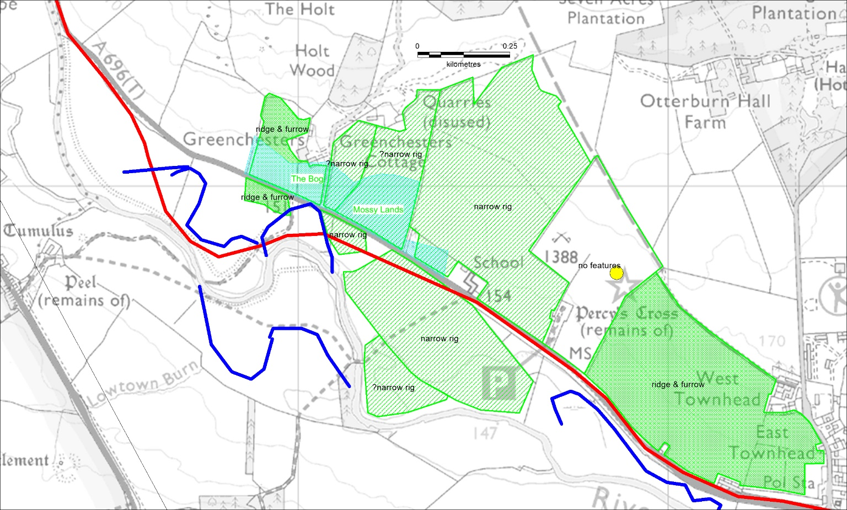
Figure 2: Approximate course of the road prior to turnpiking, shown in relation to the most obvious sections of palaeochannel, also with the extent of surviving wide and narrow rig, and the location of bog and moss names.

BATTLE ARCHAEOLOGY
There is no battle-related archaeological evidence from the traditional site that has been reported in antiquarian publications or is recorded on the Historic Environment Record or the Portable Antiquities Database. A note on the antiquarian reports of tumuli on or close to the battlefield and of human remains to the east of Otterburn at Fawdon Hill, and on the burials suggested as battle-related found in the churchyard at Elsdon in the 19th century are given in Appendix 4. There has to be serious doubt as to whether any of these discoveries has genuine association with the battle and more prosaic explanations of the tumuli and of the burials at Elsdon and Fawdon Hill are likely to be correct. The individual nature of the burials on Fawdon Hill suggests a normal cemetery of pre-medieval date, while battle-related burials being placed in tumuli is not documented for any medieval battle. Only the burials in Elsdon church appear to warrant modern archaeological testing, possibly through small scale test pitting to sample the human remains to determine if they display any form of weapon trauma, although advice from a specialist in the archaeological investigation of human remains should be sought when designing a scheme of investigation.
METAL ARTEFACT SURVEY
The objective of the fieldwork was to establish the practicability of large scale metal detecting survey; to assess actual artefact condition and, through soil sampling, to establish likely condition of both ferrous and non-ferrous medieval artefacts that may have remained in the topsoil since 1388.
Small areas of 8 fields distributed across the traditional site of the battle, including gentle valley sides as well as valley floor, were sampled by metal detecting over two days in March 2017. A total of 7200m of detecting was undertaken along transects set out at 10m intervals or, where earthwork rig exists, along ridge tops so that the shallowest soil was sampled. Detecting was in non-ferrous mode.

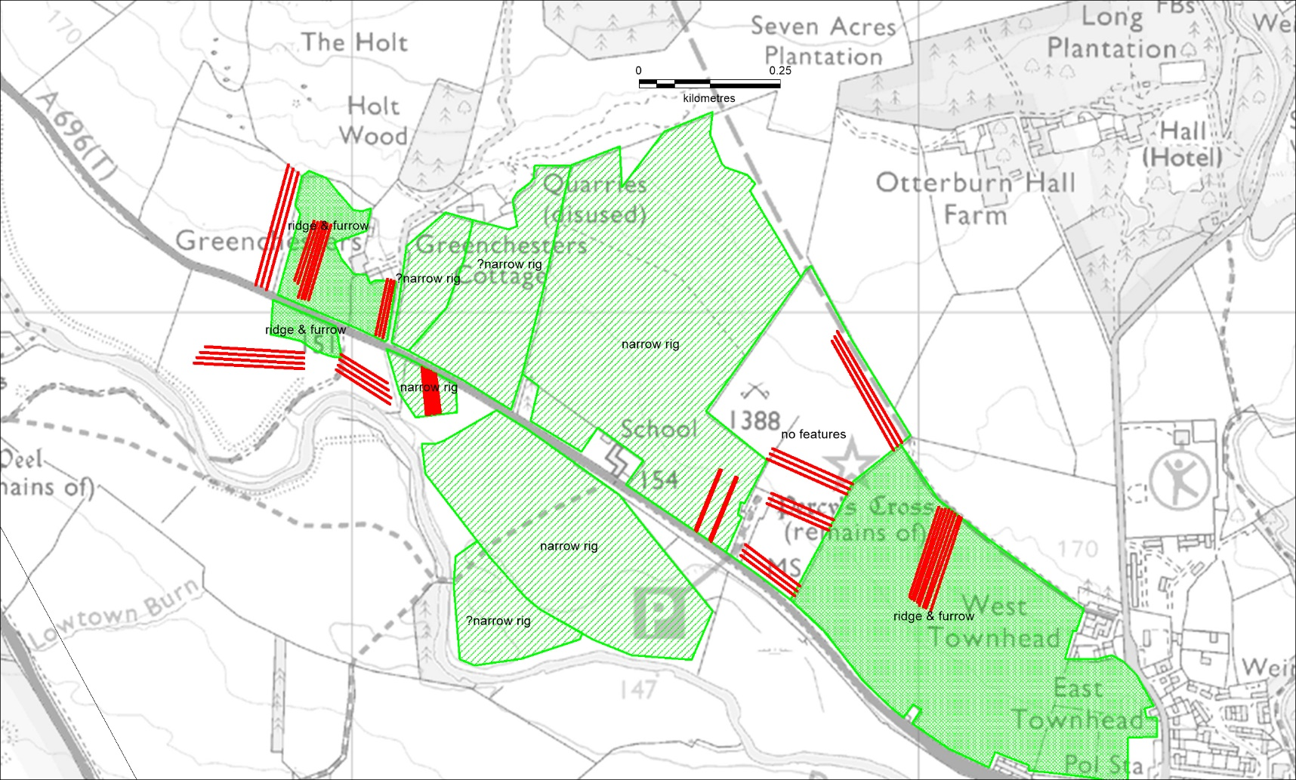
Figure 3: Detecting transects mapped in relation to the distribution of surviving wide and narrow rig
Not surprisingly for such a small scale sampling, no objects were recovered which are likely to be related to the battle. What was demonstrated was that the level of background noise, in the form of modern non-ferrous junk, was within normal range and appears to make survey viable even in fairly close proximity to modern farms. In addition, several sample transects were tested in all-metal mode to assess the number of ferrous signals relative to non-ferrous, but without recovering artefacts from the non-ferrous signals. While the latter was not a rigorous assessment it did suggest that the density of ferrous artefacts is not so high as to preclude at least some sampling in all-metal mode during a larger scale survey. In the first field this data was recorded an unusually low ratio of 3:1 for ferrous to non-ferrous was suggested, but elsewhere a ratio closer to 10:1 was observed.
In addition there was a relatively low level of recordable finds, and these almost all early-modern. The lack of earlier material probably reflects the marginal nature of this landscape. If correct, then this is a positive factor for battlefield survey because, as at Bosworth, it would mean that any medieval battle archaeology should stand out distinctly from medieval background noise rather than being swamped by it.
The analysis of soil chemistry indicated that while conditions in neither topsoil nor subsoil were particularly conducive to the good preservation of ferrous artefacts, having a soil pH significantly below neutral, it was not sufficiently acidic to suggest non-ferrous artefacts would be in poor condition (Appendix 1). This is a conclusion supported by the subjectively observed condition of the early modern and modern metal artefacts, which did not suggest a particularly aggressive soil chemistry.
The most significant observation however was in the fields with narrow or wide rig, which is most of the target area. Here the finds considered worth recording (ie early modern artefacts) were generally at significant depth within the ploughsoil – at around 25cm – with only very modern junk close to the surface. This is consistent with data from other sites, notably Hastings, where the rate of migration of metal artefacts from the top to the bottom of the soil column, a distance of some 30cm, has been documented as in the order of 100 years. While exact rates will vary according to the intensity of worm action on different sites, it suggests that all significant metal artefacts will have migrated to the base of the topsoil where land has not been cultivated for 100 or more years. This is what the presence of earthwork rig indicates at Otterburn. In contrast, in field 4, which has been relatively recently cultivated and thus lacks rig, all artefacts appeared to be more evenly distributed through all or at least most of the soil column. If correct then this suggests that in fields with well-preserved rig (which means most fields except 2, 4 and 9) it is likely to prove difficult to recover all but the largest of medieval objects. This is because they will lie towards the limit of normal detector penetration, or at least that because at this depth they will only rarely be contacted by the much smaller cone of the detecting signal at depth. In contrast, survey work in fields with severely denuded or no rig due to relatively recent cultivation (as opposed to any areas of the floodplain where this is due to the lack of any previous cultivation) should have good distribution of artefacts through the ploughsoil and be fully amenable to normal survey methods. This indicates the viability of intensive survey, which should be on 2.5m spaced transects or closer, within these fields (fields 2, 4 and 9 on Appendix 3 fig.6 ) and in any others missed in the present assessment but which can be shown to have been recently cultivated. Within the remaining areas of rig both the narrow and the wide rig need to be more intensively tested to confirm the conclusions regarding artefacts depth and recover made here on a very small sample area. If correct then intensive survey of these areas with normal VLF detectors is unlikely to be viable. While it would be possible to use specialist detectors giving deeper penetration this would raise the major problem of large scale recovery of deeply (c.30cm deep) buried artefacts which would be very time consuming. Account also should be taken of the effect of large scale survey producing little or no result for days in end upon team morale, especially if difficult deep recovery of finds which almost all prove to be early modern junk complicates the process.

CONCLUSIONS
The present study did not involve a reworking of the primary sources for the battle, but the main sources were reconsidered in the light of our work on the historic terrain. The present assessment strongly supports the traditional site of the battle, though it does indicate the potential for small but significant modification of the position of the Scottish camps compared to the interpretation presented in the Register report. This in turn would shift the position of the English outflanking move and their attack on the main camp.
Firstly, a location of the Scottish camp on the Scottish side of Otterburn Tower makes tactical sense, for a force awaiting English pursuers coming from the south east, rather than being to the east where they might be caught between the English army and the English garrison of the Tower. This also accords with the most logical reading of the primary sources where they indicate location relative to Otterburn.
Secondly, unlike many medieval battles, the primary documentary sources for Otterburn incorporate significant topographical detail. The most important feature is the road which runs through a marsh, where the Scottish servants’ camp was placed and behind which the main Scottish camp was located. It has been possible to suggest an almost exact location for this, based on the historic map evidence supported by field investigation of the detailed topography of the valley floor. Though of course detailed analysis of all the evidence is likely to modify this interpretation. It suggests the road crossed and recrossed the river immediately to the west of Greenchesters, using a gravel bar, in order to avoid an area of bog and moss immediately south west of Greenchesters, where deep alluvial deposits have also been noted. If correct then this suggests the location of the Scottish servants’ camp south west of Greenchesters between the river channels, while the main Scottish camp would have to lie further north towards Shittlehaugh on the dry ground. This would then make it likely that any English outflanking attack on the main camp would have taken place over the higher ground immediately to the north east of the Holt, the name perhaps indicating an area of early woodland on the spur. Thus the combined river, marsh and woodland would accord well with Froissart’s implication that the Scots placed their camp with good tactical use of the terrain. This position would also mean that a larger area was available to the east of the servants’ camp where the main action might have taken place.
If the land between Greenchesters and Otterburn was largely open and possibly under arable cultivation in 1388, as the wide rig might indicate, then the logical tactical position for an attacking English force to deploy might be on the crest immediately east and north east of the former positon of the Percy Cross. Here the ground is commanding but the slope not too steep to cause difficulty for a cavalry attack. However in this case the orientation of the ridge and furrow relative to any charge would need to be considered because, as can be seen from the difficult English heavy cavalry charge at Pinkie in 1547, horse formations can be disrupted to devastating effect if a charge is made at right angles to the lands.
Our assessment of the historic landscape also indicates that the traditional location presents highly constricted terrain. This is a crucial factor when seeking to identify the location of a medieval battle and to show how the action fitted within the terrain. It means that there is little significant room within this landscape within which the battlefield could be moved from the traditional site as interpreted here. This gives a tight frame within which to apply the principles of Inherent Military Probability, taking account of historical tactical factors, to locate the likely deployments and attack. It also makes it possible to closely target metal detecting survey to seek battle archaeology. This is an unusual combination, similar to that seen at Towton where locating definitive evidence or the battle proved straightforward, but in complete contrast to that at Bosworth where the lack of constricted terrain meant that an area covering many square kilometres needed to be examined.
Our assessment has also shown that more detailed reconstruction of the historic landscape using air photographic, Lidar and historic map evidence in GIS would be practicable and very valuable in refining our understanding of the likely medieval terrain. Limited supporting evidence should also be sought from written sources, in so far as they survive, and by small scale test pitting or trenching to test key facts such as the extent of the bog and the exact position of the early road. Equally important would be a detailed consideration of the likely date of the wide rig and the former extent of this if it represents the remains of a medieval field system.
Finally, we have considered the potential for recovery of battle-related metal artefacts in a systematic archaeological metal detecting survey. This indicates that several fields in key locations on the battlefield are amenable to intensive systematic survey, but that much of the rest of the area is unlikely to be amenable to effective survey. This is a fundamental limitation that would need to be confirmed by further work. This is not to completely dismiss a follow up project, for the site still does offer the topographical detail and constricted terrain that is amenable to study of the sources which are know to exist. This can also be complemented by smaller scale metal detecting survey to test the more limited areas amenable to investigation. In this way the various potentials of the site discussed above may be realised.
A final note must be made as regards the future. While the presumed depth of medieval artefacts over most of the area may place them largely out of reach of practicable modern survey, it may also have led to exceptional preservation. If they have rested there for many centuries, especially if the open fields were put down to pasture at an early date, such deep undisturbed burial is likely to have minimised the effect of the mechanical and chemical processes which cause decay. The one note for caution here is that the soil pH is significantly below neutral, whereas at Towton the soil context within which the ferrous arrowheads were preserved was neutral. Thus more thoroughly testing of these factors is needed in order to establish the likely, or to demonstrate the actual condition of battle archaeology at Otterburn. This must be part of a larger scale project because if there is good preservation even of a low density of battle-relate artefacts this would be exceptional and would require appropriate long term management to ensure survival of the artefacts.
Glenn Foard
for Battlefields Trust and University of Huddersfield
April 2017

Appendix 1:
Otterburn battlefield soil sampling and assessment
S A Rowe, University of Huddersfield
6/04/17

Introduction
Three soil samples were collected from the battlefield site of Otterburn as part of a pilot metal detecting survey. The soils were analysed by the author to give a quick assessment as to the aggressiveness of the burial environment towards any potential buried metal artefacts, giving a broad indication of potential archaeological preservation on the site.
30cm x 30cm test pits were dug using a spade to remove the turf and then a sample was taken from the soil column (figure 1). Where changes in colour, texture and consistency were observed, new sample numbers were given.

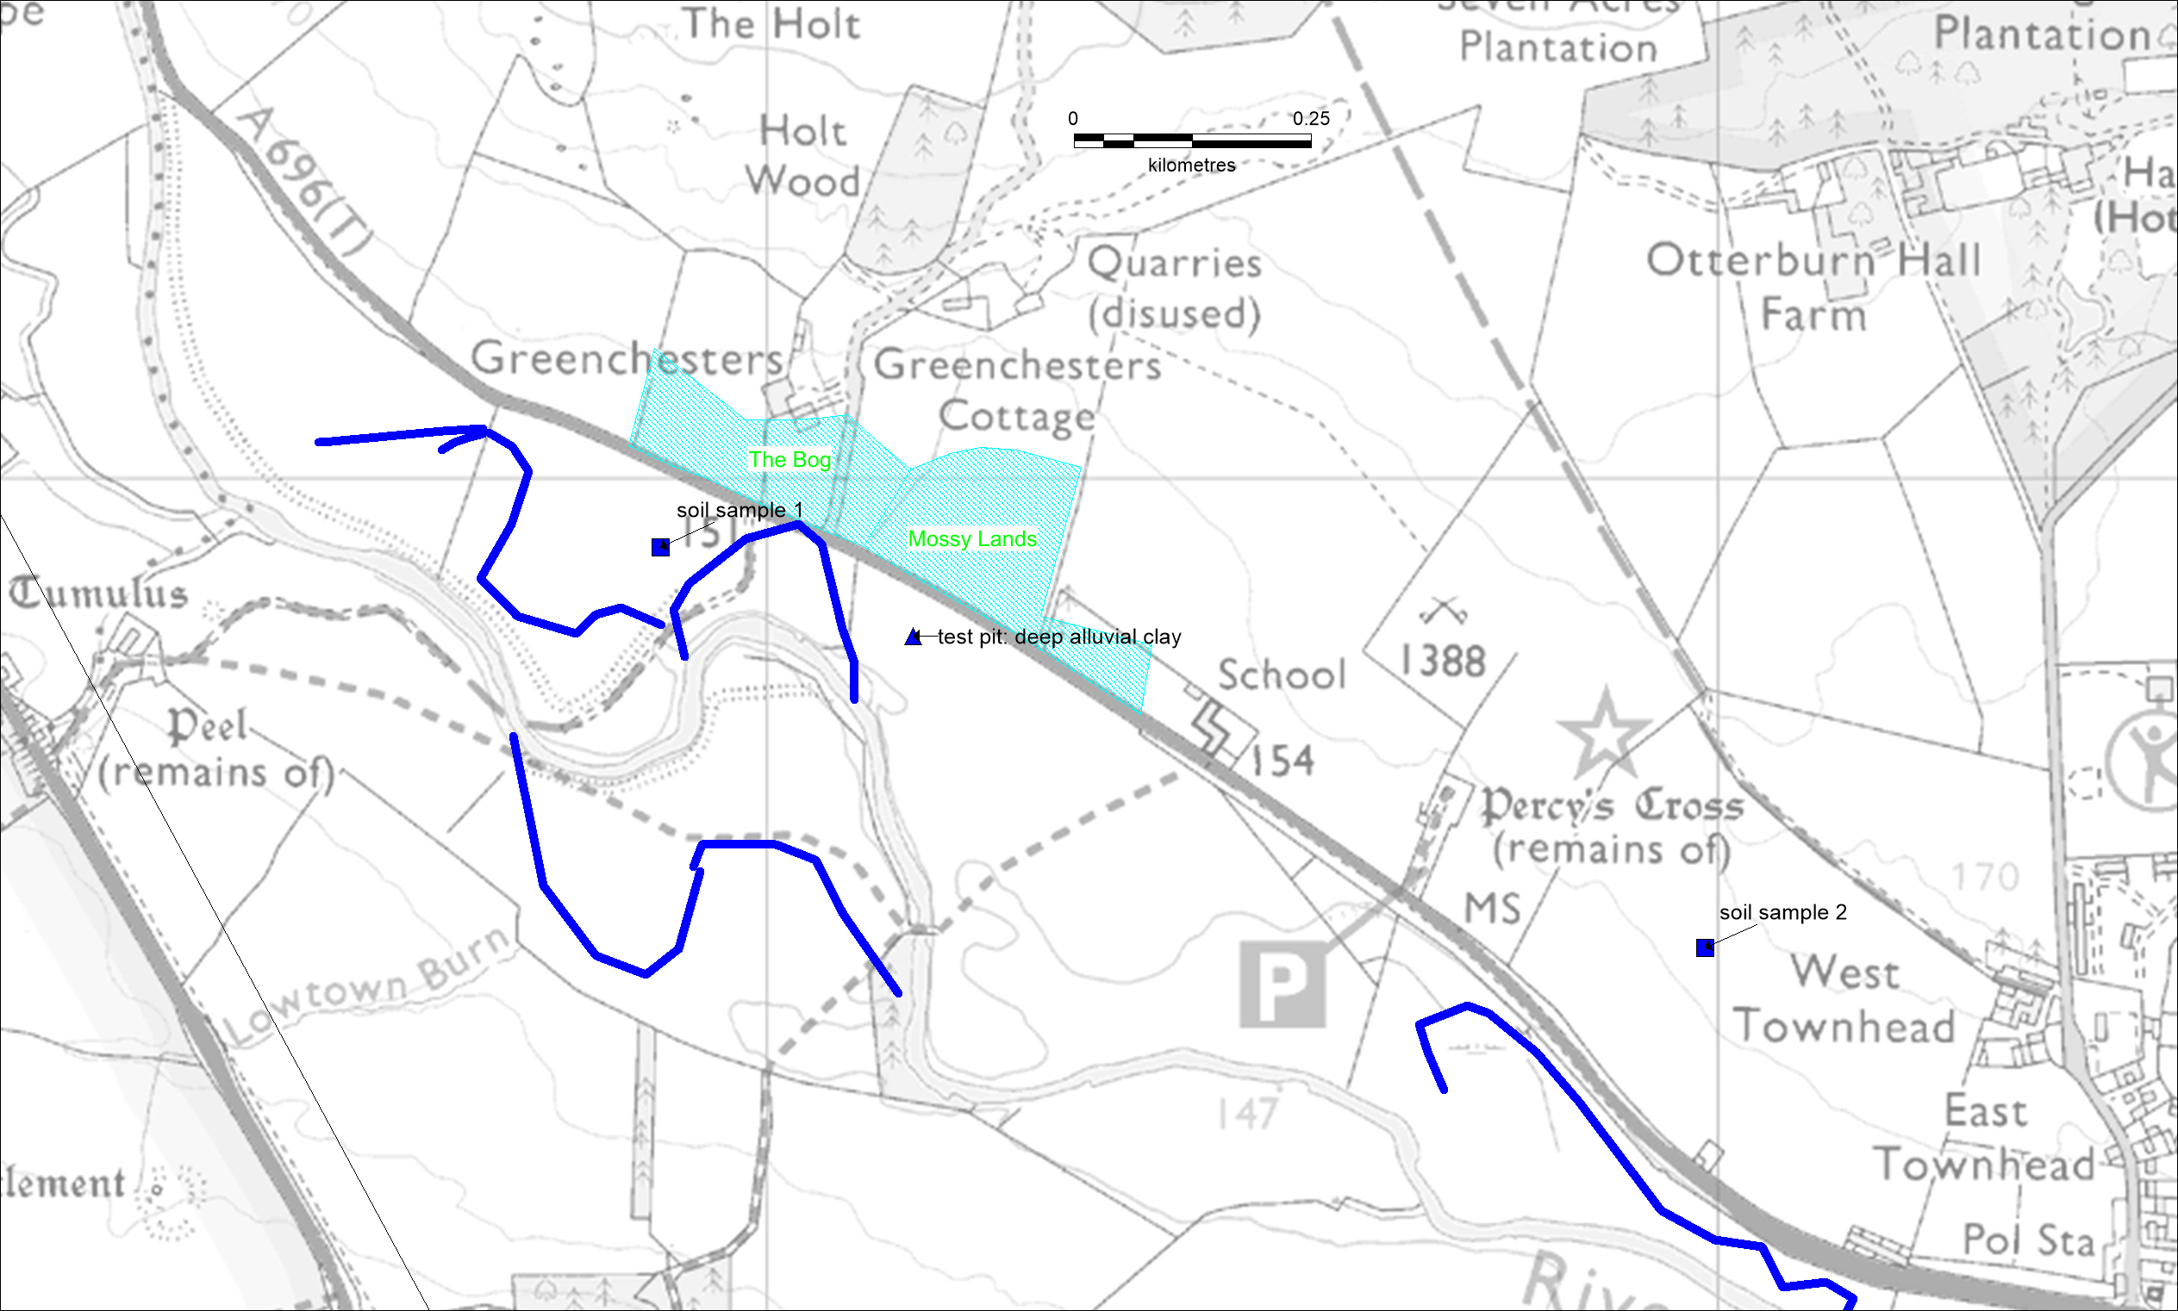
Figure 4: location of soil test pits relative to palaeochannel and bog/moss names

Data
Test pit 1
Only 1 sample was collected from test pit 1 (101): the sample consisted of a friable loamy sand with <1% irregular pebble inclusions. Observations indicated it may be alluvial with little humic content.
Analysis revealed the soil to be at pH 5.88, with a conductivity level of 25.40 µS/cm, a water content of 16% and an organic content of 3.53% (table 1).

Test pit 2
Two samples were collected from the soil column from test pit 2 as a difference could be identified between the two layers.
The topsoil (201) was recorded at a depth of 0.10-0.20m and was a loose sandy silt loam with <1% small stone inclusions. The sample was a very dark brown indicative of a higher humic content than sample 101.
Analysis revealed the soil to be at pH 4.43, with a conductivity level of 17.40 µS/cm, a water content of 26.76% and an organic content of 7.59%.
The subsoil (202) was recorded at a depth of 0.20-0.80m and was a loose sandy silt loam with <1% small pebble inclusions and appeared similar in texture and colour to sample 201.
Analysis revealed the soil to be at pH 4.47, with a conductivity level of 7.98 µS/cm, a water content of 18.71 and an organic content of 4.07.

Test Pit | Sample | Min depth (m) | Max depth (m) | Consistency | Colour undried | Colour After oven drying (105°C) | Colour after ashing (550°C) | Texture | Inclusions | pH (H²O and CaCl) | Conductivity (µS/cm) | Water content (mass %) | Organic content (mass %)
SS1 | 101 | 0.10 | 0.45 | friable | 10YR 3/6 dark yellowish brown | 2.5Y 5/4 light olive brown | 5YR 5/8 yellowish red | Loamy sand | <1% irregular pebbles <3cm wide | 6.96  5.88 | 25.40 | 16.00% | 3.53%
SS2 | 201 | 0.10 | 0.20 | loose | 7.5YR 3/2 dark brown | 2.5Y 4/2 dark grayish brown | 2.5YR 5/4 reddish brown | Sandy silt loam | <1% small stones | 5.89  4.43 | 17.20 | 26.76% | 7.59%
SS2 | 202 | 0.20 | 0.80 | loose | 7.5YR 2.5/2 very dark brown | 2.5Y 4/2 dark grayish brown | 2.5YR 5/4 reddish brown | Sandy silt loam | <1% small pebbles | 5.88  4.47 | 7.98 | 18.71 | 4.07
Table 1: lab results of soil samples from Otterburn

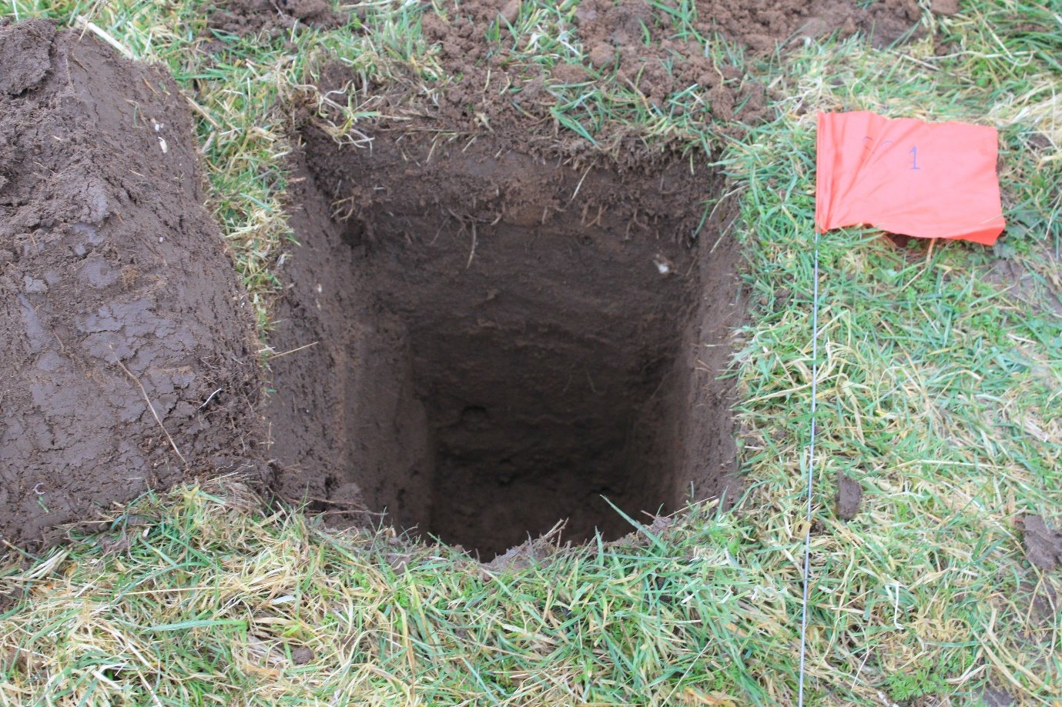
Figure 5: example of a test pit at Otterburn

Discussion
Soil corrosivity is very difficult to determine, though analysing a number of soil characteristics will enable an estimation of likely corrosion rates in particular soils. The significant soil parameters have been analysed and displayed in table 1. These results can be compared with basic statistics which relate to soils parameters which promote high or low levels of metallic corrosion (table 2).

Potential corrosion levels | PH | Conductivity | Water content | Organic content | Texture
High | Extremes  <4.5 and >9 | Corrosion increases as conductivity increases  >200 µS/cm | Corrosion increases with water content, up until near saturation  Severe at 40-50% | Corrosion increases with organic content  >20% | Poorly drained fine textured soils (moist clay/peat)
Low | Near neutral pH  6 - 9 | As low as possible  <100 µS/cm | Low water contents  <10-15% | Low organic content  <10% | Well drained coarse textured soil (sands)
Table 2: General parameters that will encourage or inhibit metallic corrosion in soils
Sample 101 is a coarse sand, slightly acidic, with low conductivity, a moderate water content, and low organic content. The fact that it is predominantly sandy means it is well drained and will not retain water well or high conductivity rates, which probably will not promote corrosion. However, it is slightly acidic so is not a benign environment. It has a pH of 5.88 which could promote the breakdown of ferrous, copper and lead materials, though perhaps not severely.
Sample 201 is a sandy silt loam, acidic, with low conductivity, high water content, and moderate organic content. Though the conductivity is still relatively low, the higher water content and level of acidity (4.43) is likely to promote metallic corrosion.
Sample 202 is a sandy silt loam, acidic, with very low conductivity, moderate water content and low organic content. It is similar to sample 201 in terms of acidity, but water and organic content is lower.

Conclusion
It is predicted that metal artefacts residing in the vicinity of sample 201 is likely to be in poorest condition on the site. The level of acidity and water content would promote some levels of corrosion, but the low levels of conductivity perhaps suggest corrosion would not be severe/rapid.

Appendix 2
Otterburn battlefield: Historic Landscape Assessment
Dr Tracey Partida

A simple reconstruction of historic landscape was made for the Pilot Survey. Some surviving historic landscape features are very good, particularly ridge and furrow - both wide medieval and narrow post medieval - and former river channels. But map sources are all post enclosure. Other enclosure documents may assist in interpretation of the pre-enclosure landscape and, given the early date of the battle, medieval documents must also be sought. If the accuracy of Armstrong’s county map can be relied upon then the pre-turnpike road crossed the river at two points to the south-west of the battle stone monument. Identification of the early pre-turnpike line of the road and all former river channels is therefore crucial.
Details of all data mapped and sources located are given below.

data mapped
Roads:
Former line of road from Elsden to Shittlehaugh mapped using Armstrong, APs and OS 1st edition. Line is crude as there are few control points and evidence of numerous former river channels.

River:
Former rivers channels mapped very crudely in area of pilot survey from aerial data. Will need further work using aerial and Lidar.

Agriculture:
Former plough features, ridge and furrow and narrow rig, mapped from aerial. Will need more work with Lidar.
Named fields mapped from C18 map ZCLB 337.

Township Boundary:
Otterburn township boundary mapped from tithe and OS 1st Edition. Incomplete on northern boundary. This is clearly the post enclosure boundary and will need refining from enclosure documents.

Sources
Nothing at BL.

Armstrong
Armstrong’s map of the county in 1769 shows the road through the battlefield to be pre-turnpike. It crosses the river Rede just below the battle stone and back again to follow the line of the later turnpike. Armstrong distinguishes Roman, turnpike and country roads and appears to indicate open or enclosed (pecked or solid lines), although the key does not specify this. Where the road lies to the west of the river it is unenclosed.

Kain & Oliver: The Tithe Maps of England and Wales
Map of Elsden parish ‘copied from old plans’ 1839. Very detailed according to description, especially for Northumberland where tithe maps are notoriously poor in detail. No ref found at NA or NRO.

Otterburn no ref.

Tate: A Domesday of English Enclosure Acts and Awards
1729 Elsden Common in Elsden (parish), 10,500 acres (estimated, awarded not stated)

1769 Troughend Common in Redesdale (manor) Elsden (parish) 2441 acres awarded

Northumberland Record Office (NRO)
NRO website difficult to use – slow and frequently crashes or seizes up. Also initial search on any term will often give zero results but if the ‘search’ button is clicked again records appear. Some known references are not found. Therefore online searches are not comprehensive. Visit to NRO and discussion with archivist is essential.
Searched terms: Otterburn (only half a dozen pre C19 records), battle, Ellison, Elsden, map, enclosure, tithe, Greenchesters, Garretshields, Shittlehaugh, Carr – Ellison.

?Ref C18 Ellison estate map. #12 The Bog 6 0 3. #13 Mossy [Morry? Merry?] Lands 8 1 36. Township boundary not shown. Roman road edited as far as Ellison map covers in south and to extent of OS 1st edition coverage in the north. Road through battlefield is already turnpiked at this date and is the same as the modern A696.

ZCE Carr-Ellison family of Hedgely 1572-2016
There are 6338 records in this collection and no way of seeing or searching hierarchy. Some records known to exist (see below) are not recognised.

ZCE/A Manorial Records – all Hartleyburn manor

ZCE/23 Carr-Ellison (Hedgley) Mss. ESTATE: Maps and Plans ref from NA not recognised in NRO search

NRO 08211 1807. ELSDON AND CORSENSIDE, NORTHUMBERLAND: RECORDS Printed Parliamentary Enclosure Acts relating to Northumberland

NRO 08211/1 An Act for inclosing Lands in the Parish of Elsdon, Northumberland.

QRUP/24 deposited plans new line of turnpike road from Otterburn to Newcastle

EP/83/34 Tithe award and maps for Rochester, Otterburn, Woodside and Monkridge 1839 ref from NA not recognised in NRO search

DT1 64M Plan of Otterburn Ward, Parish of Elsdon 12 chains to 1 inch 1840, tracing ref not recognised in NRO search. Have digital copy but incomplete and no copy apportionment.
Apportionments shown by holding so very little landscape detail.

NRO 00542/18 Elsdon Lairds II, Earlside - Ironhouse. Manuscript notebook regarding lands and tenants at: Earlside Eastnook Elishaw Elsdon Mill Elsdon Evistones Featherwood Ferneycleugh (inc. sketch plan) Foulshield Garretshields Girsonfield Grassless Greenchester Haining Hatherwick (inc. sketch plans regarding Elsdon Common Award 1731) Headshope Highfield Highshaw Hill (Laingshill) Hillhouse Hillock Hirdlaw Himeshouse Hole and Hole and Mill Holy Dod Hopefoot Hopehead Horsley Hudspeth Ironhouse nd. [c.1970]
Late copy but must be seen.

Q/R/D/2/1,p32,35 Conveyance of property entitled Greenchesters, in Elsdon, Northumberland 1 June 1751-2 June 1751
Extent of Greenchester property uncertain but must be seen.

NRO 3590/40 Plan of Garretshields and Greenchesters in the Parish of Elsdon 1779.
ref not recognised in NRO

ZCLB 337 An undated map of Otterburn probably eighteenth century. Covers the north-western part of the Battlefield Area. The present day Otterburn road is shown as `the Jedburgh Road'. The Holt Wood area is marked as Wood Pasture. The Roman Road of Dere Street is shown, and the River Rede has an island in its channel north of Dargues. Garretshields Farm is marked
Have digital copy. ref not recognised on CRO

National Archives (NA)
Searched terms: Otterburn, Ellison, Elsden, map.
Various records re pleadings over land disputes in Elsden C17, also lease & release, settlements etc. C18 not listed but may be worth chasing depending on how much local history wanted in main project.
E 178/4294 2 & 9 James I. 24 March 1604 – 23 March 1612. NORTHUMBERLAND: Harbottle, Redesdale, Otterburn, and other places Surveys of lands leased to George, late Earl of Dunbar.
E 134/18Jas1/Mich21 18 Jas 1 1620. Theophilus Lord Howard de Walden and the Lady Elizabeth his wife. v. John Hall, Matthew Reade, Robt. Reade, Edwd. Reade.: Castle and lordship of Harbottle, in Riddesdale, a capital messuage called "Otterburn," lands called "Otterburn Manor," "Davy Sheeles," "Ridshead," and lands in Woodburn alias West Woodburn and Riddesdale. Touching customs of customary or tenant right. Survey. [Gilbert Umframville, Earl of Angus, and after him Walter Talboys, Esq., sometime lords of the lordship, are mentioned.]: Northumberland.
C 5/167/100 1697. Short title: Hall v Grey. Plaintiffs: John Hall. Defendants: Thomas Grey, and others. Subject: property in East Otterburn, West Otterburn, Fairhaugh, Fallowlees, Elsden, etc, Northumberland. Document type: bill only
Possibly gives no description of lands concerned but may be worth looking at if trip to NA were made.
FEC 1/577 undated. ERRINGTON, Thomas, and HALL, John: An account of the estate of Thomas Errington, at St. John, and the estate of John Hall, in Elsden, co. Northumberland (to be sold 2 July)
FEC – Records of Forfeited Estates Commission 1552 – 1770 – so possibly provides a description of the lands concerned.
IR 30/25/170 1839. Tithe map of Elsdon (parish), Northumberland. Shows buildings (named), school, toll bars, boundary stones and cairns, hilltop cross, hill-drawing, marsh (moss), waterbodies, rock outcrops, crags, cauldron pot, named streams, springs, antiquities (Roman encampment, Roman road). Colouring used. Scale: 1 inch to 12 chains; index map at 1 inch to 80 chains [1:63,360]. Map was 'Copied from Old Plans' by Thomas Arkle, High Carrick. With 3 altered apportionment maps, dated 1900, 1921, 1925.

Northumberland HER
Simplified database online http://www.keystothepast.info/article/10338?SEARCH=otterburn but needs contact to HER for any detailed enquiry. at http://www.northumberland.gov.uk/Planning/Conservation/Archaeology.aspx
Heritage Gateway website has link to Keys to the Past but no searchable dataset.

Prehistoric: no sites in pilot survey area. A couple on west side of Rede and one to north-west of Greenchesters.
Roman: no sites in pilot survey area. Roman farmstead on same site as prehistoric near Greenchesters above.
Medieval: battlefield and battle cross the only sites in pilot area. Very few in wider area closest is Greenchester DMV.
Post medieval: battle cross and milestone in pilot survey area. Other sites at and near Greenchesters.

Elsden: search of church / churchyard brings no reference to the supposed burial dead, only one Roman and a few medieval tombstones are recorded.

National Park HER
Otterburn village lies just outside the National Park boundary. It is uncertain how much, if any, of the Registered boundary lies within the park. http://www.northumberlandnationalpark.org.uk/
Doesn’t seem to be a separate dataset – website states Historic Environment Officer Chris Jones ‘manages the Historic Environment Record maintained by Northumberland County Council as part of the Northumberland HER’.

County Histories
No VCH.

History of Northumberland Part II. Vol. I. 1858. John Hodgson.

Parish history of Elsden includes quite substantial description of the battle mostly taken from Froissart. No mention of any burials in churchyard.

Appendix 3: Metal detecting survey
Dr Glenn Foard
Metal detecting was undertaken on two full days. Recording of finds and soil test pit locations was with Trimble hand held, sub-metre accuracy GPS.
The majority of the land within the search area is under ridge and furrow, either narrow rig or wide rig. It is almost certainly the case that these fields have not been under cultivation for at least a century and probably far longer, especially in the case of wide rig. In one or two places (particularly field 2) this rig is very degraded as a result of modern cultivation. Only two fields were identified within the search area where ridge and furrow was wholly absent due to modern cultivation (fields 4 and 9).
In fields with ridge and furrow, unless highly degraded, all detecting was conducted along ridge tops. This is for two reasons. Firstly, experience from surveys at Naseby, Edgehill and especially from Hastings shows that artefacts migrate down the soil column over many decades and after a century or so, in most situations, are to be expected at the bottom of the topsoil. This normally places artefacts at 25 – 30cm depth, which for many smaller artefacts is beyond normal VLF detector penetration or, if one considers the detector signal as a cone tapering with depth, is only within range of a very small diameter of the detecting cone compared to artefacts close to the surface. This causes problems for the detecting methodology which aims, as far as practicable, to achieve full surface coverage, which is effective where artefacts are mixed throughout a recently cultivated ploughsoil. Secondly, experience of extensive survey on ridge and furrow at Edgehill indicates that topsoil is shallowest on the ridge tops and thus here artefacts are most easily identified (Foard 2012). This is however a question which would need to be objectively tested, through test pitting to establish topsoil depth and recording of artefact depths during detecting, in any larger scale investigation on the Otterburn battlefield. Such a survey should also test more specialist PI detectors and new VLF models which allow deeper penetration, though these pose the added complication of not enabling effective discrimination of ferrous metals.
In contrast, in field 4 (which was tested) and field 9 (which was not tested) the artefacts should be expected to be distributed through most of the topsoil column as these fields appear to have been cultivated at some point during recent decades as the earthwork rig has been completely destroyed. Here normal detecting practices should be far more effective in sampling the metal artefact assemblage in the topsoil than on ridge and furrow.
In each field detecting was undertaken along a small sample of transects set at 10m spacing, or closer where detecting along ridge tops. Detecting speed was approximately 10-15m per minute with an attempt to achieve full surface coverage with the detector coil over a width of circa 2m, though individual detecting technique varies to some degree between team members. Detecting was with a Minlab E-Trac, Minelab Quattro, Minelab XTerra705, XP Deus.
Field 1
Detecting GF, SW, BG. Wide rig c. 50cm high. Low cropped grass over most of field but some tussocky areas more difficult to detect. 780m of detecting on 6 ridge top transects. Depth of all but modern finds circa 15-25cm. Fine non-stony soil down to c.25cm. Signals on one ridge in all-metal mode suggest a ratio of 3 ferrous to 1 non-ferrous artefacts. 3 finds recorded. 13 modern non ferrous junk.
Field 2
Detecting GF, SW, BG. Slight trace of wide rig, presumably ploughed down by modern cultivation. Low cropped grass. 650m detecting. No pre-modern finds. 8 modern non ferrous junk.
Field 3
Detecting GF, SW, BG. Slightly lower wide rig compared to field 1. Low cropped grass. Detected first three ridge tops. 300m detecting. No pre-modern finds
Field 4
Detecting GF, SW, BG. 1850m detecting. No ridge and furrow, presumably due to modern cultivation. Low cropped grass. 6 pre-modern finds recorded. Mixing of finds throughout the topsoil. Very sandy grey soil with iron panning effect throughout, on top of grey sand subsoil, in the south west corner but this may be a fragment of the floodplain.
Field 5
Detecting GF, BG. 470m detecting. No pre-modern finds recorded. Narrow rig, possibly slightly ploughed down by modern cultivation, but narrow rig may all be this low here. Detected four ridge tops. Low cropped grass where detecting but rest of field very high and tussocky and not detectable. Very dark grey-black sol with top 25cm stoneless. Only one find, at 25cm a big copper alloy coin (Georgian?) – collected but only approx location recorded. 3 modern non ferrous junk.
Field 6
Detecting GF, SW, BG, Gary Graig. Very low rig possibly reduced by modern cultivation. Low cropped grass except for a few peripheral areas. Only 1 find recorded. 19 modern non ferrous junk. 5 ferrous junk also collected, due to discrimination problems due to shape or size, from many more signals. 1150m detected.
Field 7
Detecting GF, SW, BG, Gary Craig. Narrow rig. Low cropped grass over most of detected area. 600m detected.
Small area also detected on the higher gravel ridge immediately south of the recorded transect. No transects recorded in this area and no finds but gravel shown to be immediately below shallow topsoil.
In complete contrast, between the ridge and the main road a deep alluvial deposit was found in a small soil test pit (3rd test pit on fig 1 in appendix 1) where no soil sample was taken as it was thick alluvial clay from just under turf and continuing to 1m deep, with coarse orangey gravel just touched at the bottom.
Field 8
Detecting GF, SW, Gary Craig. Wide rig very well preserved. Detected 8 ridge tops. 1400m detected. 4 finds recorded, all deep. Soil test pit 2.

Field  number | Metres detected | Non fe finds recorded | Per 100m | Non-fe junk counted | Per 100m | All non fe per 100m | Fe junk counted
1 | 780 | 3 | 0.38 | 13 | 1.66 | 2.05 | 0 | /
2 | 650 | 0 | / | 8 | 1.23 | 1.23 | 0 | /
3 | 300 | 0 | / | No data | / | / | No data | /
4 | 1850 | 6 | 0.32 | No data | / | / | No data | /
5 | 470 | 1 | 0.21 | 3 | 0.63 | 0.85 | 0 | /
6 | 1150 | 1 | 0.08 | 19 | 1.65 | 1.73 | 5 | 0.43
7 | 600 | 0 | / | No data | / | / | No data | /
8 | 1400 | 4 | 0.28 | No data | / | / | No data | /

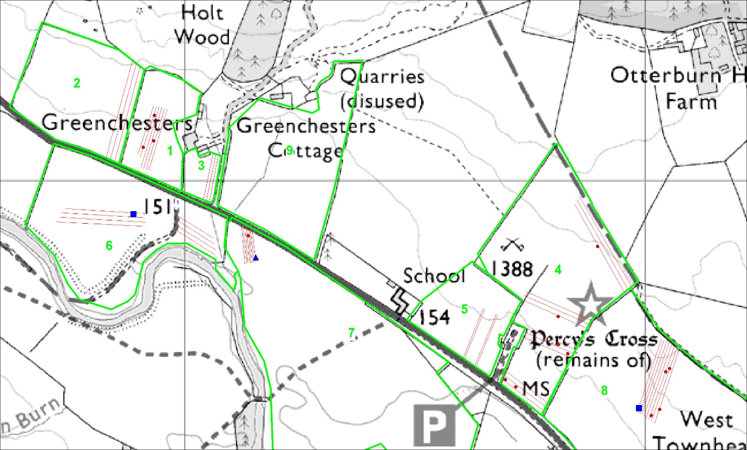
Figure 6: Map showing detecting transects and recorded find locations in each numbered field

Appendix 4:
Notes on the primary sources in regard to the dead of the battle and antiquarian reports on the burials at Elsdon
2007 © Sarah Taylor, University of Huddersfield

- Westminster Chronicle: that 550+ English killed, he blames the Bishop of Durham for not coming to Percy’s aid. Notes that the second prong, led by Sir Matthew Redmayne was successful, and that he ordered no quarter unless opponent could pay 100. Redmayne apparently chased the Scots all the way to the border --- so might expect burials at quite a distance from the battlefield, if this is the case. Scots lost 500+, retreating when they heard about Redmayne’s success.
  - Source reliability: written 3-9 years later at Westminster, so second hand but in a good position for information from the English royal court. Maybe also had a written eye-witness source. So quite reliable.
- Andrew of Wyntoun: he says estimates of dead vary from 1000-1500+. James Douglas found naked the day after the battle, whereupon his body was removed to his tent.
  - Source reliability: Scottish source, a canon of St Andrews, writing in his retirement and finished between 1420 and 1424 so could be up to 36 years later he was writing. But it is thought that maybe the Otterburn section was written by an eye-witness, not Andrew, some 18 months after the battle.
- Thomas Barry of Glasgow: he doesn’t know how many killed and captured but many men were killed and then buried.
  - Source reliability: very unreliable as more interested in rhyming couplets than factual accuracy.
- John Hardyng: very little information, just that they killed Douglas and routed the Scots
  - Source reliability: he was writing some 50 years later, as a second hand author, but he served in the household from relatively close to the battle, so he may have had good first hand information/accounts.
- Henry Knighton: 1100 killed.
  - Source reliability: writing from Leicester Abbey, so second hand, but seems to have been well informed, and probably started writing 1390, so writing relatively close to events too.
- Thomas Walsingham: Henry killed Douglas, then many English killed
  - Source reliability: again second hand but in a good position at St Albans for reliable information, while he could also have got information from Tynemouth Priory which was a cell of St Albans.
- Continuation of Ralph Higden: Has Matthew Redmayne’s attack killing 500+ Scots, while 550+ English killed in the battle.
  - Source reliability: writing in Chester and again second hand, written by John Malverne [of Worcester?], seems to be fairly contemporary with events BUT he clearly had the same source as the Westminster Chronicle so perhaps a written eye-witness account.
- Jean Froissart: English did not realise that they had killed the Earl of Douglas, simply believing him to be another man-at-arms because otherwise it’s likely the Scots would have been demoralised and broken at the death of their commander. Fact that Ralph Percy had to verbally identify himself shows the difficulty of recognising people and their status in the dark. Douglas was mortally wounded and asked his protectors to keep his death secret so that his men would continue fighting. His Scots sources told him that 1860 men killed altogether ---although another edition of Froissart has 1040 English killed and 1840 killed in the pursuit.
  - Source reliability: he says he had eye-witness accounts from men who fought on both sides (2 Scots and 2 Gascon knights who fought for the English) and was writing within 4 years of the battle, so relatively reliable, although we still have to remember his agenda for chivalry etc.
- Walter Bower: has cause of Douglas’ death because he didn’t have time to arm properly due to English rapid advance which allowed him to be fatally wounded. His body was found next morning. English lost 1500 and ‘many of the Scots too’.
  - Source reliability: abbot of Incholm so a Scottish source, died 1445 so written before then. Probably written some time between 1440 and 1445, used Wyntoun as a source.
- Note: there are also 3 ballads, but as literary sources I haven’t included their detail here. Of those the Battle of Otterburn usually though to be the earliest, probably dating to the early 15th century. The Hunting of Cheviot and Chevy chase are also thought to be 15th century, but slightly later. The latter 2 have the source of the conflict as a hunt, no the pennon incident before Newcastle as the other does.
Monuments:
- Percy’s Cross: moved in 1777 to current position so that it could be seen from the road. Apparently moved 180 paces east of where it had been originally. Tradition that the original site (Battle Stone) marks the spot where Douglas was killed. Burne suggests that the location of the Battle Stone as marking where Douglas fell may be accurate since they had to find his body in the morning, instead of carrying him off and so could easily have noted that location. Plus it is not in an obvious place in terms of being seen in that it is not on the crest of the hill, and so might be genuine.
Burials:
- Walton (in a 1961 journal article) claimed to have found battle burials at a site that is not the traditional battlefield (the traditional site centring on the Percy Cross area), but on Fawdon Hill. He believes these ‘graves’ mark where men were killed attacking the Scottish camp. He has the Scots burying the dead, covering them with earth and loose stones. All that can be seen today (or when he was writing) were ‘the mere shadows of these bodies outlined by the rust of their chain mail’. He excavated these ‘graves’ in October 1961 –oblong-shaped mounds of large, flat stones, of which there were about 100 ‘single graves’ and about 20 ‘mass graves’ which could be up to 10 yards wide. He seems to have opened a mass grave and 2 single graves, under the stones he found yellow sand and under one a layer of rust, the shape of which revealed ‘a complete body lying on its right side, covered with the remains of what had been, perhaps, a suit of chain armour, covering even the head’. He believes the dead were laid side by side ‘as there are traces showing of another body beside the one on which we are still working.’ --- I couldn’t find any further articles by him since he was clearly still in the process of investigation, but he apparently took photos during his excavation. ---Not convinced by his argument – why bury the armour when it was valuable, and why would that armour then cover the head, plus no dating evidence or battle-related artefacts.
- Robert White: believes it was the Scots who erected Battle Stone after having buried the dead there. He notes that the Scots ‘also placed a number of stones on the graves of those who were either greatly beloved or renowned, several of which might be traced in the vicinity of the camp about the beginning of the present century’ ---here he is referencing Wallis’s History of Northumberland from 1769 which notes that ‘tumuli or sepultures of the slain are still conspicuous’. Douglas taken home and buried at Melrose Abbey. Unclear if White himself saw these tumuli. ---again no evidence that these tumuli relate to the battle or that they even have burials in.
- Elsdon Church mass grave: found during 1877 work on Elsdon church (St Cuthbert’s) (Anthony Goodman: Otterburn lies in Elsdon parish). Edward Robertson: north wall of the nave had very shallow foundations, underneath of which were skeletons. They were lying E-W under the wall, multiple rows with the heads of one row in between the knees of the next--- so all buried along same orientation. Hodgson notes that more burials had been found around 1810 ‘against the north wall of the church’, thought to be about 30 interments in 2 rows, again with the heads of one row on the legs of the next. So Hodgson’s bones exactly opposite the wall that the later burials found under ---so 2 separate burials on either side of the church? one under the north nave wall and the other just outside the north wall?? Robertson examined the bones and thought them to be ‘mainly the remains of men, and chiefly of young and middle-aged men’. From their proximity very likely they were all buried together. ---he gives no indication of what made him think they were male and predominantly young and no mention of any trauma (which is surprising when he does mention lack of trauma in other burials in the same article suggesting he did not observe any clear trauma). The bodies were clearly buried before the nave was built, as they were under the nave wall. He suggests that they were buried only shortly before the nave was built, hence why the wall was so shallow because they did not want to move the dead which had not fully decomposed. An ecclesiastical architect has suggested that the nave is early 15th century (c.1400) and therefore that the bodies predate 1400, but not by much, since they had not decomposed, he argues. Otterburn was fought 3 miles away. Robertson suggests that these are the ‘bodies of the glorious dead’ brought to Otterburn for burial in consecrated ground while the ‘meaner soldiers found a grave where they fell’. No other battle of that period in the area to which these burials might belong. ---quite a convincing case but need more solid dating evidence, sex/age info and trauma to really make the association more likely. Other plausible explanations for a late 14th century mass grave too – e.g plague burials.

BIBLIOGRAPHY

Kain, R. J. P. and R. R. Oliver (2001). Historic Parishes of England and Wales: Electronic Map - Gazetteer - Metadata. Colchester, History Data Service.

National Army Museum (1995). "Battlefield Register Report: Otterburn 1388." from http://www.english-heritage.org.uk/caring/listing/what-can-we-protect/battlefields/.

Otterburn – Final Heritage Lottery Fund Submission

1. The Battle of Otterburn – Conflict in a Landscape

Start date January 2018 |  | End Date December 2022
Lead organisation  The Battlefields Trust | Person  Geoffrey Carter | Position/role  Chairman, North East & Borders
Full contact details
10 Dorset Avenue South Shields NE34 7JA
0191 4228601 / 0795 4690430 geoffrey.carter@battlefieldstrust.com
Other Partners ( New row for each partner) | Role/input | Contact details
Northumberland National Park  Authority | Advisory and logistical support | Chris Jones  Historic Environment Officer
Otterburn Parish Council | Have the Percy Cross site on a long lease | Martin Chilvers, Parish Clerk
The Redesdale Society | Engaging local community | Ian Roberts / Maire West
Historic England | Statutory Body | Bessie Surtees House  Sandhill Newcastle NE1 3JF
Landowners – Campbell  Hewitson and Jim Brydon | Permissions for fieldwork
Sam Kellie / David Walmsley | Engaging young people | Sam- 07757 286357
Is this an original project from first bid ?
Yes

Project Summary:
The Battle of Otterburn (August 1388) was not a turning point in British history in the manner of Hastings, Bosworth or Naseby. It is, however, of special significance in several ways. This is recognised by its status as a Registered Battlefield – a designation by Historic England given to only forty-six of the hundreds of battles fought in these islands. Otterburn is probably the bestdocumented of all English medieval battles due mainly to the chronicle of Jean Froissart. This clash between two of the ‘young Turks’ of late medieval chivalry – James, Earl Douglas & Harry ‘Hotspur’ Percy – has left us with a description of late medieval warfare that is almost unparalleled.

On the ground, very little investigative work has been undertaken in the modern period. The exact location of the battle remains open to debate and the detailed course of the battle itself is not entirely clear. The fact that the battle was fought in the failing light of the evening into the night is most unusual for the medieval period and adds a further dimension to the questions which remain to be answered.

The proposed project will operate at various levels:

- A landscape archaeology project will seek to reconstruct the pre-modern landscape. We know, for example, that the road system was altered in the 18th century and the course of the Rede may have altered in ways that affect the surrounding ground. The pattern of forest and vegetation may also have changed. By understanding the medieval landscape better we will be able to use contemporary sources to review the location of the battle within the landscape. This methodology was used successfully at Bosworth.
- Alongside the landscape work there will be a programme of intensive metal detecting in fields where fighting is believed to have occurred. This will again make use of battlefield methodologies developed at Bosworth, Towton and other pre-modern sites. Initial preproject investigations have established that only some fields are suitable for this work. Many fields have not been ploughed in the modern era which leaves medieval artefacts too deep for detection. The detecting will largely involve community volunteers trained and supervised by specialist battlefield archaeologists.
- Following all archaeological work conservation management guidance will be prepared for landowners and other stakeholders. As technology in areas such as metal detecting improve it is possible that artefacts not currently detectable may become so in the future and management of the land will need to be informed of the need to accommodate this.
- To complement the archaeology the project will undertake a full review of primary and secondary sources relating to the battle under the supervision of specialist from The Battlefields Trust. Much of this work will be carried out by community volunteers with suitable training and guidance. This work will be combined with the archaeological findings to produce a full review of the battle and its location. It is possible that new light will be shed on both the location and the course of the battle.
- To complete the project and to leave a substantial legacy in Redesdale, the present visitor area will be redesigned and rebuilt to present the battle and the area to visitors in an imaginative way. The redesigned area will become a visitor hub, providing an important focal point within Redesdale. Within this part of the project The Battlefields Trust will create an educational resource pack for use by schools, locally and nationally, who wish to study the battle and its related history. This will be a part of a wider series of such packs that the Trust is creating for battles in the UK.

The results of the research & archaeological work will be written up and presented locally and nationally by The Battlefields Trust.
Outputs (bullet point key works and activities):
Year 1
- Landscape archaeology project to reconstruct pre-modern landscape
- Archaeological field work / Finds analysis & conservation
- Primary & Secondary source review relating to the battle of Otterburn
Year 2
- Continuation of source review (if required)
- Archaeological field work / Finds analysis & conservation
- Final analysis of all archaeological work
Year 3
- Conservation management – guidance to landowners etc.
- Preparation & presentation of work undertaken in Years 1 & 2
- Creation of schools’ educational resource pack
- Redesign & remodelling of visitor area
Year 4
• Completion of any work not finished within Year 3

Location
Project address Otterburn Battlefield

Location/Parish
Otterburn Parish - the currently accepted site of the battlefield is to the west of the village of Otterburn. This is a Registered Battlefield and the location & extent of the site is as shown on the attached definitive map prepared by Historic England.

Postcode or grid reference
The National Grid Reference of the Percy Cross at the Otterburn visitor area is NY8771793664

Benefits
Main beneficiaries:
- Local community will benefit from training & involvement in volunteer opportunities and an increased understanding of local heritage.
- Local community will benefit from increase in visitors to the battlefield and Redesdale generally.
- Young people will benefit from the availability of an education resource pack.
- There will be national benefit from an improved understanding of an important Registered Battlefield.
Evidence of project buy-in and support:
- Positive feedback from social media sites
- Good attendance and positive feedback from Redesdale Society lecture on the battle & project
- Positive interest from youth leaders and schools in Redesdale
Proposed Communications
• Project update bulletins via web site & social media
• | Attendance at community events during course of project to provide updates
• | Open day(s) during archaeological field work to allow community to see work in progress
• | Programme of battlefield walks during project led by The Battlefields Trust
• | Publication of all results of research & archaeological work

Monitoring and Evaluation
Outputs | Evidence | Outcomes | Evidence
Reconstruction of premodern landscape | Report by landscape archaeologists | Understanding the nature of the landscape at the time of the battle of  Otterburn | Comparison with contemporary sources describing the landscape
Archaeological fieldwork | Programme of metal detecting completed | Finds | Analysis &  conservation of finds
Primary & secondary source review | Report of research findings | Improved understanding of location and course of battle | Report of research findings analysed against improved understanding of contemporary landscape
Schools education pack | Publication of resource pack | Material made available to schools and other groups | Pack downloaded from The Battlefields Trust’s we site (and other locations)
Redesign and remodelling of visitor area | Visitor area remodelled | Increased number of visitors | Evidence of visitor numbers collected

Heritage Lottery Fund outcomes this project will achieve (tick all that apply)
Outcomes for heritage  Heritage will be:  - better managed✓  - in better condition✓  - identified/recorded✓ | Outcomes for people  People will have:  - developed  skills✓  - learnt about heritage✓  - volunteered time✓ | Outcomes for communities  - Negative environmental impacts will be reduced  - More people and a wider range of people will have engaged with heritage✓  - Your local area/community will be a better place to live, work or visit✓

Finance
Deliverable costs (itemised)

Documentary research & reporting | 3,000
Soil analysis & reporting | 950
Final analysis & reporting | 4,000
Training | 1,700
Fieldwork | 7,000
Finds analysis & conservation | 1,000
Senior battlefield archaeologist | 3,900
New entrance feature | 2,400
Interpretative display & information point | 35,000
New seating area | 2,400
Battlefield interpretation panels | 3,750
School education Resources Pack | 0
TOTAL | 65,100

In-kind contributions £46,400 – Volunteer Contribution
VAT- Will any part of this project costs be subject to unrecoverable VAT
No
TOTAL PROJECT COST | £111,500
Total project cash cost  In-kind support (expertise Battlefields Trust- research and running events- 192 volunteer days detilaed historical research and leading workshops@ £150 per day and 352 volunteer research support, and involvement in archaeology investigations @£30 per day | £65,100  £46,400
Total value of Partnership contribution | £46,400
£ HLF contribution | £65,100
% HLF contribution | 58%

Procurement and Permissions
Will you be procuring capital or capital works No
Consents and permissions
• | Landowner consent for archaeological fieldwork (permission given for pre-feasibility work  March 2017 and landowners have agreed in principle for subsequent years)
• | Listed building consent for works affecting the Percy Cross (Historic England)
• | Historic England will be advised and consulted as regards the work programme within the  Registered Battlefield but formal consent is not required
• | Agreement with Otterburn PC who have a long lease on the Percy Cross site.

Legacy and Maintenance of benefits
What is the project legacy

The battle of Otterburn will be better understood. The local community will better understand and appreciate a major local historic event. Schools will be provided with all material needed to study the battle and its historical context. Visitors to Redesdale will learn about the battle and its place in British medieval history.
What are the future long-term maintenance requirements 2028 onwards

Research reports will continue to be available via the Battlefields Trust and Revitalising Redesdale websites.
Infrastructure at the Percy Cross site will be designed to minimise any maintenance costs to the Parish Council. Arrangements will be made between the Battlefields Trust and Northumberland National Park to take responsibility for repairing or replacing any damaged panels.

Risk and Mitigation
Risk | Impact  (1-4) | Likelihood  (1-4) | Risk rating  (RAG) | Mitigation
Availability of pre-  modern documents and maps may limit the extent of landscape reconstruction | 3 | 2 | Amber | None – documents have either survived or they have not. This will not be known until archival research is undertaken.
Fieldwork may not produce relevant finds | 3 | 3 | Amber | Battlefields do not typically produce large numbers of finds, especially from the medieval period. Use of bestpractice battlefield archaeological methodology under specialist supervision will increase the likelihood of finding anything that has survived.
Bad weather may affect archaeological field work | 3 | 2 | Amber | The areas to investigate are not large and there is time within the project to mitigate bad weather.
Securing agreement with | 3 | 4 | Red | The project team will work alongside
Otterburn Parish Council for changes to Percy  Cross |  |  |  | Otterburn PC to ensure that they are able to shape the proposals for Percy  Cross
Identifying an organisation to take future management responsibility for interpretation and infrastructure at Percy  Cross | 2 | 3 | Amber | Percy Cross is leased by Otterburn PC and proposals will aim to minimise future maintenance and management, but agreement will be sort to ensure that any requirements to repair or replace interpretation is met by either the Battlefields Trust or NNPA.

Other information
Changes in project design since 2015
The research aspect of this project has been increased since phase1, and following the pre-feasibility study to look at site in terms of battlefield archaeology undertaken by the University of Huddersfield (March 2017), there has been a greater focus on landscape archaeology and the reconstruction of the medieval landscape, as the opportunity for metal detecting across the entire site is seen to be limited in terms of potential finds and ability to extend our understanding of the battle.

Links with other project schemes
The analysis of the pre-modern landscape will be helpful in understanding the evolution of the ecology of Redesdale.

The project will have strong links with the community history and archaeology project: Lost Redesdale.

Any monitoring or maintenance requirements 2023-8 (post scheme)
The management of Percy’s Cross site will be subject to a management plan that will be prepared during the final design of the infrastructure and interpretation. The proposals will use materials designed to be long lasting and have low maintenance requirements.

Location of Project

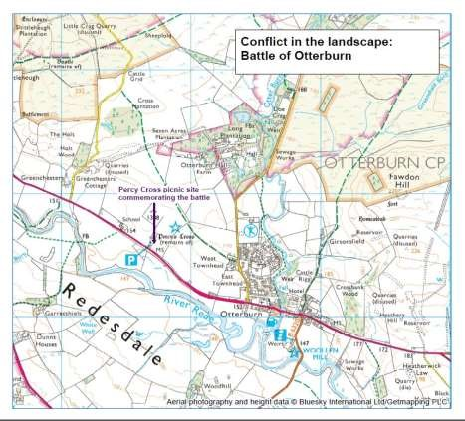

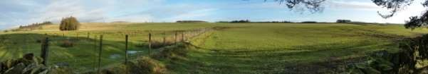
The composite image shows Greenchesters to the left and the whole of the area in which the fighting is thought to have taken place

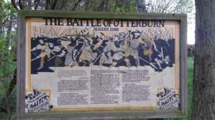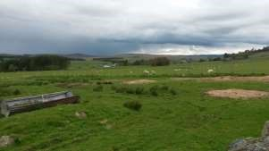
The current old defaced panel at the Percy . Site The view from the village towards the Scottish camp Cross Picnic ^{on the left} site at Greenchesters with the viewing area from the picnic site

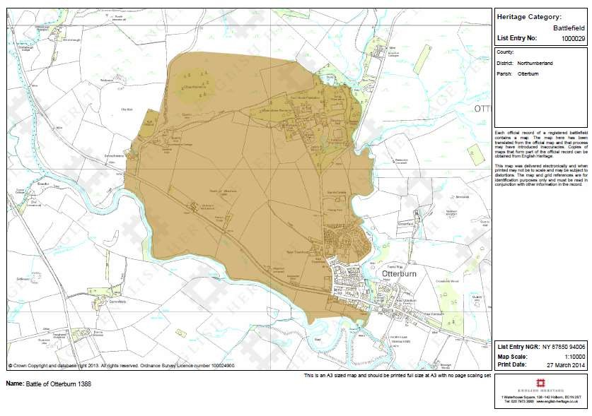
Boundary of registered Battlefield site

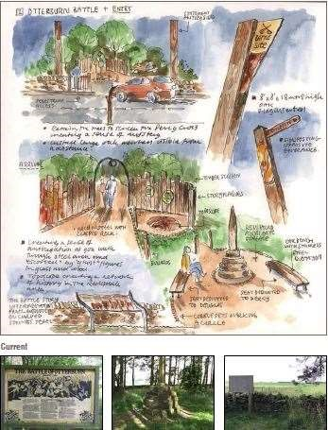

Suggested designs for Percy Cross Picnic Site from the Revitalising Redesdale Interpretative Strategy

BRIEFS FOR ARCHAEOLOGICAL INVESTIGATION AT OTTERBURN BATTLEFIELD (Year 1 & 2)

Brief for Senior Battlefield Archaeologist
Tasks: TheSenior Battlefields Archaeologist will be responsible for the project element Archaeology Supervision. They will:
- oversee and provide guidance on all aspects of the landscape and field archaeology
- provide training in the field in battlefield metal detecting survey and recording, including use of GPS and GIS
- integrate the three strands of evidence reported on by the other consultants to create a single coherent report.
Required expertise:
- a specialist in battlefield archaeology working at post-doctoral level
- extensive experience in the design, implementation and publication of major battlefield archaeology projects, especially those of medieval date
Fee: 13 days @ £300: £3900

Brief for Landscape Historian
Tasks: The Landscape Historian will be responsible for tasks under the project element Landscape Archaeology, undertaking work relating to medieval and early modern written documentary sources. They will work in consultation with the Senior Battlefield Archaeologist and will be required to:
- undertake archive searches for and produce a digital catalogue of primary documentary sources relating to the township of Otterburn. Searches will be both online and, where necessary, of manual catalogues of the National Archives, British Library and
Northumberland County Record Office. Also using the National Archives online system and in consultation with archivists at the Northumberland County Record Office and relevant private archives such as Alnwick, seek to identify relevant documentary sources in other record offices and private archives nationally.
- review the relevant primary sources; identify data relevant to the understanding of the medieval and early modern landscape of Otterburn township; produce in Word a summary of relevant sections of each document; and where relevant prepare in Word a transcription and, as appropriate, a parallel translation.
- Review these data with the Landscape Archaeologist and Senior Battlefield Archaeologist and transcribe/translate any additional material that is felt necessary.
- in consultation with the Landscape Archaeologist and Senior Battlefield Archaeologist, prepare a brief report on the investigation and its conclusions in relation to the historic landscape.
Required expertise:
- qualifications in medieval and early modern history or a closely related subject at post graduate level;
- expertise in palaeography and medieval Latin;
- extensive experience working on primary historical documents of both medieval and early modern date relating to the rural historic landscape;
- a good understanding of historic landscape character and evolution, and the methodology for its reconstruction.
- peer reviewed publications, or at least extensive unpublished ‘grey literature’, demonstrating the relevant abilities and experience.
Fee: 15 days @ £200: £3000

Brief for Landscape Archaeologist
Tasks: The landscape archaeologist will be responsible for tasks under the project element
Landscape Archaeology, undertaking reconstruction of the medieval and early modern landscape in GIS using historic map, remote sensing and other archaeological data; integrating all digital map data for the project and preparing publication quality maps for the final report/publication; and archiving the whole digital archive for the project. They will work in consultation with the Senior Battlefield Archaeologist and will be required to:
- locate and analyse all historic map and other relevant data sets (including Lidar, geology, soils, historic land use, aerial photographs) for the township of Otterburn and, with regard to the early road network, historic mapping for the surrounding study area.
- Interpret, transcribe and rectify all the relevant data in GIS to a late 19th century 1:10560 Ordnance Survey map base;
- integrate these data together with relevant data provided by the Landscape Historian to produce data sets on relevant aspects of the historic landscape of the medieval and early modern period at Otterburn. They will also integrate the digital data provided by the Field Archaeologist from the metal detecting survey. They will prepare publication quality maps as agreed with the Senior Battlefield Archaeologist. They will prepare the digital archive for the whole project and deposit this with the Archaeology Data Service.
- in consultation with the Landscape Historian and Senior Battlefield Archaeologist, prepare a report on the character and evolution of the historic landscape of Otterburn and its environs
Required expertise:
- qualifications in landscape history/archaeology at post graduate level
- extensive experience in the implementation of projects on the historic landscape, working on historic maps, air photographs, Lidar and other data
- a high level of expertise in the use of GIS to integrate and analyse such data sets; and in producing publication quality maps in digital form
- have prepared digital archives for deposition with ADS.
Fee: 20 days @ £200: £4000

Brief for Field Archaeologist
Tasks: The Field Archaeologist will be responsible for tasks under the project element Field Archaeology. They will be responsible for the supervision of all fieldwork, comprising systematic metal detecting survey, and all related post-collection processing of finds and data. They will work in consultation with the Senior Battlefield Archaeologist and will be responsible for:
- building a detecting team
- supervise and undertake detecting in all metal detecting survey
- undertake all field recording using GPS
- provide training for volunteers undertaking finds processing
- integrate all survey and finds data in GIS
- analyse the survey results and prepare a report on the detecting survey
Required expertise:
- a degree or post graduate qualification in archaeology
- extensive experience in the implementation and writing up of field archaeology projects
- experience in the supervision of metal detecting surveys
- ideally experience in battlefield survey
- a good level of personal expertise in the use of a metal detector.
Fee: 35 days @ £200: £7000

Brief for Finds Specialist
Tasks: The Finds Specialist will be responsible for tasks under the project element field archaeology, to undertake the identification of those metal finds selected as potentially significant by the field archaeologist; prepare a brief report on any significant artefacts. They will work in consultation with the Field Archaeologist. Required expertise:
- a degree or higher qualification in archaeology or a related subject
- a high level of expertise in the identification of metal artefacts from metal detecting
- ideally experience working as a Finds Liaison Officer for the Portable Antiquities Scheme or a comparable job
Fee: 5 days @ £200: £1000

Otterburn – Primary Source Research Protocol


Documentary Research Protocol Primary Sources
This document is intended as a guide to those engaged in researching the Battle of Otterburn 1388. The purpose of the document is to help ensure that we consider all of the material to the extent that this is possible. Not all elements will be covered in each source.
The purpose of this exercise is to put us in the best position to read the secondary sources (i.e. what later historians have written) critically. It will help us to see which parts of their work are
‘interpretation’ (i.e. what they have assumed or made up) and which parts have a solid basis in the primary sources.
This, therefore, is just the first step on the path of attempting to build up a picture of the events at Otterburn in 1388. There is no ‘right’ answer and we will not have a complete picture at this stage. It is likely that we will never know exactly what happened but the job of the historian is to construct a narrative of what might have happened based on the available evidence, supplemented with some reasoned and educated guesses to fill in the gaps. But that all comes a bit later.
For the moment, we must stick just to the primary sources and not permit ourselves to embellish or supplement what they say. This will leave gaps in the narrative. There may be errors – chroniclers were never free of these and they relied, usually, on what other people had told them. There may be conflicting accounts – in the case of Otterburn we will see this between the English and the Scottish accounts. Chroniclers were not unbiased observers. We must take account of all of these problems.
The output from this exercise should be a summarised account of the events of 1388 under the broad headings below. There are some guidelines on how to go about this in the methodology section towards the end of this document.
When all initial research has been completed the summaries will be circulated and we will meet in a workshop to discuss them. We will then collate them into a master document summarising the research findings. This will serve as a starting point for the examination of the secondary sources.
An important aspect of all historical research is proper referencing. When we move on to the secondary sources we will look at this in more detail but for the moment just use the system outlined in the methodology below.

Research Elements

The Scottish Invasion of 1388
- Motivation and objectives.
- Instigators.
- Participants.
- Planning – co-ordinated or individual opportunism?
- The muster(s) – when, where, how many soldiers?
- Command structure.
- Composition of army - types of soldiers.
- Route(s) into England – dates and border crossing point(s).

On English Soil
From this point we are primarily concerned with the Scottish forces under the command of James, 2nd Earl Douglas. We should, however, note in outline the movement and operations of the rest of the invading Scottish army. It is possible that intelligence of this part of the force had some bearing on decisions which affected the battle of Otterburn. If your source(s) cover this then please summarize the information briefly. To Newcastle – James Douglas
(A map here would be useful)
- Route from border crossing to Newcastle.
- Dates.
- Camps.
- Raids and other military activities en route – dates, locations, details, casualties.
- Arrival at Newcastle – date, location of camp(s).

The English Response
- First knowledge of Scottish invasion plans – when, who, where.
- Who is responsible for defensive action? What did he do – meetings, planning, muster(s).
- Details of muster(s) – when, where, how many soldiers?
- Command structure.
- Disposition of forces – who was sent where? When did they go and with how many soldiers.
- Composition of army – types of soldiers.
From this point we are primarily concerned with the English forces under the command of Sir Henry (Hotspur) & Sir Ralph Percy, the two sons of Henry, 1st Earl of Northumberland. The same points apply to the remainder of the English army as are set out above for the Scottish forces not under the command of James Douglas.

To Newcastle – the Percy Brothers
- Route from muster point to Newcastle.
- Dates.
- Camps.
- Arrival at Newcastle – date, location of any camp(s) outside of the city.

Events at Newcastle
- Details of all contact between the Scottish and English forces in and around Newcastle.
- Dates, names of those involved, nature of interactions.
- Outcomes.

Departure from Newcastle – James Douglas
(A map here would be useful)
- Date and time of departure.
- Route from Newcastle into Redesdale – this is very important – we need as much detail as is available.
- Raids and other military activities en route – dates, locations, details, casualties.
- Camp(s).
- Arrival in Redesdale – date, time, location of camp(s). Ancillary elements – servants, stolen livestock etc.

Departure from Newcastle – the Percy Brothers
(A map here would be useful)
- Date and time of departure.
- Composition of the force – numbers and types of soldier.
- Route from Newcastle into Redesdale – this is very important – we need as much detail as is available, especially as regards the date and time of departure and the subsequent relative progress of the constituent parts of the Percys’ forces.
- Which parts arrived at what time?

The Battle
Medieval battles are often confused and unstructured affairs. Combatants do not wear uniforms in the modern sense and battlefield communications are haphazard once the action begins. Most combatants (which will include the commanders) are only aware of what is happening in their immediate vicinity. It is difficult to list the topics to consider and summarise as accounts vary in the level of detail. In essence, we need a summary to record everything that the source says about the course of the battle.
In broad terms we need to know:
- what happened,
- when it happened (remember that many things will be happening simultaneously)
- who was in command and who was involved,
- troop movements,
- any specific incidents (e.g. the death of Douglas, the capture of the Percy brothers)
- anything else that seems significant in determining the course of the battle.
Our aim is to be able to compare all primary source accounts and (in due course) secondary source interpretations to build a detailed view of the action from start to finish with a timeline (as far as possible) for the various phases.

The End of the Battle
- When and how did the battle end – most medieval battles end when one side starts to run away.
- Was there a chase / rout? ( A rout is where one side runs away and is chased and often killed by the other. This is where most casualties occur in medieval battles.) If so, who was chasing whom, for how long and for how far?

The Bishop of Durham
Most sources will have something to say about the Bishop of Durham. Medieval bishops were often the sons of noble families and had their own armies. He fits into the picture after the battle itself so we can include him here.
- When and how did he become aware of the Scottish threat?
- Was he sent to assist or did he act on his own initiative?
- Details of his forces – muster- when, where, how many soldiers?
- Command structure.
- Composition of army - types of soldiers.
- Route from muster towards Otterburn – dates and times.
- Meetings, discussions and encounters on the way to Otterburn.
- Encounters and actions after the battle.
- Subsequent reaction to the Bishop’s involvement / criticism.

The Aftermath
- Casualties and prisoners – names and details where possible.
- Disposal and burial of the dead. Elsdon?
- Disposal of prisoners taken for ransom – where were they taken, how were they treated, what ransoms were requested / paid. Details of release or other fate. (Selling important prisoners and sometimes ordinary soldiers back to their families was standard practice in the Middle Ages.)
The English – retreat :
- where did they go
- what was their reception
- political implications local / national.
The Scottish – return home :
- actions in Redesdale after the battle.
- Departure for Scotland – when?
- Route(s) home / border crossing(s).
- Reception, political implications local / national.
We should also record, where possible, a summary of anything said about the activities of the other parts of the original invading Scottish army up to the point of their return home. This need not be too detailed and is primarily for context.

Methodology
Groups have been established for those who wish to work in this way. If anyone prefers to work alone then that is good too. Please organise this amongst yourselves to fit your circumstances and preferences. Similarly it does not matter if we end up with one document per group or one document per individual or a mix of the two – we will look at everything produced.
The easiest way to approach this is probably to start with one source – the translation of Froissart’s account is the obvious one. Using this, create a summary under the headings above. We are not looking for flowing prose here! What is required is a summary in extended note form. Indicate under each heading that your summary has come from Froissart.
Once this is complete then move on to the next source – the order is not important – and work through the headings again for each one. Some of the shorter sources will be silent on some of the topics. Make a note under the heading that ‘X’ has nothing to say about this – in some cases Froissart may be silent so add a note to that effect too.
If there is new information not previously mentioned in the sources already considered, add it to the summary under the relevant heading with a note as to the source.
If there is information that confirms (broadly) something previously mentioned in the sources already considered, add a note that ‘X’ confirms ‘Y’s account.
If there is information that contradicts something mentioned in the sources already considered, add it to the summary under the relevant heading with a note that ‘X’’s account differs from ‘Y’s account.
Of course, it may be a bit more complex – ‘X’ may agree with ‘Y’ and they may both contradict ‘Z’ – just record this as seems best.
Feel free to adapt this suggested methodology as suits your style of working.

When this exercise is complete we should have a number of detailed summaries of the primary sources with a clear indication of who agrees with whom and who does not. We are not concerned at this stage with who is right or wrong – we will form our views on that at a later stage.

GC / January 2019

Otterburn – Volunteers’ Primary Source Summary

The Battle of Otterburn.

Key

The Westminster Chronicle
The Chronicle of Henry Knighton
Scotichronicon
Froissart
John Hardyng
Cronykil of Scotland

Scottish invasion of 1388
12th August - Scots invaded England.
The Scots entered England on the west near Carlisle, plundering the countryside and capturing 300 men, including Sir Peter Tyrell (Sheriff of Carlisle) and other knights. The Scots escaped back over the border with no major losses. On 3rd August they attacked from the east led by The Earl of Fife, Earl James Douglas and others.

The Earl of Douglas had said he would join forces with the western attack near Carlisle, however, instead he gathered 7,000 soldiers and attacked in the east.

The main army of the Scots went towards Carlisle, and Douglas entered England via Northumberland with a smaller force.

In 1388 (no month given) the Earl of Fife raided England. At the same time, William Douglas sailed to Ireland with 500 men. The Irish of Dundalk gave him money to leave. He then returned and went south into England where he joined the Earl of Fife’s army in ‘Ryddysdale’.

On English soil
Scots invaded with 30,000, laying waste to all in their path en route to Newcastle.

The full force of the Scots, plundered and fired the northern countryside of England.

Douglas burnt and devastated all in his way on the route to Newcastle.

The Scots went to County Durham, peaceably to start with, but then started to kill, burn and make war. News of this came to Newcastle and Durham and that the Scots could be detected by the smoke of the fires they set. The Earl of Northumberland sent his sons, Henry and Ralph to Newcastle whilst he stayed in Alnwick in case the Scots passed that way.

William Douglas had been told that the Earl of Fife had ridden with his father and many men to “Ryddysdale”/ Redesdale. He caught them up and joined them. There were 30,000 men. When they got to “Stanemwr” they burnt it and all the land around as they continued. James Douglas had promised to join the Earl of Fife but failed to do so. He had seven thousand men under his command.

To Newcastle – James Douglas
Scots attacked the English with losses on both sides. Douglas sent an abusive message to Henry Percy.

Douglas arrived in Newcastle where the county's militia were waiting for him, also the militia from as far away as York.

From Durham and Newcastle was 12 leagues and all towns were burnt unless behind closed walls. The Scots crossed the Tyne again, to Newcastle. Scrimmishing took place and in one episode of hand to hand combat Douglas managed to take Percy's pennon. He told Percy he would fly it from his castle at Dalkeith, for all to see.

Douglas reached Newcastle they fought at the walls.

The English response
Percy's response was that they would cross paths before Douglas reached Scotland.

Henry Percy came to meet the Scots and fought with them at Elsdon, near Newcastle.

Henry Percy fought the Scots in Newcastle.

Percy's response was that Douglas would not make it back across the border with the pennon, to which Douglas answered that he'd fly it outside his lodgings that night and Percy could see if he could get it back.

The “flower' of Northumberland was in town, men from York and Henry Percy.

Departure from Newcastle – James Douglas
The Scots withdrew from Newcastle and made camp ‘some little way off’.

Douglas was trying to get back to his own country.

The next morning Douglas left Newcastle and arrived at Ponteland where he captured the castle of Edmund of Aphel before continuing to Otterburn some 8 leagues from Newcastle. They fortified their camp by siting it near the marshes. They placed their wagons at the entrance to the marshes and had all their livestock within the marshy land. The following day they attacked Otterburn castle but it stood in marshland and they grew tired of their attack. The Scottish Earls had a council and most wanted to return via Carlisle, but Douglas wanted to wait and see if Percy would come and try to retrieve his pennon. He still believed Otterburn castle was pregnable.

Douglas decided to return home when his men had done enough fighting outside of Newcastle.

Departure from Newcastle – Percy Brothers
Percy went in search of the Earl of Fife's army, but finding it too large decided to attack the army of Douglas instead.

Percy was desperate to pursue Douglas and reclaim his pennon, but the council who met in Newcastle said it was better to lose a pennon than 2 or 3 hundred knights and squires. However, once word arrived in Newcastle about what Douglas and his men had done Percy and his troops set off in Pursuit. He was told about Ponteland and Otterburn and that Douglas had only around 3,000 men with him. The Bishop of Durham had set off for Newcastle with an army in support but Percy did not wait for him.

The Scots left Newcastle via Morpeth, northwards to Otterburn, where Percy engaged them with a small army.

Percy saw that the Earl of Fife’s force was strong and turned instead towards Earl Douglas who was in his country. Percy followed after Douglas with 10,000 men and rode until he came to Otterburn in Redesdale.

The Battle
The Scots’ plan was that their main strength was to fall back behind the English troops, cutting off their rear. The English plan was similar, with Percy leading the frontal attack and Sir Matthew Redmayne the rear. However, Percy was too hasty and rushed off at Vespers without organising his troops into battle formation. He killed Douglas in his own tent, but the Scots, alerted by the noise and still in their armour, fought back. Henry and Ralph Percy were captured. 550 English died. The English were confused in the dark, especially by voices that sounded the same as their own, and killed some of their own men in error.

In Elsdon Percy killed Earl Douglas and mortally wounded the Earl of Moray. The Scots captured Percy, his brother, 21 other knights and many soldiers and archers. They were taken to Scotland.

Douglas had pitched camp at Otterburn and was dressed for the feast of St. Oswald (5th August) and without armour when a rider alerted him to the approaching Percy army. The Scots rushed to put on their armour, but Douglas didn't fix his correctly which led to him being fatally wounded in the face and neck in the ensuing battle by an unnamed soldier. He was not found until the next day. Percy's men were crowded together, so he decided to split the army in two, with him and his brother leading one contingent and Redmayne and Ogle the other. The Scots took flight pursued by Redmayne and Ogle. Percy's contingent were rejoicing at the sight of the retreating Scots, but unknown to them Douglas had gathered his best men who advanced on horseback, hidden by thickets and thorn brakes. Shortly before sunset, they dismounted and attacked the English, who outnumbered them 3 to 1. The English line was broken by a Scot, John Swinton, enabling the Scottish troops to break through.

After laying siege to the castle at Otterburn, Douglas' men were tired. They ate and lay down to sleep. Percy's men arrived at their lodgings but found servants when they had expected lords. There was fighting which allowed Douglas and his men time to put their armour on. It was a clear moonlit August night. Douglas and his men had already reconnoitred the area and knew of a “little mountain” which would hide them from view. They set off for it silently. The English were busy fighting so were taken by surprise when Douglas and his men came from behind the mountain. The battle commenced. Both sides fought nobly and the English had the best of it at first. When Douglas felt his men were weakening he grabbed an axe and hurled himself into the fray. Eventually he was struck by 3 spears simultaneously, one to his shoulder, one to his breast (which also sliced his belly) and the third to his thigh. Neither the Scots or the English realised who he was. Henry Percy was captured.

Percy killed Douglas and the Scots fled. He sent Redmayne, Grey and Umfraville to cut off the Scottish retreat. However, the Scots regrouped and captured Percy who was taken to Dunbar and ransomed. Umfraville, Grey and Ogle held the field and did not know where Percy had gone. The battle was on St Oswald’s Day 1388.

Douglas received warning that Percy was nearby. He and his knights hastily tried to get their armour on. Some failed to do so properly. Percy divided his forces into two battles and he had the larger force. Percy would ride direct to engage Douglas while the others under Redmayne and Ogle would ride round to the right to attack the camp. Douglas came around unseen through bushes. The English were watching the Scots flee from Redmayne and Ogle’s attack but when Percy and his men saw the Scottish banners they set off to fight in disarray. The battle began at sundown. They fought all night. It was a Scottish victory. Percy and his brother were captured. Some 1,000 – 1,500 men and horses were killed. Douglas was killed but no-one knew how this had happened.

End of the Battle
Redmayne was more successful, chasing the Scots to the border, killing 500 men and capturing Sir James Lindsay. The Scots who had captured Percy were baying for his blood, but his life was saved by the Earl of Dunbar.

The English captured Sir James Lindsay, brother of the Queen of Scotland. The dead numbered 1,000 with an additional 100 near Carlisle out of the 30,000 who fought against the English and who were put to flight and driven into the water.

After the Scots broke their line, the English began to retreat and throughout the night were pursued. Many were killed or captured. Amongst the captured were Henry and Ralph Percy. The captives were said to outnumber the captors.

Ralph Percy was seriously hurt and captured. The English outnumbered the Scots, but were tired having ridden from Newcastle that day. The Scot, James Lindsay, believing Redmayne was fleeing the battle, set off after him. They fought and Redmayne took Lindsay prisoner. The pursuit of the English by the Scots lasted 5 miles.

In the morning the Scots found Douglas' naked body with a large wound to the neck and throat and to his face.

Bishop of Durham
The Bishop of Durham had approached the Scots at Otterburn with a substantial army, and despite being close by, decided it was too dark to send his men into battle to support Hotspur. He returned to Newcastle.

When the Bishop heard about the Scots in Newcastle he set off to support Percy with his army but Hotspur was too impatient to wait for him, especially when he believed Douglas only had a small force with him. When he arrived in Newcastle and was told about the battle, he set off for Otterburn with his men but was halted by a rider who said the Scots were in pursuit. The Bishop's forces panicked and scattered.. The Bishop decided to return to Newcastle as he was worried that pursuing Scots might gain entry to the town and resume his pursuit in the morning. Many others thought he could have defeated the Scots. He went back the next day with 10,000 men but turned away again because his men were so distracted by the noise of the Scottish horns that they decided not to fight. Ralph Percy and others were sent back to Newcastle to recover from their wounds against their word to surrender or pay their ransoms in due course.

Aftermath
When the King heard of the battle he was furious and met with his council in Northampton on 22nd August. However, it was decided that it was too close to winter to pursue the Scots so they would wait until next campaigning season and make preparations.

1,040 English taken prisoner, 1,840 killed and more than a 1,000 wounded. The scots lost 100 lives 200 taken captive. The Scots retreated to Melrose where Earl Douglas was buried. They then began to ransom their prisoners. The date of the battle was 19th August.

The Earl of Fife heard about the battle and was angered at the loss of life. He returned to Scotland via the Solway. The Scots took the body of Douglas home with their wounded and prisoners.

Thomas Walsingham – Chronica Maiora

This is not summarised because it is so brief and lacking in any detail. In essence it presents Otterburn as an English victory. Percy is said to have killed Douglas himself. The Scots are said to have been ‘humiliated by this disgrace’ and to have suffered ‘irreparable losses’. Percy, despite his capture had set the kingdom ‘completely free from fear and from the Scots’.

Otterburn – Volunteers’ Secondary Source Reading List

Addleshaw, G. W. O. The Battle of Otterburn Wednesday 5th August 1388. Vaux & Associated Breweries Ltd, 1968.

Armstrong, Peter. Otterburn 1388: Bloody Border Conflict. Oxford, UK: Osprey Publishing, 2006.

Battle of Otterburn (1388) | Medieval Battles | Battlefields of Britain. Accessed 24 September 2018. http://www.battlefieldsofbritain.co.uk/battle_otterburn_1388.html.

Boardman, A. W. Hotspur. First Edition. Stroud, Gloucestershire: The History Press Ltd, 2003.

Brooks, Richard. Cassell’s Battlefields of Britain and Ireland. First Edition. London: W&N, 2005
.
Brown, Michael. The Black Douglases. Edinburgh: John Donald Publishers Ltd, 2007.

Burne, A. H. Battlefields of England. Barnsley, South Yorkshire, England: Pen and Sword, 2005.

Fonblanque, EB de. ‘Annals of the House of Percy’, 1887.

Goodman, Anthony, Prof Anthony Tuck, and Anthony Tuck, eds. War and Border Societies in the Middle Ages: Conference : Papers. 1 edition. London ; New York: Routledge, 1992.

Historic England Registration Report : Battle of Otterburn, n.d.

Macdonald, Alastair J. Border Bloodshed: Scotland, England and France at War, 1369-1403. First UK Edition. East Lothian: Tuckwell Press Ltd, 2000.

McKisack, May. The Oxford History of England: The Fourteenth Century 1307-1399. 1992 reprint edition. Oxford: OUP Oxford, 1963.

Rayner, Michael. English Battlefields: 500 Battlefields That Shaped English History. 07 edition. Stroud: The History Press, 2006.

Ridpath, George. ‘The Border History of England and Scotland’, 1776.

Rose, Alexander. Kings in the North: The House of Percy in British History. 1st Edition. London: W&N, 2002.

Sadler, John. Battle for Northumbria. 1st edition. Morpeth, Northumberland: Bridge Studios, 1988.

———. Border Fury: England and Scotland at War 1296-1568. 1 edition. London; New York: Routledge, 2006.

Scott, Walter, Redesdale Society, J. C. Tyson, Hugh Algernon Percy, Caroline Douglas-Home, Anthony Tuck, Charles F. Wesencraft, Mervyn Wynne Jones, Terry Champion, and John Sadler. The Battle of Otterburn. 1 edition. The Redesdale Society, 1988.

Sumption, Jonathan. Hundred Years War Vol 3: Divided Houses. Main edition. Philadelphia: Faber & Faber, 2012.

Traquair, Peter. Freedom’s Sword. 1st Edition. Niwot, CO: Denver Museum of, 1998.

Wesencraft, Charles F. Battle of Otterburn, 19th August 1388. Doncaster, South Yorkshire, England: Imprint unknown, 1988.

White, Robert. ‘The Battle of Otterburn’, 1857

Otterburn – Landscape Archaeology Report

Otterburn Battlefield Landscape
Tracey Partida

INTRODUCTION
The Battle of Otterburn was fought in August 1388, between a Scottish army led by the Earl of Douglas and an English army led by Henry Percy. Today, the believed site of the battle is marked by Percy’s Cross and is designated as a Registered Battlefield. But the exact location of the battle remains open to debate and the detailed course of the battle itself is not clear.

As part of the Revitalising Redesdale’s Conflict in a Landscape: The Battle of Otterburn Project, the landscape archaeology review seeks to enhance our understanding of the medieval landscape, enabling us to better use contemporary sources and to better understand the tactical potential of the historic terrain to reassess the location of the battle, following the methodology that was used successfully to locate the Battle of Bosworth.

The battlefield landscape study area encompasses some 14.5km² in the townships of
Otterburn and Troughend in the parish of Eldon, lying either side of the river Rede, between Elishaw in the north to just beyond Otterburn in the south (Fig.1). The traditional site of the battle lies at the centre of this region. Figure 2 shows the same area against a background of relief generated from the lidar data. This image reveals the undulating topography as well as showing some remarkably fine archaeological features, and the complex nature of the former river channels.
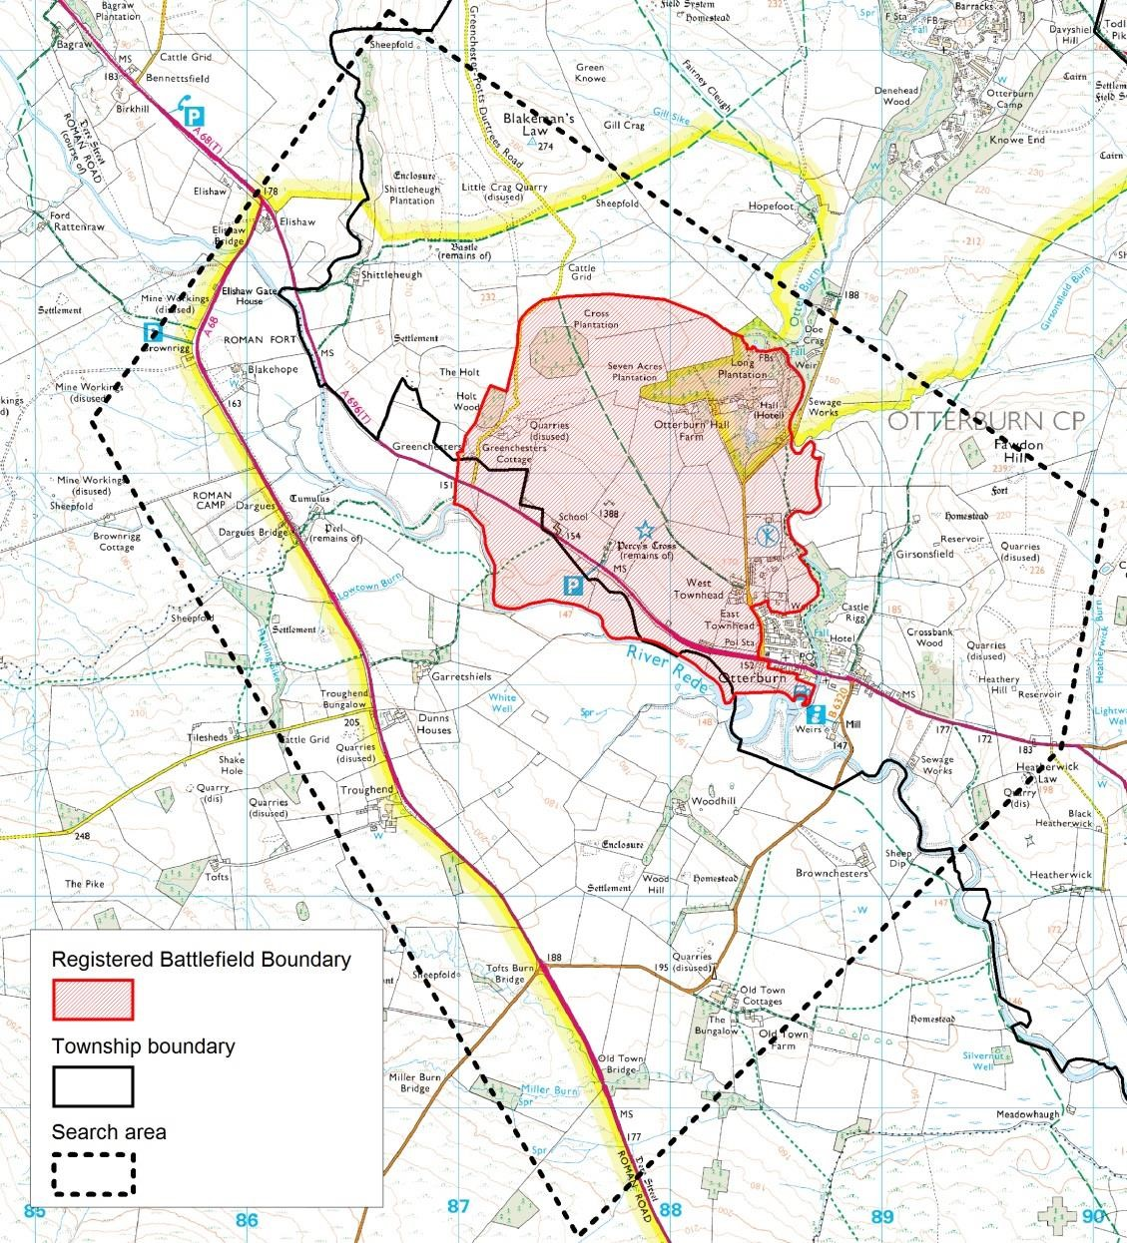

Figure 1: Ordnance Survey Explorer map showing Historic England’s Registered Battlefield boundary, the township boundary between Otterburn and Troughend, and the battlefield landscape study area.
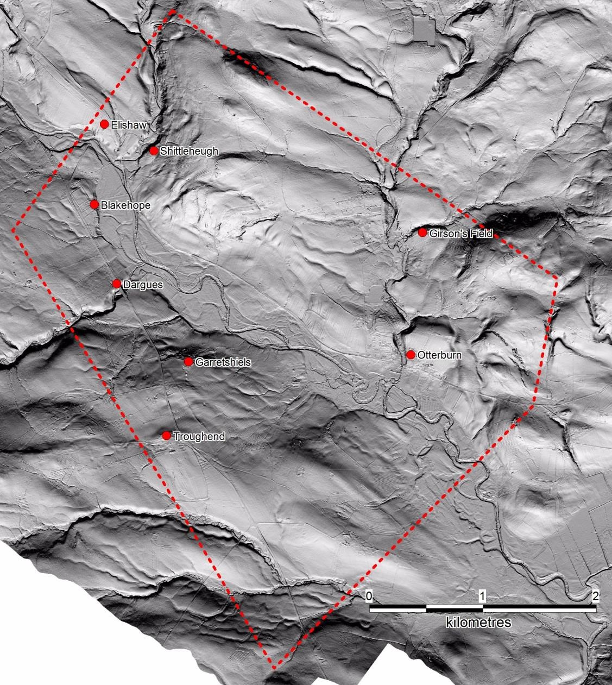
Figure 2: The historic landscape survey area outlined in red, also showing settlements recorded before
1388 against a background of lidar data.

The key features sought when reconstructing the landscape of a battlefield are those that affect the logistics - the long distance movement of men and materials - and the more immediate tactics of warfare, and are principally: roads; rivers with the position and nature of crossing points, whether ford, bridge or embankment; the pattern of relief; marsh or boggy land; wood and woodland; the extent and nature of unenclosed land, whether arable open field, common pasture or other broken ground such as furze or other scrubland; enclosed land; and settlement whether nucleated or dispersed. All these features can assist or hinder the movement of an army, the deployment of troops, and the engagement and action of the battle. But the landscape is not static and such features have often been altered, to a greater or lesser extent, since a battle. Roads might be realigned, upgraded to turnpikes and later major modern thoroughfares, or downgraded or even deserted entirely. Similarly rivers can be straightened, scoured or diverted, but might also meander and create new channels by natural process. Marshes can be drained, woods grubbed up and evidence of early agricultural practices such as ridge and furrow destroyed by modern agriculture or development. Landscape evolution can result in many early features being obscured or obliterated and the earlier the landscape we seek to understand the more complex and challenging is the task. The earlier character of the landscape and the chronology and mechanism of its change, as well as the nature of land tenure, the production of records of it, and survival of archives can all lead to very different potential for reconstructing terrain at the time of a battle.

The battle of Otterburn took place in 1388. To understand the landscape of this period it is necessary to work backwards in time beginning with map and documentary sources from the early-modern.

The character of the landscape in the medieval was governed by the natural environment and the agricultural regime, the latter in turn influenced by the administrative structure. Understanding the way in which the landscape was managed can assist in interpreting boundaries in the landscape. The basic units of administration were the parish, township and manor. Medieval parishes were solely ecclesiastical units that in Northumberland often contained multiple townships, but they did not control the agrarian system and so are not discussed here. The manor was a feudal unit presided over by the lord of the manor, which governed through manorial courts controlling estate administration, including legal matters, and customary rights and duties. Such issues would be applicable to all members of the manor and some manors were vast, particularly in the north of the country, containing multiple townships. In the fourteenth century the Umfravilles held the principal manor in Redesdale. The capital messuage was the castle at Harbottle, but they also held an additional centre and messuage at Otterburn.³ The choice of Otterburn for this role is noteworthy as it likely reflects the importance, and vulnerability, of the road through the valley up to Scotland. A survey made in 1415 records a tower at Otterburn as well as at Elsdon.

Manor courts often also governed agricultural practice, but locally the basic unit for managing the agricultural landscape was the township. A township was, in its simplest terms, a settlement with its agrarian system. It was, usually, a discrete expanse of land with defined boundaries, often using natural features such as rivers and watercourses. It might contain within its boundary nucleated and dispersed settlement, as well as communal open fields, woodland, meadows and pasture. Other shared resources outside of the townships territory, such as woodland and common pastures, might be vast areas enjoyed by members of a particular manor or township, or indeed multiple townships.⁵ Such shared resources did not form part of the township’s territory until enclosure when allotments were made to each township in lieu of the common rights. The area of study encompasses land in Otterburn and Troughend townships (Fig.1). The boundary between them has been plotted from the 1840 tithe map which is the earliest map source to show it in its entirety. This boundary runs parallel to the river Rede, but along it only for a short distance. It might be expected that the river formed the original boundary but its meanderings and alterations over time may have forced a fixed line to be imposed. The same boundary is shown on a c.1779 estate map marking the border between Garretshiels and Greenchesters farms. It is not possible to state how early this boundary is.

METHODOLOGY AND SOURCES
Data searches for historic maps and documents were initially made by township as that is how the agricultural regime was organised (see above). Individual places and estates identified from this were then targeted for further searches. Where possible digital copies of historic maps were made as this allows features not easily seen with the naked eye to be digitally enhanced, thus allowing more accurate data to be extracted. Data from map sources were digitised directly into GIS. Data are mapped to a base of the Ordnance Survey (OS) 1st Edition 1:10560 scale maps from 1855-1884 as it provides the first systematic, accurate large-scale mapping for the whole country.

The primary sources for landscape analysis are the various types of historic map: county, enclosure, tithe, and estate. All have particular advantages and limitations as each was made for a specific purpose. County maps being of smaller scale than the others omit much detail but are particularly useful for placing features in a wider landscape context; and are especially useful for road networks. Enclosure maps document the process of enclosure and, as they are legal documents, are typically highly accurate. They largely date from the eighteenth and nineteenth centuries, the parliamentary period of enclosure, and very few preeighteenth century enclosure maps have been found nationally. Their function was to plot the new allotment boundaries and roads. They often also map ancient enclosures, and preexisting roads and buildings. But within the newly enclosed land former features are not shown so the landscape being replaced cannot be discovered from enclosure maps. Draft enclosure maps do plot both the existing and new landscape but these rarely survive and none have been identified in this study.

Tithe maps, like enclosure maps, were legal documents and, in addition to being highly accurately plotted, also all record the same information, although not always presented in the same way. The purpose of the tithe map and apportionment was to record the new tithe tax, or rent charge, payable on every titheable parcel of land in England and Wales. In many parts of the country they are extraordinarily detailed giving data field-by-field: name, description, state of cultivation (arable, pasture, meadow etc.), measurement (acres, roods, perches), rent charge, owner and occupier. Unfortunately in Northumberland apportionment was by holding rather than by field making this county’s surveys ‘among the most impoverished of the whole country’. Moreover, their date range 1836-1850 means they post-date enclosure for most places and any features they show, including the township boundaries, are enclosure or later impositions.

Estate maps can be the most useful as they are not confined to a particular process, function or period. However, they are limited to the land belonging to the estate, often wholly ignoring other property and for this reason should be treated with caution.

Other documentary sources such as county histories, estate and parish records are also consulted for evidence of landscape history and management. All of these can provide information about how agricultural systems were organised and managed, and the types of crops being grown and stock being reared. Archaeological features are also of great importance to understanding past landscapes, particularly so for those as early as the fourteenth century. Aerial photography and lidar data have been examined for Otterburn and have proved especially useful in identifying features, ridge and furrow and former river channels.
A full list of sources is given in the Appendix.

LANDSCAPE DISCUSSION
A reconstruction of the historic landscape, encompassing at least part of its medieval character, for our search area has been made using a combination of documentary and archaeological sources. The primary source for this analysis is the historic map. All maps identified from the searches have been copied, analysed and relevant data digitised in GIS. In addition aerial photographs and lidar data were examined to identify significant features and to assist in accurately locating those shown on maps. A compilation of these data is shown in Figure 3.

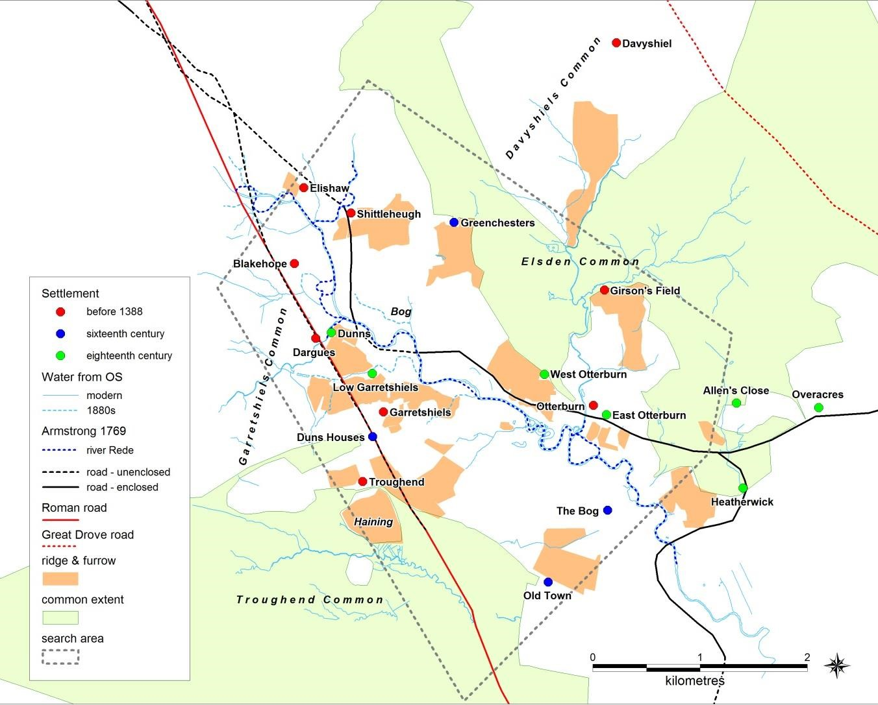
Figure 3: A compilation of potentially medieval landscape features from map and archaeological sources. The areas of ridge and furrow are interpretations from lidar data and aerial photography and are those features identified as being early (probably medieval). Rig suggested here as being of late origin (narrow rig) or of uncertain but probably late date is excluded from this map. See Figure 4 for a more detailed analysis of the rig data. The dates of the settlements refer to the earliest source. All other data are from map sources. The extent of Davyshiel and Garretshiels commons has not been established.

The river Rede runs through the centre of this landscape with land-use types mirrored on either side. At the outer edges were vast commons of rough grazing; inside these were areas of ridge and furrow cultivation which represent probable medieval open fields. At the centre lay a broad area of meadow on low lying ground either side of the river (Fig 8 & 9)
Settlements lay on either side of the river, though were more numerous on the west. It can be seen that the landscape was largely unenclosed. There were no woods within this area. There was a parcel of some 37 acres marked as ‘woody pasture ’on an eighteenth century estate map, with a small close adjacent called ‘The Holts ’(Figs.8 & 9). The name ‘holt ’denotes a wood, but both the close and the woody pasture have ridge and furrow within them, though of uncertain date (Fig.9).

Arable and Meadow
An analysis has been made of the character of ridge and furrow to see if it might be possible to identify period of origin of the pre-modern field systems. An initial search was made for early documentary sources but this did not locate any evidence regarding the medieval agricultural régime that might have assisted interpretation, though a more detailed search could be made in future. The principal data used to define the extent and character of the ridge and furrow was the lidar data from the Environment Agency processed by the Northumberland National Park Authority for the Redesdale Lidar Landscapes Project. The data were processed to yield a series of 8 images for each km square with azimuth increasing by 45 degrees in each to better reveal the fine detail of rig whatever its orientation. The RAF vertical photography from the mid-20th century, held at Swindon, was also consulted but added little to the analysis. The extent of rig has been sketch-mapped on screen with reference to these images and each discrete area of rig classified according to several attributes. Firstly whether broad or narrow, the latter taken to indicate very late cultivation probably extending into the 19th century. The broad rig, which is taken to be earlier, was then divided according to whether it is curved or has a reverse S curve, which is suggested as indicative of early cultivation, possibly as early as medieval; versus that which is straight, which is suggested may be indicative of early modern cultivation but probably predating the narrow rig. The results are presented in Figure 4 and examples given in Figures 5-7.
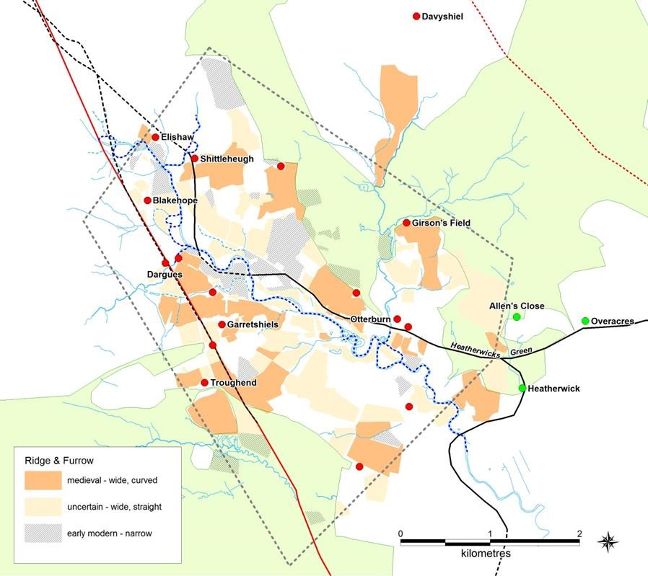
Figure 4: An analysis of ridge and furrow from lidar data indicating probable date of origin. The total area of uncertain period is as great as that classified as medieval and needs further research. Note the plot of probable medieval rig on Heatherwicks Green, the only place it appears on the former commons. For names and dates of other features see Figure 3.

Classification of period of rig by form (broad, narrow etc.) is not straightforward as there are various complicating factors including population decline caused by the Black Death (1348), climatic change causing the altitude limit for cereal ripening to reduce to around 200m, and Border Warfare and reiving. Some, or all, of these issues may have had an effect on settlement and on the extent of arable land use in Redesdale. It is likely that by the time of the battle, in 1388, these factors may already have led to abandonment of some settlements and reversion of some, perhaps even most or all, arable to pasture around Otterburn, even if there was perhaps subsequent reoccupation of settlements and return of early rig to arable. Thus the presence of potentially early rig, even if it is medieval in origin, does not prove it was still arable when the battle was fought. Moreover, classification here of rig as early is further complicated by the well documented continued use of wide rig, and indeed of ox teams for cultivation as late as the 18th century.

This has been a rapid analysis in order to seek, within the resources of the project, some indication as to where land might have been under open field cultivation in 1388 as opposed to some form of outfield, pasture or more extensive common. While reverse S form is generally very distinctive, classification as straight versus curved did not always prove straightforward. This is partly because of the poor condition of some rig and partly due to later features overlying earlier ones, a problem also noted by the Lidar Landscape Project. A much more rigorous but time consuming classification might be achievable by taking account of additional attributes, such as whether headlands or heads are present, as well as reviewing again the attributes used here, which might reinforce the argument for an early date of broad rig.

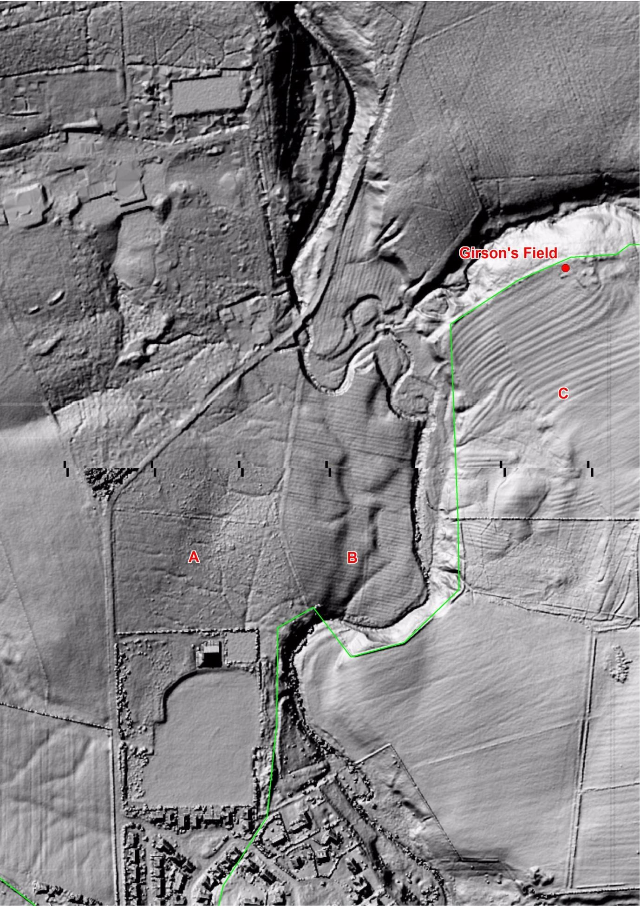
Figure 5: Examples of uncultivated land at A, straight narrow rig at B both within the former Elsdon Common, and at C broad reverse S shaped rig adjacent to Girson’s Field lying outside of the common.

At ‘A’ the pattern of drainage suggests this area within the former Elsdon Common, the extent of which eastward is defined by the green line, has never been cultivated either while it was a common or since enclosure. At ‘B’ while underlying terracing caused by the stream is still visible it is overlain by very straight narrow rig. That this rig lies within the former
Elsdon Common suggests this cultivation took place since enclosure of the Common in 1731. The distinctly reverse ‘S’ form of the ridge and furrow at ‘C’, which lies within the anciently enclosed land adjacent to the settlement of Girson’s Field, and which abuts but does not cross into the former Common, suggests this cultivation was limited by the presence of the common and thus pre-dates the enclosure of Elsdon Common. It may be the early arable belonging to Girson’s Field. Immediately to the south are small patches of broad rig which are too small to classify, showing the difficulty of classifying the broad rig in some cases, though the fragmentary form of the rig here may perhaps indicate late cultivation. Further south modern cultivation has probably levelled any former ridge and furrow.

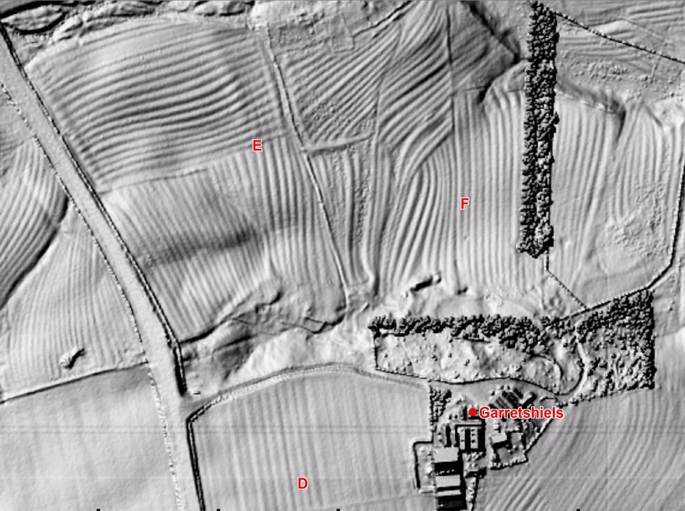
Figure 6: Complex ridge and furrow at Garretshiels. Broad, straight rig at D of uncertain date, at E broad curved rig with visible over-ploughing of a headland, and at F possible realignment of rig to fit a now removed field boundary.

At ‘D’ this image shows distinct straight broad rig which fits neatly within the hedged field boundaries, supporting a late date, and perhaps having replaced earlier rig in a more comprehensive fashion than the smaller modifications nearby discussed below. To the east and north of this is an extensive area of curving and reverse S broad ridge and furrow surrounding Garretshiels settlement. The complexity of evidence which it has not been possible to adequately address in this rapid assessment, can be seen in the ridge and furrow north of Garretshiels. Here a headland has been over-ploughed at ‘E’, extending the strips eastward across a former furlong which ran at right angles but has been truncated and creating a new headland, with traces of the preceding rig just visible beneath the extended strips. At ‘F’ part of a furlong appears extended and straightened beside and following a now removed field boundary. These may indicate quite late continued use and modification of the curving/reverse S broad rig, further complicating any analysis.

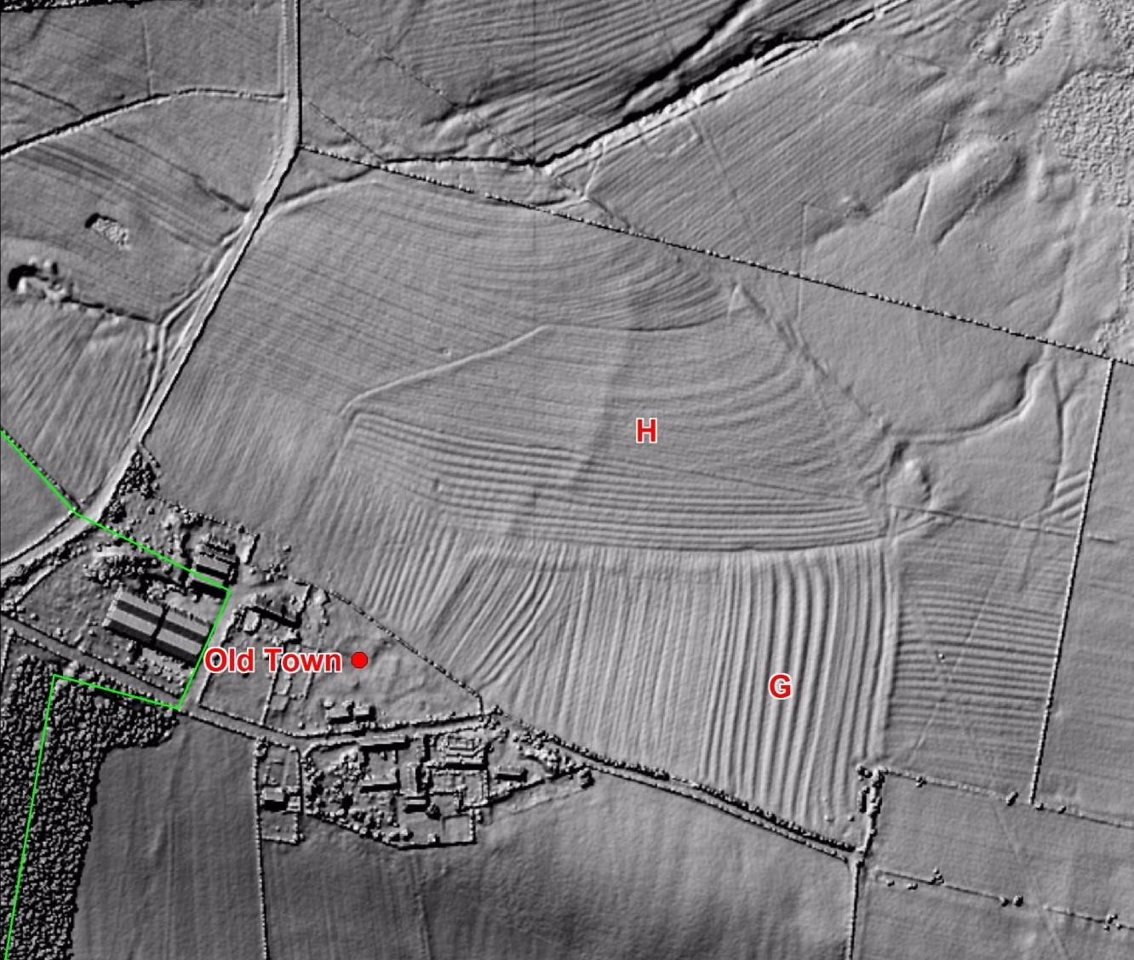
Figure 7: Examples of broad, curving rig at G and over-ploughing of headlands at H around the settlement of Old Town.

At ‘G’ can be seen an example of broad curving rig, part of a substantial area of ridge and furrow adjoining Old Town. Again there appears to be evidence of modification with possible former heads or headland running north-south across furlong ‘H’, having been overploughed to merge two furlongs into one. Detailed documentary study might enable dating to be allocated to such changes, helping to show how late the broad curving rig here remained in use.
This classification of the rig was intentionally undertaken without any reference to the other data sets collected in the landscape study. However, when comparison was subsequently made with the extent of commons enclosed in 1731 and 1768 (Elsdon and Troughend respectively), and with the distribution of medieval and early modern settlement, potentially significant patterning was noted. The rig classified as early was found to form discrete areas which in almost every case abutted or encompassed a settlement which existed by 1388 or which was in existence by the 16th century (Figs. 3 & 4). A particularly good example of this can be seen at Garretshiels in Figures 6 & 9. Previous studies have shown a direct relationship between broad rig and medieval settlement, notably at Davyshiel within the Otterburn Military Training Area. The overall pattern suggests the extent of curving/ reverse S broad rig may define the approximate extent of arable infields which in some if not most cases may be as early as the medieval period and thus possibly existing at the time of the battle unless already reverted to pasture as part of the late medieval retraction of arable.

Both narrow rig and broad straight rig often extend into areas of former common, which reinforces the dating of the broad straight rig to the 18th or even perhaps 19th century. Only one small block of broad curved/reverse S rig lies within the former common. The latter, which is clearly reverse S in form, lies on the former Hatherwicks [Heatherwicks] Green, immediately south west of the ancient enclosure of Allen’s Croft (Fig. 4). With this one exception, the distribution of broad curved/reverse S rig reinforces the argument that this form is indicative of an early, possibly medieval date. It is of course the case that where narrow rig or indeed broad straight rig exists any earlier curving rig will have been destroyed, but the discrete nature of the surviving areas of broad curved rig, together with its association with early settlement, may indicate that this has not been a major problem.

There is also clear evidence of ridge and furrow lying immediately adjacent to either side of the Rede. It might be expected that such low-lying, wet, and periodically waterlogged land would have been meadow. Indeed an eighteenth century estate map marks ‘Haughs ’(the vernacular term for meadows), and an area called ‘The Bog’ in the same places as much of the ridge and furrow (Figs.8 & 9). It has been noted that in Northumberland the often complex furlong patterns were ‘fitting in with topography and drainage’, but whether this accounts for what is seen at Otterburn is uncertain. Almost all the rig in this area been classified here as late or of uncertain date, so probably does not reflect the medieval pattern of land use, but it requires further analysis.

Meadow grass was a valuable resource even in townships with access to large areas of rough pasture as it provided winter fodder for stock and was particularly valued for cattle. That the townships held mixed resources, including meadow, is recorded by Hodgson from late thirteenth century courts detailing the type and amount of lands held by individuals in Dayscheles (Davyshiel) and Troghwen (Troughend) and Ellesden. Meadow, like commons, was often a shared resource. By the eighteenth century meadow was organised in blocks associated with individual farms, some of which lie detached from the farm. The undated estate map marks paths from both Dunns and Garretshiels farms across another’s property to such detached meadow as ‘The owner of Dunns/Garretshiels has a right to a road here ’ (Fig.5).
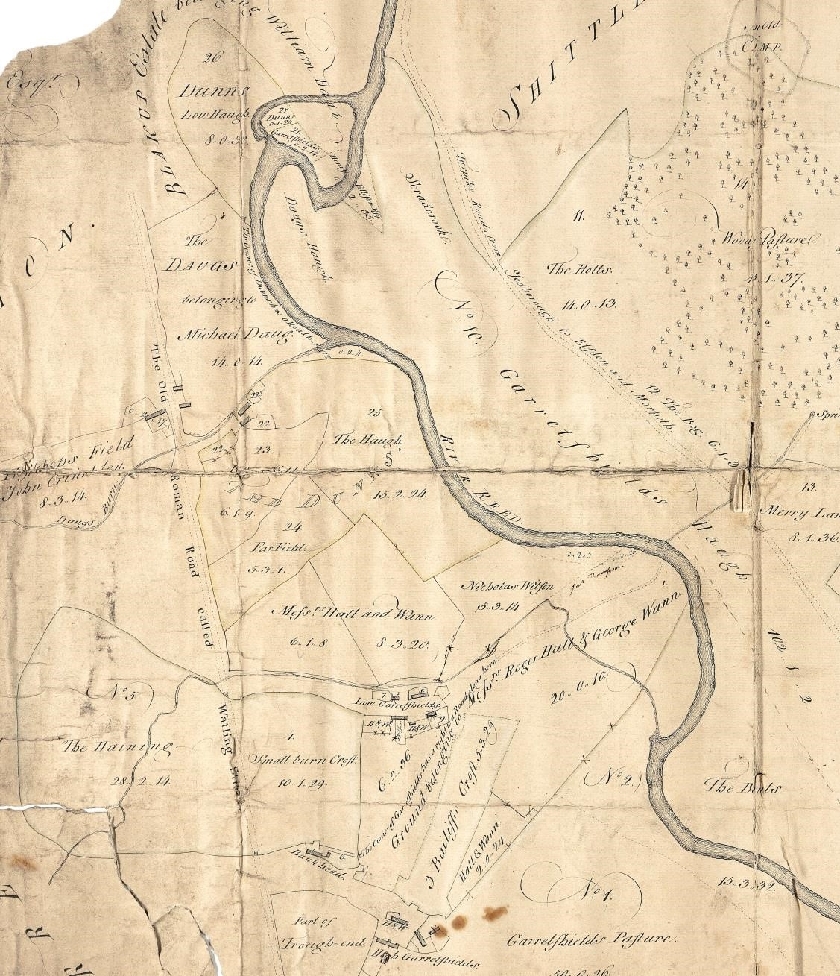
Figure 8: An estate map c.1779 marking several haughs (meadows) where ridge and furrow is also evident. Compare to Figure 9. Note also the access roads from Dunns and Garretshiels to their detached meadows, and the position of the ford to the north-east of Low Garretshiels. (ZCL B 337)

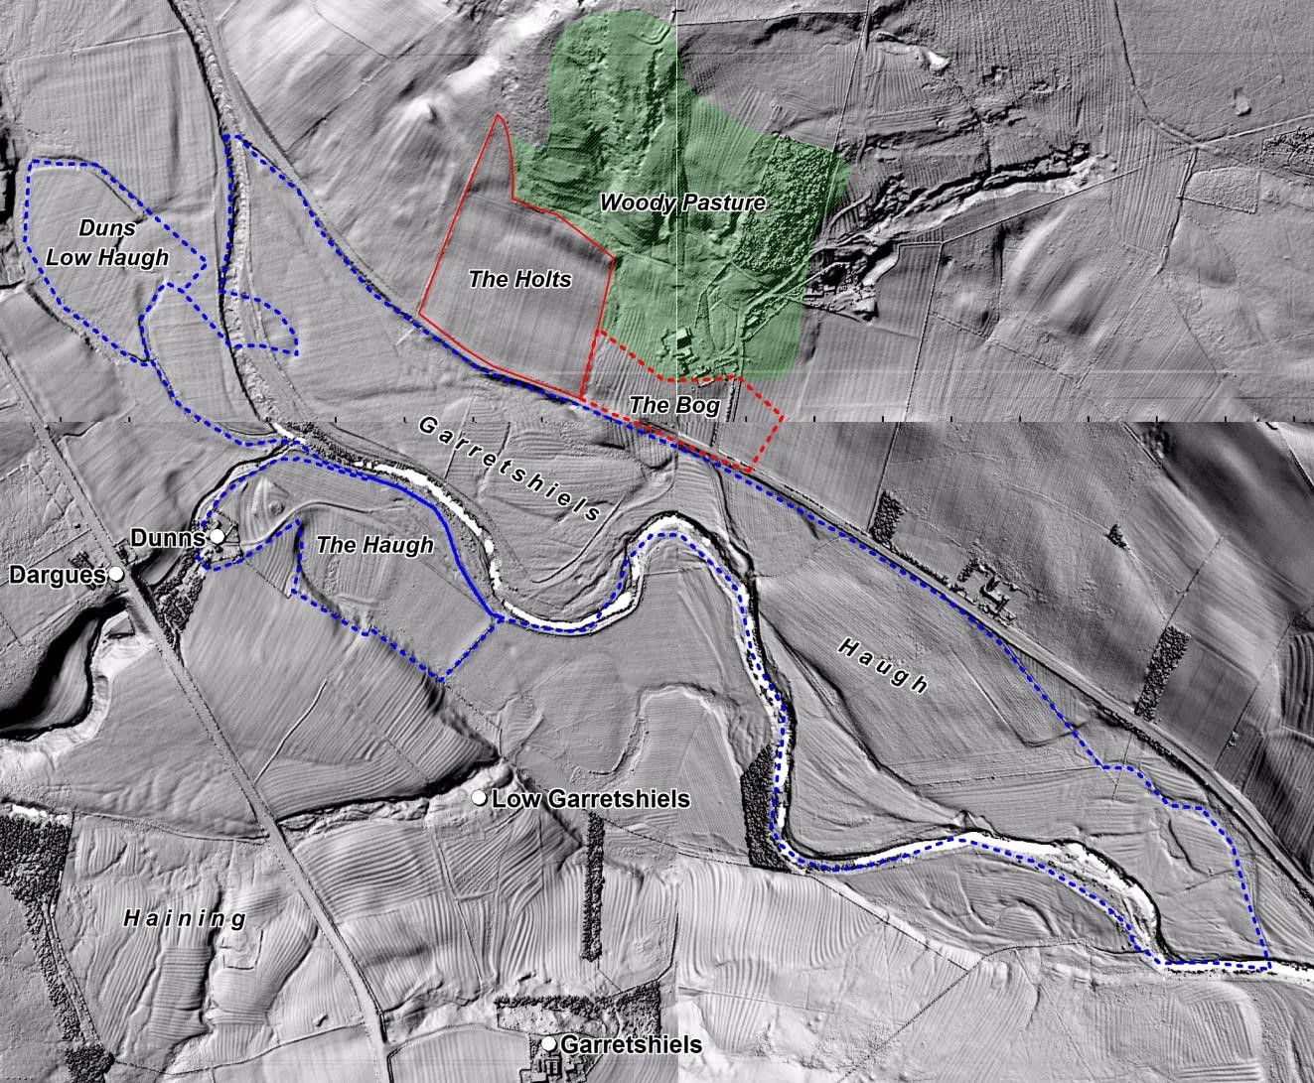
Figure 9: Lidar image showing, outlined in blue, the areas identified as meadow (haugh) on the eighteenth century estate map (Fig.8). Areas called The Bog, The Holts and Woody Pasture from the same map have ridge and furrow within them but of uncertain date. There is also wide rig within the complex former river channels. The potentially medieval ridge and furrow around Garretshiels is particularly fine. The ridge and furrow within the Haining is also clear, as is the boundary around that enclosure which is shown on the c.1779 estate map (Fig.8). The faint ploughed-out features and narrow early-modern rig can be seen in the north of the image.

Commons
Bordering the arable fields on the higher ground on both sides of the valley were vast areas of common pasture. These lay on higher ground as noted by the Northumberland antiquarian John Hodgson who noted that Otterburn ‘basks finely under the shelter of higher grounds on the north and east’.²⁹ Elsdon common was enclosed in 1731 and Troughend common in 1768. At the enclosure of Elsdon common allotments were made to Shittleheugh,
Greenchesters, and Otterburn as well as those in Elsdon. Attempts had been made to enclose
‘Garretsheles common ’in 1723 but this failed and it was not enclosed until 1807. However, it is on the periphery of our study area and thus likely to have less significance to the site of the battle than the other commons. The date of enclosure of Davyshiel common is unknown, but it was still open in 1819 when it was referred to by Hodgson in his colourful description of a storm on the common that caused the Otter to ‘pay an unexpected and unwelcome visit to the village … and carry off with it pigs, poultry, all sorts of farmer’s gear, and other things it could find and float away’. That these commons were still open in the eighteenth century means that it can be said with confidence that they were open in the fourteenth century, though at that time they may have been even more extensive. It was rare for common pasture to be enclosed and then later returned to the waste but rare examples do exist, as for example at another medieval battlefield site in Northumberland, Hexham. At Dilston near Corbridge, close to the site of the battlefield, some 60 acres were enclosed from the common in 1517-18. This land was held under lease and when it expired the land was returned to waste and was once more commonable.

Such large areas of unenclosed grounds, both open field arable and common pasture, would have offered few constraints to the movement of troops. However, it is possible that there was some form of physical boundary to the commons, such as a wall or dike, separating them from the arable fields.³⁴ Divisions within the commons were more likely to have been unbounded and marked by smaller features such as meer stones, and there are numerous stones and cairns marked on Elsdon common enclosure map on the boundary between Elsdon and Davyshiel commons. Similar demarcations are likely to have existed between other commons such as Garretshiels and Troughend. And in the case of Troughend and Corsenside the boundary between them was only fixed at enclosure as evidenced on the map of 1771 which marks ‘Boundary betwixt Corenside and Troughend as Awarded by the Arbitrators’. Access would have been required from the farms to the commons and two droves from High
and Low Garretshiels can be seen to run either side of the enclosed Haining out to Garretshiels Common (Fig.8). The name ‘Haining’ refers to an enclosure that was specifically used for ‘preserving grass for cattle’. But whether that meant an enclosure in which cattle grazed or in which the grass was cut for hay to provide winter fodder is unclear. In addition the Haining is full of what appears to be early ridge and furrow (Fig.9), which may suggest either an early reversion to pasture or, conversely, expansion of arable onto pasture.

The allotments from the common made to Otterburn, Greenchesters and Girson’s Field are shown in an extract Elsdon common enclosure map (Fig.10). It also shows the gated funnellike droveway into Otterburn village from the commons. Note also the locations of
Greenchesters and, the aptly named, Girson’s Field farms. Both sit at the edge of the common behind large areas of medieval strips suggesting these farms were created by taking land from the common pastures for arable. However, as Girson’s Field was in existence by 1378 it may have originated as a shielding. Girson’s is called ‘Grasing Field ’by Armstrong in 1769 possibly a corruption of Girson or perhaps an indication of a reversion to pasture. Indeed Hodgson writing in 1827 refers to Girsonfield farmhouse as lying ‘on a plot of rich green sward’. Both farms have modern locations to the south and survive only as earthwork remains in their original locations.

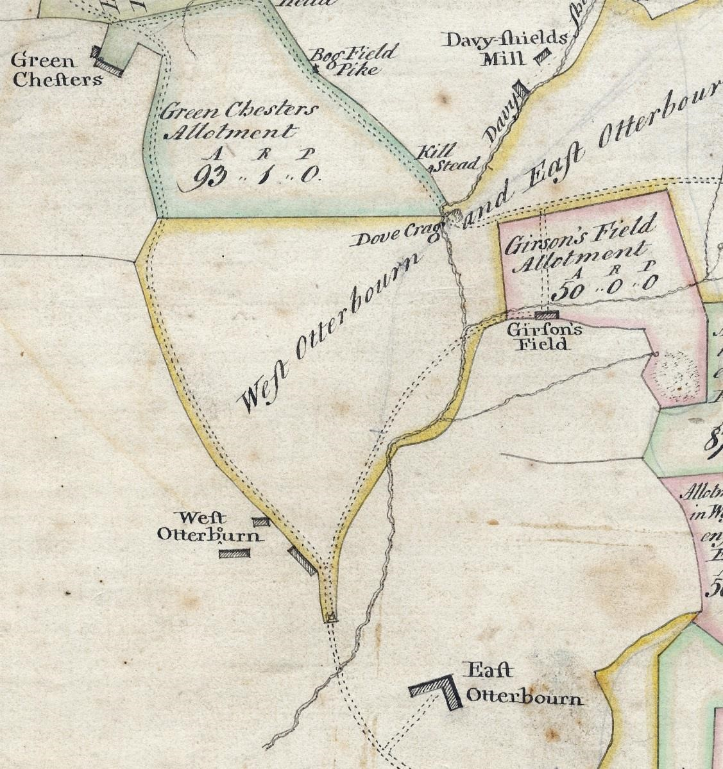
Figure 10: An extract from Elsdon enclosure map showing the allotments to Otterburn Greenchesters and Girson’s Field. Note the gate at the end of the funnelled droveway into the common. (QRD 3)

Settlement
There were a number of settlements within the study area, most of them single farms. The location of these settlements is shown in Figure 3 with an indication of the date by which they had become established. There are four places that do not appear in the sources, seen so far, before the eighteenth century: Dunns, Low Garretshiels, West Otterburn and East Otterburn. They are all probably post-enclosure, secondary settlements to earlier places; i.e.
Dunns to Dunshouses, Low Garretshiels to Garrretshiels, West and East Otterburn to
Otterburn, and as such not expected to have any significance to the landscape of the battle.
Low Garretshiels had gone by 1840. East Otterburn is described in the OS Name Books of
1861, as ‘The farmhouse and dwellings of the outdoor servants of T. James Esqr. Otterburn
Castle. West Otterburn has been renamed West Townhead and is described in the Name
Books as ‘A farmhouse with outhouses..’. There are another four settlements first recorded in the sixteenth century. Old Town is mentioned first in the Watch lists of 1552 (see below), when it is named Aldertone. Dunshouse, Greenchesters, and The Bog are all listed in a survey of 1568. It is unclear when any of these places were established, although Greenchesters may be an example of expansion onto the commons, as has been suggested above.

The eight settlements identified as being established by the the mid-fourteenth century,
Otterburn, Shittleheugh, Elishaw, Blakehope, Dargues, Troughend, Garretshiels, and Girson’s Field are, with the exception of Garretshiels, securely located from map sources. Garretshiels is slightly complicated by an eighteenth century estate map that marks two places ‘High ’and
‘Low ’Garretshiels as separate farms some 370 metres apart. For our purposes its location has been given as that of the modern farm, the former High Garretshiels. It is worth remarking that the document of 1552 mentions ‘the two fords at the Garret Sheels ’perhaps indicating dual settlement from an early date. High Garretshiels is now a single large modern farm. There are no buildings remaining at Low Garretshiels but there is very good earthwork survival indicating multiple buildings. Similarly, Greenchesters and Girson’s Field have surviving earthworks indicating a once larger settlement.

Elishaw is potentially of greatest significance to the battle as it was the site of a spital by 1240, and it is located at the point where two major roads, the Roman Dere Street and the pre-cursor to the modern A696, meet. Spitals not only provided care for the sick but also acted as a type of inn providing ‘hospitality ’to travellers, and as such would have had provision for accommodating both people and horses. This may have been used to advantage by Scottish troops. Shittleheugh lies some 500 metres southeast of Elishaw on the opposite side of Durtrees Burn and may, according to Hodgson, be linked to Elishaw. Hodgson suggests that the name Shittleheugh is a corruption of Spittlehaugh, and may owe its origin to its proximity to the spital at Elishaw. Mawer does not follow this argument suggesting a derivation from either a personal name or from ‘some fancied resemblance to a shuttle’. Certainly documents from 1378 use Shittleheugh and it is unclear what Hodgson is basing his interpretation on as he does not provide a reference.

Several of these sites may have had their origin as temporary sheltering places for people attending stock during the summer, notably those with the ‘sheil ’suffix (and all its variant spelling). ‘Sheil ’indicates a clearing for that purpose, and ‘sheild‘ ’a field with shiels or shieling on it’. It is also possible that although in existence by the late thirteenth century and still evident in the eighteenth century, they may not have been continuously occupied. It is however, worth noting that Dargues is mentioned in 1552 as Daugsburn and was owned by Anthony Daug in 1723 and Michael Daug in 1779 showing continuity of family ownership, if not occupation. But, what is of note is that all of the settlements, including the
‘shiels’, are within the tract of arable and surrounded by ridge and furrow. Presumably as the settlement became permanent then land was taken into cultivation around the farms and gradually expanded. An example of this happening can be seen in the study of Davyshiel. Much has disappeared beneath the Otterburn Training Camp but there is still some fine surviving medieval ridge and furrow.

The date of enclosure for any of the land outside of the great commons has not been established. Certainly by the second half of the eighteenth century there are discrete farms with their own mix of agricultural resources. Enclosure would appear to have been a gradual and piecemeal process as we haven’t found any documentation for it. It is therefore impossible to tell what happened and when either side of the river between Otterburn and Shittleheugh on the north and east, and Old Town and Blakehope on the south and west. It is possible that the agricultural system here, along with small settlements and individual farms, meant some enclosure took place as early as the fourteenth and fifteenth centuries. But unlike the Central Province where early enclosure was usually for grazing and especially for sheepwalks, in Northumberland access to plentiful grazing meant enclosed fields could remain under the plough. However, the survival of extensive areas of ridge and furrow indicates an early return to pasture or continued cultivation in wide rig even after enclosure, which is the implication of the earthwork evidence (fig. 6). Nevertheless, all the settlements were small and there were none within our search area close to the traditional site of the battle. And any early enclosures associated with them are likely to have been few and small, as evidenced by the archaeology, and are thus unlikely to have had a significant effect upon the movement of troops.

Roads
Two major roads ran through the study area on either side of the Rede (Fig.3). The two roads join approximately 1.5km north of Elishaw. Both still operate as modern roads though modified in alignment. The Roman road, Dere Street, on the western side of the Rede, ran from York into Scotland. The line of the Roman road presented here has been accurately digitised from Woodhouse in Corenside parish in the south, to Rochester in Elsdon in the north following the precise description given in MacLauchlan’s Memoir of his Survey of
Watling Street. This road was in the medieval a ‘major component in the political
geography of the region ’and used by Scottish forces in several conflicts. Further north the importance, and permanence, of Dere Street resulted in it being used as a property boundary mentioned in various perambulations by the twelfth century.⁵⁹ Within our search area it is not respected by either parish or township suggesting it did not have a similar status, or not as important a status as the Rede (See Fig. 1 for the township boundary).

The road on the east side of the Rede, the modern A696, was turnpiked in 1776. The traditional site of the battle and the monument lie some 200 metres to the north-east of this road (Fig.1). Armstrong’s county map of 1769 shows the road in its pre-turnpike condition (Fig. 11). Given the complex nature of the river channels and the scale of Armstrong’s map, accurately placing the former line of the road has proved challenging. Armstrong clearly shows the road fording the river twice to the west of the battle monument. And it is of note that where the road lies on the west side of the river it is shown as unenclosed (with pecked rather than solid lines). It was not unusual for the road to cross the river in this way as can be seen further north around Byrness where it repeatedly fords the river (Fig.12). However, even with the benefit of lidar data it has not been possible to identify any earthwork evidence for the pre-turnpike road alignment on the west of the Rede, nor the position of the fords (see below).

In addition to the Roman and turnpike roads there were numerous lesser local tracks. Of these the most significant was the Great Drove Road which ran from Scotland over the high ground to the north of Otterburn into Elsdon, and on to Corbridge (Figs.3 & 11).⁶¹ Although this road was of undoubted importance to drovers and probably local traffic, it is unlikely to have had any influence on the movement of troops if the battlefield is in the accepted location. There would also have been smaller routes for the movement of people and stock between settlements and into the great pastures.

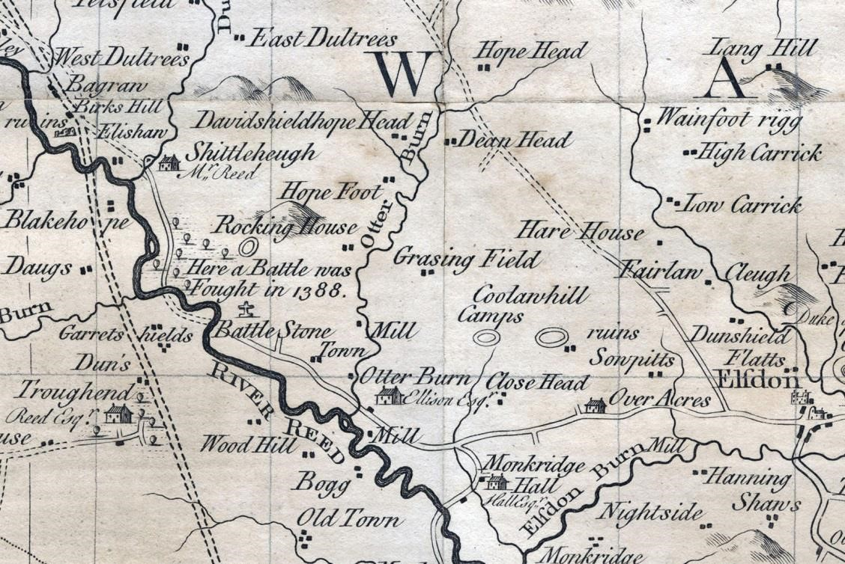
Figure 11: Extract from Armstrong’s map of Northumberland 1769 showing the three principal and parallel routes. Note where the valley road (middle of the three roads), fords the river twice, and the unenclosed section of this pre-turnpiked road on the west side of the river. The double pecked lines running further to the west represent the Roman road and are not indicative of the enclosed state of the road. The Great Drove Road runs from the top centre of the map in a south-east direction to join the main valley road to the west of Elsdon.

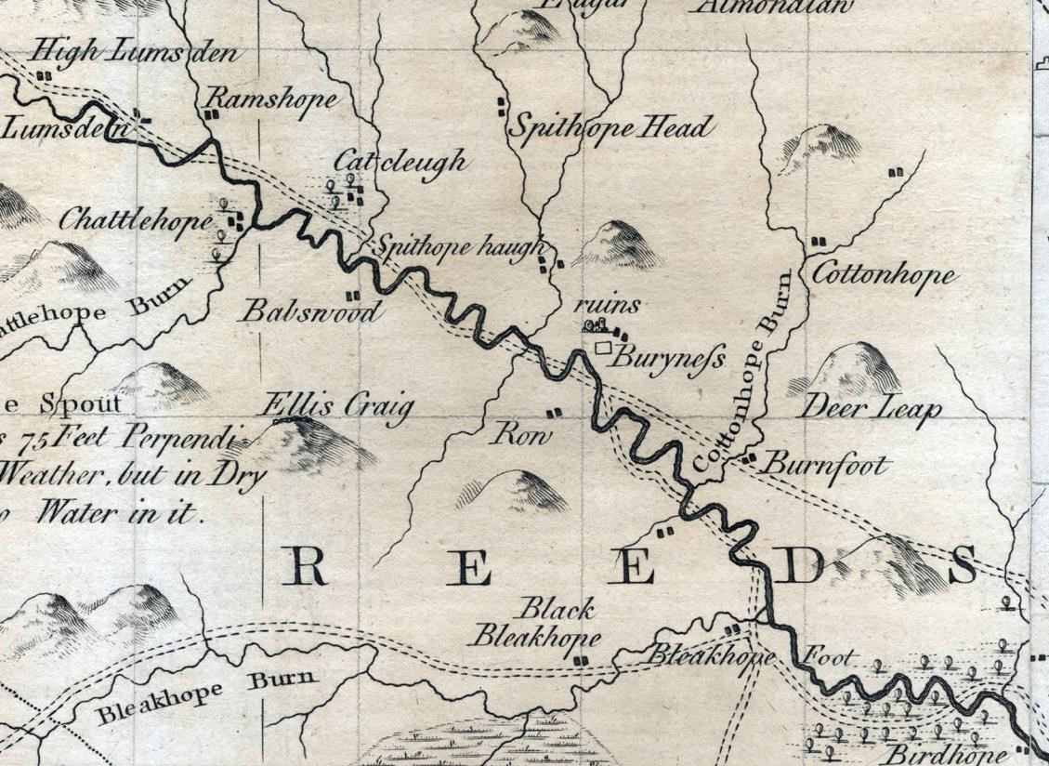
Figure 12: Extract from Armstrong’s map of Northumberland 1769 showing the road repeatedly fording the river.

River Rede, Fords and Watch posts
There were numerous fords on the Rede, and Hodgson in 1827 comments on their number noting ‘nine between the Whitelees and Birness’. He also speculates the name of the Rede to originate from this feature, ‘the ancient Britons called a ford a rydd, and in this sense Redesdale would mean the Dale of the Fords.’ However, the precise location of the fords has proved difficult to determine as the course of the river has altered significantly. The fords to the west of Elishaw where both roads cross can be tentatively located with lidar although the data are complex. But the two fords to the east of Garretshiels where the pre-turnpike road crossed have not been securely located.

The importance of the fords is indicated by their prominence in the day and night watches established by the Earl of Northumberland in 1552 against Scottish incursions. Hodgson provides a detailed description: ‘The ford at Otterburn mill to be watched nightly with the inhabiters of the Old-Town with two men. The two fords at the Garret sheels to be watched with the inhabiters of Troughen and Garret Sheels, with two men nightly … The two fords at Elishaw to be watched with the inhabiters of Daugsburn and Blakam and Rattenraw, with two men at every ford nightly ’(Fig.13). There were numerous other fords, ‘streets’, and places
to be watched within the region. This information is significant as it identifies the places, in the mid-sixteenth century at least, that were considered appropriate places to monitor for reiver and more substantial incursions and highlights the numerous crossings of the Rede.
This might also suggest a potential tactical significance during the 1388 campaign. The
c.1779 estate map marks a single ford to the north-east of Low Garretshiels (Fig.8), and various later maps up to the modern OS Explorer also mark fords. But none correspond with those marked by Armstrong even allowing for the constraints of a map at this scale.

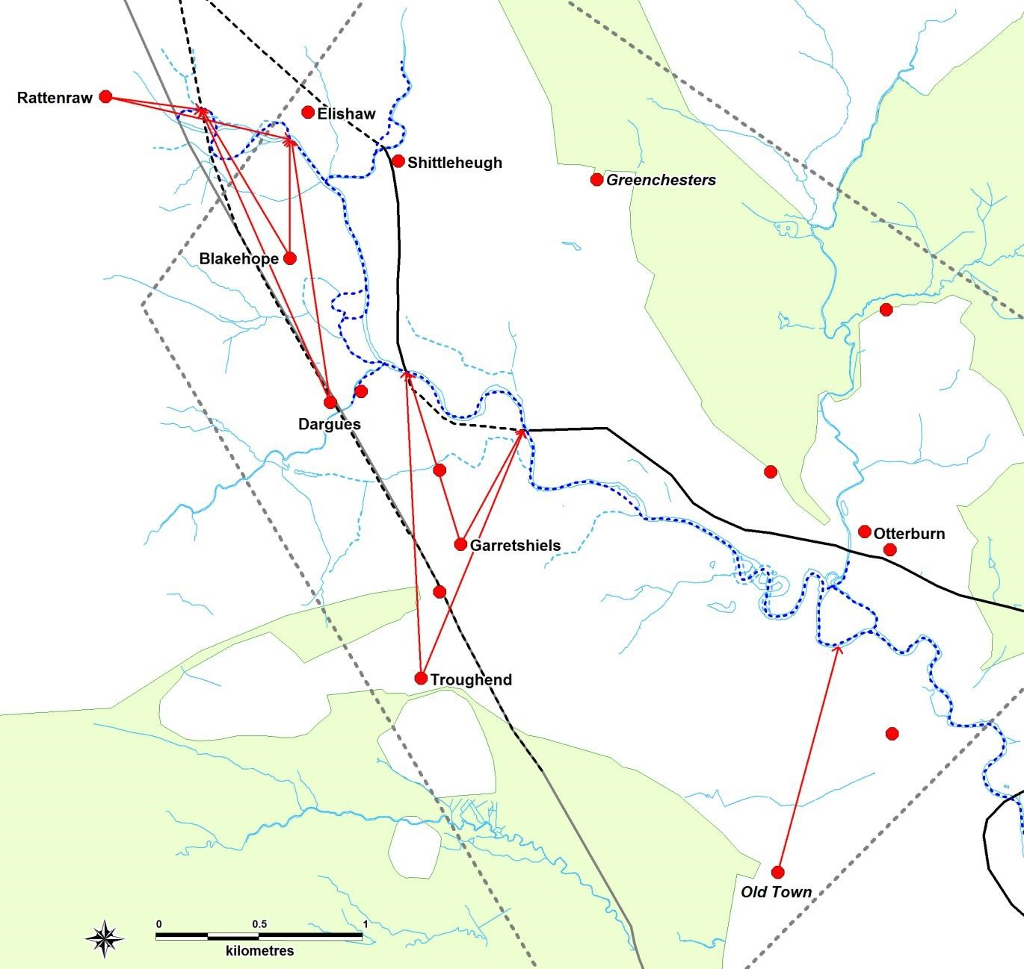
Figure 13: Map of the 1552 Watches indicating the places providing men and the fords at which they watched. The location of the fords is tentative due to the lack of precise documentary information, the complexity of the river channels and absence of archaeological evidence on the lidar data.

The need to repeatedly ford the river would have had a significant effect upon the movement of troops to or from the battlefield. And the very presence of a river would have placed a constraint upon action during the battle, particularly as the numerous former channels suggest wet and possibly waterlogged ground for some distance either side of the main channel. However, the river could have been a major asset for an army if using it to control enemy movement. But it would not have been used as a means of transport as the suggestion that the river may have been navigable in the Roman period, and thus in the medieval, has been thoroughly refuted by Anderson. He goes on to argue that ‘Rather than to facilitate riverborne supply, forts at Piercebridge, … Risingham, Blakehope and High Rochester … were constructed to protect strategic river crossings of the all important, road system.’⁶⁶

RECOMMENDATIONS
The greatest potential for further research in this landscape, and indeed in the wider Revitalising Redesdale Project, is the ridge and furrow. Extensive surviving features and exceptionally good lidar data provide the potential for further analysis that could seek to classify the rig by period, which would greatly enhance our understanding of agricultural practices over several centuries. Otterburn might be used as an example, but it is suggested that it would be more useful to target an area that has good surviving early documents to enhance the interpretation of the archaeology. Secondary works that provide analysis of field systems, even if not specifically of Redesdale or Northumberland, should also be consulted. David Hall’s national study includes a chapter on Northumberland, and the Northamptonshire Atlases by Hall, Foard and Partida provide far greater detailed investigation, albeit in a different landscape. A study of the field systems in Scotland by Piers Dixon may reveal a landscape closer in character to Northumberland than that of Northamptonshire.

To be properly understood field systems should be studied in the context of their settlements, and vice versa. Therefore further research on settlements should also be undertaken. Piers Dixon’s study of DMV’s in north Northumberland, although not including Redesdale, does examine issues affecting desertion such as climate conditions, warfare and reiving, and plague, which could provide a useful background to the settlements in Redesdale.

Fieldwork survey is recommended for archaeological evidence of field systems and settlements, but also for former river channels, early road alignment and to locate the position of fords.

It is also suggested that he wider Revitalising Redesdale Project might pursue the issue of protection of rig and indeed of associated settlement earthworks by taking specialist advice on how unusual such survival is and whether protection might be justified.

APPENDIX

Sources
NORTHUMBERLAND RECORD OFFICE

3590/40
A Plan of Garretshields and Greenchesters in the Parish of Elsdon 1779.
The earliest dated map identified for the battlefield area. It maps the lands belonging to the two farms which lay in the heart of the search area. The boundary between the farms followed the township boundary for most of its length. Greenchesters farm lay some 900m north of its present location within an area marked as ‘Greenchesters in Field’. Adjacent to that to the east is ‘Greenchesters Fell Close’, the allotment made to the farm at enclosure of Elsdon Common in 1731. A small area of woody pasture lay on rough ground to the northwest of the modern farm location.

Both Low and High Garretshields are drawn though only Low is named. An enclosure called the ‘Haining ’and another called ‘Smallburn Croft ’with a house and barn belonged to Garretshields, as did a large enclosure called ‘Pasture Field ’and a substantial meadow to the north of the river called Garretshields Haugh’. The river is named Red Water.
The present A696 is marked as the ‘Turnpike Road’. The Roman road, Dere Street, is not marked although it separated the Haining and Smallburn Croft enclosures. Includes a schedule.

ZCL B 337
An undated map of Otterburn but post 1776 as it includes the turnpike road ‘from Jedborough to Elsdon and Morpeth’. The map covers the same area as the 1779 map of Greenchesters and Garretshields (3590/40 above), but includes additional land.

The Roman Road, Dere Street, is shown but marked as ‘The old Roman road called Watling Street’. Lands belonging to Dunns and Daugs are distinguished. All land parcels are named with either the owners or a field name, and acreage given. Meadows, haughs, are identified and this map is particularly useful for locating detached parcels; an island in the river to the north of Daugs is shared between four owners. Roads, or tracks, leading from Garretshields and Dunns farms across another’s property to their detached meadows are marked respectively, ‘The owner of Garretshields has a right to a road along here’, and ‘The owner of Dunns has a road here’. Of note is a small area adjacent to the turnpike road and close to the location of the modern Greenchesters farm called ‘The Bog’. House and barns are shown but not distinguished though a ‘smith’s shop ’is identified at Low Garretshields. Includes a schedule but damage to the map has removed the title.

QRD 003
A Map of Elsdon Common Divided in the Year 1731
Allotments are named by the property rather than owner e.g. ‘Green Chesters [sic]
Allotment’. Includes a schedule to the numbered allotments that were too small to contain all the information within the map. Ancient enclosure is indicated by colour and some are named, but only those around the village of Elsdon. No ancient enclosure is marked or named at Otterburn and Greenchesters. Shittlehugh ‘ancient land ’is named but no boundaries are drawn. Buildings are drawn in plan with some named. Numerous features around the outer edge of the common, many of them stones, are marked and named.

ELS M&D 045
A Plan of Troughend Common, 1771 [ref.O XXV 2]

SANT/PLA/03/01/01/01
Map of Elsdon Parish by Thos. Arkle, 1840
Shows the whole parish with the seven wards or townships marked.

DT 164/4 M
Tithe map of Elsdon (parish), Northumberland 1839. Shows buildings (named), school, toll bars, boundary stones and cairns, hilltop cross, hill-drawing, marsh (moss), waterbodies, rock outcrops, crags, cauldron pot, named streams, springs, antiquities (Roman encampment, Roman road). Colouring used. Scale: 1 inch to 12 chains; index map at 1 inch to 80 chains [1:63,360]. Map was 'Copied from Old Plans' by Thomas Arkle, High Carrick. With 3 altered apportionment maps, dated 1900, 1921, 1925

(A) 542
Historical notes re farms and hamlets in Elsdon Parish by W. Percy Hedley

QRD 2/1
Conveyance of property entitled Greenchesters, in Elsdon, Northumberland 1 June 1751-2 June 1751
Generic description of ‘all lands ’belonging to Greenchesters but no named plots, abutments, boundaries or acreage.
ZCE
Carr-Ellison family of Hedgely 1572-2016

ZCE/23
Carr-Ellison (Hedgley) Mss. ESTATE: Maps and Plans
ZCE/A
Manorial Records – all Hartleyburn manor

(A) 542/18
Elsdon Lairds II, Earlside - Ironhouse. Manuscript notebook regarding lands and tenants at:
Earlside Eastnook Elishaw Elsdon Mill Elsdon Evistones Featherwood Ferneycleugh (inc. sketch plan) Foulshield Garretshields Girsonfield Grassless Greenchester Haining
Hatherwick (inc. sketch plans regarding Elsdon Common Award 1731) Headshope Highfield
Highshaw Hill (Laingshill) Hillhouse Hillock Hirdlaw Himeshouse Hole and Hole and Mill Holy Dod Hopefoot Hopehead Horsley Hudspeth Ironhouse nd. [c.1970]

EP/83/34
Tithe award and maps for Rochester, Otterburn, Woodside and Monkridge 1839.

EP 83
Elsdon Parish records 1672-1977
(A) ZWN/A3
Inclosure Act, Elsdon Common, 1731. Description of boundaries NRO 1731, 1766

(E) DT 164/4 D
Tithe award 1840 Elsdon parish.

QRA/56
(ref from TNA) Inclosure Award 6 April 1771. Troughend in Elsdon by act of 9 Geo. III. (1768)

10958 and QRA/17/1 (enrolled copy)
Elishaw Common award, plan and related records 1868-1871 (ref from TNA)

NATIONAL ARCHIVES (NA)
Various records re pleadings over land disputes in Elsdon C17, also lease & release, settlements etc.

E 134/18Jas1/Mich21
18 Jas 1 1620. Theophilus Lord Howard de Walden and the Lady Elizabeth his wife. v. John Hall, Matthew Reade, Robt. Reade, Edwd. Reade.: Castle and lordship of Harbottle, in
Riddesdale, a capital messuage called "Otterburn," lands called "Otterburn Manor," "Davy Sheeles," "Ridshead," and lands in Woodburn alias West Woodburn and Riddesdale. Touching customs of customary or tenant right. Survey. [Gilbert Umframville, Earl of Angus, and after him Walter Talboys, Esq., sometime lords of the lordship, are mentioned.]: Northumberland.

E 178/4294
2 & 9 James I. 24 March 1604 – 23 March 1612. NORTHUMBERLAND: Harbottle, Redesdale, Otterburn, and other places Surveys of lands leased to George, late Earl of Dunbar.

D1447
Freeman-Mitford family Barons Redesdale, Gloucs (Batsford, etc), Northumberland (Elsdon), Oxon (Astall, etc) and Warks (Great and Little Wolford) deeds, manorial records, estate and family papers C16-C20. Held by Gloucestershire Archives

C 5/167/100
1697. Short title: Hall v Grey. Plaintiffs: John Hall. Defendants: Thomas Grey, and others.
Subject: property in East Otterburn, West Otterburn, Fairhaugh, Fallowlees, Elsdon, etc, Northumberland. Document type: bill only

FEC 1/577
undated. ERRINGTON, Thomas, and HALL, John: An account of the estate of Thomas
Errington, at St. John, and the estate of John Hall, in Elsdon, co. Northumberland (to be sold 2 July)

BRITISH LIBRARY

Add MSS 36639-51
Mitford family of Elsdon, Northumberland estate and family papers 1500-1900

ALNWICK
AC:C/XI/1/1-3, AC:C/XI/1/5a-30b
Elsdon and Otterburn manor court files 1618-1634.

AC:C/XI/1/31a-33c, AC:C/XI/2a/1a-18
Elsdon and Otterburn manor court files 1648-1658

PARLIAMENTARY ARCHIVES

HL/PO/PU/1/1776/16G3n84
An Act for repairing, widening and altering the Road from the Termination of the present
Turnpike Road at Elsdon High Cross, near the Town of Elsdon, in the County of
Northumberland, on the North East Side of the River Reed, through Overacres, Elishaw and Cateleugh, to the Red Swyre upon the Mid Border betwixt England and Scotland.

A. Rushworth, I. Roberts, R. Carlton (2005), 'Droving in Northumberland National Park: An Historical and Archaeological background', (Northumberland National Parks Authority).
Anderson, James. (1991), 'The Piercebridge Formula in the North-east of England: an assessment and alternative method of supply to the Roman army', PhD, (Newcastle). Dixon, Piers. (1984), 'The Deserted Medieval Villages of North Northumberland', (Cardiff).
Dixon, Piers. 'Field-Systems, Rig and Other Cultivation Remains in Scotland: The Field Evidence', in S. Foster and T. C. Smout (ed.), The History of Soils and Field Systems Aberdeen, (Scottish Cultural Press, 1994).
Foard, Glenn, Hall, David, and Partida, Tracey. Rockingham Forest: An Atlas of the Medieval and Early-Modern Landscape, (Northampton, 2009).
Gelling, M., Place-Names in the Landscape, (London, 2000).
H. H. E., Craster. A History of Northumberland: The Parish of Corbridge, (X), (Newcastle Upon Tyne, 1914).
Hall, D., The Open Fields of England, 2014).
Hodgson, John. A History of Northumberland in Three Parts (Part II. Vol. I. edn.), (Newcastle Upon Tyne, 1827).
Ian Roberts, Richard Carlton, Alan Rushworth. Drove Roads of Northumberland, (Stroud, 2010).
Kain, Roger J. P. & Oliver, R.R., The Tithe Maps of England and Wales: A Cartographic Analysis and County by County Catalogue, (Cambridge, 1995).
MacLauchlan, Henry. A Survey of Watling Street, (London, 1852).
Mawer, A., The Place-Names of Northumberland and Durham, (Cambridge, 1920).
Oram, Richard. 'Trackless, impenetrable and underdeveloped? Roads, colonization and environmental transformation in the Anglo-Scottish border zone, c.1100 to c.1300', in Valerie Allen and Ruth Evans (eds.), Roadworks: Medieval Britain, medieval roads Manchester, (Manchester University Press, 2016).
Partida, T. (2014), 'Drawing the Lines: A GIS Study of Enclosure in Northamptonshire', PhD, (Huddersfield).
Partida, T, Hall, David, and Foard, Glenn. An Atlas of Northamptonshire: The Medieval and Early-Modern Landscape, (Oxford, 2012).
Tate, W. E., A Domesday of English Enclosure Acts and Awards, (Reading, 1978).
The Archaeological Practice Ltd. (2004), 'Historic Village Atlas 5: Elsdon', (5).
Young, A., A Six months tour through the north of England, (3), 1771).
Young, R., et al. 'An Archaeological Research Framework', (Northumberland National Park).

Otterburn – Routes To and From Otterburn



The Cambo Question

Background
Charles Wesencraft has questioned the location of the Otterburn battlefield, the identity of the ‘castles’ assaulted by Douglas on his retreat from Newcastle and the route taken by Douglas (and Percy) from Newcastle into Redesdale. To my mind these are separate issues and should be considered as such. This note is thus concerned only with the route taken from Newcastle to Redesdale. If we are able to reach a consensus on this then we can move on to consider the question of the assaults and the battlefield as felt necessary.

Turnpikes
Since there is no dispute over Douglas’ reported assault on the ‘castle’ at Ponteland we need only be concerned with the latter part of his route. The modern route from Newcastle to Otterburn is the A696 via Ponteland, Belsay and over the summit of Ottercops Moss past the site of the WW II chain radar station. This is known to be the route of the turnpike from Newcastle to Carter Bar. What is perhaps less well known is that this is not the original route of the turnpike. The Highways Act 1749 deals with the establishment of the turnpike but is not available online. It appears that the Newcastle – Carter Bar road was a part of a network of turnpikes including that from Morpeth to Elsdon and that from Hexham to Alnmouth (often written as ‘Alemouth’ in older documents). These turnpikes appear to converge on or around Cambo. The current route, known as the ‘New Line’ did not come into use until the second quarter of the 19th century. Prior to this, the established route into Redesdale from Newcastle would seem to have been via Cambo and Elsdon, taking advantage of the long-established drove road north from Cambo and then turning west along the six mile straight drove road which formed the end of the Morpeth – Elsdon turnpike past Winter’s Gibbet. This was the original turnpike route. By way of support for this view please see:
- The Newcastle to Carter Bar Road (A696 and A68) W. Lawson 1971 Archaeologia Aeliana 4/49 – especially p194ff
- The construction of the military road from Newcastle to Carlisle 1751 – 1758 W. Lawson 1971 Durham University M. Litt. Thesis
- Northumberland Turnpike Maps (image) – retrieved from http://www.turnpikes.org.uk/map%20Northumberland%20turnpikes.jpg
- The Monthly Chronicle of North-Country Lore & Legend 1887 page 148
The role of Cambo prior to the advent of the ‘New Line’ is also clear from two further items I have been able to find online. First is the description of the road from London to Edinburgh as set out as set out in ‘Paterson’s Roads’, (1822), on pages 284 & 285. Second is the old stagecoach route of the ‘Chevy Chase’, from Newcastle to Edinburgh, as set out in ‘A New Picture of Newcastle Upon Tyne’ (1831) on page 13.

Secondary Sources
We have not yet begun our detailed review of secondary sources but there is one of which I am aware that deals with this issue. More will probably come to light in due course.
In 1988 an academic conference was held at Otterburn Hall as part of the commemoration of the 600th anniversary of the battle. The papers were published as ‘War & Border Societies in the Middle Ages’ (1992) edited by Anthony Tuck and Anthony Goodman. In his chapter ‘The Battle of Otterburn: When and Where Was It Fought’, Colin Tyson refers to the difference between the modern turnpike and the medieval route into Redesdale and has this as ‘via Belsay, Cambo, the Steng Cross at Harwood Forest and so downhill to Elsdon’. He does not seem to have quite understood the evolution of the turnpike as previously described but this is not of any consequence. The full chapter has been scanned into a separate file for reference. The quotation is from page 76.

Primary Sources
Charles Wesencraft makes much of the fact that the original French manuscript of
Froissart’s Chroniques clearly states that on the return journey from Newcastle into
Redesdale an assault was made on the ‘chastel de Combourch’ after the previous assault at Ponteland. In this, Wesencraft is quite right. The transcription is not open to any alternative interpretation. The texts are given in my previous note ‘Comparison. docx’ – the French is thus :


As noted in my earlier note, the ‘classic’ 16th century English translation by Lord Berners treats this as an error and substitutes ‘Otterburn’. The Penguin Classics edition by Geoffrey Brereton follows this. Most scholars prefer to work with the 19th century translation into French by Baron Kervyn de Lettenhove. In his edition he follows the same practice :
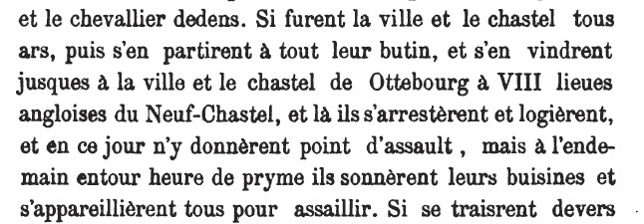
It would seem that the subsequent references to Otterburn have led them to assume that Froissart wrote the wrong name down and must have meant Otterburn. This is not entirely convincing. First, it seems an odd mistake to make given that he was familiar with
Otterburn as a place / name. Second, he states Combourch to be eight English leagues from Newcastle. This is wrong if he means Otterburn but about right if he means Cambo. Clearly, however, there is some confusion. We know from Froissart that he drew his account from many conversations with both Scots and English veterans of the battle and thus may have received conflicting statements which he has not entirely resolved, being unfamiliar himself with the local geography. Perhaps, as Wesencraft believes, the Scots assaulted Cambo – there were two towers at Cambo. One was knocked down when the house at Wallington was built. The other eventually ended up in the 20th century as the village post office and the is still there. Perhaps they assaulted Cambo and Otterburn. Perhaps the name of
Cambo was mentioned as being on the route and he has conflated that with the assault on Otterburn. These are matters for further thought and research but do not, per se, determine the question of the route into Redesdale.

Topography
Driving today from Belsay to Otterburn offers the same two options – the A696 (the New
Line) over the high summit of Ottercops or via Cambo and Elsdon using the old drove roads / original turnpike route. The former route is quicker in a motor vehicle but it seems clear that if one were marching an army, its baggage and driving stolen livestock then the climb up and over Ottercops on lesser-used medieval tracks would be an odd choice as against the straight and relatively flat drove roads which would have most likely been well-known to the Scots. Burne’s ‘inherent military probability’ would lean heavily in favour of the second route.

Conclusion
There is nothing above that can be said to ‘prove’ which route was taken by the Scots and Percy into Redesdale. My own view is that the ‘Cambo route’ is the more likely and, at worst, is as likely as the Ottercops route. The question of the assaults, the timings, the site of the camp and the location of the battle remain to be considered and should take the ‘Cambo route’ fully into account as a factor into this consideration.

Geoffrey Carter
April 2019

From Elsdon to Scotland

Background
Having established that the likely route of Douglas (and Percy) from Newcastle into Redesdale went via Cambo and Elsdon it is now necessary to consider how the armies moved from Elsdon to Otterburn and how the Scots subsequently travelled back across the border.

Turnpikes
The route from Elsdon to Carter Bar was under the control of a different turnpike trust to that which managed the route from Newcastle. The Elsdon and Redewater Trust is, unfortunately, not as well documented as the Ponteland Trust previously considered. This seems to be especially true of its earliest years following its establishment in 1776. A survey of the route from Edinburgh to Newcastle was undertaken by McAdam and completed in 1828 but seems to be unavailable online. There is a copy in the NRO which will be consulted in due course. It seems unlikely that this will be of great use as apparently it related mainly to the plan to improve the then existing turnpike. We know, however, that the modern route from Otterburn to Carter Bar via the A686 and A68 follows the turnpike route and there is no suggestion that this changed substantially after its creation, unlike the section from Newcastle to Otterburn. The turnpike / modern route remains on the northern side of the Rede whereas the ‘old’ route crosses the river twice near the likely site of the battle as previously noted from the Armstrong map.

Elsdon to Otterburn
Accepting that the route from Newcastle was via Cambo and the drove roads, the Scots would have come to Elsdon. From the end of the drove road there are three possible modern routes to Otterburn as shown here:
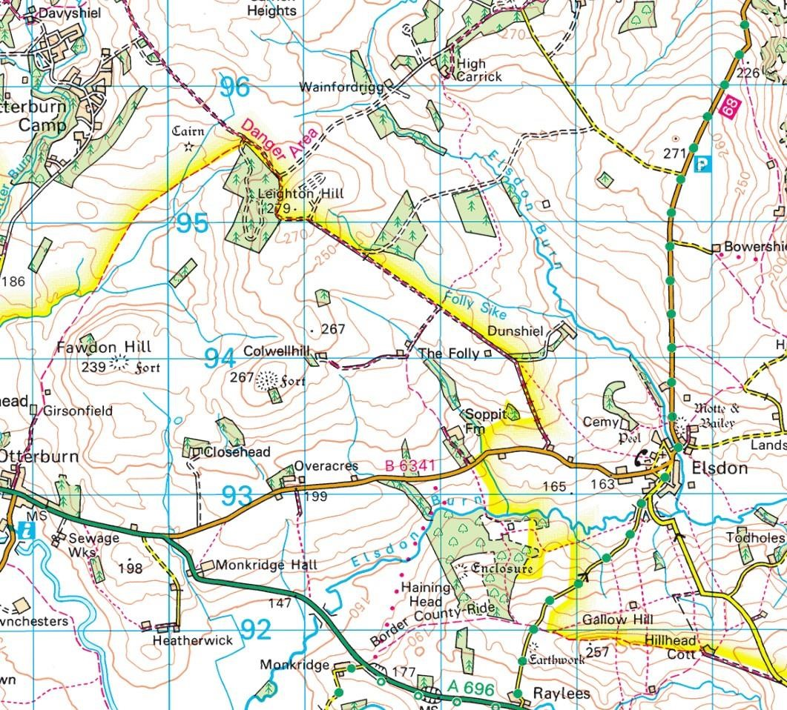

The northern route would be via the old drove road to Davyshiel and then down along the Otter Burn. Tyson (War and Border Societies in the Middles Ages, p76) raises this possibility and then dismisses it in favour of the ‘less arduous route’ which is the modern B6341 - the usual route today from Elsdon back to the A696 / turnpike. Finally, there is a route south from Elsdon to the A696 via Raylees.
The Armstrong map is thus:
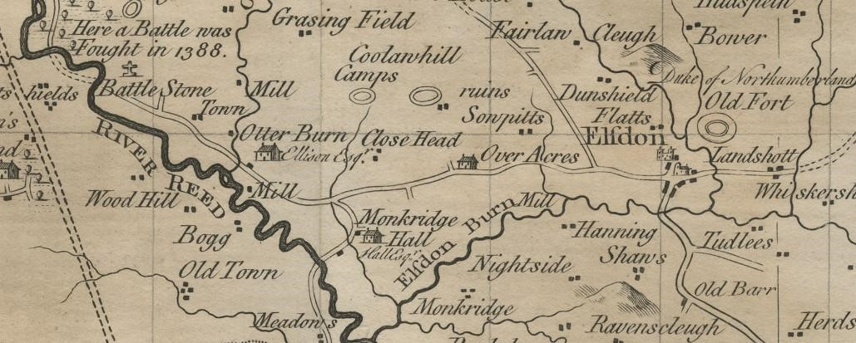
This shows the first two routes but not the third. Also, the drove road north is shown but there is no road south from Davyshiel on the map.
None of the primary sources gives any detail on this part of the route although Henry
Knighton does, interestingly, say ‘Henry (Percy) fought with them (the Scots) at Elsdon near Newcastle upon Tyne’. This seemingly the only reference to Elsdon which some writers have noted as surprising given that Elsdon was the principal settlement and marketplace in medieval Redesdale. Wesencraft makes much of this in his siting of the battle close to Elsdon. The B6341 route passes today (and on Armstrong’s map) through the middle of Elsdon close to the church and the Norman motte & bailey castle. In the absence of sources, we cannot know why Elsdon does not figure more in the story but it is possible that Douglas, for whatever reason, simply bypassed the settlement and picked up the road to the west of it.
As to the southern road down to Raylees, this may be modern and from personal knowledge of the topography this is a narrow winding road and it is difficult to imagine why it would have been chosen over the direct route to Otterburn.
Most writers assume that the Scots were driving stolen livestock as the travelled.
Armstrong (Otterburn 1388: Bloody Border Conflict p47) suggests that the Scots had, in fact, sent the livestock on ahead but gives no reference and I cannot find anything in the primary sources to support this. If, as seems likely, this was not the case then they would presumably have chosen routes more suitable to driving animals.

Otterburn Tower
Froissart tells us that the Scots stopped to assault the tower at Otterburn. Wesencraft disputes this and claims that the assault was at Cambo (see my earlier note). Wesencraft claims that Otterburn Tower did not exist in 1388 but I have been able to find no source for this. He claims that is was built 27 years later which, presumably, he derives from its inclusion in the 1415 survey of fortresses in Northumberland. This seems erroneous as there is clear evidence of it (‘the fortlet of Oterburne’) being passed to Robert Umfraville as keeper in 1404 from Henry Hotspur following the latter’s death at Shrewsbury (Calendar of the Patent Rolls 1401 – 1405 p372). Dodds (Bastions & Belligerents: Medieval Strongholds in Northumberland p331) claims that it was built in the middle of the 13th century and mentions that Froissart refers to it in his journals made while touring northern England as part of Queen Phillipa of Hainault’s entourage prior to 1388 as ‘tolerably strong’. He gives no references for either point and I have not had time to search the whole of Froissart for this earlier mention of it! If this is correct it does suggest that Froissart had personal knowledge of both the area and the tower. On the other hand, Froissart refers to it in the same terms when writing about the battle so Dodds may have conflated the two accounts. Beryl Charlton (The Story of Redesdale) says that the date of construction of Otterburn Tower is unknown but that ‘it was certainly standing in 1388’. She gives no reference so I will ask her about this when I next see her. Tyson (op. cit.) says there is documentary evidence to suggest that the tower was standing as early as 1245 and that it may be the ‘capital messuage’ referred to in the will of Gilbert de Umfraville in 1308. He cites a paper
(Otterburn : the Tower, Hall & Dene and the Lordship or Manor of Redesdale) by H Pease (the then owner of the tower) from 1924 published by the Society of Antiquaries in Newcastle. Pease suggests that reference in the escheat following the death of Gilbert’s father (also Gilbert de Umfraville) in 1245 to ‘the Manor of Otterburn and 163 acres of demesne lands’ implies a residence which he considers may be safely suggested to be a Pele tower – this is presumably the ‘documentary evidence’ cited by Tyson.
Although the origins of the tower are far from clear, from the above it is reasonable to assume that Otterburn Tower, in some form, was probably standing in 1388 and may have been known to Froissart personally. We can thus work on the basis that it was certainly possible that this was the tower that the Scots assaulted.
From a route point of view the tower is shown by Armstrong here :
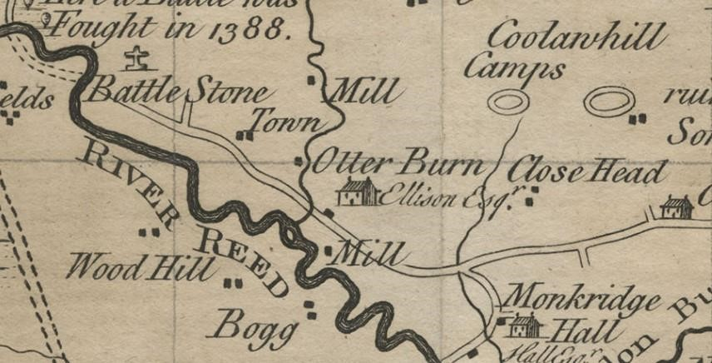
The owner at the time was Robert Ellison whose name appears on the map. Thus, the tower is in direct line from the inbound road from Elsdon to the likely site of the battle. The question of the marshes in which the tower stood according to Froissart has engaged a number of writers. Boardman (Hotspur: Henry Percy Medieval Rebel), amongst others, suggests that there may have been marshy land at the confluence of the Otter Burn and the Rede and that this may have played a part in causing the Scots failure to take the tower and, later, to have had some impact on the space available to Hotspur in forming his attack – but this is for consideration in due course. The site and actions of the battle are not the issue here.

The Scottish Route Home
Following the battle, we need to consider the route taken by the Scots to cross the border. We know from Froissart that the muster point for the Scots forces prior to entering England was the church at ‘Zedon’, modern Southdean. This is attested by Historic Environment Scotland:
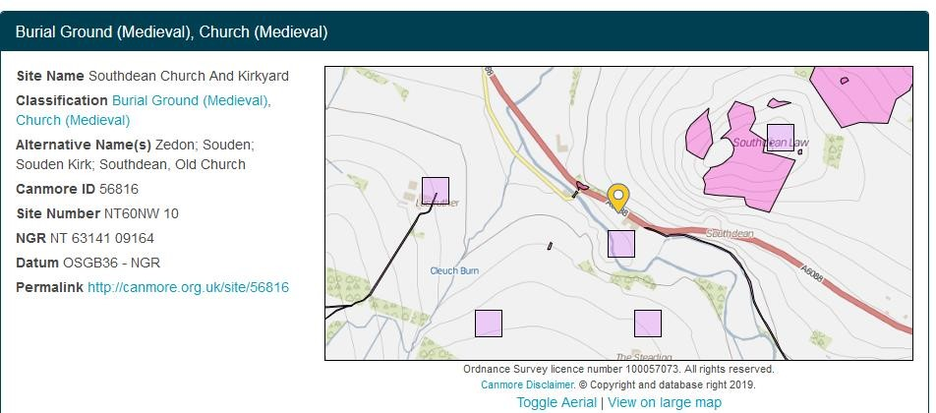
Froissart tells us that the Scots made for Melrose after the battle where the body of the fallen Douglas was interred at Melrose Abbey. Froissart tells us that Henry Percy was in the group which went to Melrose. He also says that they rode all day from Redesdale and camped still in England before crossing to Scotland and Melrose the next day.
This modern, post-turnpike, border crossing at Carter Bar on the A68 certainly existed in the medieval period but may not have been the principal route between England and Scotland. Indeed, there appear to have been many ways into and out of Redesdale for raiding Scots and these would likely have been known to at least some of Douglas’ company. So common was this raiding that Stringer notes in his detailed study of the Redesdale Liberty (Border Liberties & Loyalties: North East England, c1200-c1400 p358ff) that the only recorded example of ‘community action’ in medieval Redesdale was a communal payment in the late 1370s of some £33 per annum to purchase peace from the Scots – with, it should be said, limited success. Charlton (op .cit. p29) says that there were 40 passages between the middle march of Scotland and England with 23 of them via Redesdale in the 16th century. Her view is that the old Roman road of Dere Street had ‘for centuries’ been the main route between England and Scotland and would ‘undoubtably’ been used by the Scots after Otterburn (op. cit. p21). Finally, she refers to the 16th century system of ‘setters and searchers’ established to watch every possible route that might be taken by raiders and says that, at this, time the main route into Scotland was still via Chew Green and that the meetings of the Wardens of the Marches were held close to there rather than at the Redeswire by Carter Bar (op. cit. p 30 – 31).
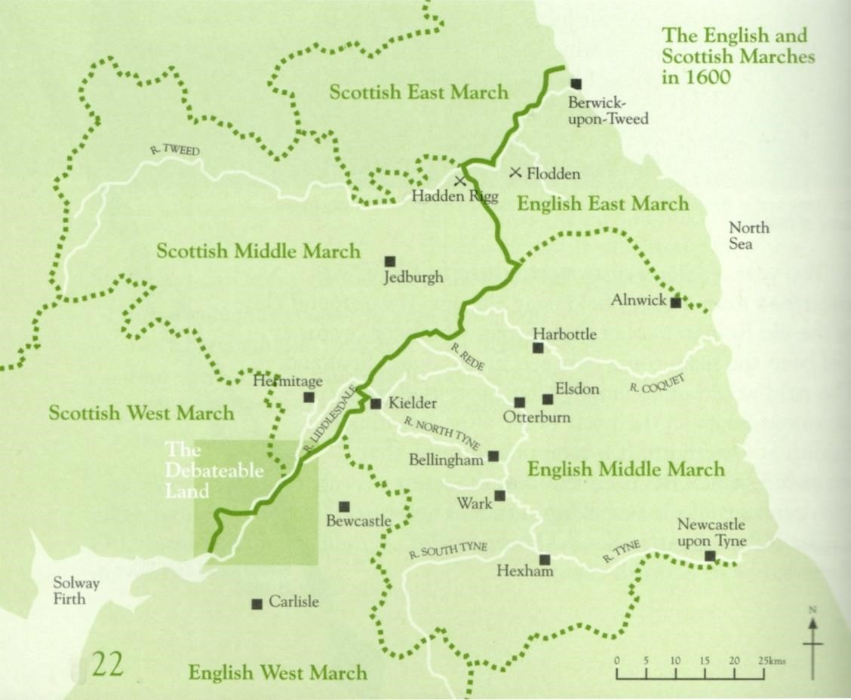

Map: The Story of Redesdale - Beryl Charlton
Dodds (op. cit. p331) also has the main ‘old’ route between England and Scotland as being via Chew Green and comments that ‘only locals and a few itinerants used the apparently easier route up the River Rede’. Armstrong (op. cit. p73) agrees that the Scots would have travelled via Dere Street to Melrose. This view is supported in the unpublished study for the NNPA (The Anglo-Scottish Border Roads of the Cheviot Hills) by Richard Carlton / The Archaeological Practice which concludes that it remained the main route for north-south travel in the central borders region until the 18th century.
In his account of the battle, White tells us ‘Then enclosing in coffins the bodies of the Earl of Douglas and of the two squires who fell near him, they placed them upon slender biers constructed for the purpose, by which they might be conveyed homeward ; and setting fire to the huts, they commenced their march up Redesdale. Reaching very soon the Roman Watling-street, they kept upon it, passing the station of Bremenium, and moving onward behind the biers, where they had more the appearance of an extended funeral procession than an army of brave men returning to their native land honoured with victory. The first night they encamped at the station of Chew Green, on English ground ; but arising early next morning, they departed without delay, and at evening reached Melrose.’ He also records that Ralph Percy was not taken to Scotland but was permitted to be taken to Newcastle for treatment of his wounds although other writers have him being taken to Scotland with his brother.

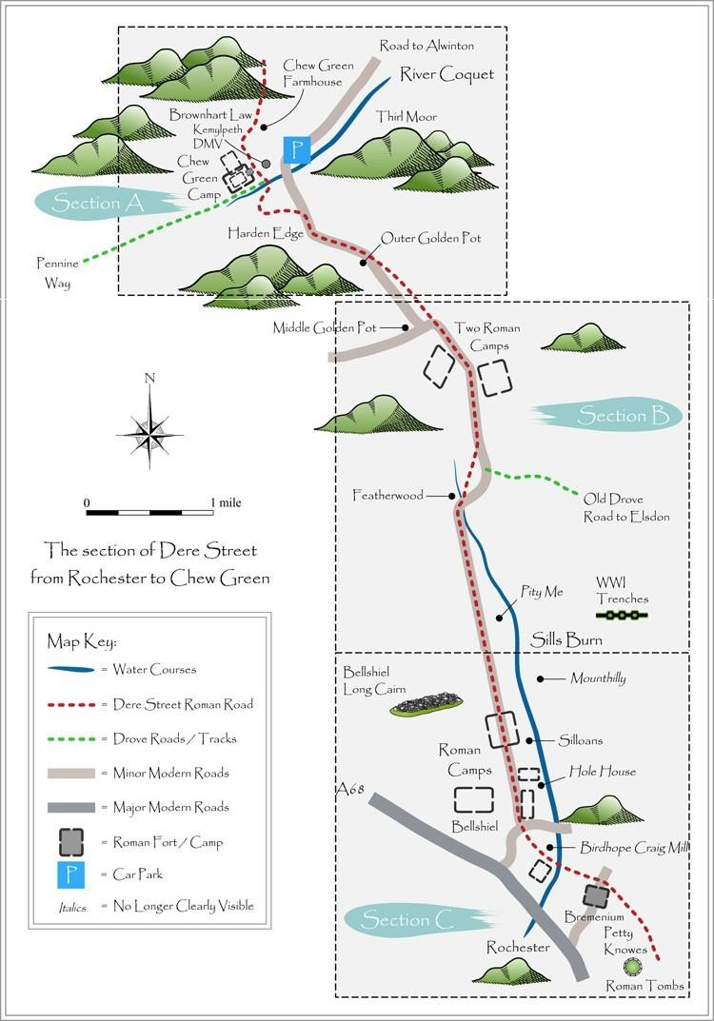

Map included with the permission of Coquetdale Community Archaeology
For more information see : http://www.border-roads.org/

The Armstrong map shows both the Roman road and the precursor to the turnpike along the river Rede but crossing it twice near the likely site of the battle.
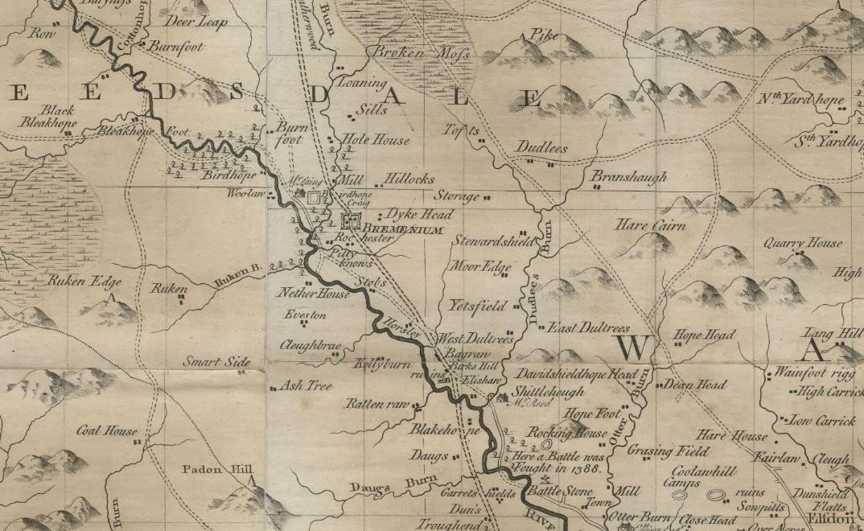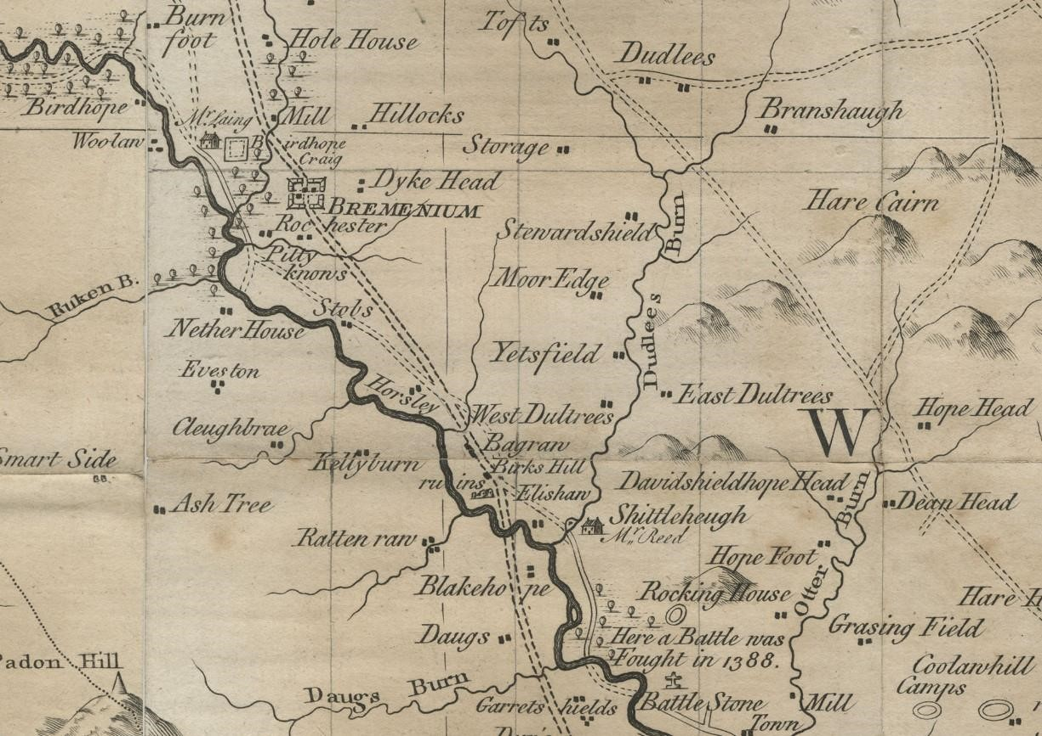

Looking more closely at the section north west of Otterburn reveals where the two routes diverged near Horsley which is well outside of our main area of investigation.

Conclusion
This note completes a review of the relevant routes taken by Douglas / Percy. It seems likely that there was a tower at Otterburn in 1388 but does not, of itself, categorically confirm that this is the tower assaulted by the Scots. The route from Elsdon into Redesdale seems clear although we have no detailed description of this in the primary sources and we cannot know the travelling formation of the Scots and their stolen livestock. After the battle it seems most likely that the journey back to Scotland would have been via the pre-turnpike route crossing the border at Chew Green but this is of limited significance for our project as the first part of that route away from Otterburn itself would have been the same had the Scots chosen to cross at Carter Bar.
Geoffrey Carter / June 2019
Otterburn – Field Archaeology Report



Battle of Otterburn, Northumberland

Combined Geophysics and Metal Detecting Report

Ref: 232820.04
December 2021

wessexarchaeology

Document Information

Document title | Battle of Otterburn, Northumberland
Document subtitle | Combined Geophysics and Metal Detecting Survey Report
Document reference | 232820.04
Client name | Revitalising Redesdale Landscape Partnership
Address | Northumberland National Park Authority Eastburn, South Park,  Hexham, Northumberland, NE46 1BS
Site location | Land west-north-west of Otterburn, Northumberland,  NE19 1LB
County | Northumberland
National grid reference | 386997 593779 (NY 86997 93779)
Statutory designations | N/A
Planning authority | Northumberland National Park Authority
Museum name | Great North Museum
Museum accession code | TBC
WA project name | Battle of Otterburn, Auger and Metal Detecting Survey
WA project code | 232820
Date of fieldwork | 09/08/2021 – 20/08/2021
Fieldwork directed by | Andres Perez Arana/Ben Saunders
Project management by | Christopher Swales
Document compiled by | Nicholas Crabb/Christopher Swales
Contributions from | Davor Čakanić, Katie Proctor, Katie Marsden, Ed Treasure, Samantha Rogerson and Ben Saunders
Graphics by | Nicholas Crabb and Rebecca Havard

Quality Assurance
Issue | Date |  | Author | Approved by
1 | 02/12/2021 | Version 1 | NLC/CS


Contents

Summary iv
Acknowledgements v
- INTRODUCTION 1
  - Project background 1
  - Scope of document 1
  - The site 2
- ARCHAEOLOGICAL BACKGROUND 2
  - Archaeological and historical context 2
  - Prehistoric to Romano-British 2
  - The Battle of Otterburn 3
  - Post- medieval 4
  - Previous investigations in the area 4
- AIMS AND OBJECTIVES 6
  - General aims 6
  - General objectives 6
  - Site-specific aims for metal detecting survey 7
  - Site-specific aims for the geophysical survey 7
  - Site specific aims of the evaluation trenching 7
- METHODOLOGY FOR GEOPHYSICAL SURVEY 7
  - Introduction 7
  - Fieldwork methods 7
  - Ground Penetrating Radar 8
  - Data processing (GPR) 8
- GEOPHYSICAL SURVEY RESULTS AND INTERPRETATION 9
  - Introduction 9
  - Gradiometer survey results and interpretation 10
  - GPR survey results and interpretation 12
- METHODOLOGY FOR TEST PITTING 15
  - Introduction 15
  - Recording 15
  - Finds and environmental strategies 15
- TEST PITTING RESULTS 16
  - Introduction 16
  - Soil sequence and natural deposits encountered in the test pitting 16
  - Trench 30 soil sequence and results 17
- ENVIRONMENTAL EVIDENCE 17
  - Introduction 17
  - Results 18
- METHODOLOGY FOR METAL DETECTING SURVEY 19
  - Methods 19
- RESULTS OF METAL DETECTING SURVEY 19
  - Introduction 19
  - Numismatics 20
  - Personal items 21
  - Household items 21
  - Textile items 21
  - Transport 21
  - Structural or other fittings 21
  - Tools 21
  - Metalworking 21
  - Militaria 22
  - Weighing and measuring 22
  - Miscellaneous 22
  - Item recovered outside the scope of work 22
  - Retention of finds 22
- DISCUSSION 22
- ARCHIVE STORAGE AND CURATION 23
  - Museum 23
  - Preparation of the archive 24
  - Selection strategy 24
  - Security copy 25
  - OASIS 26
- COPYRIGHT 26
  - Archive and report copyright 26
  - Third party data copyright 26
REFERENCES 27
Bibliography 27
Cartographic and documentary sources 28
Online resources 28
APPENDICES 29
Appendix 1: Gradiometer Survey Equipment and Data Processing 29
Appendix 2: GPR Survey Equipment and Data Processing 31
Appendix 3: Geophysical Interpretation 33
Appendix 4: Trench and test pit summaries 35
Appendix 5: Assessment of the environmental evidence 45
Appendix 6: Oasis record 46

List of Figures

Figure 1 Site location and extent of surveys with scheduled heritage assets.
Figure 2 Detailed survey extents and lidar hillshade model
Figure 3 Detailed gradiometer survey results: greyscale plot (west) Figure 4 Detailed gradiometer survey results: interpretation (west) Figure 5 Detailed gradiometer survey results: greyscale plot (central) Figure 6 Detailed gradiometer survey results: interpretation (central) Figure 7 Detailed gradiometer survey results: greyscale plot (north-east) Figure 8 Detailed gradiometer survey results: interpretation (north-east) Figure 9 Detailed gradiometer survey results: greyscale plot (south-east) Figure 10 Detailed gradiometer survey results: interpretation (south-east)
Figure 11 GPR survey results (Area A): Greyscale timeslices and representative radargram Figure 12 GPR survey results (Area A): Archaeological interpretation and annotated radargram Figure 13 GPR survey results (Area B): Greyscale timeslices and representative radargram Figure 14 GPR survey results (Area B): Archaeological interpretation and annotated radargram Figure 15 GPR survey results (Area C): Greyscale timeslices and representative radargram Figure 16 GPR survey results (Area C): Archaeological interpretation and annotated radargram Figure 17 Finds distribution plot of Metal Detecting Survey

List of Tables
Table 1: Relative velocity to depth conversion based on a dielectric constant of 23.01 for the 250 MHz antenna 9
Table 2: Finds by type and material 20
Table 3: Archive selection and deposition strategy 25
Table 4: Assessment of the environmental evidence 45

Summary
A detailed gradiometer and ground penetrating radar (GPR) survey were conducted over land west- north-west of Otterburn, Northumberland (centred on NGR 386997 593779). The results of the geophysical survey were subsequently used to target areas suitable for Metal Detecting Survey and test pitting.

The project was commissioned by Northumberland National Park Authority with the aim of establishing the presence, or otherwise, and nature of detectable archaeological features associated with the Battle of Otterburn.

The site allocated for geophysical comprises two arable fields located west-north-west of Otterburn, covering an area of 20.2 ha (centred on NGR 386997 593779). The metal detecting survey targeted fields east of Percy Cross (centred on NGR 387818, 593590).

The combination of the gradiometer and GPR survey has generally been successful in determining the presence and nature of archaeological remains across the site. The clearest anomalies of archaeological interest were located immediately adjacent to the scheduled round cairn, where several pit-like features have also been identified.

A series of linear anomalies have been identified across the site, which predominantly relates to ditch-like features. For the most part, these define several former land parcels, which also delineate the extent of ridge and furrow ploughing trends. None of these features are visible on historic mapping for the area but it is probable that these features relate to the medieval and post medieval period.

In the north-east of the site, there are two parallel strong anomalies that correspond with a ditch and bank feature. This correlates with earthwork features in the lidar data and is recorded as a footpath on historic mapping. This feature may, however, have earlier origins or possibly relate to the course of a former channel, which is further suggested by the radar data from Area C. Given that this extends to form the location of the scheduled Roman temporary camp at at Dargues (NHLE 1009376), it may have been active or modified during this period, but this interpretation is highly tentative.

The gradiometer survey has also identified several geomorphological features. Most notably a series of palaeochannels, potentially associated with ridge and swale deposits, were identified in the north- western part of the site. The GPR survey of this area (Area A), also clarified some of the subsurface complexity of these anomalies, revealing the subtle vertical profile of these features.

A series of test pits targeted several of the anomalies identified during the geophysical survey. The test pitting failed to identify any deposits or finds associated with the period of the battle and adds nothing to the discussion of the site. Neither the geophysical survey or subsequent phase of test pitting has identified remnants of a road, which was thought to relate to the battle of Otterburn or any contemporary features/finds associated with the battle.

The metal detecting survey resulted in the recovery of 68 items, comprising 30 items of copper alloy, 25 of iron and 12 of lead/lead alloy. The only items possibly relating to the period around the Battle of Otterburn are a belt buckle dating from the mid-14th to 17th century and a sword pommel recovered from a neighbouring field and recovered by a volunteer after the WA survey work had been completed. The item was recovered at a distance of 312 m from the nearest object (ON 173). The pommel is comprised of five lobes, the central lobe being the longest and the two lobes on either side dropping in height so that the outer lobes are the shortest. Pommels with five simple lobes are known from early medieval (9th / 10th century) swords (for example see NMS X.2001.16), although the more defined moulding and elongated lobes on this example is suggestive of a later date,

probably medieval or post-medieval and no exact parallels have been forthcoming. The centuries long range of these two items is unhelpful in assigning them to battlefield activity and it seems likely that they belong to the period post-dating the Battle of Otterburn.

The overall conclusion of the fieldwork is that the various intrusive and non-intrusive evaluation techniques of the fields available to us at the time of survey have failed to identify any significant evidence that the Battle of Otterburn took place across these land parcels.

Acknowledgements
Wessex Archaeology would like to thank Revitalising Redesdale Landscape Partnership for commissioning the archaeological works. The assistance of Karen Collins is gratefully acknowledged in this regard. Wessex Archaeology would also like to thank Geoffrey Carter of the Battlefields Trust, battlefield advisors Dr Glenn Foard and Sam Wilson, Landscape Archaeologist Dr Tracey Partida and NNPA archaeologist Chris Jones for their input as well as landowners for allowing us access and permission to dig.

The fieldwork was undertaken by Joanne Instone-Brewer, Andres Perez Arana and Ben Saunders. Alexander Schmidt and Brett Howard processed and interpreted the geophysical data and Nicholas Crabb wrote the geophysics report and prepared the illustrations. The geophysical work was quality controlled by Tom Richardson. The finds report was prepared by Katie Marsden. The samples were processed by Jenny Giddins. The flots were sorted and assessed by Ed Treasure. The environmental report was written by Ed Treasure with contributions from Samantha Rogerson and was edited by Megan Scantlebury. Additional graphics were prepared by Rebecca Havard. The project was managed on behalf of Wessex Archaeology by Christopher Swales.

Battle of Otterburn, Otterburn, Northumberland
Combined Geophysics and Metal Detecting Survey Report

INTRODUCTION

Project background
    - Wessex Archaeology was commissioned by Revitalising Redesdale Landscape Partnership to carry out a combined geophysical survey, test pitting and metal detecting survey at Garret Shiels, Newcastle upon Tyne, Northumberland (centred on NGR 386997 593779) (Figure 1). The geophysical survey forms part of an ongoing programme of a research project being undertaken at the site, which also comprises evaluation trenching and metal detecting (Reported separately).
    - The research project, Conflict in A Landscape: The Battle of Otterburn, is being carried out as part of the Revitalising Redesdale Landscape Partnership Scheme, led by the Battlefields Trust, supported by Northumberland National Park Authority and with funding from the National Lottery Heritage Fund. The current phase of archaeological work is intended to clarify the location of the Battle of Otterburn, fought in 1388 between English and Scottish forces, and identify the position of medieval road between Newcastle and Scotland, which is mentioned in historic documents and the purported location of a camp used by the Scottish army.

    - As part of this project, volunteers are currently involved in carrying out historic document research to piece together what the sources written at the time can tell us about the battle. This information, along with a review of current topographic information and historic mapping has been used to identify areas of significance relating to the battle, with the current phase of archaeological works intended to identify the position of a medieval road between Newcastle and Scotland, mentioned in historic documents and the purported location of a camp used by the Scottish army.
    - The site allocated for geophysical comprises two arable fields located west-north-west of Otterburn, covering an area of 20.2 ha (centred on NGR 386997 593779). The metal detecting survey targeted fields east of Percy Cross (centred on NGR 387818, 593590).
    - All works were undertaken in accordance with a written scheme of investigation (WSI) which detailed the aims, methodologies and standards to be employed in order to undertake the evaluation (Wessex Archaeology 2021a). The Northumberland National Park Authority (NNPA) Archaeologist approved the WSI, on behalf of the Local Planning Authority (LPA), prior to fieldwork commencing.

Scope of document
    - The purpose of this report is to provide a detailed description of the results of the evaluation, to interpret the results within a local, regional or wider archaeological context and assess whether the aims of the evaluation have been met.
    - The presented results will provide further information on the archaeological resource and provide community engagement as part of the wider Battle of Otterburn project designed and run by The Battlefields Trust.

The site
    - The survey area is located c. 1 km east of the Village of Otterburn, east and southwest of Percy Cross, which marks the location of the Battle of Otterburn.
    - The currently registered battlefield site (Registered Battlefield number 1000029) covers a large 227 ha area stretching from west of the village of Otterburn to the River Rede in the west. The survey area is immediately south-west of this, on both sides of the river, immediately adjacent to this.
    - The site allocated for geophysical comprises two arable fields located west-north-west of Otterburn, covering an area of 20.2 ha (centred on NGR 386997 593779), currently utilised for pasture. The site is bounded by the River Rede to the north, with further agricultural land to the east, west, and south.
    - The metal detecting survey targeted fields east of Percy Cross (centred on NGR 387818, 593590), currently used as pasture.
    - The existing ground levels at the site are relatively flat at around 148 m above Ordnance Datum (aOD). However, there are a series of notable undulations visible within the LiDAR data for the area, which may relate to former courses of the River Rede (Figure 2). One of these palaeochannels is situated south of the current river channel, although it is a possibility that this may influence the location of a Scottish camp and road.
    - The underlying geology is mapped as Alston Formation - Limestone, Sandstone, Siltstone and Mudstone, with superficial deposits of Alluvium - Clay, Silt, Sand, and Gravel (BGS 2021). Augering at the site has suggested an average depth of c. 1m for these alluvial deposits.
    - The soils underlying the site are likely to consist of Eutric Stagnosol soils of the 713g (Brickfield 3) association (SSEW SE Sheet 3 1983). Soils derived from such geological parent material have been shown to produce magnetic contrasts acceptable for the detection of archaeological remains through magnetometer survey.

ARCHAEOLOGICAL BACKGROUND

Introduction
    - The archaeological and historical background was assessed as part of the Written Scheme of Investigation (WSI; Wessex archaeology 2021). This recorded historic environment resources within the study area of the Otterburn battlefield as well as the surrounding area within the Northumberland National Park. Although not exhaustive, a summary of the information considered relevant to the interpretation of the geophysical survey is presented below.

Archaeological and historical context
    - There are a series of designated heritage assets within the vicinity of the site. The majority relate to Romano-British settlement and military activity, but a Bronze Age round cairn is located within the eastern part of the site (see Section 2.2), northeast of Dunns Cottage, although this is excluded from this survey. In addition, the recognised area of the Otterburn registered battlefield is located directly to the north-east of the site, on the northern side of the River Rede (see Section 2.3).

Prehistoric to Romano-British
    - There are limited early prehistoric activity recorded within the vicinity of the site but A series of Neolithic findspots have been identified within the vicinity of the site, pottery, worked flint,

and a polished stone axe and axehead. In addition, Bellshiel Law Cairns comprises of over 15 cairns in varying states of preservation and Bellshiel Law long cairn.

    - There are Bronze Age funerary monuments in the area, including the scheduled remains of a round cairn (NHLE 1008995), situated on raised ground in the eastern part of the site. At Todlaw Pike, a round cairn and enclosed cremation cemetery have also been discovered, and another round cairn cemetery stands on Levey Bog. Numerous further round cairns have been discovered across the parish, suggesting there was a great deal of activity here in the Bronze Age.

    - Iron Age settlement has been recorded in Otterburn including defended settlements on Colwell Hill and Fawdon Hill and an unenclosed hut circle settlement on Todlaw Pike. None of these settlements are thought to continue into Roman period and a series of small farmsteads and other sites are established.

    - Approximately 200 m to the east of the site is the Roman temporary camp at Dargues (NHLE 1009376), which is situated on a gently sloping plateau immediately to the west of Dere Street, the Roman road from Corbridge to Newstead in Scotland. Also Intersected by Dere Street and 820 m northeast of the site is Blakehope Roman fort and Roman temporary camp (NHLE 1006507). To the south, a Romano-British farmstead is located 430 m southeast of the site. Two Roman roads traverse through this area: the High Rochester to Bridge of Aln road and the aforementioned Dere Street.

The Battle of Otterburn
    - The Battle of Otterburn was fought in 1388 between the Scots and the English. The Historic England 2019 listing for the Battle of Otterburn states:

In 1388 the Scots decided to take advantage of the disunity caused in England by the power struggle between King Richard II and the Lords Appellant by mounting a large-scale cross- border raid. James, Earl of Douglas, led a force into Northumberland. As they returned northwards, the Scots paused at Otterburn where, in pursuit of a chivalric challenge to Douglas, Henry Percy ('Hotspur') led an English army into attack.

Arriving near Otterburn at evening, Percy launched a flanking attack with part of his force under the Lords Redmane and Ogyl, hoping to panic the Scots into fleeing straight into the main body of troops under Percy himself. But rather than taking flight, the Scots launched a surprise counterattack on Percy's men. Fighting continued through the night, and eventually the Scots prevailed, although Douglas himself was killed. On the English side Henry Percy and twenty-one other knights were captured, and over 1,000 were killed.

    - The accounts of the battle are amongst the best descriptions of medieval chivalry and military tactics. The open character of the battlefield in 1388 has been preserved, although the grassland is improved, and scrubby woodland on the upper slopes helped to mask the flanking attacks by both sides.

    - During this time defensive tower houses were constructed such as at Otterburn Tower Hotel and Greenchesters. There appear to have been few villages in the area although Roman farmsteads on Barracker Rigg and near Shittleheugh were reoccupied at this time.

Post- medieval
    - In the 16th and 17th century defensive farmhouses known as bastles, were constructed throughout the region. Some of these buildings have survived, albeit in ruins, at Shittleheugh (NHLE 1044870).

    - There are a series of Grade II listed properties within the study area dating to the 18th century. Many of these are located within the village of Otterburn or close to the River Rede, for example. the Vicarage (NHLE 1156215) and Otterburn Mill (1156242). In addition there is also a cluster of Grade II listed properties surrounding and associated Otterburn Hall, which also date to this period (NHLE 1156287). Otterburn Hall was built as a county retreat for Lord James Douglas.

Previous investigations in the area
    - Very little investigative work has been undertaken. The exact location of the battle remains open to debate and the detailed course of the battle itself is not entirely clear.

    - A pilot investigation of the 1388 battlefield at Otterburn was undertaken in March 2017 on behalf of the Battlefields Trust with resources from the HLF development funding for the Redesdale project. The project consisted of documentary evidence, a landscape analysis with a test pit and to establish the practicability of large-scale metal detecting survey; to assess actual artefact condition and, through soil sampling, to establish likely condition of both ferrous and non-ferrous medieval artefacts that may have remained in the topsoil since 1388. A total of 7200 m of detecting was undertaken, however, no objects were recovered which are likely to be related to the battle.

The Battle of Otterburn – Topographical evidence
    - The core primary sources for the battle of Otterburn (1388) are a series of chronicles, listed here in chronological order based on the approximate dates of composition:
Walsingham - Chronica Maiora c.1388
    - Thomas Walsingham was a senior monk of St Albans abbey where he would have had access to a wide range of documentary sources and access to the many important people of the period known to have had a connection to the abbey. St Albans, at the time, was second only to Westminster Abbey as a centre of affairs. His chronicle is thought to have been written almost contemporaneously with the events that it covers. He does not name any of his sources. No complete autograph manuscript of Walsingham’s chronicle survives. The modern edition and translation by David Preest (2004) which we have used is based on the Latin version published by HT Riley in the Rolls series in 1863 / 64 and on an edition of the later years of the chronicle (1406 – 1420) published by VH Galbraith in 1937. He describes it as ‘the fullest and most fully revised text … that is known to have circulated in fifteenth century English manuscripts’. Walsingham’s account of the battle of Otterburn is brief and attempts to portray it as an English victory despite the capture of Hotspur. He gives no topographical information of use in locating any element of the battlefield.
Unknown Author - The Westminster Chronicle c.1388
    - The Westminster Chronicle was written as a near contemporaneous account of events between 1388 and 1392 by an unknown monk of Westminster Abbey. It appears as a continuation of Higden’s Polychronicon and was published in Latin by JR Lumby in the Rolls series in 1886. Westminster was at the heart of government and the monks would have had access to the widest range of documents, including many that have failed to survive. They would also have had an opportunity to speak to many important figures of the period. We have used the edition and translation by Hector & Harvey published in Oxford Medieval

Texts (1982). Harvey suggests that the continuation was, in fact, written by several different people. The Westminster Chronicle has no topographical information of use concerning Otterburn but does include an account of the English formation and plan of attack.
Jean Froissart – Chroniques Tome III c.1390/91
    - The massive chronicle written by the Hainault-born Jean Froissart is too well-known to require much introduction and, despite, its many weaknesses, remains one of the principle sources for much of our knowledge of the period. Froissart wrote at great length about the battle of Otterburn in Book III which survives in 24 manuscripts and a handful of fragments. These present two main versions, the first is thought to have been composed in 1390/91 and the second in 1396 which is found in a single manuscript. These do not show significant differences that would affect the account of Otterburn. In the absence of a modern scholarly translation of the relevant sections from Middle French we have used i) the transcription of the Middle French from MS Besançon 865 (the first version) published by The Online Froissart Project ii) the modern French translation by Kervyn de Lettenhove (1871) iii) the English translation by T Johnes (1806) and iv) the English translation by G Brereton for Penguin Modern Classics (1968). Froissart provides the only specific topographical information on Otterburn that has come down to us, limited though it is. Most of his description is concerned with ‘feats of arms’ and chivalric episodes as is characteristic of much of his work. The parts of his account of Otterburn relevant to location of elements of the battlefield.
Knighton – Chronicon c.1390/91
    - Henry Knighton, a canon of St Mary's Abbey, Leicester, wrote his Chronicle between 1378 and 1396. Leicester was a fief of the duchy of Lancaster, and the abbey was closely in touch with the households of Henry of Grosmont and John of Gaunt. The chronicle covers the period 959 – 1395. The last section from 1377-1395 is considered to be of greatest importance as it deals with contemporary events. VH Galbraith has shown that this section was, in fact, written first – probably in or about 1390. The chronicle was first published in Latin in 1652 and again by JR Lumby in the Rolls series (1889). We have worked from the translation by GH Martin published in Oxford Medieval Texts (1995). Knighton’s Chronicon has no topographical information of use concerning Otterburn or any detail of the English or Scots attacks but it does state that Hotspur fought with the Scots ‘at Elsdon, near Newcastle upon Tyne’, rather than at Otterburn.
Wyntoun/Unknown Author - Orygynale Cronykil of Scotland c.1390
    - The Orygynale Cronykil is usually ascribed to Andrew of Wyntoun, a Scottish prior. However, Wyntoun admits that a large section was, in fact, sent to him by a friend and that he (Wyntoun) was ignorant of the author of that section which includes the account of Otterburn. This leaves us with no knowledge of its provenance, the source(s) of its content or the changes made by Wyntoun in conforming it to the rhyming couplets in which his chronicle is written. The language used (described by Wyntoun as ‘Ynglis’) is thought by scholars to be the dialect spoken between the Tees and the Tay in the early fifteenth century. There is no reliable modern English translation available and we have worked from the original text as published by D Laing (1879). This edition includes a glossary of dialect words and notes on how to read the language. We have also consulted modern dictionaries of Old Scottish usage. The Orygynale Cronykil has no topographical information of use concerning Otterburn but does include accounts of both the English attack and Scottish counter-attack.
Walter Bower – Scotichronicon c.1440
    - The Scotichronicon is a 15th-century chronicle by the Walter Bower, Abbot of Inchcolm. It is a continuation of the priest John of Fordun's earlier work Chronica Gentis Scotorum.

Bower began the work in 1440 at the request of a neighbour, Sir David Stewart of Rosyth. The completed work, in its original form, consists of 16 books, of which the first five and a portion of the sixth (to 1163) are Fordun's, or mainly his, for Bower added to them at places. In the later books, down to the reign of Robert I of Scotland (1371), he was aided by Fordun's Gesta Annalia, but from that point to the close, the work is original. The National Library of Scotland has called it "probably the most important medieval account of early Scottish history. Bower’s account of Otterburn has similarities to the Orygynale Cronykil and it has been suggested by his most recent translator, DER Watt, that Bower shows no familiarity with Wyntoun’s work but that they share some common sources. The Scotichronicon was published complete in Latin by W Goodall in 1759. We have worked from the English version included in English Historical Documents IV (1969). The Scotichronicon has no topographical information of use concerning Otterburn but does give some brief details relevant to the English and Scots attacks.
Hardyng – Chronicle c.1440-1457
    - John Hardyng (the spelling varies) entered the service of Sir Henry Percy (Hotspur) at the age of twelve in 1390 and was present at the Battle of Homildon Hill (1402) and the Battle of Shrewsbury (1403). He then passed into the service of Sir Robert Umfraville, under whom he was constable of Warkworth Castle, Northumberland, and Kyme Castle, Lincolnshire. He was in Umfraville's retinue at Agincourt in 1415 and later served as a spy for Henry V in Scotland. He was, thus, in close proximity to two of the leading English combatants at Otterburn. He was also the only chronicler of Otterburn who was not a monk and who had real first-hand experience of the realities of medieval warfare. He is known to have been fluent in English, Latin and French and died in 1465 at the age of 87. The chronicle is written in English and in verse. The first version of the chronicle which survives in a single manuscript (probably the presentation copy) was presented by Hardyng to Henry VI in 1457. A second, unfinished, version was later commenced, initially for Richard, Duke of York and subsequently for his son, Edward IV. This survives in twelve manuscripts and two printed editions from 1543. A modern edition of the earlier parts of the first version edited by S Peverley & J Simpson does not cover the section on Otterburn. We have worked from the 1543 printed edition published by H Ellis in 1812. The Chronicle has no topographical information of use concerning Otterburn but does give some brief details relevant to the English and Scots attacks.

AIMS AND OBJECTIVES

General aims
    - The general aims of the evaluation, as stated in the WSI (Wessex Archaeology 2021a) and in compliance with the CIfA Standard and guidance for archaeological field evaluation (CIfA 2014a), were to:

      - provide information about the archaeological potential of the site; and

      - inform either the scope and nature of any further archaeological work that may be required; or the formation of a mitigation strategy (to offset the impact of the development on the archaeological resource); or a management strategy.

General objectives
    - In order to achieve the above aims, the general objectives of the evaluation were to:

      - determine the presence or absence of archaeological features, deposits, structures, artefacts or ecofacts within the specified area;

      - establish, within the constraints of the evaluation, the extent, character, date, condition and quality of any surviving archaeological remains;

      - place any identified archaeological remains within a wider historical and archaeological context in order to assess their significance; and

      - make available information about the archaeological resource within the site by reporting on the results of the evaluation.

Site-specific aims for metal detecting survey
    - Following consideration of the archaeological potential of the site, the site-specific aims of the metal detecting survey are:

      - to identify the location of the Scottish army camp at locations highlighted in the documentary sources; and
      - to identify locations of fighting based on topographic descriptions in the documentary sources

Site-specific aims for the geophysical survey
    - Following consideration of the archaeological potential of the site, the site-specific aims of the geophysical survey are:

      - to identify the location of the medieval road between Scotland and Newcastle; and
      - to identify the location of palaeochannels relevant to finding the Scottish army camp

Site specific aims of the evaluation trenching
    - Following consideration of the archaeological potential of the site, the site-specific aims of the evaluation trenching are:

      - to identify medieval layers contemporary with the Battle of Otterburn within the alluvial deposits on site;
      - to expose the surface of the former medieval road, where and if it is identified; and
      - to retrieve dating material associated from archaeological deposits and palaeochannels that may be contemporary with the Battle of Otterburn.

METHODOLOGY FOR GEOPHYSICAL SURVEY

Introduction
    - All works were undertaken in accordance with the detailed methods set out within the WSI (Wessex Archaeology 2021a) and in general compliance with the standards outlined in CIfA guidance (CIfA 2014d). The methods employed are summarised below.

Fieldwork methods
    - The geophysical survey was undertaken by Wessex Archaeology’s in-house geophysics team between 9 and 13 August 2021. Field conditions at the time of the survey were mostly good, with some areas of waterlogged ground. An overall coverage of 15 ha was achieved with the gradiometer survey, which was complemented by a total of 0.22 ha of GPR data.
    - The methods and standards employed throughout the geophysical survey conform to that set out in the Written Scheme of Investigation (WSI) (Wessex archaeology 2021), as well

as to current best practice, and guidance outlined by the Chartered Institute for Archaeologists’ (CIfA 2014d) and European Archaeologiae Consilium (Schmidt et al. 2015).
    - A detailed gradiometer was carried out over a total area of 15 ha. This was supplemented by a series of X GPR transects, which were targeted over features of interest established by the gradiometer survey and lidar data for the area. The following outlines the specific methodology adopted for each geophysical technique.

    - The gradiometer survey was conducted using SenSYS FGM650 fluxgate gradiometers, which have a vertical separation of 1 m between sensors, and four of these sensors were attached to a Bartington cart system, with horizontal separations of 1 m.

    - Data were collected at 0.25 m intervals along transects spaced 1 m apart with an effective sensitivity of 0.03 nT, in accordance with European Archaeologiae Consilium recommendations (Schmidt et al. 2015). In areas where small features, such as pits, are expected or where a high level of detail is required, the horizontal separation can be reduced to 0.5 m if necessary.

Data processing
    - Data from the survey were subjected to minimal correction processes. These comprise a ‘Destripe’ function (±5 nT thresholds), applied to correct for any variation between the sensors, and an interpolation used to grid the data and discard overlaps where transects have been collected too close together.
    - Further details of the geophysical and survey equipment, methods, and processing are described in Appendix 1.

Ground Penetrating Radar
    - The GPR survey was conducted using a Malå RAMAC/GPR XV11 monitor and control unit with a 250 MHz shielded antenna. This was mounted on a rough terrain cart, which is fitted with an odometer to measure horizontal distance along the ground surface. This was deployed across all of the GPR areas with data collected along traverses spaced 0.5 m apart. This was collected in the zigzag method, providing three transects of data measuring 4-6 m wide (Area A-C).

    - Data with the 250 MHz antenna were resampled to provide 25 scans per unit (1 unit = 1 m) with an effective time window of 110 ns. The GPR survey was undertaken in accordance with European Archaeologiae Consilium recommendations (Schmidt et al. 2015).

Data processing (GPR)
    - Data from the survey were subjected to common radar signal correction processes. These comprise amplitude and wobble correction of the radar profile to correct for variance in temperature and soil moisture content, background and bandpass filtering to remove noise in the data from the surrounding area, and a Hilbert transform to convert the radargram sinusoidal pulses to positive domain envelopes. These steps were applied to all datasets collected across the Scheme.
    - The approximate depth conversion for the 250 MHz antenna is shown in Table 1. These have been calculated on the assumption that the GPR pulse through the ground is 0.063m/ns for the 250 MHz antenna. It is possible to determine more precisely the average velocity of the GPR pulse through the ground is excavated features at a known depth can be identified in the data. Radargrams were analysed for suitable hyperbolic reflections, which can be used to determine the velocity of the GPR pulse through the subsurface deposits.

    - Further details of the geophysical and survey equipment, methods and processing are described in Appendix 2.
Table 1: Relative velocity to depth conversion based on a dielectric constant of 23.01 for the 250 MHz antenna

Time Slice | Time (ns) | Depth (m)
1 | 0.-3.2 | 0.-0.1
2 | 3.17-6.37 | 0.1-0.2
3 | 6.34-9.54 | 0.2-0.3
4 | 9.5-12.7 | 0.3-0.4
5 | 12.67-15.87 | 0.4-0.5
6 | 15.84-19.04 | 0.5-0.6
7 | 19.01-22.21 | 0.59-0.69
8 | 22.18-25.38 | 0.69-0.79
9 | 25.34-28.54 | 0.79-0.89
10 | 28.51-31.71 | 0.89-0.99
11 | 31.68-34.88 | 0.99-1.09
12 | 34.85-38.05 | 1.09-1.19
13 | 38.02-41.22 | 1.19-1.29
14 | 41.18-44.38 | 1.29-1.39
15 | 44.35-47.55 | 1.39-1.49
16 | 47.52-50.72 | 1.49-1.59
17 | 50.69-53.89 | 1.59-1.69
18 | 53.86-57.06 | 1.68-1.78
19 | 57.02-60.22 | 1.78-1.88
20 | 60.19-63.39 | 1.88-1.98
21 | 63.36-66.56 | 1.98-2.08
22 | 66.53-69.73 | 2.08-2.18
23 | 69.7-72.9 | 2.18-2.28
24 | 72.86-76.06 | 2.28-2.38
25 | 76.03-79.23 | 2.38-2.48

GEOPHYSICAL SURVEY RESULTS AND INTERPRETATION

Introduction
    - The detailed gradiometer survey has identified magnetic anomalies across the site, many of which relate to former agricultural activity and alluvial landforms. Results are presented as a series of greyscale plots, and archaeological interpretations at a scale of 1:1000 (Figures 3 to 10). The data are displayed at -2 nT (white) to +3 nT (black) for the greyscale image.
    - Numerous ferrous anomalies are visible throughout the dataset. These are presumed to be modern in provenance and are not referred to, unless considered relevant to the archaeological interpretation.
    - Gradiometer survey may not detect all services present on site. This report and accompanying illustrations should not be used as the sole source for service locations and appropriate equipment (e.g. CAT and Genny) should be used to confirm the location of buried services before any trenches are opened on site.
    - The GPR survey has identified several point reflectors, planar returns, and linear responses, along with anomalous areas of high and low amplitude in each area. This has helped to

clarify some of the anomalies identified in the gradiometer survey and provided further information regarding the nature of subsurface material within the three surveyed areas. Results are presented as a series of greyscale timeslices, and archaeological interpretations at a scale of 1:1750 for Area A (Figure 11) and 1:1000 for Area B and C (Figure 13 and 15). These are presented with the gradiometer survey results underlain for reference, together with representative radargrams, which are taken from the centre of each area providing vertical cross-sections through the data. This is followed by archaeological interpretations of the timeslices and annotated radargrams (Figure 12, 14, and 16).
    - The interpretations of the gradiometer dataset highlight the presence of potential archaeological anomalies, ferrous responses, burnt or fired objects, and magnetic trends. The interpretation of the GPR data also highlights the presence of potential archaeological features and high amplitude responses alongside a series of linear trends Full definitions of the interpretation terms used in this report are provided in Appendix 3.
    - It should be noted that small, weakly magnetised features may produce responses that are below the detection threshold of magnetometers. Moreover, small features and waterlogged features may produce responses that are below the detection threshold of the GPR antenna. It may therefore be the case that more archaeological features may be present than have been identified through these geophysical surveys. It is also important to stipulate that all the depths referred to in this report are approximate levels below the current ground surface.

Gradiometer survey results and interpretation
    - The gradiometer survey has identified several features that may be associated with archaeological remains. However, given the floodplain setting of the site, it is difficult to confirm this based on these results alone. Many of the anomalies are equally likely to have a natural origin, possibly being associated with subsurface alluvial landforms or variations in sediment sequence. Moreover, in areas where the depth of alluvium exceeds 1 m, any features will fall below the detection threshold and, therefore, be undetected by this gradiometer survey.
    - The clearest example of anomalies associated with possible archaeological remains are in the north-east of the site, immediately adjacent scheduled remains of a round cairn (NHLE 1008995; Figure 4). Directly to the north and west of this are a cluster of small (c. 0.5 – 3 m) positive anomalies (4000), which are circular in form. These could relate to pit-like features and given that this area is situated on higher ground adjacent to a known funerary monument, they may be archaeological in origin. However, if this upstanding part of the floodplain relates to a topographic high point such as a gravel island, it is equally possible that it relates to variations within such material.
    - To the west of the round cairn (4001), there are five larger more irregular anomalies that may also relate to archaeological remains. These are orientated in a north-east to south- west alignment and are subcircular in form, measuring between 4 m and 9 m in diameter. The largest is located in the south, closest to the round cairn. These could relate to further, albeit larger pit-like features but the strong, dipolar nature of the response suggests that they could contain burnt material. This could potentially relate to activity associated with the round cairn, but further investigation would be required to ascertain the precise nature of this.
    - Extending from the eastern boundary of the site is a linear positive (4002). This is slightly sinuous but is broadly east to west aligned, covering a total distance of 130 m. It measures 3 m wide but does not appear as a topographic feature in the lidar data and is also not visible on any historic mapping of the area. This relates to a ditch-like feature of probable archaeological origin. As the trajectory of the anomaly is heading towards the Roman road

and south-eastern corner of the temporary camp at Dargues (NHLE 1009376), it is possible that it may be associated with such activity.
    - To the south-west of the western extension of 4002, there is a further linear positive anomaly, which also measures 3 m wide (4003). It curves from the south to a north-easterly position and extends for a total distance of 43 m. This is probably also a ditch-like feature but it is not clear if it is associated with the nearby Romano-British activity as it is equally likely that it may relate to subsequent agricultural activity, which is recorded extensively across this area.
    - In the south-eastern corner of the site, a small number of further possible archaeological features have been identified (Figure 10). This includes a fragmented penannular anomaly at 4004, which is characterised by a weakly positive anomaly. This has an internal diameter of 9.5 m and is approximately 2 m wide, with breaks on the eastern and western edges. This is associated with a poorly defined ditch-like feature and could be associated with a Bronze Age round barrow or an Iron-Age to Romano-British roundhouse. However, the fragmented nature of the anomaly suggests that any remains are heavily ploughed down, and this is interpretation is, therefore, considered tentative.
    - Approximately 35 to the west of 4004 is a north-west to the south-east aligned positive linear anomaly (4005). This is likely associated with a ditch that extends for 75 m and is 2 m wide. It is not apparent on the lidar data and or any of the available historic mapping and could be archaeological in origin. However, it is also probable that it may relate to a drainage ditch and further investigation would be required to clarify the precise nature of this anomaly.
    - Across the entirety of the site, numerous linear anomalies intersect the area. In the western part of the site, this comprises a sinuous parallel positive and negative response, which is situated on a roughly south-west to north-east alignment that turns towards a more easterly trajectory after approximately 120 m, continuing for a further distance of 290 m (4006). This is most likely associated with a drainage ditch feature with an associated bank, which is clearly upstanding in the lidar data for the area (Figure 2). It also corresponds with a footpath visible on historic mapping of the area dating to 1888, but the strong nature of the magnetic response suggests that it may relate to a larger earthwork feature. The sinuous form likely also suggests that this may have been reworked from a former channel, but it is not clear if this is natural or anthropogenic in origin.
    - Directly south of 4006 and elsewhere within the north-western part of the site are numerous further linear anomalies. Many of these are more regular or straight in form and are probably associated with further drainage ditches. This comprises the roughly orthogonal arrangement of linear anomalies at 4007 - 4009, which are positioned slightly askew to a north-south to east-west alignment (Figure 4). These are not visible within the lidar data but are likely associated with former drainage ditches. Collectively they may have defined a former land parcel, albeit not recorded on any of the available historic mapping.
    - Within the area defined by 4007 - 4009 are numerous closely spaced (c. 5 m) parallel anomalies, which are perpendicular to this alignment. These are characteristic of ridge and furrow ploughing and are also apparent as such within the corresponding lidar data. Such activity is typically of medieval and post-medieval date.
    - In the central and southern portion of the site, a series of further positive linear anomalies are also interpreted as drainage ditches that define former land parcels (Figure 10). For example, at 4010 there is south-west to north-east aligned anomaly, which curves towards the west in the western extent. This extends for a total distance of 345 m and is approximately 2 m wide. To the south of this are a series of more closely spaced (c. 3 m) linear anomalies that. It is probable that these relates to ploughing trends, but the closer

spacing suggests that they may not relate to ridge and furrow, perhaps being more recent in origin.
    - To the north-east of 4010, there are several more poorly defined positive linear anomalies (4011; Figure 6). These also appear to define the extent of ridge and furrow ploughing and may also relate to former field boundaries. However, as none of these linear anomalies are visible on the available historic mapping for the area, it is perhaps more likely that they relate to former drainage ditches that previously divided the area into different parcels.
    - In addition to drainage ditches, there are also several linear trends recorded within this area that also likely relate to the historic cultivation of the site. However, these are extremely poorly defined and are not considered to be archaeological in origin. In addition, in the south-east of the site, there is north to south aligned weakly negative response, which corresponds to a modern trackway that traverses the area (4012).
    - Across the northern portion of the site, towards the River Rede, the gradiometer data is generally quieter; with fewer anomalies being recorded (Figure 8). This probably corresponds with a lower-lying, wetter or more frequently flooding part of the site where there may be an increased thickness of alluvium. However, a series of anomalies that likely relate to geomorphological features have been identified. This is clearest in the north- eastern part of the site where numerous amorphous, weakly positive anomalies have been identified (4013). These likely relate to palaeochannels or ridge and swale, where a series of alternating ridge and marshy depressions record the migration of the present river meander. Although there is a limited archaeological potential associated with such features, there is potential for the recovery of paleoenvironmental material should any organic-rich deposits be preserved in this location.
    - Elsewhere in the north-western part of the site, there are several further weakly positive linear and curvilinear anomalies (4014). Some of these may also be related to palaeochannels, but their narrower form may suggest that they are related to drainage (Figure 4). Indeed, numerous weak linear features across the site are likely associated with drainage.
    - In the south-east of the site, there is a strong dipolar linear anomaly, forming part of 4010 (Figure 10). This extends for 75 m on a south-west to north-east alignment and is most likely associated with a modern service such as a buried pipe or cable.
    - Close to the western boundary of the site, there is a larger ferrous response, which is associated with the location of a pylon supporting overhead cables that traverse this part of the site on a south-east to north-west trajectory.

GPR survey results and interpretation
    - The GPR survey was undertaken across three areas of varying size (Area A-C). Each area is approximately 5-8 m wide consisting of a series of linear GPR transects separated by 0.5
m. They were each positioned in potential locations where the medieval road between Scotland and Newcastle has potential to be located, and also where paleochannels relevant to locating the Scottish army camp were identified in the gradiometer survey.
    - In general, the limited lateral extent of the GPR areas has made the interpretation of this data challenging as it is difficult to provide contrast within the surrounding background material in each area. However, numerous anomalies of interest have been identified. In addition, high amplitude response has also been identified widely across the site, which is not thought to be associated with any archaeological or geomorphological features of interest. These likely relate to random variations in the subsurface such as the presence of stones or other items.

Area A

    - The largest GPR area is Area A, which covers 200 x 5 m. It is situated on a north-south alignment and is in the eastern part of the site. The time slices for the area revealed several high and low amplitude responses that correlate well with the gradiometer survey results. For example, many of the ploughing trends identified in the gradiometer survey are apparent within the uppermost timeslices as a high amplitude linear response (Figure 12a).
    - Within the northern part of Area A, numerous amorphous anomalies were identified in the gradiometer survey. These were attributed to variations in the superficial alluvial deposits that cover the area, and some were thought to potentially relate to the course of former channels or ridge and swale. The GPR survey has also shown an equally complex range of responses, which are difficult to define within these timeslices. For example, there are a series of high and low amplitude anomalies in Timeslice 7 (0.59 – 0.69 m; Figure 12b) that likely relate to variations in the composition of the underlying alluvial sediment. The high amplitude responses may indicate coarser-grained/gravel-rich material, whereas the surrounding low amplitude response may represent finer-grained silt-clay.
    - In the southern part of Area A, there is a consistently visible moderate-high amplitude anomaly (5000). This correlates with the presence of a drainage ditch that traverse the area, but within the timeslices located at around 1 m below the ground surface (which augering has indicated represents the approximate depth of alluvium), some poorly defined responses likely relate to variations in the thickness of the alluvial sediment sequence. This is most clearly visible in Timeslice 11 (0.99 – 1.09 m; Figure 12c), where a slightly denser concentration of higher amplitude response is apparent in the southern part of Area A (5001), with a lower amplitude response recorded towards the north. This suggests that the thickness of alluvium extends below 1 m towards the north of Area A, nearest the River Rede. This is supported by the corresponding representative radargram for the area (Figure 12d), which shows a slight decline in the subsurface topography.
    - In the northern part of the radargram for Area A, there are a series of hyperbolic point reflectors located between 150 m and 170 m along with the profile. These may represent some more isolated, and deeply buried, gravel ridge deposits. Either side of this is quieter areas (with no hyperbolae) that likely indicate former channel courses. These broadly relate to those identified by the gradiometer survey, but they are very poorly defined by both survey methods, suggesting that they may be very poorly defined, most likely relating to a very thin deposit measuring c. 0.1 – 0.3 m thick.
    - Between 0.6 and 1.1 m, it is possible to identify several high amplitude planar returns, which most likely relate to the interface between the alluvium and the underlying solid geology. This dips laterally across the radargram and is shallower towards the south, gradually increasing in depth towards the River Rede in the north. However, between approximately 110 m and 170 m along the profile, a slight depression is apparent that likely corresponds with a possible paleochannel. Since this is predominantly located below 1 m, it is not particularly clear within the gradiometer survey results, but it does correspond with an area where a series of palaeochannels were identified.

Area B
    - Area B is located to the west of Area A in the approximate centre of the site. It covers a 67 x 6 m area and is the smallest covered by the GPR survey. It is orientated on a north-east to south-west alignment.
    - Within the uppermost timeslices, the ridge and furrow identified by both the lidar and gradiometer data can be visualised as high amplitude linear responses. These are also apparent in the representative radargram as a series of regularly spaced point-source hyperbolae close to the surface (Figure 13d). Many of these are also visible within the

deeper timeslices, but this is caused by a ‘ringing’ of the radar signal as the pulse is returned to the antenna, as opposed to the presence of these features below 1 m.
    - In the northern part of Area B there is a north-south aligned linear high amplitude anomaly which does not correlate with any features visible in the gradiometer survey. This can be identified at 5002 in Timeslice 2 (0.1 – 0.2 m; Figure 14a). Given the small proportions of the survey area, it is not clear precisely what this may represent but its relatively shallow depth may suggest that it is modern in origin, possibly relating to a drainage feature. However, it is not possible to rule out an archaeological origin.
    - In the south-western part of Area B at 5003, there is a concentration of high amplitude anomalies, which are persistent through timeslices up to 1 m below the ground surface. This likely relates to coarse-grained/gravel-rich deposits. Either side of this is poorly defined lower amplitude responses, which may relate to shallow depressions within the subsurface topography of the area. However, these are very difficult to define.
    - Within the representative radargram for Area B, numerous planar responses indicate the interface between the alluvium and the underlying solid geology. In the south-western part of the area, this is visible at approximately 0.4 m bellow the ground surface, steadily increasing in depth towards the north-east. In the centre of the profile, between 30 and 40 m, there is a slight depression, which may indicate a very slight channel (Figure 14d). This located at around 1 m below the ground surface, which explains why it is not identifiable in the gradiometer survey, as this is below the detection threshold of this instrument.

Area C
    - Area C is the most westerly of the GPR survey areas. It measures 100 x 8 m and is orientated north-east to south-west. Within the uppermost timeslice of the area, a series of high amplitude linear anomalies correlate with the position of ridge furrow identified by the lidar and gradiometer survey (Figure 15a). These are also visible as a series of regularly spaced point source hyperbolae in the corresponding radargram for the area (Figure 15d).
    - In the north-eastern part of Area C, three parallel linear high amplitude anomalies (5004). These broadly correspond with a drainage ditch recorded by the gradiometer survey, but. extend beyond this. The larger extent indicated by the GPR survey may be indicative of an underlying palaeochannel, potentially suggesting that the drainage ditch may have reworked the former channel within this location. However, this is poorly defined and further investigation would be required to confirm this.
    - Within the deeper timeslices (below 0.6 m) there are numerous randomly distributed high amplitude responses in the south-west of Area C (5005; Figure 16). Such variations may relate to the presence of coarse-grained/gravel-rich material, possibly suggesting that the alluvial sediment sequence is relatively thin here. Indeed within the corresponding radargram, the interface between the alluvium and solid geology is likely indicated by a series of planar returns from around 0.6 m below the ground surface. This declines gradually towards the River Rede in the north-east.
    - In the northeast of the representative radargram for area C, between approximately 60 and 80 m along the profile, there is a slight depression in the interface between the alluvium and the solid geology. This extends to a depth of approximately 1 m and may indicate the presence of a palaeochannel. However, it is equally possible that there is simply a decline in the overall subsurface topography here, which may not contain any channel deposits as such.

METHODOLOGY FOR TEST PITTING

Introduction
    - 26 test pits, each measuring 2.5 m in length and 1.1 m wide, and one trial trench measuring 20 m in length and 1.1 m wide, were excavated in level spits using a 360º excavator equipped with a toothless bucket, under the constant supervision and instruction of the monitoring archaeologist. Machine excavation proceeded until either the archaeological horizon, the natural geology was exposed or a depth of 1.2 m was reached.
    - In addition to these test pits a 11.5 m in length and 1.1 m wide trench was excavated across a double set of parallel ditches identified on the geophysics. This trench was machined to a depth of 0.3 m to remove the turf and topsoil layer, and then two alluvium filled ditches were hand excavated.
    - Where necessary, the base of the trench/surface of archaeological deposits were cleaned by hand. A sample of archaeological features and deposits was hand-excavated, sufficient to address the aims of the evaluation.
    - Spoil from machine stripping and hand-excavated archaeological deposits was visually scanned for the purposes of finds retrieval. Artefacts were collected and bagged by context. All artefacts from excavated contexts were retained, although those from features of modern date (19th century or later) were recorded on site and not retained.
    - Trenches and test pits completed to the satisfaction of the client were backfilled using excavated materials in the order in which they were excavated, and left level on completion. No other reinstatement or surface treatment was undertaken.

Recording
    - All exposed archaeological deposits and features were recorded using Wessex Archaeology's pro forma recording system. A complete record of excavated features and deposits was made, including plans and sections drawn to appropriate scales (generally 1:20 or 1:50 for plans and 1:10 for sections) and tied to the Ordnance Survey (OS) National Grid.
    - A Leica GNSS connected to Leica’s SmartNet service surveyed the location of archaeological features, the location of trenches and the location of metal detecting transects and finds. All survey data is recorded in OS National Grid coordinates and heights above OD (Newlyn), as defined by OSTN15 and OSGM15, with a three-dimensional accuracy of at least 50 mm.
    - A full photographic record was made using digital cameras equipped with an image sensor of not less than 16 megapixels. Digital images have been subject to managed quality control and curation processes, which has embedded appropriate metadata within the image and will ensure long term accessibility of the image set.

Finds and environmental strategies
    - Strategies for the recovery, processing and assessment of finds and environmental samples were in line with those detailed in the WSI (Wessex Archaeology 2021a). The treatment of artefacts and environmental remains was in general accordance with: Guidance for the collection, documentation, conservation and research of archaeological materials (CIfA 2014b), Environmental Archaeology: A Guide to the Theory and Practice of Methods, from Sampling and Recovery to Post-excavation (English Heritage 2011), and CIfA’s Toolkit for Specialist Reporting (Type 2: Appraisal).

TEST PITTING RESULTS

Introduction
    - Detailed descriptions of individual contexts are provided in the trench summary tables (Appendix 4). The location of all test pits is shown across Figures 3-16. Two north-south transects of test pits were completed with the shorter western one containing TP1 – 12 and the longer eastern one containing TP13 – 26. These transects were laid out to overlap and cover as much of the width of the floodplain of the Rede as possible, in order to attempt to locate any deposits relating to the medieval road. Test pits were limited to the southern side of the river, although the eastern line extended as far north as possible within a meander.

Soil sequence and natural deposits encountered in the test pitting
    - Within the flood plain of the River Rede the natural substrate was a mottled mid yellow to pale yellow sand and gravel mix, with occasional patches of mid yellow sandy clay. This was up to 1.2 m below ground level (bgl) although it was not encountered in all test pits and so will have been deeper below either the palaeochannel fills or the gravel banks encountered. The depth at which it was encountered became shallower within the four test pits (TP09 – TP12) that approached the southern edge of the flood plain. The depth at which it was encountered within the northern three test pits in the western transect (1.1 – 1.2 m bgl) with no overlying palaeochannel deposits demonstrates the quantity of alluvial material that has infilled the floodplain throughout the centuries.

    - Above this were either mottled mid to dark grey and greyish brown sandy clays with occasional charcoal flecks which had the appearance of waterlain deposits, or mid greyish brown sand and gravel bank deposits. The clays were encountered in 10 test pits at a depth of 0.9 – 1.1 m bgl, while the gravels were encountered in 14 test pits at a depth of 0.55 –
0.7 m bgl, and in one below the palaeochannel clays at a depth of 1.1 m bgl. A 20 litre sample was recovered for the clay fill 2304 for dating material.

    - One palaeochannel was identified within TP04 – 08 in the western transect and a further one in the eastern transect. These were not likely to be of the same date, with the palaeochannel identified in the eastern transect appearing to turn north over the earlier palaeochannel in the western transect. The palaeochannel in the eastern transect was identified in TP21 – 25, with gravel bank deposits to the north of it in TP13 – 20 and to the south of it in TP26.

    - Above the palaeochannel deposits within TP21 – TP24 was a banded layer of mid yellowish brown alluvial material and pale yellow sand which was interpreted as a series of flood deposits overlying the former infilled palaeochannel. These were not present above the palaeochannel found in TP04 – 08, suggesting again that these two palaeochannels have different time periods when they were flowing.

    - Every test pit contained a layer of mid yellowish brown sandy silt with occasional charcoal flecks which was interpreted as alluvium. This layer was 0.3 – 0.8 m thick and the top of the layer was below the topsoil layer at 0.15 – 0.3 m bgl. The variation in thickness of this layer is likely to be due to the migration of the river through time, with it being thickest above the palaeochannel suspected to be oldest and shallowest in the areas thought to be most recently infilled.

    - Over the top of every test pit was a layer of turf and topsoil of mid greyish brown sandy silt with rooting, up to 0.3 m thick from 0 m bgl.

Trench 30 soil sequence and results
    - Trench 30, measuring 11. 5 m in length and 1.1 m in width contained a layer of mid yellowish brown sandy silt 3002 identified as alluvial material within its base at 0.3-0.5 m bgl, similarly to the test pits around it. Cut into this material were two parallel shallow ditch cuts 3003 and 3005 aligned south-west – north-east identified on the geophysical survey and visible on the surface as slight linear depressions. These cuts, measuring 1.2 m in width and 0.2 m in depth were filled with further alluvial material 3004 and 3006 which made their exact shape very difficult to fully identify. A sherd of modern ceramics was found within the base of one ditch, demonstrating the two to be of recent date.
    - Overlying the alluvial material and ditches was a layer of turf and topsoil of mid greyish brown sandy silt with rooting, up to 0.3 m thick from 0 m bgl.

ENVIRONMENTAL EVIDENCE

Introduction
    - Two bulk sediment samples were taken from palaeochannel fills in Test Pits 7 and 23. The samples were processed for the recovery and assessment of environmental evidence.

  - Aims and methods
    - The aim of this assessment is to determine the nature and significance of the environmental remains preserved at the site, and their potential to address project aims. This assessment follows recommendations from Historic England (Campbell et al. 2011).

    - A waterlogged sample from palaeochannel fill 703 in Test Pit 7 was 100 ml in volume and processed by manual flotation; the sample was washed gently through a 0.25 mm mesh and stored in water. A bulk sediment sample from palaeochannel fill 2304 in Test Pit 23 was 15 litres in volume and processed by standard flotation methods on a Siraf-type flotation tank; the flot retained on a 0.25 mm mesh, residues fractionated into 4 mm and 1 mm fractions.

    - The coarse residue fractions (>4 mm) were sorted by eye for artefactual and environmental remains. The fine residue fractions and the flots were examined using a stereomicroscope at up to x40 magnification for uncharred and charred environmental remains (eg, plant macroremains, charcoal, wood, invertebrates). Different potential indicators of bioturbation were noted where present, including the percentage of modern roots and abundance of modern seeds, alongside the presence of mycorrhizal fungi sclerotia (eg, Cenococcum geophilum), burrowing snails (eg, Cecilioides acicula), earthworm eggs and modern insects.

    - Plant remains were identified through comparison with modern reference material held by Wessex Archaeology and relevant literature (Cappers et al. 2006). Selected wood and charcoal fragments were identified through examination of the transverse (TS), tangential longitudinal (TLS) and radial longitudinal (RLS) sections at up to x400 magnification using a Kyowa ME-LUX2 microscope. Wood and charcoal identifications were assisted by the descriptions of Gale and Cutler (2000), Hather (2000) and Schweingruber (1990), together with modern reference material held by Wessex Archaeology. Nomenclature follows Stace (1997) for wild taxa.

    - Remains within flots and residues were recorded semi-quantitatively on an abundance scale: C = <5 (‘Trace’), B = 5-10 (‘Rare’), A = 10-30 (‘Occasional’), A* = 30-100 (‘Common’), A** = 100-500 (‘Abundant’), A*** = >500 (‘Very abundant/Exceptional’).

Results
    - The results are presented in Appendix 5, Table 4.

Test Pit 7
    - Palaeochannel fill 703 produced a moderate-sized flot containing environmental remains preserved through waterlogged (anoxic) conditions. The flot is dominated by wood fragments, with a selection of these identified as alder (Alnus glutinosa). Plant remains are restricted to a single sedge (Carex sp.) seed. Other remains include frequent water flea (Daphnia sp.) ephippia and caddis fly (Trichoptera) larval cases.

Test Pit 23
    - Palaeochannel fill 2304 produced a very small flot containing frequent small diameter charred heather-type (Calluna vulgaris tp.) stems, together with a trace of ash (Fraxinus excelsior) charcoal. There is no evidence for waterlogged preservation. Coal and clinker/cinder are common within the sample residue and flot.

  - Conclusions
    - The samples vary in composition, although they indicate that waterlogged preservation conditions are likely to be present in other palaeochannel deposits across the site. There is also potential for the preservation of charred plant remains and charcoal within these features.

    - The evidence recovered from Test Pit 7 indicates that alder was growing in the local environment, with this species being a common component of wet woodland habitats adjacent to rivers. Sedges can similarly grow in these wet/damp conditions. Remains of water fleas and caddis flies provide strong evidence for areas of standing or slow-moving water, possibly due to seasonal flooding or high ground water levels. Overall, these lines of evidence suggest that the palaeochannel was predominantly infilled with sediment, although it still retained shallow pools of standing, or slow-moving water. This would be consistent with the local context of the site on the River Rede floodplain.

    - No evidence for waterlogged preservation was identified in palaeochannel fill 2304, with the sample instead containing small quantities of fuel debris. This is likely to reflect background ‘noise’ associated with nearby settlement activity, with this material potentially being discarded onto fields before becoming worked into the palaeochannel. Whilst the evidence recovered is slight, the remains provide some information on the nature of the local environment. Ash tolerates seasonally waterlogged soils, and it is often found in association with alder in relatively open scrub or woodland habitats (Preston et al. 2002). Heathland vegetation is indicated by heather-type stems, with heather moorland habitats occurring extensively across this area of Northumberland (Preston et al. 2002). The presence of coal and clinker/cinder could indicate a later medieval/post-medieval date for the deposit, although coal does appear to have been used as a fuel source on a small-scale from the later prehistoric/Romano-British periods onwards in northern England (Claughton et al. 2016).

Recommendations for future sampling
    - Waterlogged palaeochannel deposits may have potential to provide further information on the nature of the local environment at the time of the Battle of Otterburn, although obtaining close dating evidence for the deposits could be challenging.

    - If further fieldwork is undertaken at the site, monolith samples could be taken through palaeochannel fills to record the sediments present and to assess their potential for the preservation of pollen and other microfossils. This should be supplemented by bulk sampling for the recovery of wood, plant macroremains and other remains (eg, insects).

METHODOLOGY FOR METAL DETECTING SURVEY

Methods
    - The metal detecting survey was undertaken between 16 and 20 August. The survey was carried out using Garrett Euroace metal detectors, which are capable of several modes of operation, including motion with discrimination and non-motion all metal-detection.
    - The equipment set up is listed below. The set up remained consistent through the whole survey to avoid bias.

      - Frequency of operation: 8.25Khz
      - Search mode: all metal non-motion (with ferrous and non-ferrous objects identified by use of the integrated meter)
      - Coil size: 28 cm x 22cm
    - The survey was carried out along transects spaced at 2.5 m intervals, which were established with an RTK GNSS unit capable of survey grade accuracy and marked with bamboo canes with flags.

    - Metal detecting progressed along each transect by sweeping the search head as close to the surface as possible and allowing for approximately 30% overlap in order to produce a consistent sample. Each sweep will cover a width of 2.5 m (1.25 m each side of the centre of the transect).

    - Metal detectors were set to discriminate against ferrous to create the best environment for identifying high status objects associated with a medieval battlefield site.

    - One transect per field was surveyed without any discrimination to allow for an assessment of the background ferrous materials

    - A 100% recovery policy was used for all recovered artefacts with no on-site discard.

    - All recovered artefacts were labelled with a unique ID number. All artefacts were surveyed in relation to the OS Grid with each survey point tagged with the corresponding find ID number. They were stored in breathable plastic bags or wrapped in acid-free tissue and placed in plastic cases, as appropriate.

    - Spoil derived from excavated areas will be visually scanned for the purposes of finds retrieval and will also be metal-detected by trained personnel. Artefacts and other finds will be collected and bagged by context.

RESULTS OF METAL DETECTING SURVEY

Introduction
    - The metal detecting survey resulted in the recovery of 68 items, comprising 30 items of copper alloy, 25 of iron and 12 of lead/lead alloy. One item is of uncertain white metal, probably pewter. A further item was recovered by metal detecting outside of the scope of

the project. This item has been included in the report (see section 9.13). Although much of the assemblage consists of objects that are not chronologically distinctive, a small number of items are of medieval to post-medieval date but the likelihood is that the majority is of post-medieval/modern date. The battle of Otterburn took place in August 1388 but few items are dateable to period.

    - A finds distribution plot is shown within Figure 17.

    - The assemblage is summarised by material type and by object type in Table 2 and discussed by functional group below.

Table 2: Finds by type and material

Object Type | Grand Total | Functional Group | Copper Alloy | Iron | Lead Alloy | Other Metal
BAR | 1 | Miscellaneous |  | 1
BOLT | 1 | Structural |  | 1
BUCKLE | 3 | Personal | 3
BUTTON | 5 | Personal | 4 |  |  | 1
COINS | 8 | Coins | 7
 |  | Miscellaneous | 1
FILE | 1 | Tools |  | 1
FRAGMENT | 4 | Militaria | 3
 |  | Miscellaneous | 1
HANDLE | 1 | Household | 1
HORSESHOE | 10 | Transport |  | 10
KNIFE | 1 | Tools |  | 1
LUMP | 3 | Miscellaneous |  | 2 | 1
NAIL | 2 | Structural |  | 2
OBJECT | 13 | Household | 2
 |  | Miscellaneous | 2 | 5 | 4
PLATE | 1 | Miscellaneous |  | 1
SHELL | 1 | Militaria | 1
STRIP | 3 | Miscellaneous | 2 | 1
THIMBLE | 1 | Textile | 1
VESSEL | 1 | Household | 1
WASTE | 4 | Metalworking |  |  | 4
WEIGHT | 4 | Measuring | 1 |  | 3
Grand Total | 68 |  | 30 | 25 | 12 | 1

Numismatics
    - A small group of seven coins were recovered, all copper alloy. One coin, ON 163, is highly corroded but is possibly Roman on the basis of the thickness and alloy. The remainder are of post-medieval or modern date. The group includes a probable penny of William III (1694-1702 AD, ON 182), halfpenny of George III (1760-1820 AD, ON111) and a probable halfpenny of Victoria (1837-1901 AD, ON 181) from early in her reign. The latest dated coins are a halfpenny of George VI (1939 AD, ON 162) and a threepence of Elizabeth II (1945 AD, ON 157).

Personal items
    - Personal items amount to eight, seven of copper alloy and one of other metal (probably pewter) and the group is limited to buckles (three) and buttons (five). Of the buckles, ON 125 is the earliest, dateable from the mid 14th to mid 17th centuries (Whitehead 1996, no. 257). The frame is annular, with a copper alloy plate attached. The earlier end of the date range overlaps with the date of the Battle of Otterburn, but the long range means it cant be attributed with any confidence. ONs 103 and 170 are two-piece type buckles with separate, drilled, spindles. ON 103 dates to the period 1660-1720 AD and ON 170, a knee buckle with decorative moulded frame, dates to 1720-1790 AD.

    - The buttons are mostly of a post-medieval date, with three (ONs 101, 179 and 150) taking the form of a flat disc with loop on the reverse from which the attachment loop protrudes. The other two are two piece buttons; ON 176 is missing the back piece and the design is illegible and ON 177 is a uniform button of the royal household, probably of 19th or 20th century date.

Household items
    - Three objects are tentatively identified as fragments of cast copper alloy cooking vessels, broadly of medieval to post-medieval date. ON 175 is a rim fragment, 104 is a curved strip, likely to be a posnet or skillet handle and ON 114 is a probable body fragment. A decorative pressed metal object, ON 126, is likely to be of modern date. It comprises a disc of metal with a lace-effect edge and two attachment holes.

Textile items
    - One textile item was recovered, a copper alloy thimble fragment. The square indentations mark it as a post-medieval type, but the fragmented nature means it is not more closely dated.

Transport
    - Ten iron horseshoes were recovered, eight are complete and two are fragments. Six have toe clips (ONs 110, 112, 116, 124, 15 and 186) and ON 172 has side clips. ON 124 contains the nails through the attachment holes and a corrective bar across the toe. Whilst horseshoes are difficult to precisely date, it is likely that these are post-medieval or modern.

Structural or other fittings
    - Only two iron nails (ON 105 and 156) and one iron bolt (ON 108) were recovered. The nails are a standard form, with square shank and flat head, introduced in the Roman period and which continue largely unchanged until industrialisation in the post-medieval period. They cannot be closely dated, but the bolt is of modern date.

Tools
    - Two iron tools were recovered; ON 158, a file or rasp and ON 183 a knife with broken tip. Neither are closely dated but are in generally good condition, suggesting they are probably post-medieval or modern in date.

Metalworking
    - Two items of indeterminate lead alloy waste (ONs 109 and 167), probably from metalworking are present in the group, but are undatable.

Militaria
    - Whilst items of militaria are present in the assemblage, they are of modern date and not relatable to the Battle of Otterburn. ONs 115, 166 and 173 are copper alloy items of fragmentation; pieces of shell casing of modern date (sometimes referred to as ‘shrapnel’). ON 161 is a copper alloy modern artillery shell case with a base diameter of
1.2 inches (31 mm).

Weighing and measuring
    - ON 119 is a copper alloy trade weight, weighing 0.5 oz (13 g). The trade weight is stamped with a crowned C, indicating it dates to the reign of Charles I (1625 to 1649 AD) or Charles II (1660 to 1685 AD). It is also stamped with the sword of St. Paul and an ewer, the marks of the London Guildhall and London Founders Company respectively.

    - Three lead alloy weights are also recorded: ONs 154, 159 and 168. Two are annular with a central circular hole, although use as a spindle whorl is also possibly. They are undecorated and could be medieval or later in date. ON 158 is triangular in shape, with iron corrosion at the wide end and isn’t dateable.

Miscellaneous
    - The remaining objects are grouped together in a miscellaneous category. This includes fragments of bar, strip, rod, unidentifiable lumps and objects (or parts of objects) that are unidentifiable and cannot be assigned to any other functional categories. Also included in one copper alloy item (ON 153) which is either a coin or a button. Nothing in this category is dateable, with the exception of ON 185, an iron plate. The plate has raised lettering, identifying it as belonging to the North Eastern Electric Board, who were operational from the late 19th century until nationalisation in 1947.

Item recovered outside the scope of work
    - A copper alloy probable sword or dagger pommel was recovered by metal detecting in an adjacent field. The item was recovered at a distance of 312 m from the nearest object (ON 173). The pommel is comprised of five lobes, the central lobe being the longest and the two lobes on either side dropping in height so that the outer lobes are the shortest. Pommels with five simple lobes are known from early medieval (9th / 10th century) swords (for example see NMS X.2001.16), although the more defined moulding and elongated lobes on this example is suggestive of a later date, probably medieval or post-medieval and no exact parallels have been forthcoming.

Retention of finds
    - Evidence of a medieval to post-medieval household in the vicinity could be inferred, but no evidence can be attributed to the Battle of Otterburn from the survey undertake by Wessex Archaeology. The sword or dagger pommel, recovered outside the scope of this work, is possibly the closest in date to the battle, although swords and daggers were common affects outside of military use, so the link cannot be made with confidence. The modern and undated finds have little or no archaeological significance.

DISCUSSION

    - The combination of the gradiometer and GPR survey has generally been successful in determining the presence and nature of archaeological remains across the site. The clearest anomalies of archaeological interest were located immediately adjacent to the scheduled round cairn, where several pit-like features have also been identified.

    - A series of linear anomalies have been identified across the site, which predominantly relates to ditch-like features. For the most part these define several former land parcels, which also delineate the extent of ridge and furrow ploughing trends. None of these features are visible on historic mapping for the area but these features probably relate to medieval and post-medieval period.
    - In the north-east of the site, there are two parallel strong anomalies which correspond with a ditch and bank feature. This correlates with earthwork features in the lidar data and is recorded as footpath on historic mapping. This feature may, however, have earlier origins or possibly relate to the course of a former channel, which is further suggested by the radar data from Area C. Given that this extends form the location of the scheduled Roman temporary camp at at Dargues (NHLE 1009376), it may have been active or modified during this period, but this interpretation is highly tentative.
    - The gradiometer survey has also identified several geomorphological features. Most notably a series of palaeochannels, potentially associated with ridge and swale deposits, were identified in the north-western part of the site. The GPR survey of this area (Area A), also clarified some of the subsurface complexity of these anomalies, revealing the subtle vertical profile of these features.
    - Neither the gradiometer or GPR surveys have identified remnants of a road, which was thought to relate to the battle of Otterburn. Although some paleochannels and alluvial landforms have been identified, there are no anomalies that clearly relate to the presence of a Scottish fort.
    - The test pitting failed to identify any deposits or finds associated with the period of the battle and adds nothing to this discussion. It did identify two palaeochannels within the southern half of the flood plain, likely to be of different dates, and demonstrated that there was no evidence for a medieval road within this area.
    - The metal detecting survey in fields east of Percy Cross produced mostly material dated to the post-medieval period and associated with domestic life or the agricultural economy of the area. Whilst items of militaria are present in the assemblage, they are of modern date and not relatable to the Battle of Otterburn. ONs 115, 166 and 173 are copper alloy items of fragmentation; pieces of shell casing of modern date (sometimes referred to as ‘shrapnel’). ON 161 is a copper alloy modern artillery shell case with a base diameter of 1.2 inches (31 mm).
    - The only items possibly relating to the period around the Battle of Otterburn are a belt buckle dating from the mid-14th to 17th century and a sword pommel recovered from a neighbouring field and recovered by a volunteer after the WA survey work had been completed. This sword pommel again has a broad date range of between the 14th and 17th century. The centuries long range of these two items is unhelpful in assigning them to battlefield activity and it seems likely that they belong to the period post-dating the Battle of Otterburn.
    - The overall conclusion of the fieldwork is that the various non-intrusive and intrusive evaluation techniques of the fields available to us at the time of survey have failed to identify any significant evidence that the Battle of Otterburn took place across these land parcels.

ARCHIVE STORAGE AND CURATION

Museum
    - The archive resulting from the evaluation is currently held at the offices of Wessex Archaeology in Sheffield. The Great North Museum has agreed in principle to accept the archive on completion of the project, under an accession code TBC. Deposition of any finds

with the museum will only be carried out with the full written agreement of the landowner to transfer title of all finds to the museum.

Preparation of the archive
Physical archive
    - The archive, which includes paper records, graphics, artefacts and ecofacts, will be prepared following the standard conditions for the acceptance of excavated archaeological material by the Great North Museum, and in general following nationally recommended guidelines (SMA 1995; CIfA 2014c; Brown 2011).

    - All archive elements are marked with the site/accession code, and a full index will be prepared. The physical archive currently comprises the following:

      - 01 cardboard boxes or airtight plastic boxes of artefacts and ecofacts, ordered by material type

      - 01 files/document cases of paper records

Digital archive
    - The digital archive generated by the project, which comprises born-digital data (eg site records, survey data, databases and spreadsheets, photographs and reports), will be deposited with a Trusted Digital Repository, in this instance the Archaeology Data Service (ADS), to ensure its long-term curation. Digital data will be prepared following ADS guidelines (ADS 2013 and online guidance) and accompanied by metadata.

Selection strategy
    - It is widely accepted that not all the records and materials (artefacts and ecofacts) collected or created during the course of an archaeological project require preservation in perpetuity. These records and materials will be subject to selection in order to establish what will be retained for long-term curation, with the aim of ensuring that all elements selected to be retained are appropriate to establish the significance of the project and support future research, outreach, engagement, display and learning activities, ie the retained archive should fulfil the requirements of both future researchers and the receiving Museum.

    - The selection strategy, which details the project-specific selection process, is underpinned by national guidelines on selection and retention (Brown 2011, section 4) and generic selection policies (SMA 1993; Wessex Archaeology’s internal selection policy) and follows CIfA’s Toolkit for Selecting Archaeological Archives. It should be agreed by all stakeholders (Wessex Archaeology’s internal specialists, external specialists, local authority, museum) and fully documented in the project archive.

    - In this instance, given the relatively low level of finds recovery, the selection process has been deferred until after the fieldwork stage was completed. Project-specific proposals for selection are presented below. These proposals are based on recommendations by Wessex Archaeology’s internal specialists and external specialists and will be updated in line with any further comment by other stakeholders (museum, local authority). The selection strategy will be fully documented in the project archive.

    - Any material not selected for retention may be used for teaching or reference collections by Wessex Archaeology.

Finds
    - Modern and undated finds are recommended for disposal, all other finds are recommended for retention within the site archive.

Environmental remains
    - The flots should be retained within the site archive since they both contain material suitable for radiocarbon dating. The residues were discarded after sorting.
Documentary records
    - Paper records comprise site registers (other pro-forma site records are digital), drawings and reports (Written Scheme of Investigation, client report). All will be retained and deposited with the project archive.

Digital data
    - The digital data comprise site records (tablet-recorded on site) in spreadsheet format; finds records in spreadsheet format; survey data; photographs; reports. All will be deposited, although site photographs will be subject to selection to eliminate poor quality and duplicated images, and any others not considered directly relevant to the archaeology of the site.

    - Given the very limited results of the fieldwork, it is recommended that only selected digital data are deposited with ADS, an approach commensurate with the scale and significance of the project. Deposition will involve the uploading of the site report via OASIS only [optional: with selected additional photographs].

    - The table below summarises the recommended selection and deposition strategy.

Table 3: Archive selection and deposition strategy

Class | Element | Quantification | Depository | Format
Physical archive | Paper records | 1 A4 file | Great North Museum | N/A
 | MD survey finds | 22 items  recommended for retention | Great North Museum | N/A
 | Environmental flots | 2 bags | Great North Museum | N/A
 | Sword Pommel (recovered by  external MD enthusiast) | 1 item | Great North Museum | N/A
Digital archive | Report | 1 (15 MB) | ADS | .pdf
 | Digital recording sheets | 29 (c. 6 MB) | ADS | .pdf
 | Images | 132 c. (820 MB) | ADS | .jpg
 | Finds database | 500 KB | ADS | .csv
 | Survey | 1 MB | ADS | .dxf (vector graphics)

Security copy
    - In line with current best practice (eg, Brown 2011), on completion of the project a security copy of the written records will be prepared, in the form of a digital PDF/A file. PDF/A is an ISO-standardised version of the Portable Document Format (PDF) designed for the digital

preservation of electronic documents through omission of features ill-suited to long-term archiving.

OASIS
    - An OASIS (online access to the index of archaeological investigations) record (http://oasis.ac.uk) has been initiated, with key fields completed (Appendix 5). A .pdf version of the final report will be submitted following approval by the NNPA Archaeologist on behalf of the LPA. Subject to any contractual requirements on confidentiality, copies of the OASIS record will be integrated into the relevant local and national records and published through the Archaeology Data Service (ADS) ArchSearch catalogue.

COPYRIGHT

Archive and report copyright
    - The full copyright of the written/illustrative/digital archive relating to the project will be retained by Wessex Archaeology under the Copyright, Designs and Patents Act 1988 with all rights reserved. The client will be licenced to use each report for the purposes that it was produced in relation to the project as described in the specification. The museum, however, will be granted an exclusive licence for the use of the archive for educational purposes, including academic research, providing that such use conforms to the Copyright and Related Rights Regulations 2003.

    - Information relating to the project will be deposited with the Historic Environment Record (HER) where it can be freely copied without reference to Wessex Archaeology for the purposes of archaeological research or development control within the planning process.

Third party data copyright
    - This document and the project archive may contain material that is non-Wessex Archaeology copyright (eg, Ordnance Survey, British Geological Survey, Crown Copyright), or the intellectual property of third parties, which Wessex Archaeology are able to provide for limited reproduction under the terms of our own copyright licences, but for which copyright itself is non-transferable by Wessex Archaeology. Users remain bound by the conditions of the Copyright, Designs and Patents Act 1988 with regard to multiple copying and electronic dissemination of such material.

REFERENCES

Bibliography
ADS 2013 Caring for Digital Data in Archaeology: a guide to good practice. Archaeology Data Service and Digital Antiquity Guides to Good Practice

British Geological Survey Geology of Britain Viewer http://mapapps.bgs.ac.uk/geologyofbritain/ home.html (accessed 24/08/2021)

Brown, D H 2011 Archaeological Archives: a guide to best practice in creation, compilation, transfer and curation (revised edition). Archaeological Archives Forum

Campbell, G, Moffett, L and Straker, V 2011 Environmental Archaeology: a guide to the theory and practice of methods, from sampling and recovery to post-excavation (2nd edition). Portsmouth, Historic England

Cappers, R T J, Bekker, R M and Jans, J E A 2006 Digital Seed Atlas of the Netherlands. Groningen, Barkhuis Publishing

Claughton, P, Gill, M, Jackson, P, Newman, P, Russell, A, Shaw, M, Thomas, I, Timberlake, S, Williams, D and Willies, L 2016 The Archaeology of Mining and Quarrying in England: a research framework for the archaeology of the extractive industries in England. Matlock Bath, National Association of Mining History Organisations

CIfA 2014a Standard and Guidance for Archaeological Field Evaluation (revised edition June 2020).
Reading, Chartered Institute for Archaeologists

CIfA 2014b Standard and Guidance for the Collection, Documentation, Conservation and Research of Archaeological Materials (revised edition October 2020). Reading, Chartered Institute for Archaeologists

CIfA 2014c Standard and Guidance for the Creation, Compilation, Transfer and Deposition of Archaeological Archives (revised edition June 2020). Reading, Chartered Institute for Archaeologists

CIfA 2014d Standards and guidance for archaeological geophysical survey. Reading, CIfA

CIfA Toolkit for Selecting Archaeological Archives https://www.archaeologists.net/selection-toolkit (accessed 24/08/2021)

CIfA Toolkit for Specialist Reporting https://www.archaeologists.net/reporting-toolkit (accessed 24/08/2021)

Crummy, N. 1995 The post-Roman small finds from excavations in Colchester, Colchester Archaeological Report no. 5, Colchester, Colchester Archaeological Trust
English Heritage 2011 Environmental Archaeology: a guide to theory and practice of methods, from sampling and recovery to post-excavation. Swindon, Centre for Archaeology Guidelines

Gale, R and Cutler, D 2000 Plants in Archaeology: identification manual of vegetative plant materials used in Europe and the southern Mediterranean to c. 1500. Otley, Westbury and Royal Botanic Gardens, Kew

Hather, J G 2000 The Identification of Northern European Woods: a guide for archaeologists and conservators. London, Archetype

Preston, C D, Pearman, D A and Dines, T D 2002 New Atlas of the British and Irish Flora. Oxford, Oxford University Press

Schmidt, A, Linford, P, Linford, N, David, A, Gaffney, C, Sarris, A and Fassbinder, J. 2015 Guidelines for the use of geophysics in archaeology: questions to ask and points to consider. EAC Guidelines 2, Belgium: European Archaeological Council.

Schweingruber, F H 1990 Microscopic Wood Anatomy (3rd edition). Birmensdorf, Swiss Federal Institute for Forest, Snow and Landscape Research

SMA 1993 Selection, Retention and Dispersal of Archaeological Collections. Society of Museum Archaeologists
SMA 1995 Towards an Accessible Archaeological Archive. Society of Museum Archaeologists Wessex Archaeology 2021a Battle of Otterburn, Otterburn, Northumberland Written Scheme of
Investigation for Geophysical Survey and Archaeological Evaluation Unpublished client report ref 232820.01

Whitehead, R. 1996. Buckles 1250-1800. Chelmsford. Greenlight Publishing

Cartographic and documentary sources
Ordnance Survey 1983 Soil Survey of England and Wales Sheet 3, Soils of Midland and Western England. Southampton.

Online resources
British Geological Survey online viewer http://mapapps.bgs.ac.uk/geologyofbritain/home.html (accessed November 2021)

NHLE1008426
389000
388000
387000
386000
595000

NHLE1017596

NHLE1007528
NHLE1006507

NHLE1006507

594000

NHLE1009376

NHLE1008995

Area C

Area A

Battle of Otterburn 1388 NHLE 1000029

The Site

Area B

NHLE1009377

593000

0 1,000 m

GPR Survey Extents

Metal detecting survey area

Scheduled monuments Battlefield

Contains Ordnance Survey data © Crown copyright and database right 2021.
This material is for client report only © Wessex Archaeology. No unauthorised reproduction.

Detailed Survey Extents Site boundary
Date: Scale:
20/12/2021

1:15,000 and 1:350,000 at A3
Revision Number:
Illustrator:
0
NLC/RJH

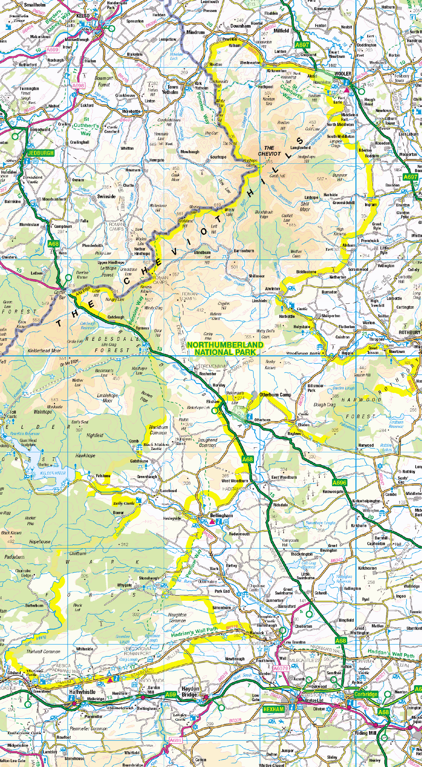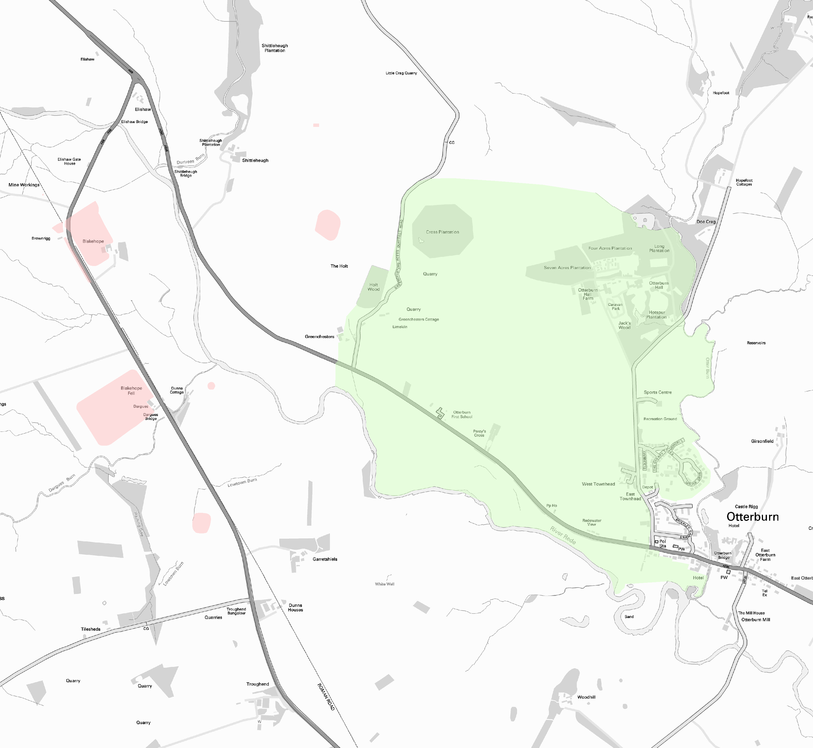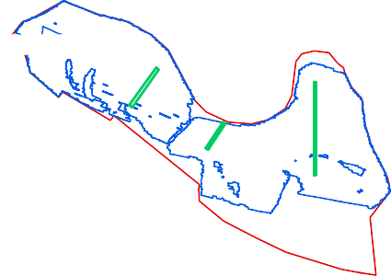Path: S:\PROJECTS\232820\GIS\FigsMXD\Geophysics

594000

NHLE1008995

Battle of Otterburn 1388 NHLE 1000029

NHLE1009376

NHLE1009377

Test pit
Gradiometer Survey Extents
Scheduled monuments Battlefield

0 250 m
Environment Agency LiDAR and derived data:
© Environment Agency copyright and/or database right 2021. All rights reserved.
This material is for client report only © Wessex Archaeology. No unauthorised reproduction.

GPR Survey Extents
Date:
Scale:
20/12/2021

1:5,000 and 1:350,000 at A3
Revision Number:
Illustrator:
0
NLC/RJH

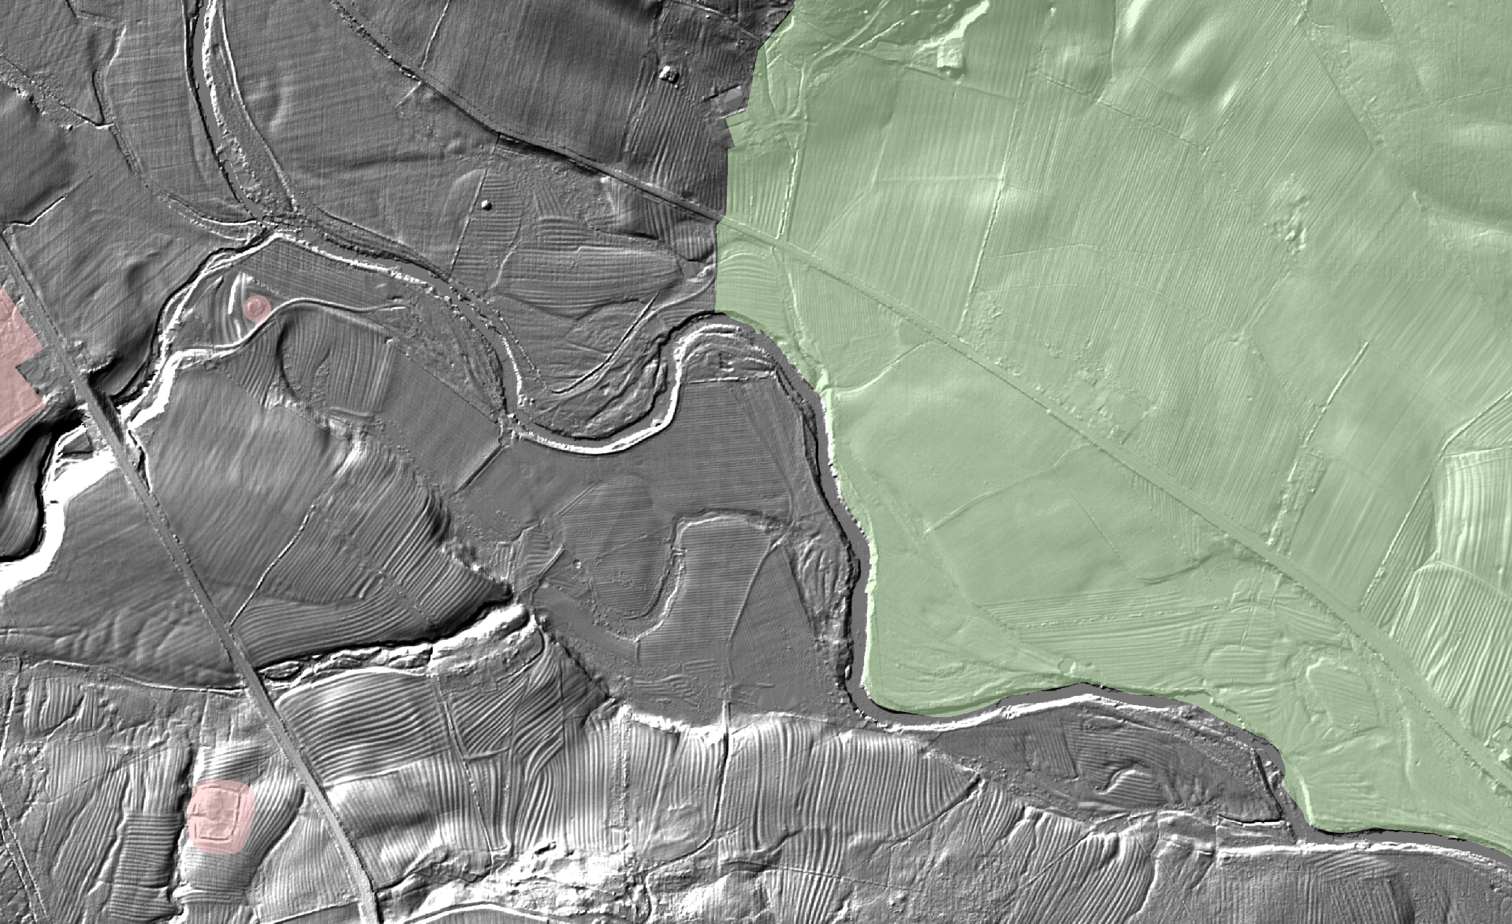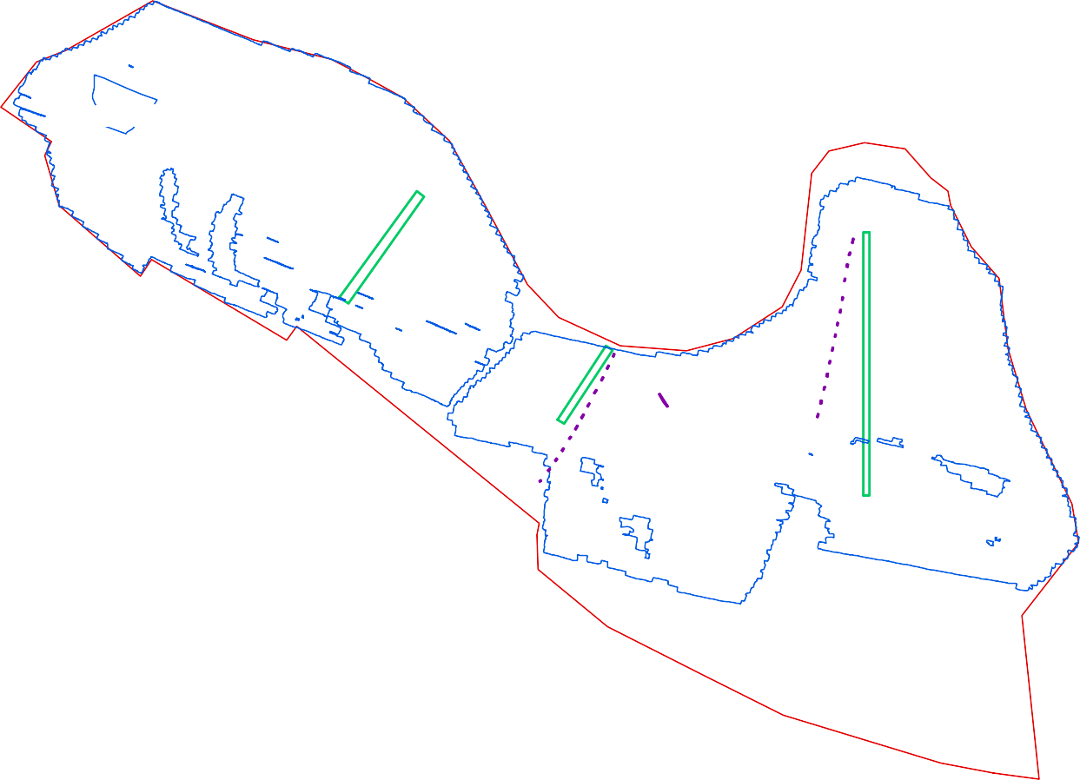Site boundary
387000
Path:
S:\PROJECTS\232820\GIS\FigsMXD\Geophysics

Detailed Survey Extents Site boundary

+ 3nT

- 2nT

Coordinate system:
OSGB36 (OSTN15/OSGM15)

Contains Ordnance Survey data © Crown copyright and database right 2021. This material is for client report only © Wessex Archaeology.
No unauthorised reproduction.

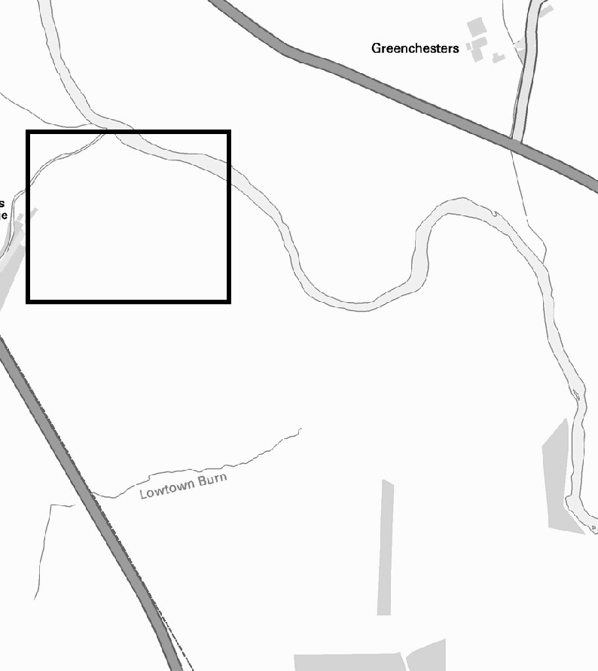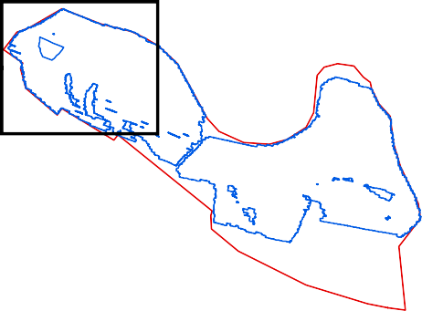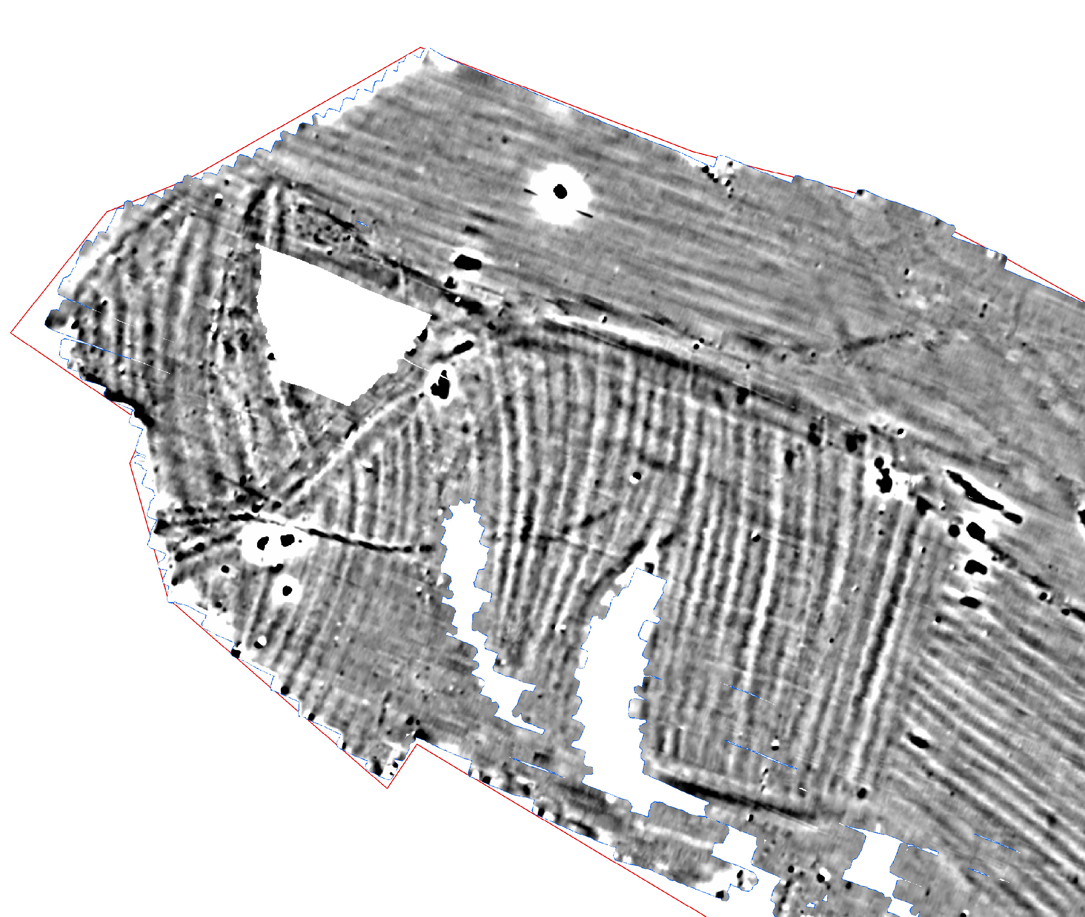
386500

Detailed gradiometer survey results: Greyscale plot (west)
0 50 m
Date: Revision Number:
Scale:
Illustrator:
Path:
09/11/2021
0
1:1,000 at A3 NLC
S:\PROJECTS\232820\GIS\
FigsMXD\Geophysics
Figure 3

593900

4000
4006

4001

593800

4006

4002

4003

4007

4008

4014
Detailed Survey Extents Site boundary
Possible archaeology Drainage ditch
Track
Superficial geology Ferrous
Ridge and furrow Drainage Ploughing
Trend

Coordinate system:
OSGB36 (OSTN15/OSGM15)

Contains Ordnance Survey data © Crown copyright and database right 2021. This material is for client report only © Wessex Archaeology.
No unauthorised reproduction.

4009

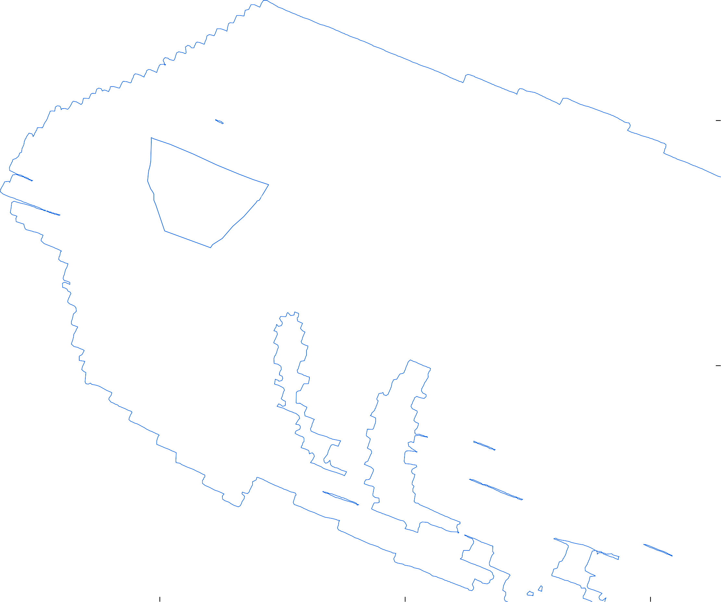
386600
386500
386400

Detailed gradiometer survey results: Interpretation (west)
0 50 m
Date: Revision Number:
Scale:
Illustrator:
Path:
09/11/2021
0
1:1000 at A3 NLC
S:\PROJECTS\232820\GIS\
FigsMXD\Geophysics
Figure 4

59
3800
386800
386700
386600

593700

Test pit
Detailed Survey Extents Site boundary
+ 3nT

- 2nT

Coordinate system:
OSGB36 (OSTN15/OSGM15)

593600

Contains Ordnance Survey data © Crown copyright and database right 2021. This material is for client report only © Wessex Archaeology.
No unauthorised reproduction.

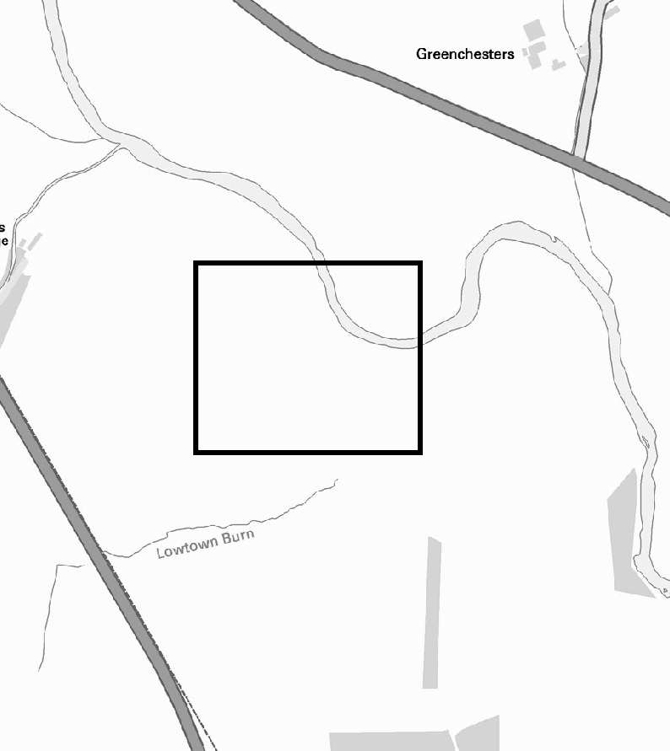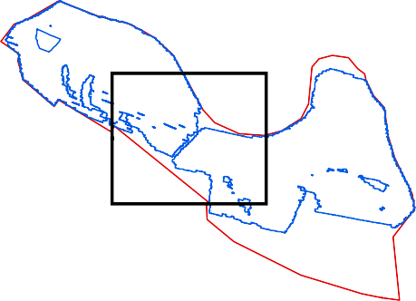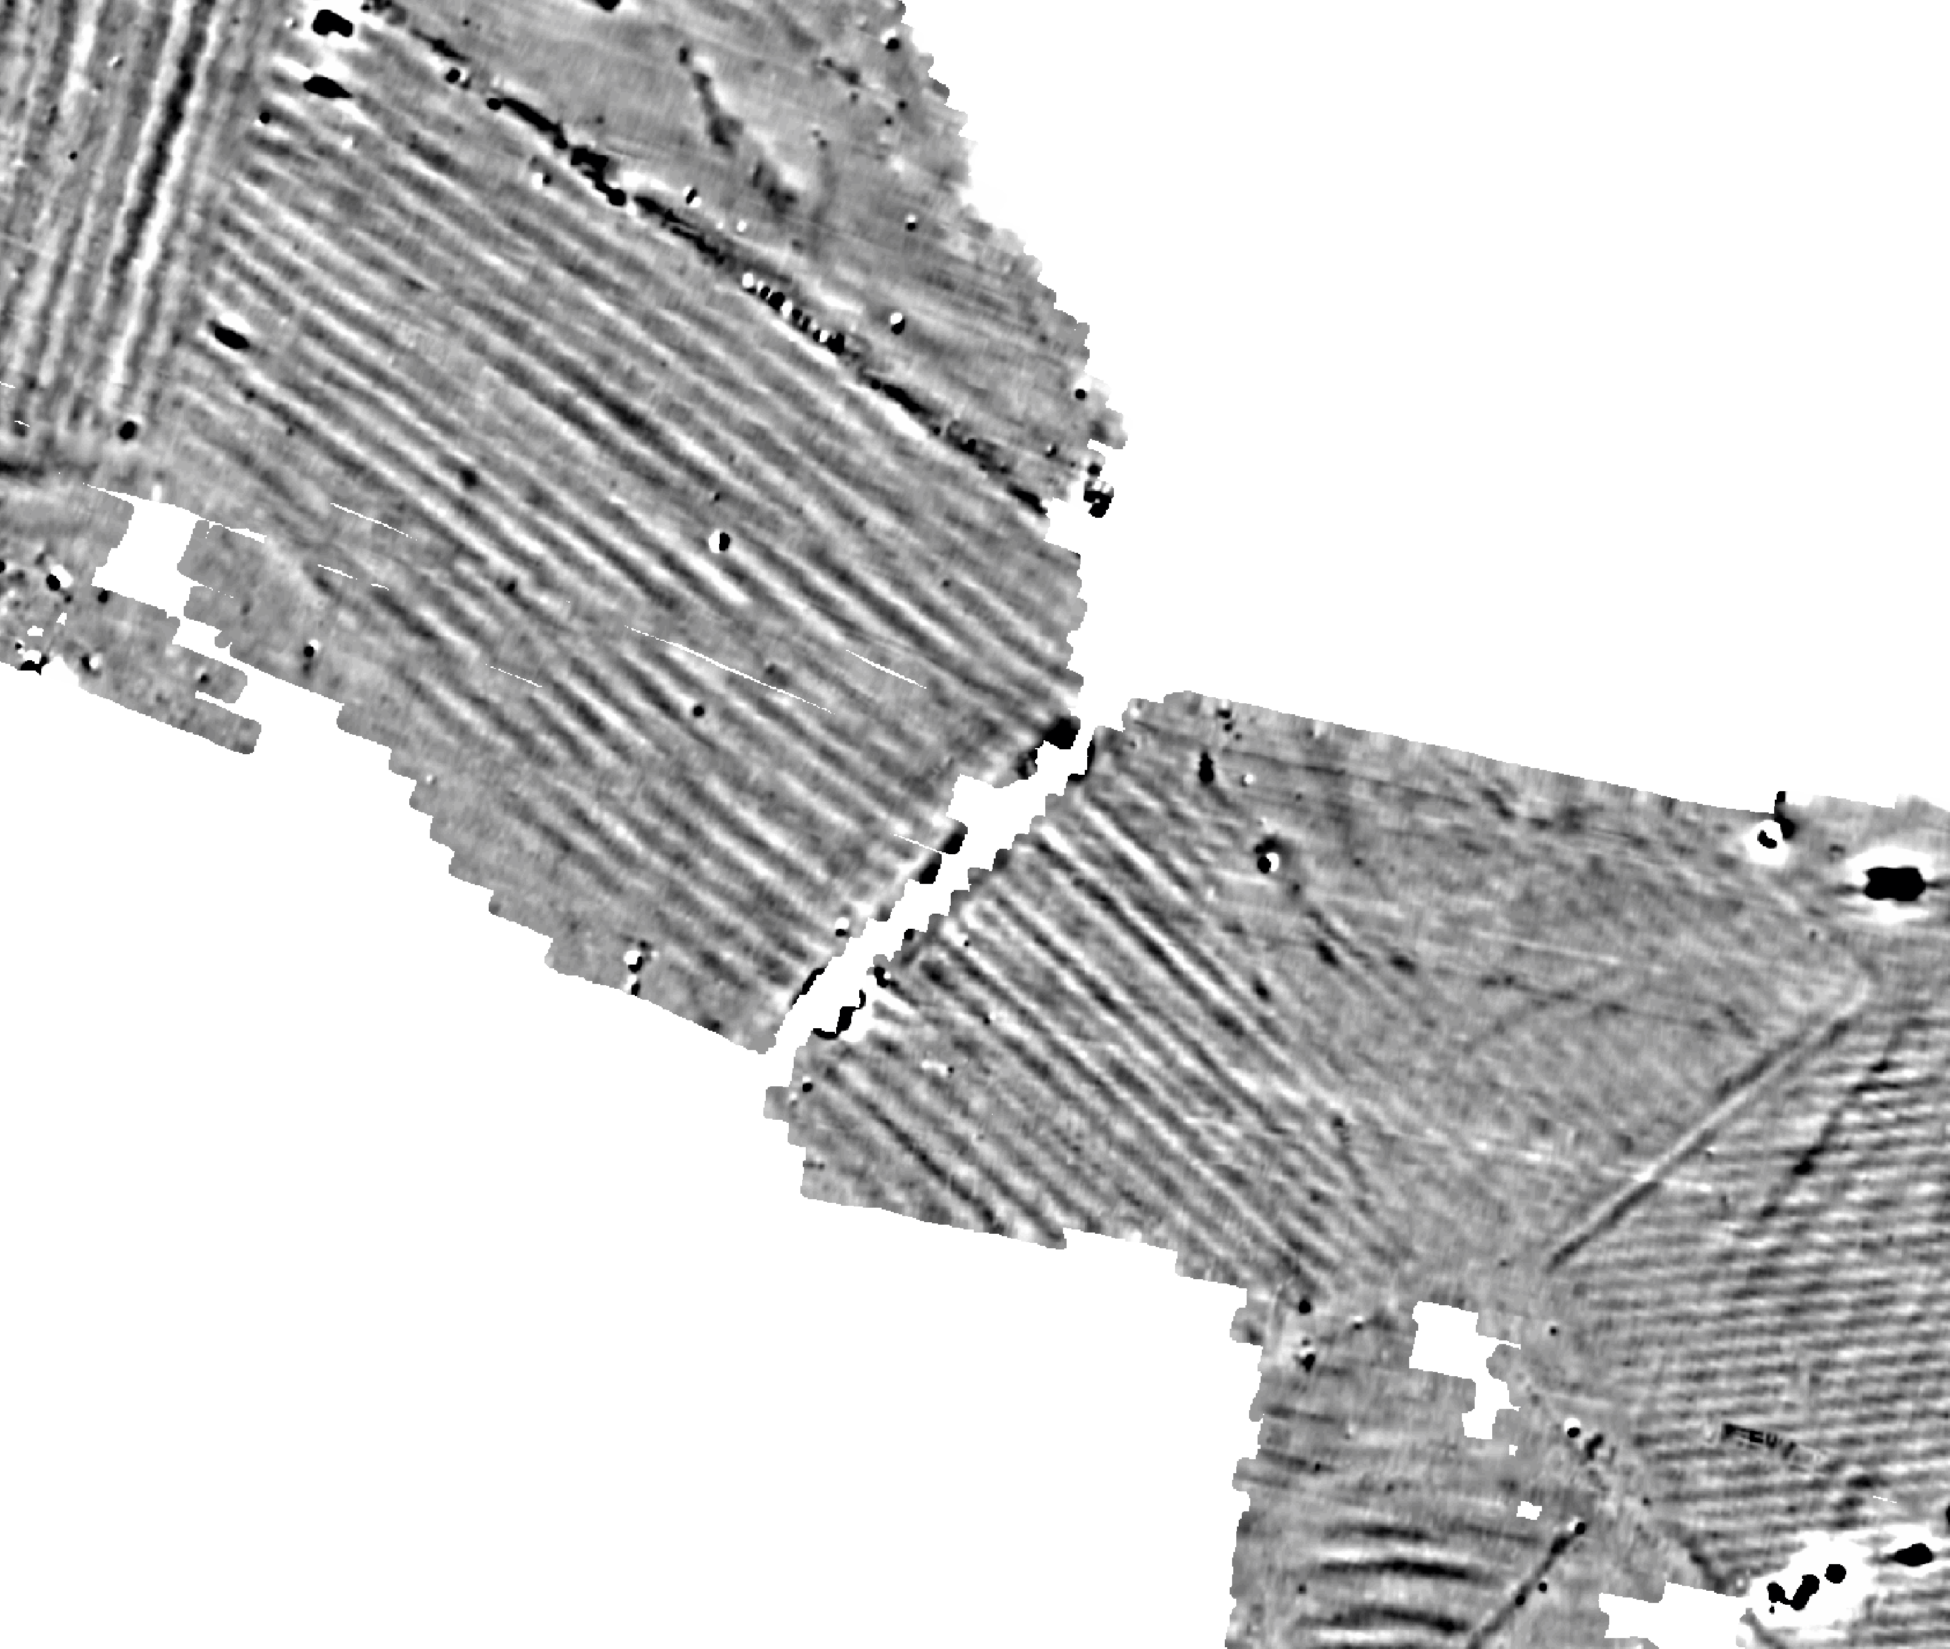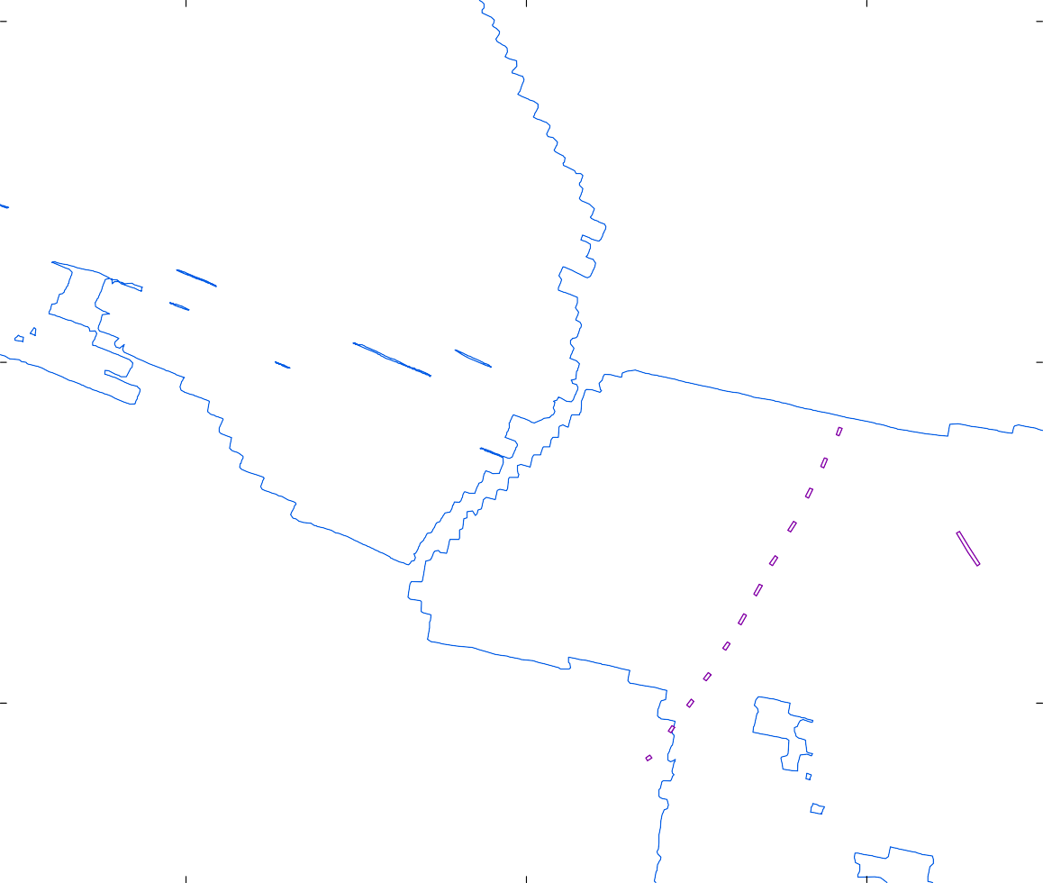

Detailed gradiometer survey results: Greyscale plot (central)
0 50 m
Date: Revision Number:
Scale:
Illustrator:
Path:
20/12/2021
0
1:1000 at A3 NLC
S:\PROJECTS\232820\GIS\
FigsMXD\Geophysics
Figure 5

59
3800
386800
386700
386600

4008

593700

Test pit
Detailed Survey Extents Site boundary
Possible archaeology Drainage ditch
Track
Superficial geology Ferrous
Ridge and furrow Drainage Ploughing
Trend

Coordinate system:
OSGB36 (OSTN15/OSGM15)

593600

Contains Ordnance Survey data © Crown copyright and database right 2021. This material is for client report only © Wessex Archaeology.
No unauthorised reproduction.

4011

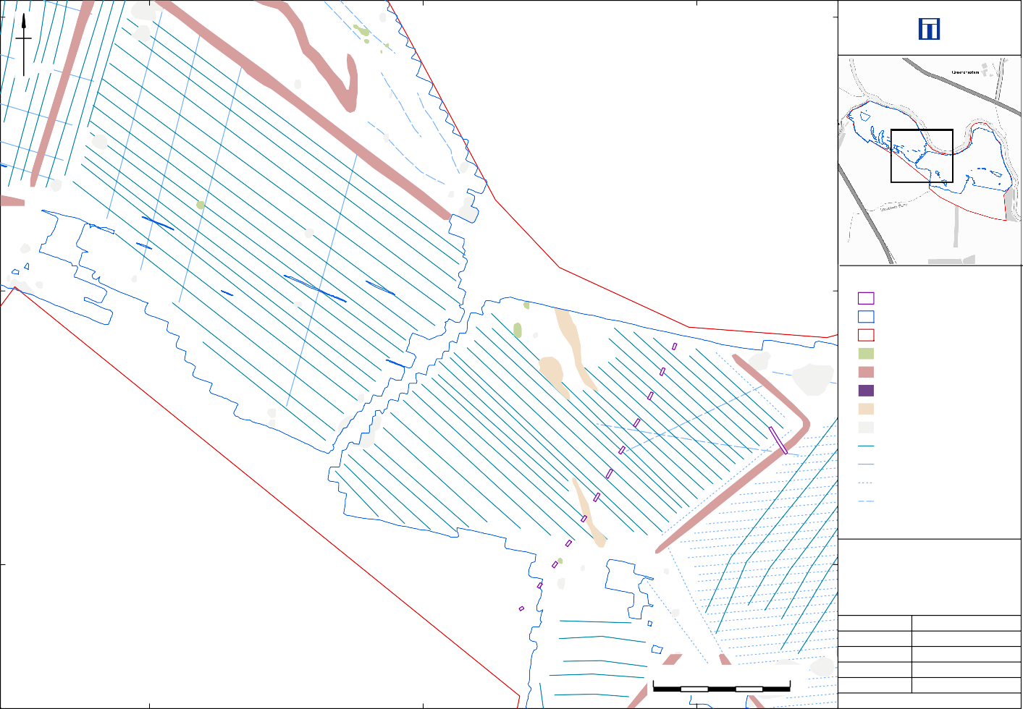

Detailed gradiometer survey results: Interpretation (central)

0 50 m
Date: Revision Number:
Scale:
Illustrator:
Path:
20/12/2021
0
1:1000 at A3 NLC
S:\PROJECTS\232820\GIS\
FigsMXD\Geophysics
Figure 6

593800

Test pit
Detailed Survey Extents Site boundary
+ 3nT

593700

- 2nT

Coordinate system:
OSGB36 (OSTN15/OSGM15)

Contains Ordnance Survey data © Crown copyright and database right 2021. This material is for client report only © Wessex Archaeology.
No unauthorised reproduction.

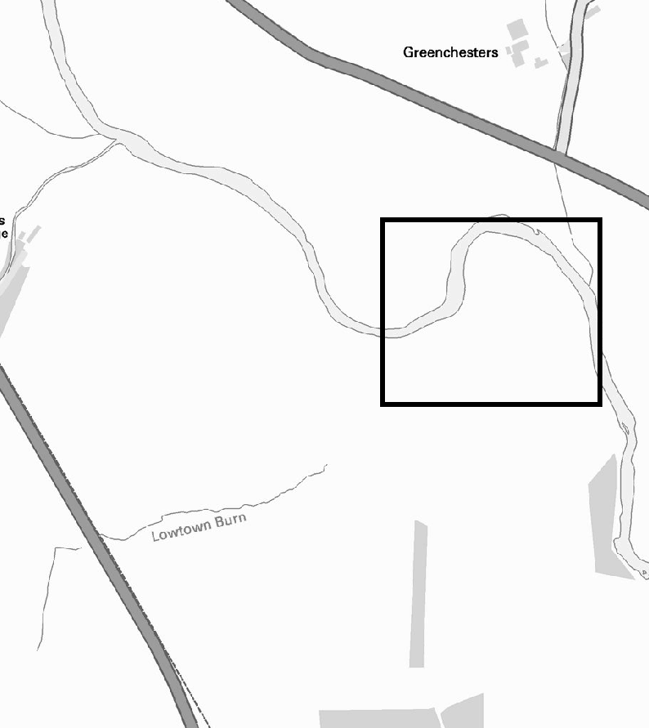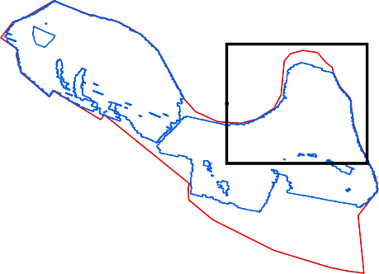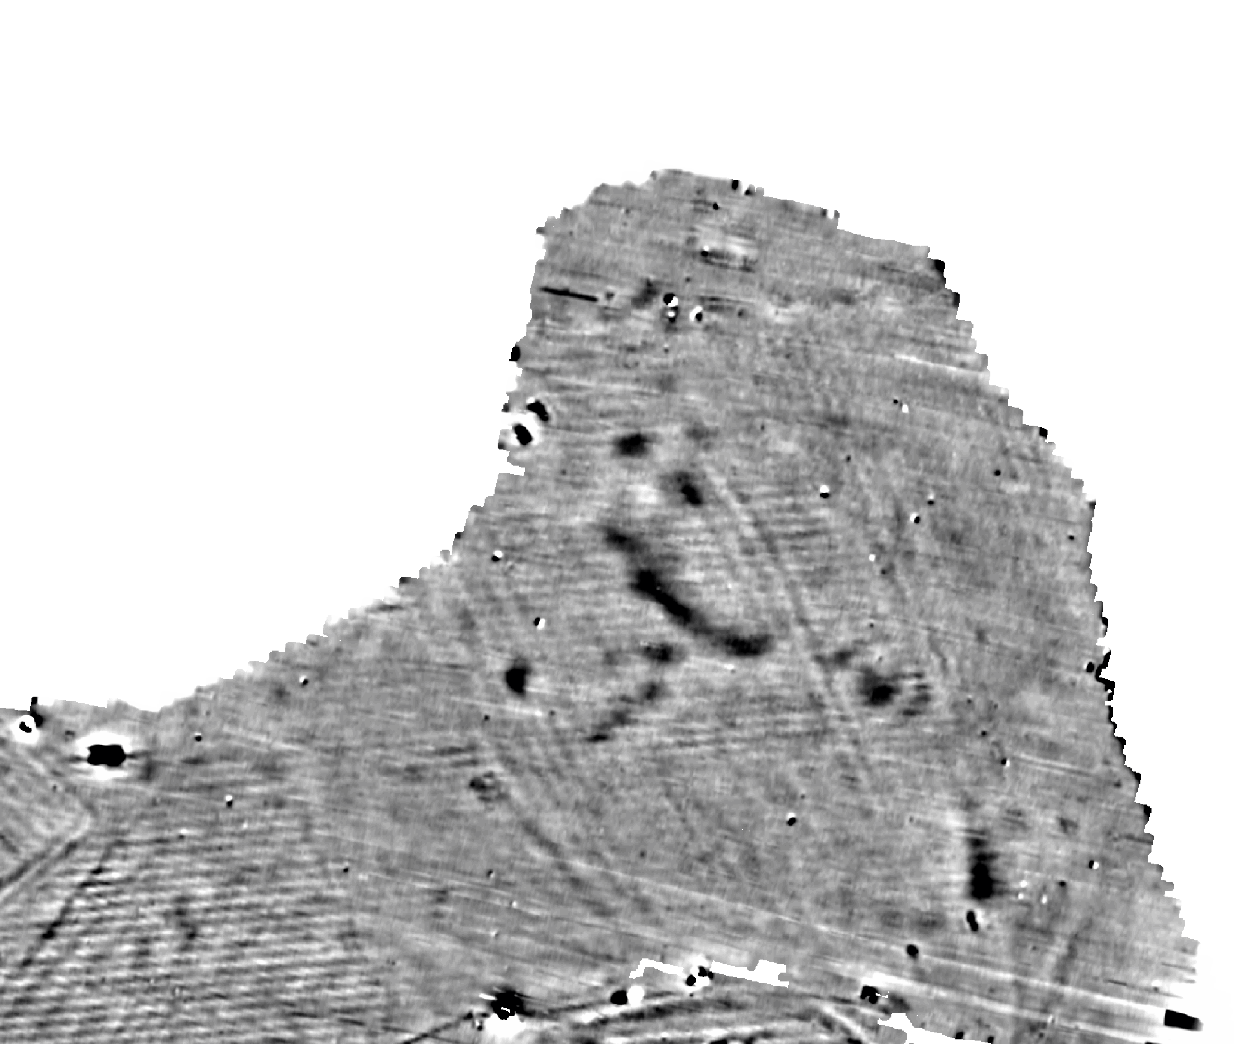
387100
387000
386900

593600

Detailed gradiometer survey results: Greyscale plot (north-east)
Date: Revision Number:
Scale:
Illustrator:
0 50 m
Path:
20/12/2021
0
1:1000 at A3 NLC
S:\PROJECTS\232820\GIS\
FigsMXD\Geophysics
Figure 7

593800

593700

4013
Test pit
Detailed Survey Extents Site boundary
Possible archaeology Drainage ditch
Track
Superficial geology Ferrous
Ridge and furrow Drainage Ploughing
Trend

Coordinate system:
OSGB36 (OSTN15/OSGM15)

Contains Ordnance Survey data © Crown copyright and database right 2021. This material is for client report only © Wessex Archaeology.
No unauthorised reproduction.

593600

4010
Date: Revision Number:
Scale:
Illustrator:
Path:
20/12/2021
0
1:1000 at A3 NLC
S:\PROJECTS\232820\GIS\
FigsMXD\Geophysics

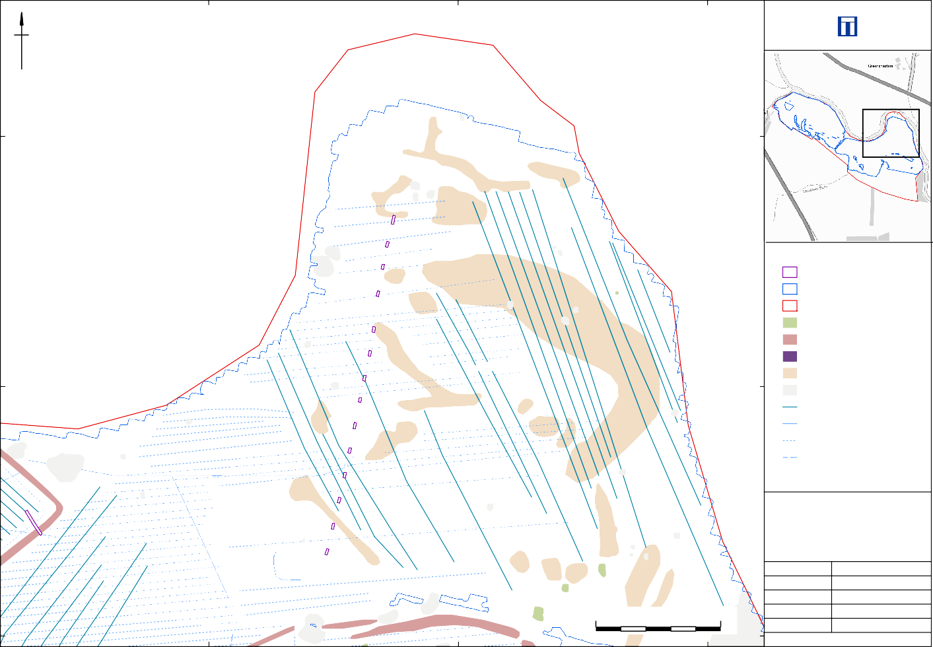
Detailed gradiometer survey results: Interpretation (north-eastl) Figure 8
0 50 m
387100
387000
386900

593700
387100
387000
386900

593600

Test pit
Detailed Survey Extents Site boundary
+ 3nT

- 2nT

Coordinate system:
OSGB36 (OSTN15/OSGM15)

Contains Ordnance Survey data © Crown copyright and database right 2021. This material is for client report only © Wessex Archaeology.
No unauthorised reproduction.

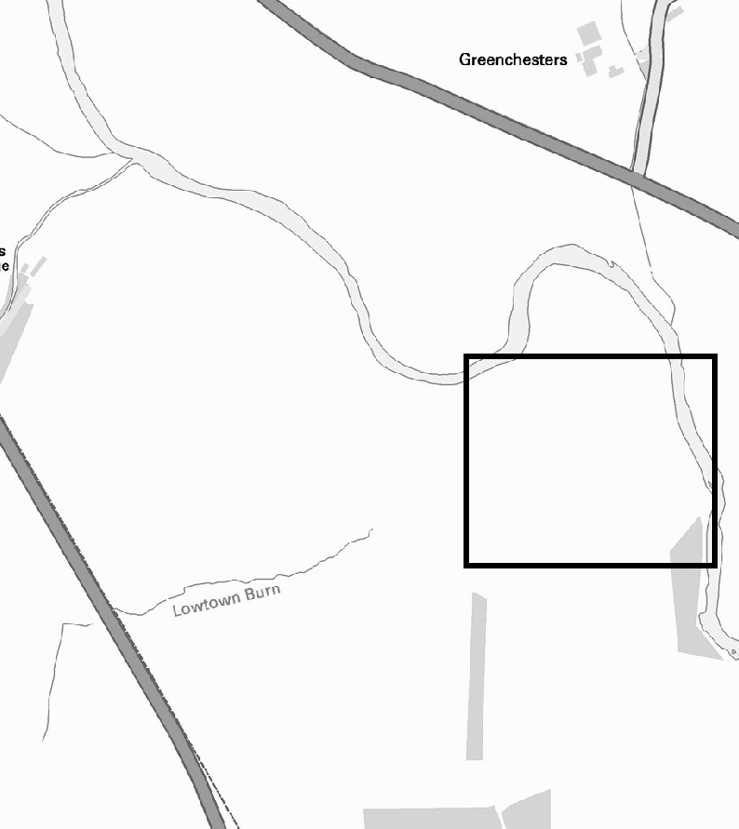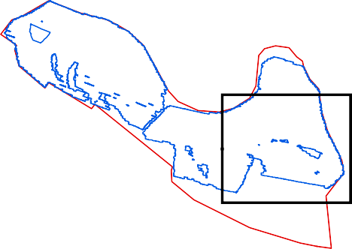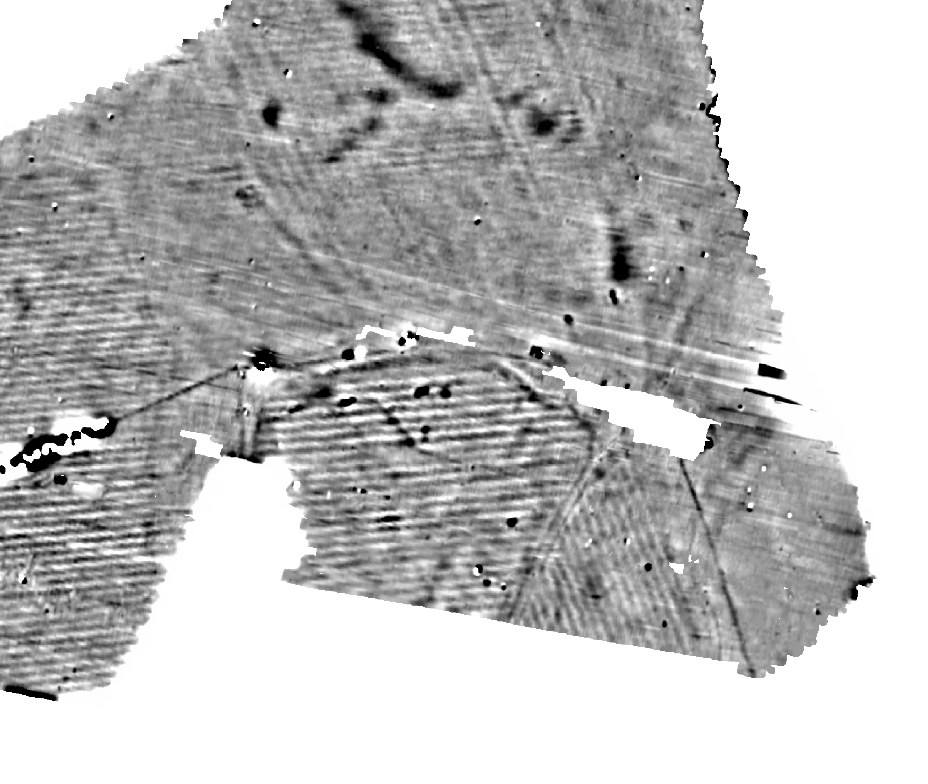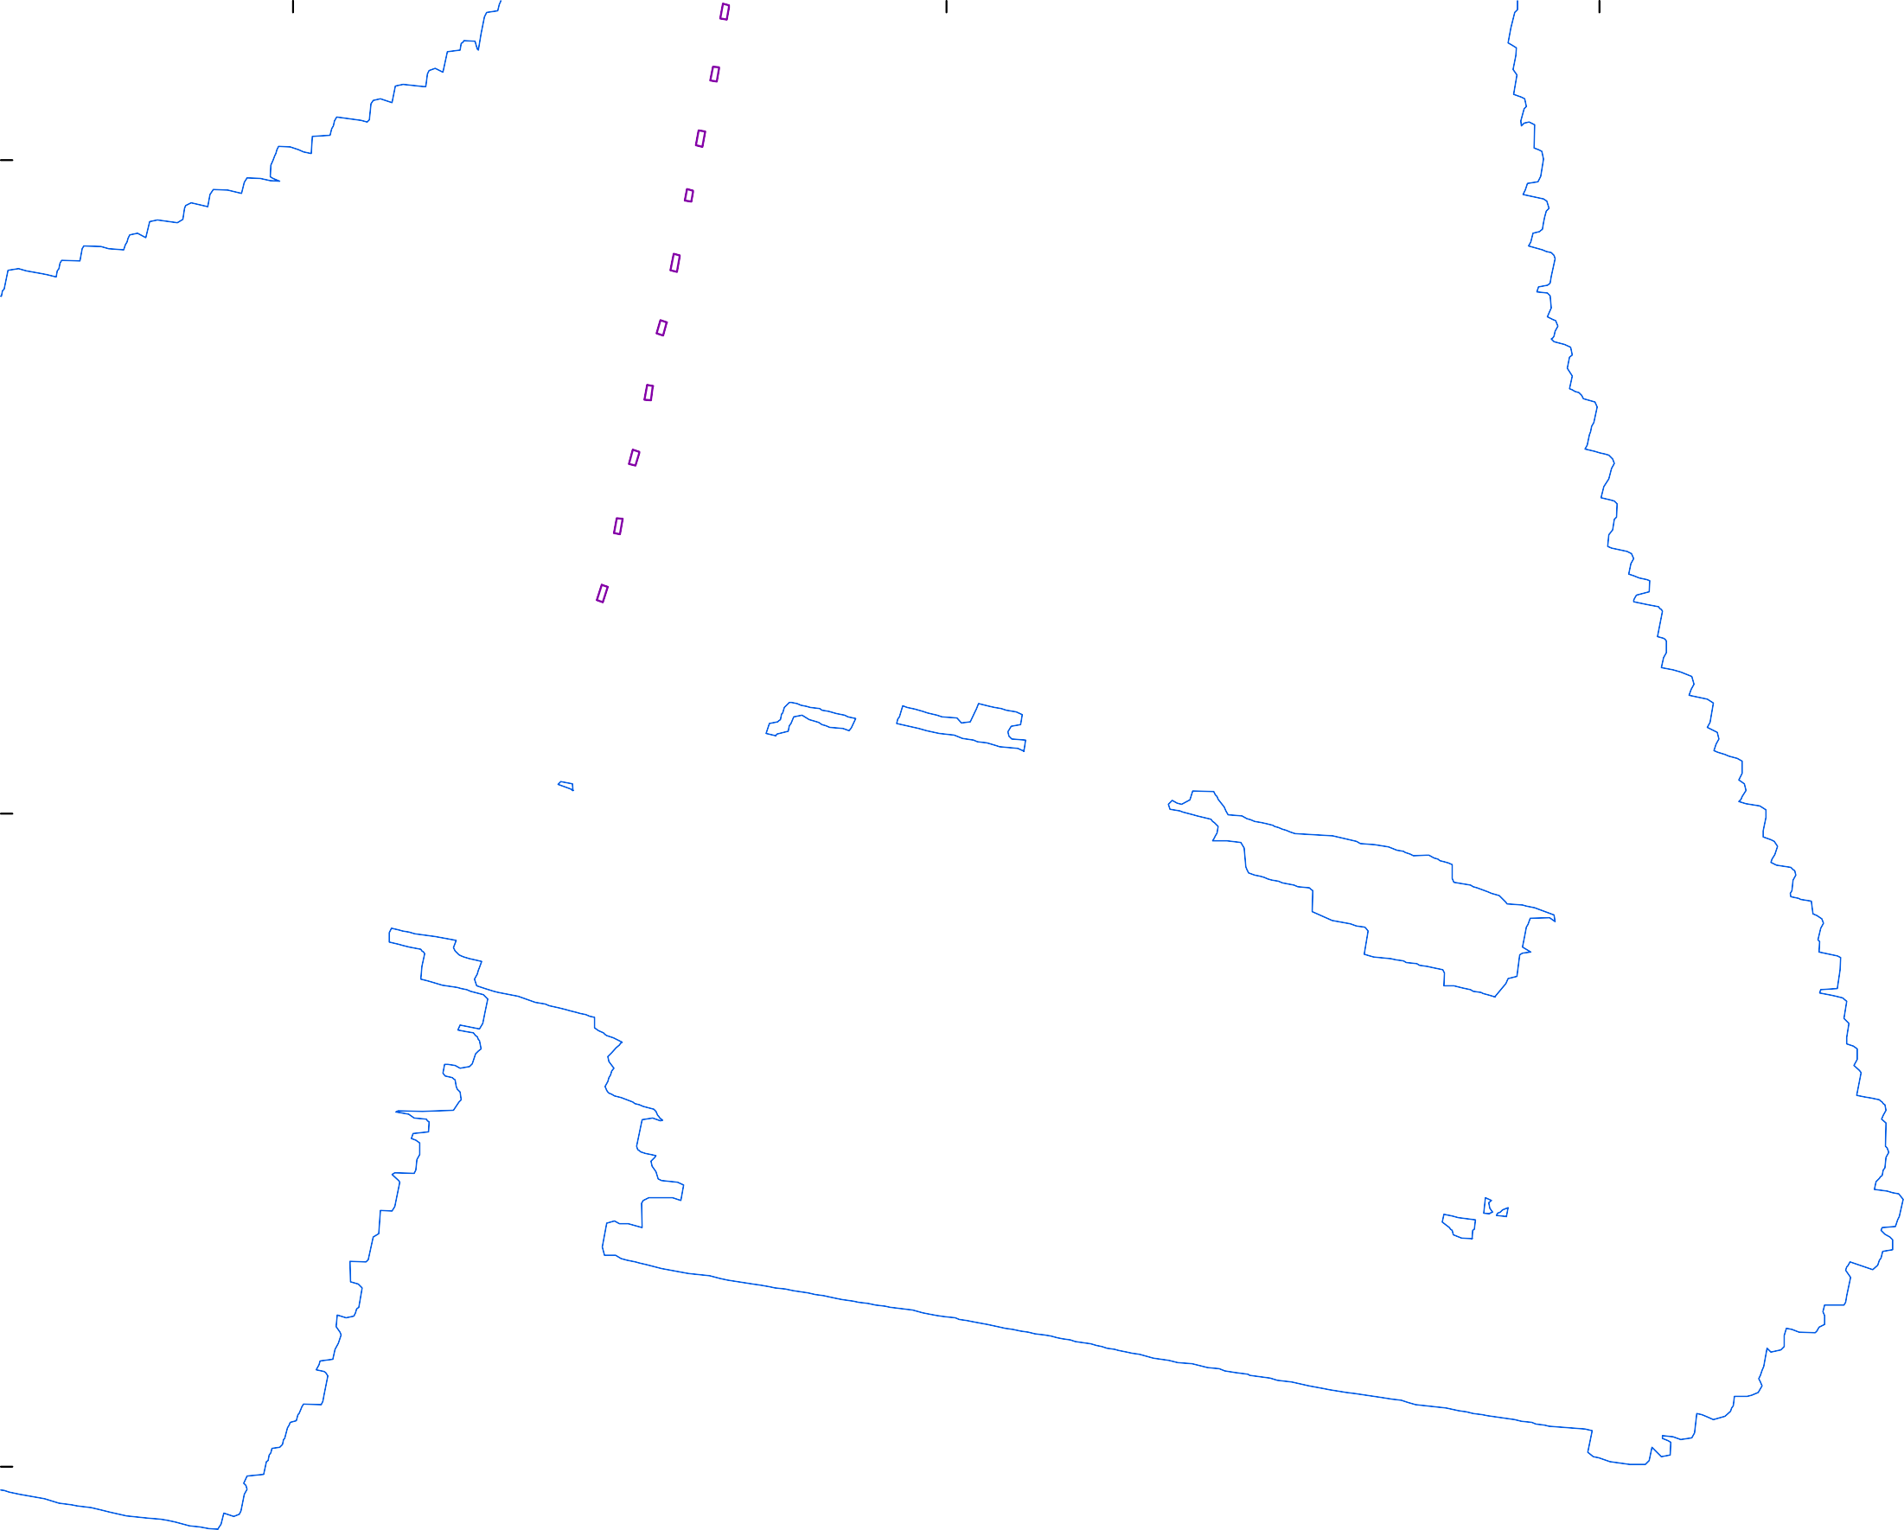593500

Detailed gradiometer survey results: Greyscale plot (south-east)

0 50 m

Date: Revision Number:
Scale:
Illustrator:
Path:

20/12/2021
0
1:1000 at A3 NLC
S:\PROJECTS\232820\GIS\
FigsMXD\Geophysics
Figure 9

4013
387100
387000
386900

59
3700

593600

4010

4012

4004

4005

Test pit
Detailed Survey Extents Site boundary
Possible archaeology Track
Drainage ditch Superficial geology Ferrous
Ridge and furrow Drainage Ploughing
Trend

Coordinate system:
OSGB36 (OSTN15/OSGM15)

Contains Ordnance Survey data © Crown copyright and database right 2021. This material is for client report only © Wessex Archaeology.
No unauthorised reproduction.

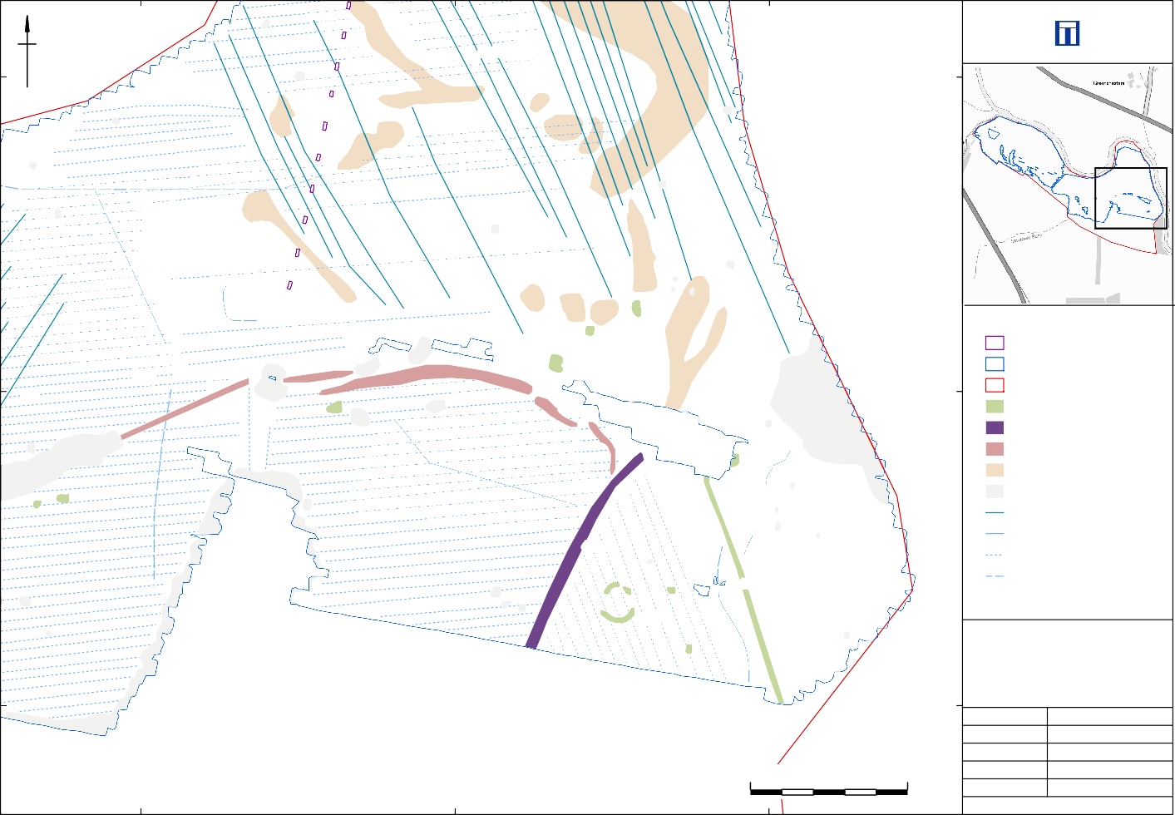
593500

Detailed gradiometer survey results: Interpretation (south-east)

0 50 m

Date: Revision Number:
Scale:
Illustrator:
Path:

20/12/2021
0
1:1000 at A3 NLC
S:\PROJECTS\232820\GIS\
FigsMXD\Geophysics
Figure 10

593750 593750
387100
387050
387000
386950
386900
387100
387050
387000
386950
386900

593700

593700
Area C

Area A

Area B

593650 593650

593600

Timeslice 2: 0.1 - 0.2 m (3.17 - 6.37 ns)
387100
387050
387000
386950
386900

593600

Timeslice 7: 0.59 - 0.69 m (19.01 - 22.21 ns)
Test pit
GPR survey extents Gradiometer Survey Extents Site boundary

593750

S N

593700

593650
Coordinate system:
OSGB36 (OSTN15/OSGM15)
Contains Ordnance Survey data © Crown copyright and database right 2021. This material is for client report only © Wessex Archaeology.
No unauthorised reproduction.

0 50 m

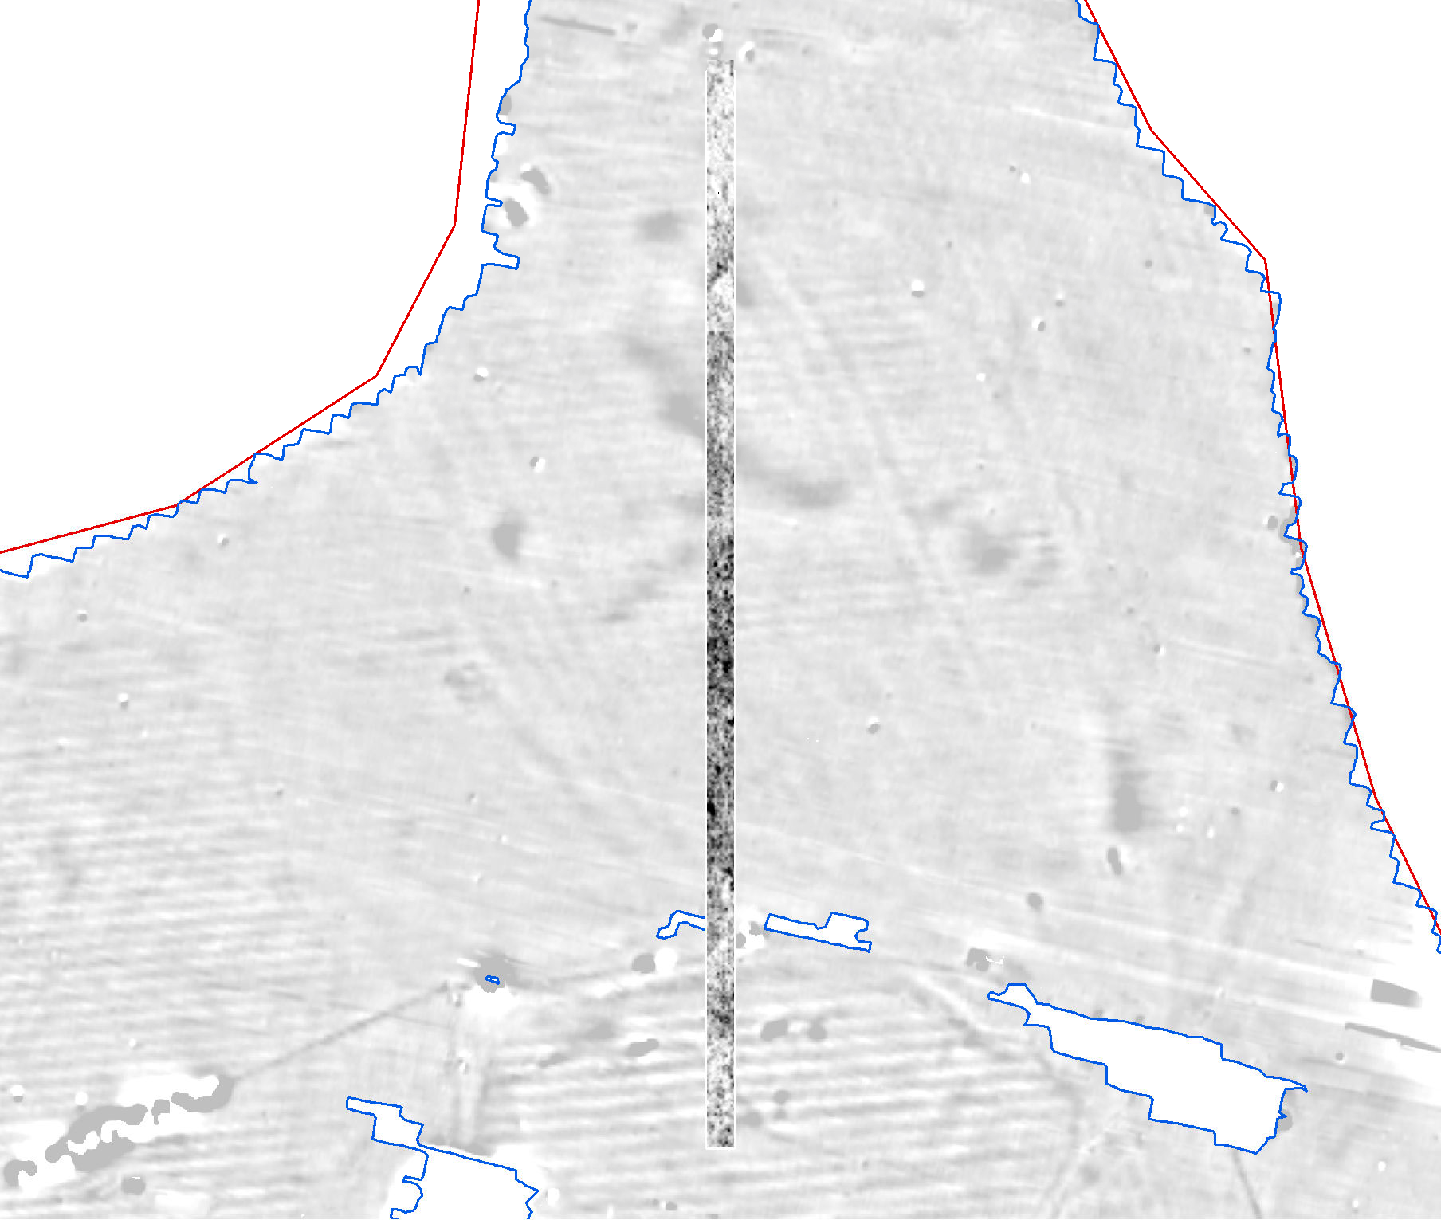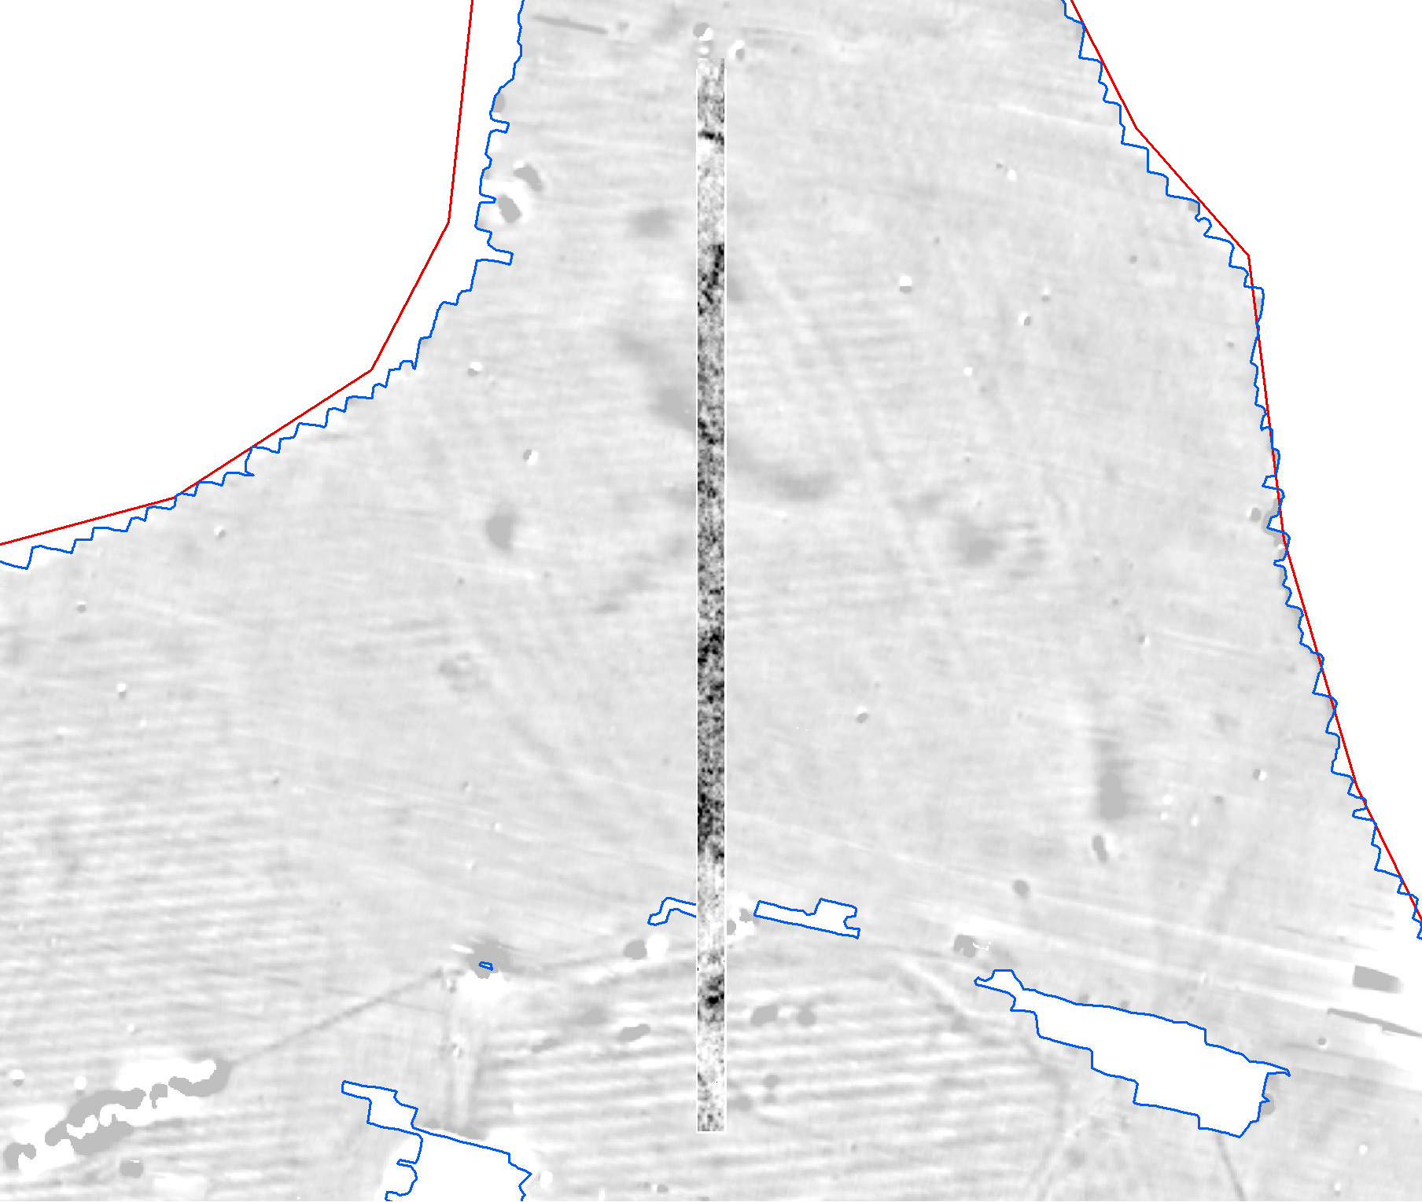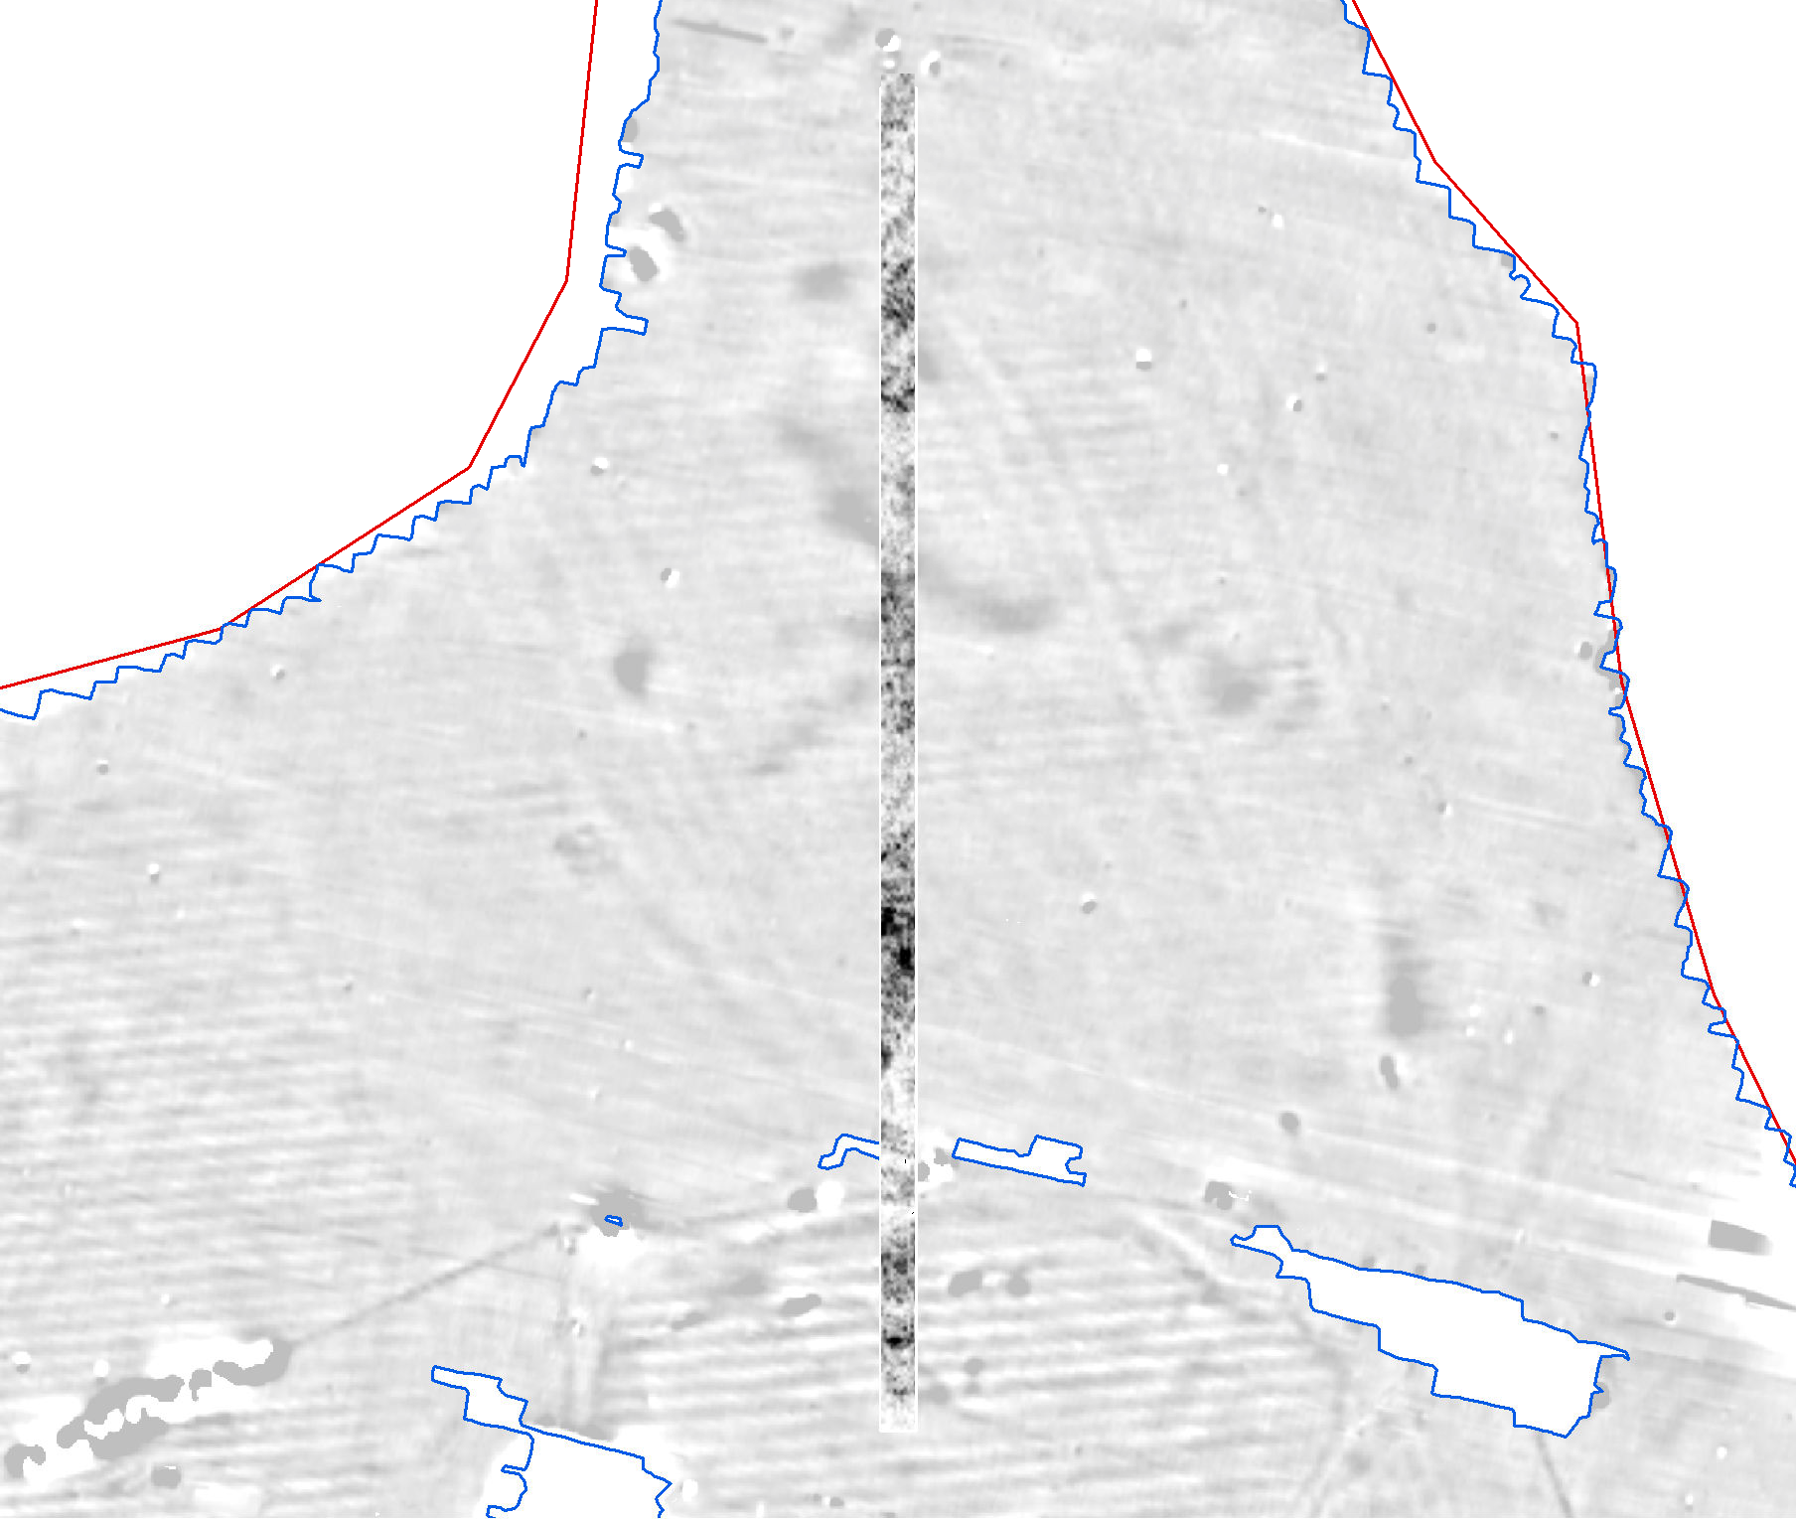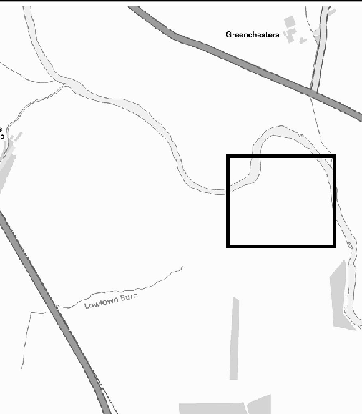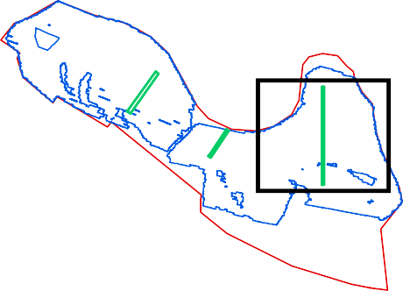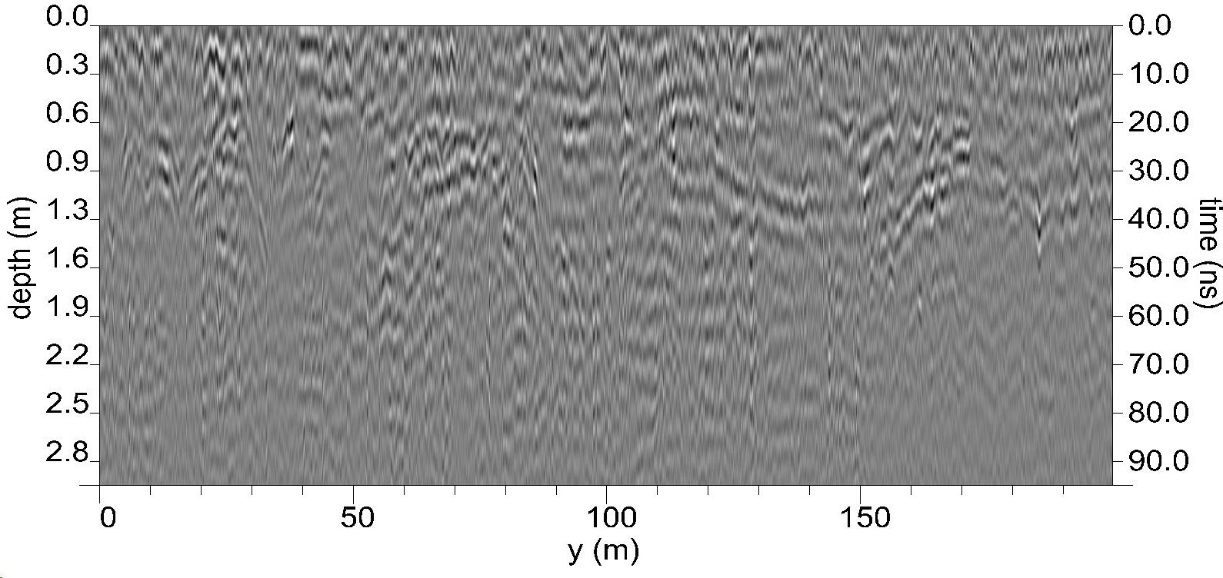

593600

Timeslice 11: 0.99 - 1.09 m (31.68 - 34.88 ns)
GPR survey results (Area A): Greyscale timeslices and represetative radargram

Representative radargram
Date: Revision Number:
Scale:
Illustrator:
Path:
20/12/2021
0
1:1,750 at A3 NLC
S:\PROJECTS\232820\GIS\
FigsMXD\Geophysics
Figure 11

593750 593750
387100
387050
387000
386950
386900
387100
387050
387000
386950
386900

593700

593700
Area C

Area A

Area B

593650 593650

593600

5000

593600

5000
Test pit
Gradiometer Survey Extents Site boundary

Timeslice 2: 0.1 - 0.2 m (3.17 - 6.37 ns)
387000
386950
386900

593750

Timeslice 7: 0.59 - 0.69 m (19.01 - 22.21 ns)
GPR survey extents Drainage ditch Possible archaeology High amplitude Superficial geology

S Palaeochannel?
387100
387050
Palaeochannel(s) N
Ridge and furrow Trend

593700
5001

593650
Coordinate system:
OSGB36 (OSTN15/OSGM15)
Contains Ordnance Survey data © Crown copyright and database right 2021. This material is for client report only © Wessex Archaeology.
No unauthorised reproduction.

0 50 m

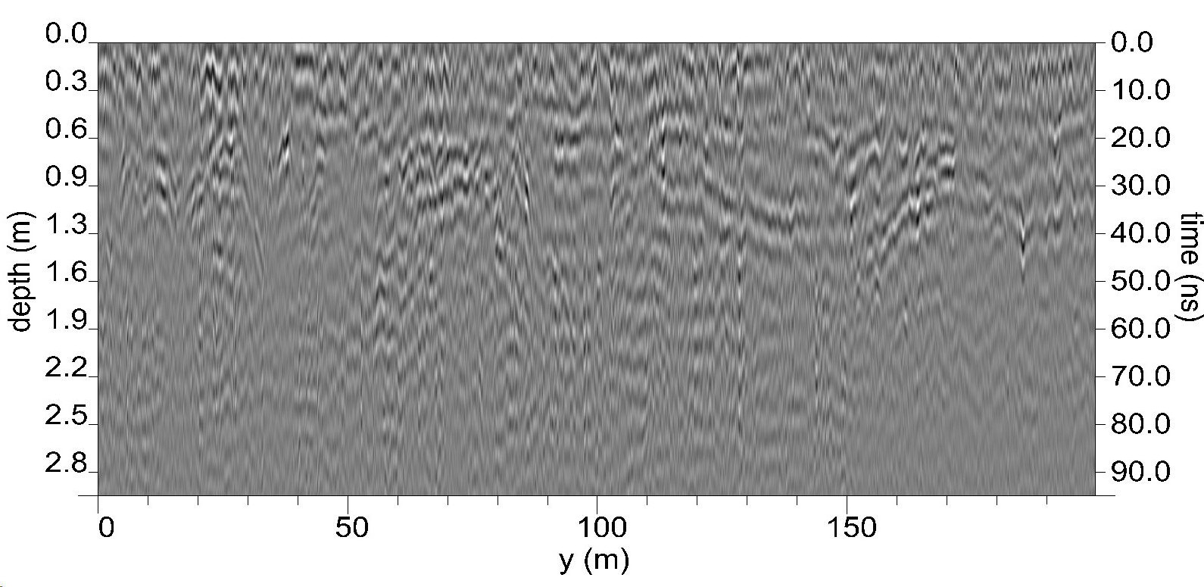

593600

Timeslice 11: 0.99 - 1.09 m (31.68 - 34.88 ns)
GPR survey results (Area B): Archaeological interpretation and annotated radargram

Representative radargram
Date: Revision Number:
Scale:
Illustrator:
Path:
21/12/2021
0
1:1,750 at A3 NLC
S:\PROJECTS\232820\GIS\
FigsMXD\Geophysics
Figure 12

59 593700
3700
386800
386750
386700
386800
386750
386700

Area C

Area A

Area B

593650 593650

593600

Timeslice 2: 0.1 - 0.2 m (3.17 - 6.37 ns)
386800
386750
386700

593600

Timeslice 7: 0.59 - 0.69 m (19.01 - 22.21 ns)
Test pit
GPR survey extents Gradiometer Survey Extents Site boundary
High
Amplitude

593700

SW NE

593650
Low Amplitude
Coordinate system:
OSGB36 (OSTN15/OSGM15)
Contains Ordnance Survey data © Crown copyright and database right 2021. This material is for client report only © Wessex Archaeology.
No unauthorised reproduction.

0 25 m

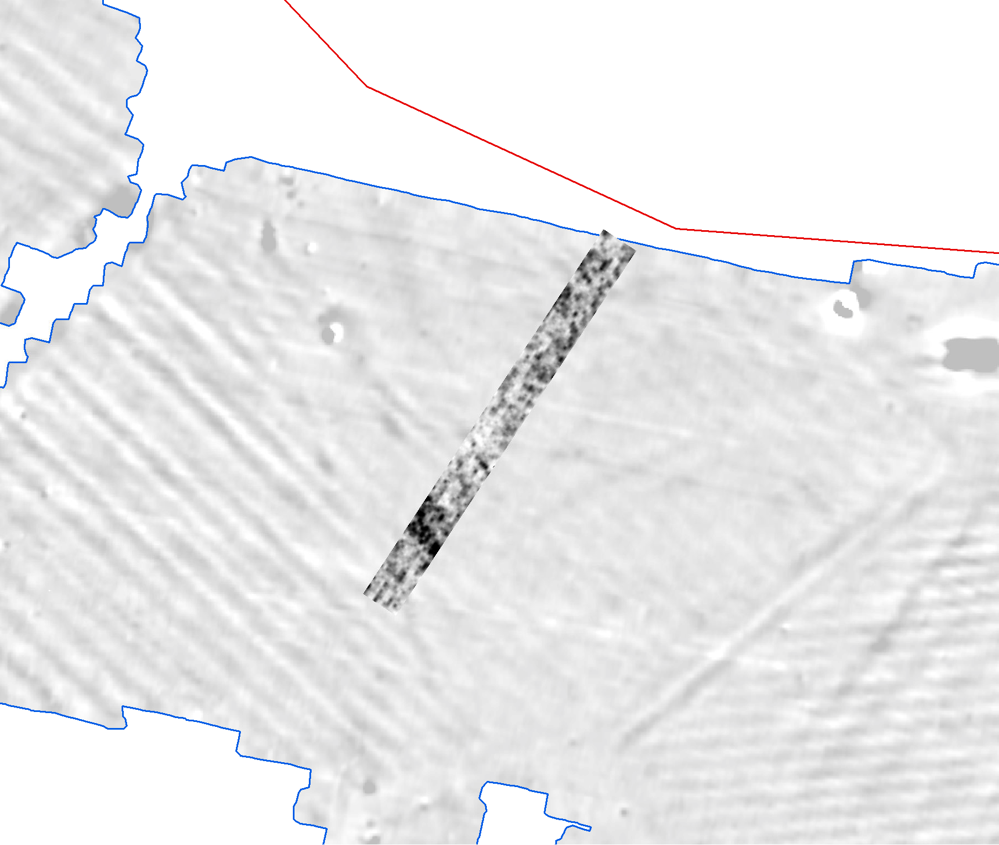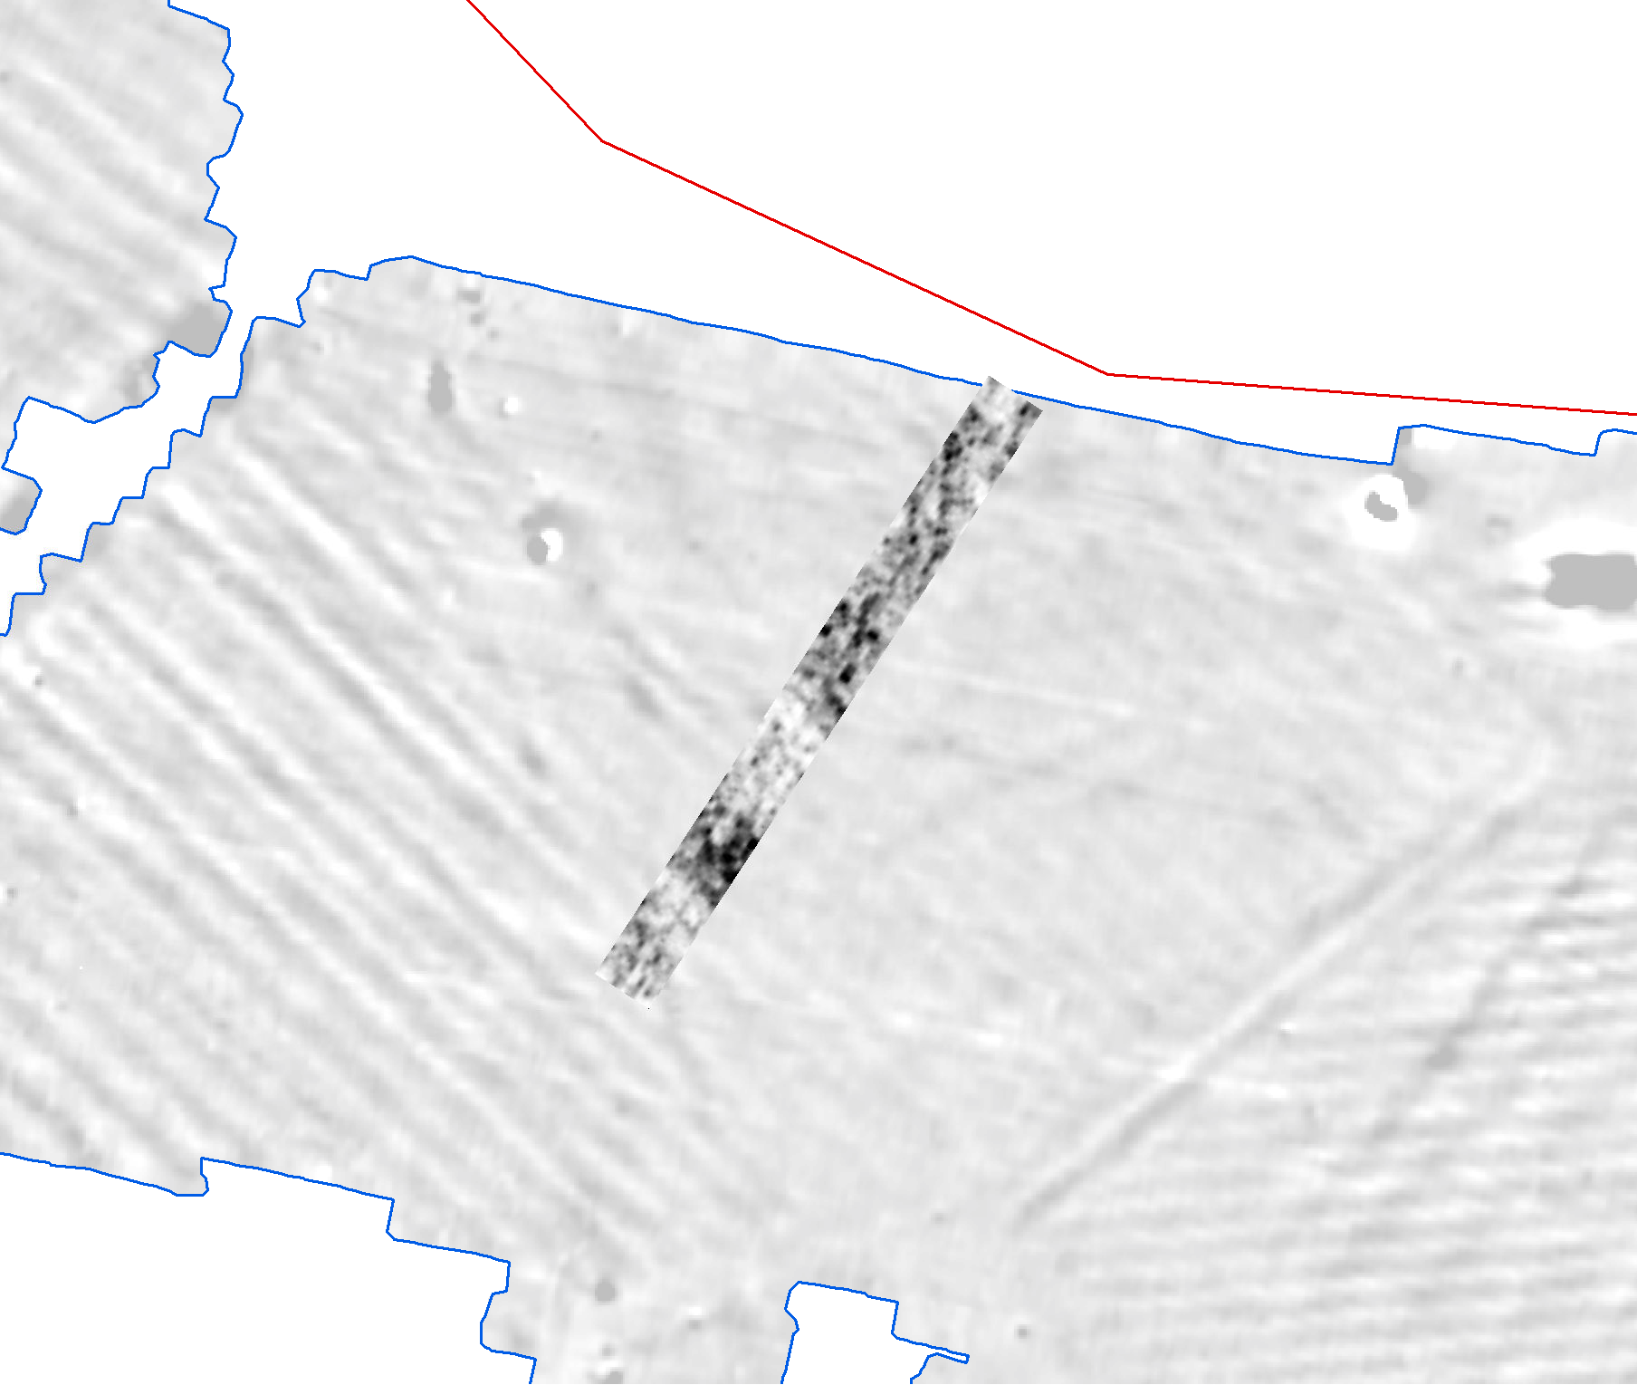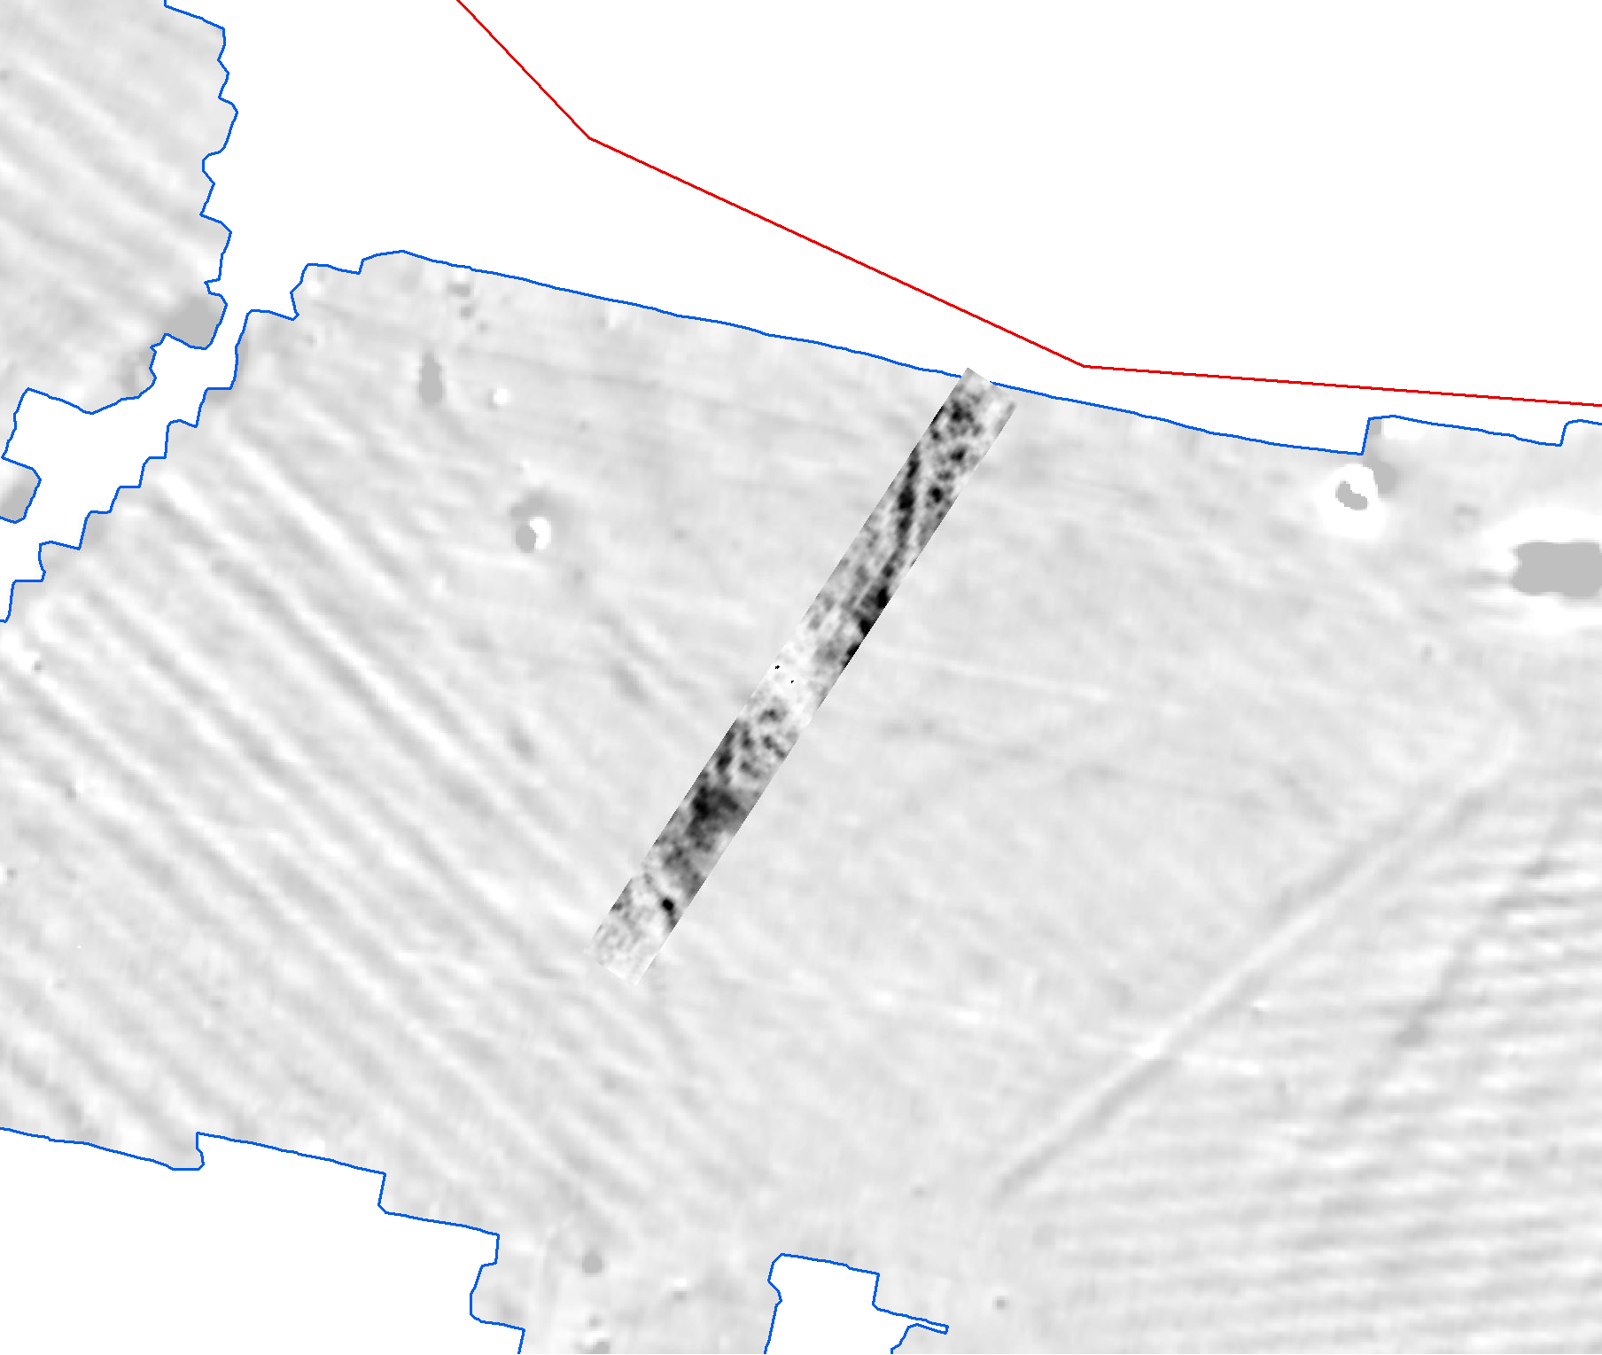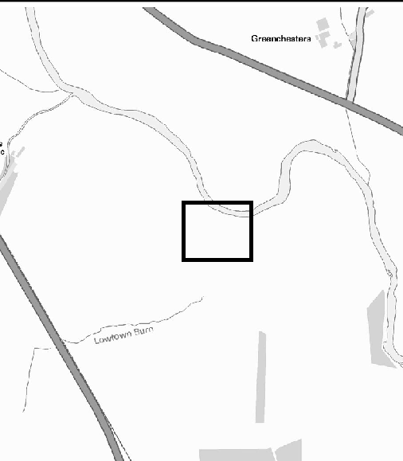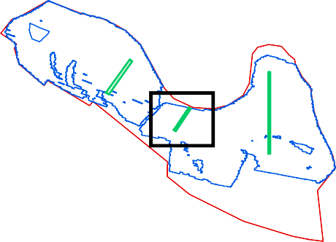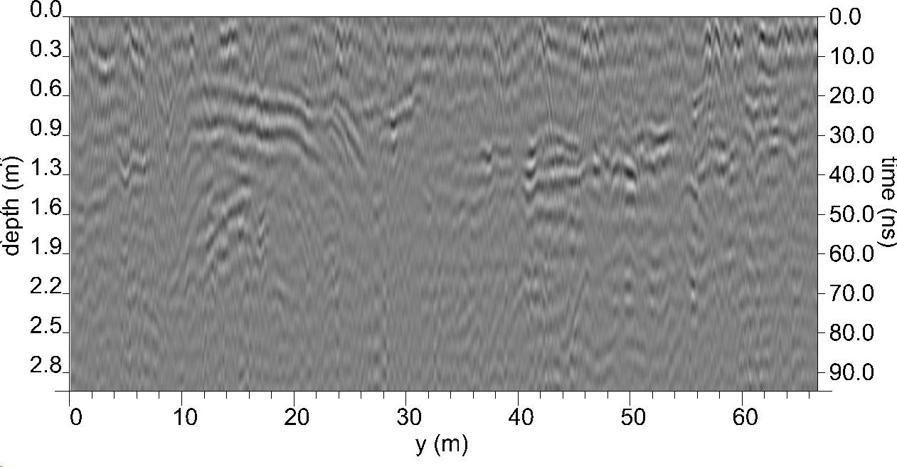

593600

Timeslice 11: 0.99 - 1.09 m (31.68 - 34.88 ns)
GPR survey results (Area A): Greyscale timeslices and represetative radargram

Representative radargram
Date: Revision Number:
Scale:
Illustrator:
Path:
20/12/2021
0
1:1,750 at A3 NLC
S:\PROJECTS\232820\GIS\
FigsMXD\Geophysics
Figure 13

59 593700
3700
386800
386750
386700
386800
386750
386700

Area C

Area A

5002

Area B

593650 593650

5003

593600

Timeslice 2: 0.1 - 0.2 m (3.17 - 6.37 ns)
386750
386700

593700

593600

Timeslice 7: 0.59 - 0.69 m (19.01 - 22.21 ns)
386800
Test pit
Gradiometer Survey Extents Site boundary
GPR survey extents Drainage ditch Possible archaeology High amplitude Superficial geology
Ridge and furrow

SW Alluvium NE Trend

Palaeochanne l

593650
Coordinate system:
OSGB36 (OSTN15/OSGM15)
Contains Ordnance Survey data © Crown copyright and database right 2021. This material is for client report only © Wessex Archaeology.
No unauthorised reproduction.

0 25 m



593600

Timeslice 11: 0.99 - 1.09 m (31.68 - 34.88 ns)
GPR survey results (Area B): Archaeological interpretation and annotated radargram

Representative radargram
Date: Revision Number:
Scale:
Illustrator:
Path:
21/12/2021
0
1:1,000 at A3 NLC
S:\PROJECTS\232820\GIS\
FigsMXD\Geophysics
Figure 14

59 593800
3800
386650
386600
386550
386650
386600
386550

Area C

Area A

Area B

593750 593750

5937a0)0 Timeslice 2: 0.1 - 0.2 m (3.17 - 6.37 ns)

5937b00) Timeslice 7: 0.59 - 0.69 m (19.01 - 22.21 ns)
GPR survey extents Gradiometer Survey Extents Site boundary
High Amplitude
386650
386600
386550

593800

SW NE

Low Amplitude

593750
Coordinate system:
OSGB36 (OSTN15/OSGM15)
Contains Ordnance Survey data © Crown copyright and database right 2021. This material is for client report only © Wessex Archaeology.
No unauthorised reproduction.

0 25 m

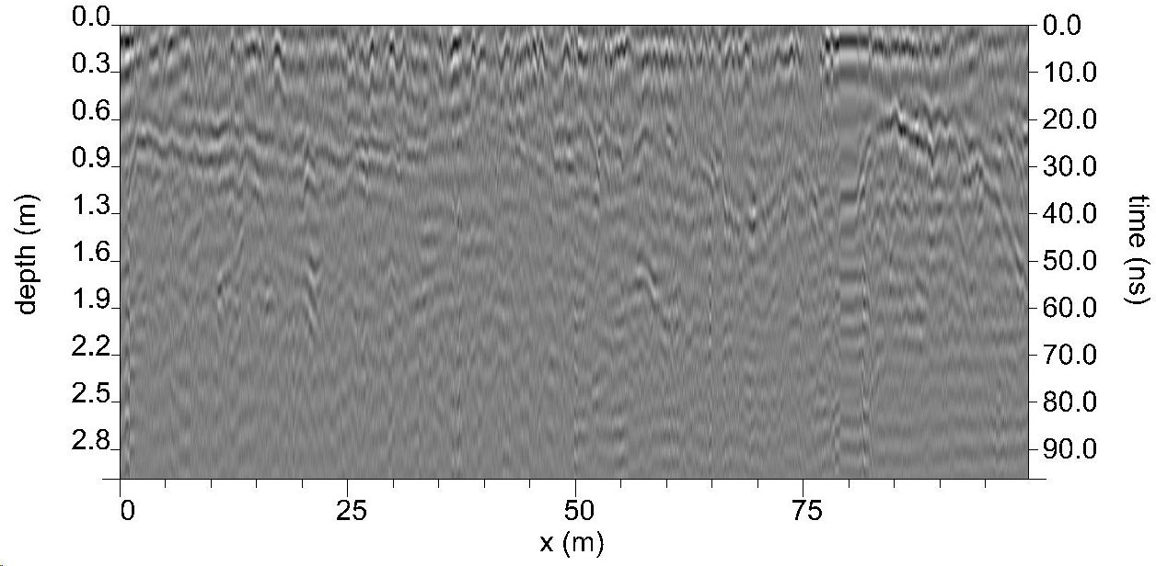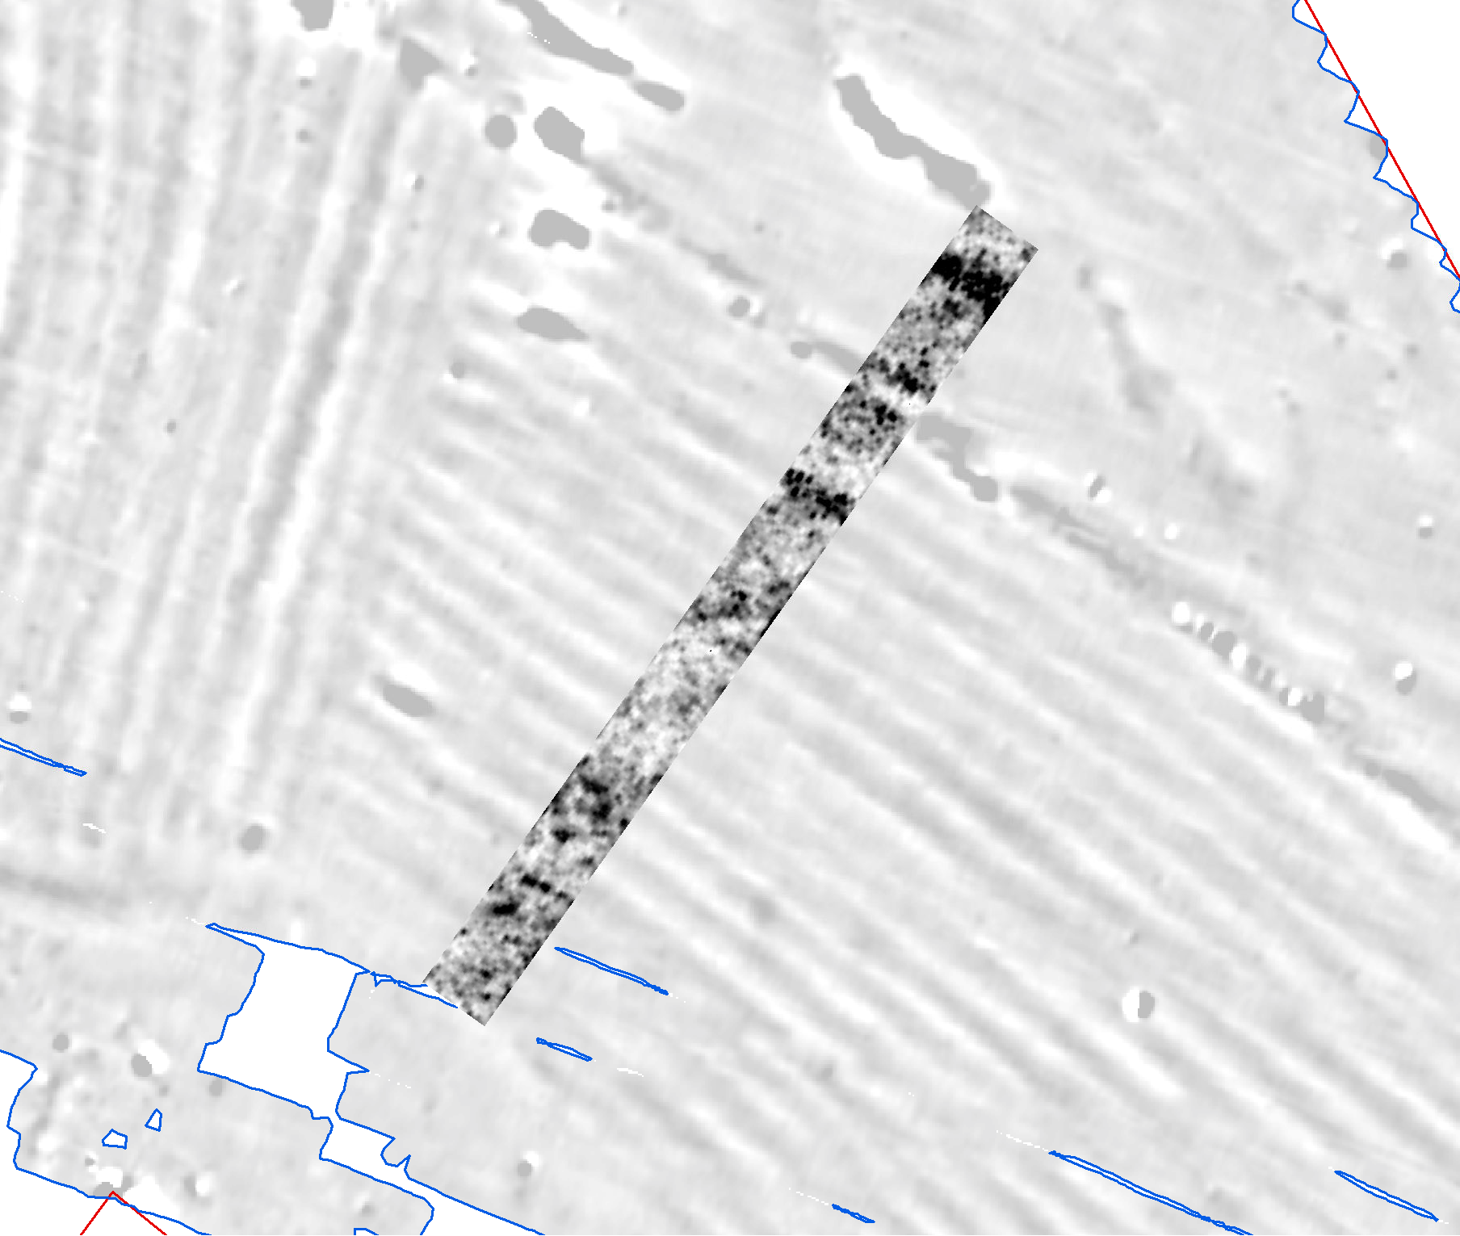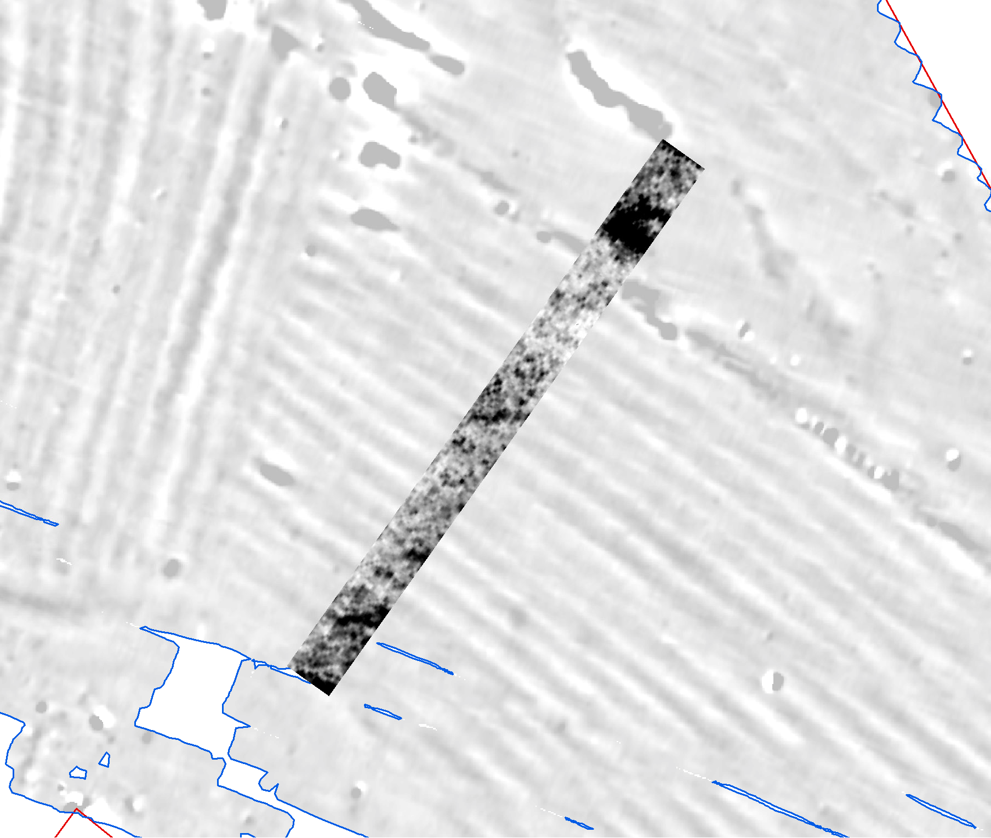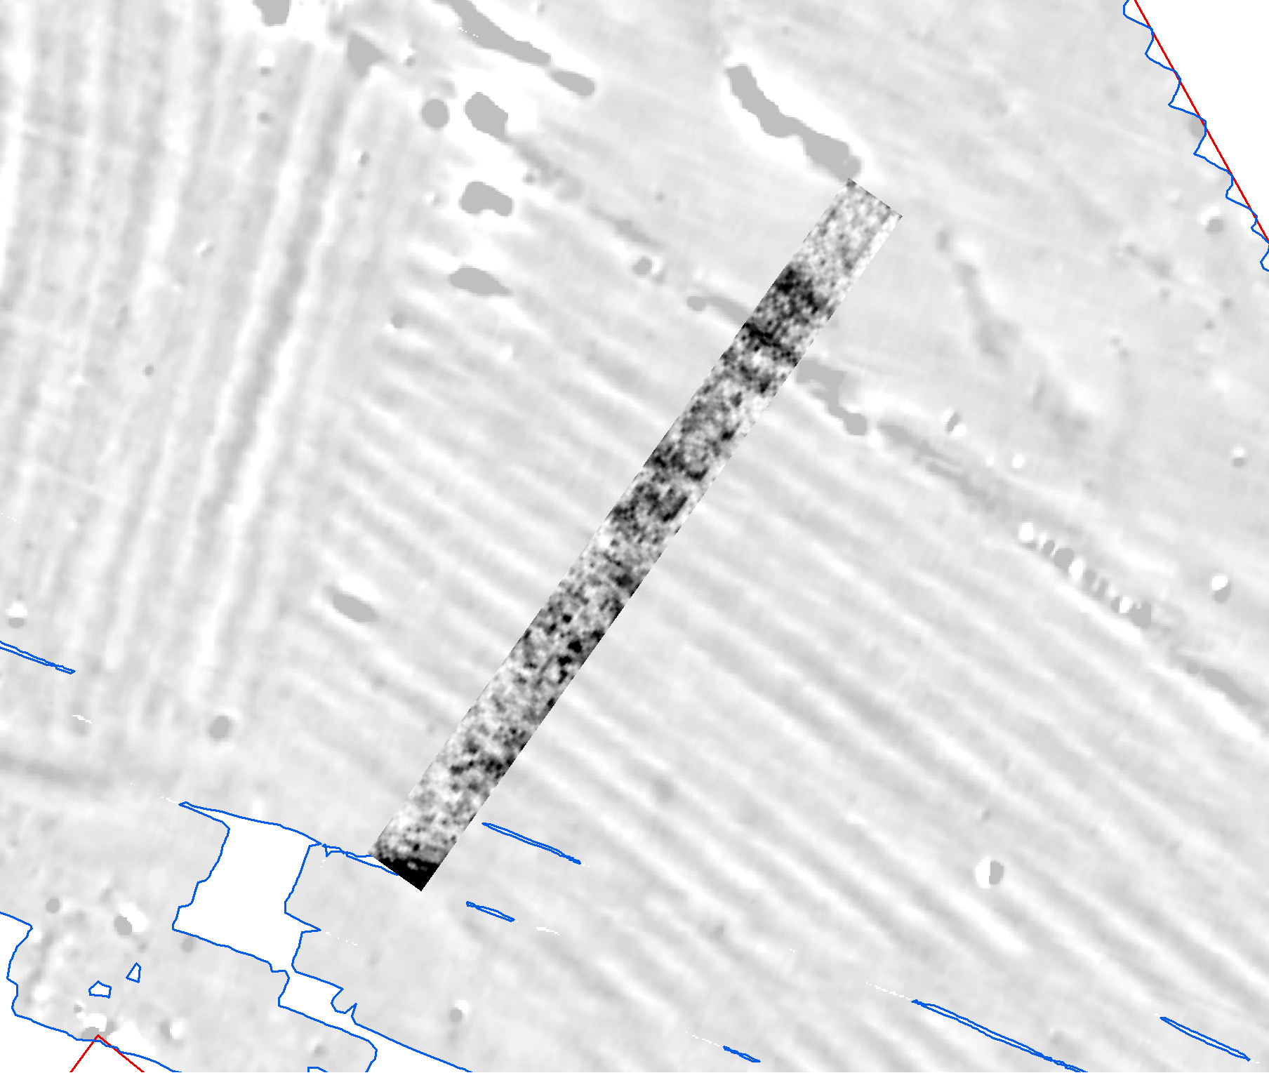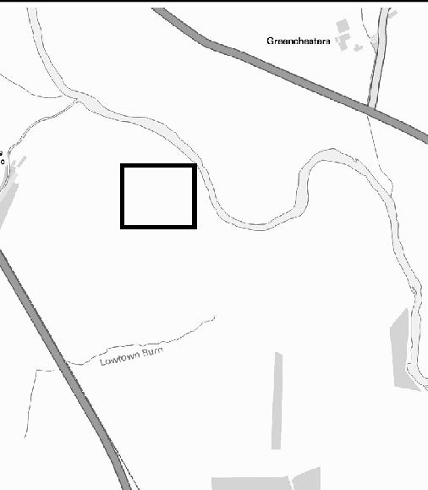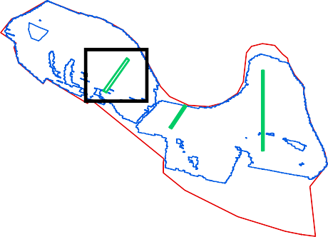

59370c0) Timeslice 11: 0.99 - 1.09 m (31.68 - 34.88 ns)
GPR survey results (Area C): Greyscale timeslices and represetative radargram

d) Representative radargram
Date: Revision Number:
Scale:
Illustrator:
Path:
17/11/2021
0
1:1,750 at A3 NLC
S:\PROJECTS\232820\GIS\
FigsMXD\Geophysics
Figure 15

59 593800
3800
386650
386600
386550
386650
386600
386550

5004
Area C

Area A

Area B

593750 593750

5937a0)0 Timeslice 2: 0.1 - 0.2 m (3.17 - 6.37 ns)
386650
386600
386550

593800

5937b00) Timeslice 7: 0.59 - 0.69 m (19.01 - 22.21 ns)

SW NE
Alluvium
Gradiometer Survey Extents Site boundary
GPR survey extents Drainage ditch Possible archaeology High amplitude Superficial geology Ridge and furrow Trend

Palaeochanne l

593750
Coordinate system:
OSGB36 (OSTN15/OSGM15)
Contains Ordnance Survey data © Crown copyright and database right 2021. This material is for client report only © Wessex Archaeology.
No unauthorised reproduction.

0 25 m

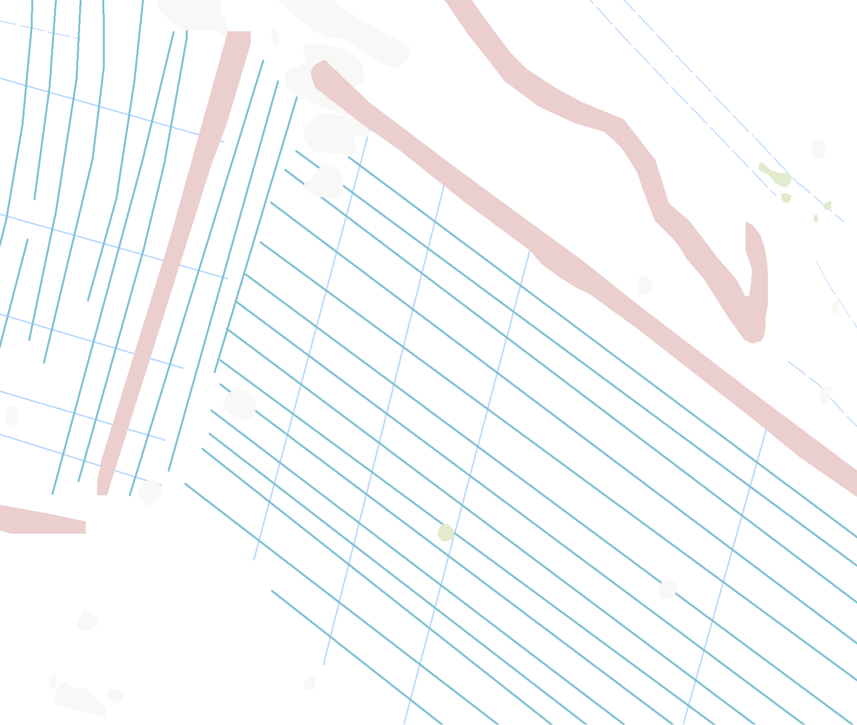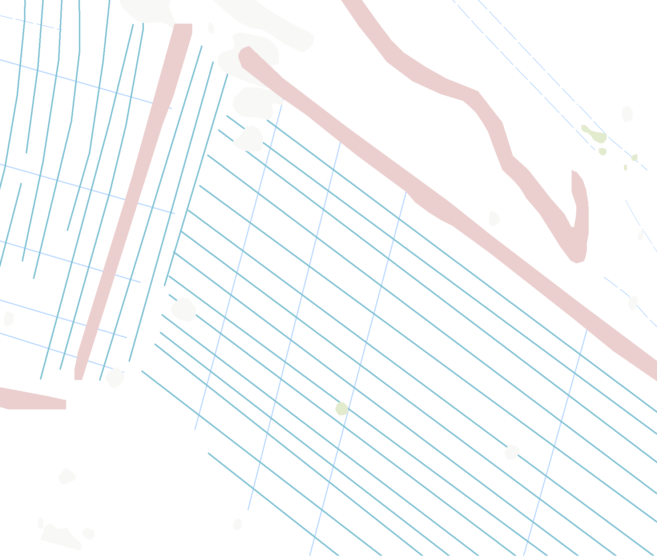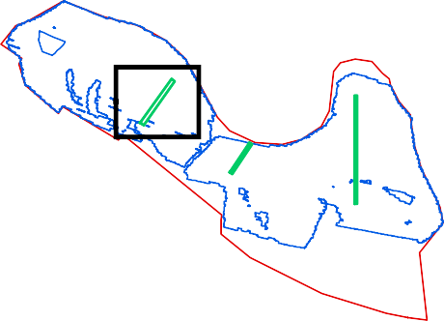

59370c0 ) Timeslice 11: 0.99 - 1.09 m (31.68 - 34.88 ns)
GPR survey results (Area C): Archaeological interpretation and annotated radargram

d) Representative radargram
Date: Revision Number:
Scale:
Illustrator:
Path:
21/12/2021
0
1:1,000 at A3 NLC
S:\PROJECTS\232820\GIS\
FigsMXD\Geophysics
Figure 16

593800
388100
388000
387900
387800
387700
387600

593700
Sword pommel
^

162

152
!<

!

153
!.

" 165
164

168
"

166

176

157
155
156 !<
154

2%

161
"!!163 "
#
!. 177

593600

158

jk!>

159

%2

"

170

160

"
$

174
"
169

175
'­
"
167

182

!
!.

178
"
!. 179
# 180

181

Metal detecting survey area
Battlefield
Metal Detecting Finds by Material and Type
^ Unknown, Sword pommel

# Cu, Weight/measure
G Cu, Strap end
" Cu, Object
S" Fe, Curved object
kj Fe, Farrier's file
!< Fe, Horseshoe

173
"

118

172
!<

119
171

121

"$ X "/
#
125

126
127
!
" 183

" 184
$ Ag, Buckle
X Cu, Brooch
$ Cu, Buckle
!. Cu, Button
! Cu, Coin
!> Fe, Nail
" Fe, Object
2% Pb, Spindle Whorl
G Pb, Strap
# Pb, Weight/measure

111
!< "
185
"
'­ Cu, Cooking Pot fragment
"/ Pb, Fragment
" Pb, Object

593500

110
!

114
!< "
116

115
117 120

122

!< G G

112
!<
123
"

"S !<
124

"S

129

Coordinate system:
OSGB36 (OSTN15/OSGM15)

Contains Ordnance Survey data © Crown copyright and database right 2021. This material is for client report only © Wessex Archaeology.
No unauthorised reproduction.

593400
128
"

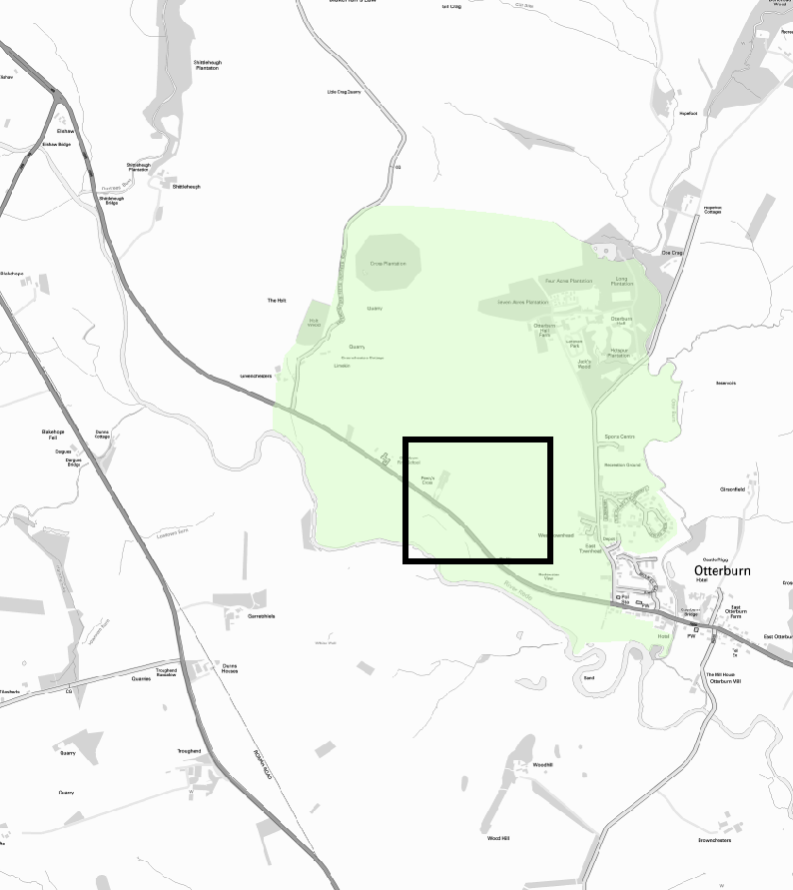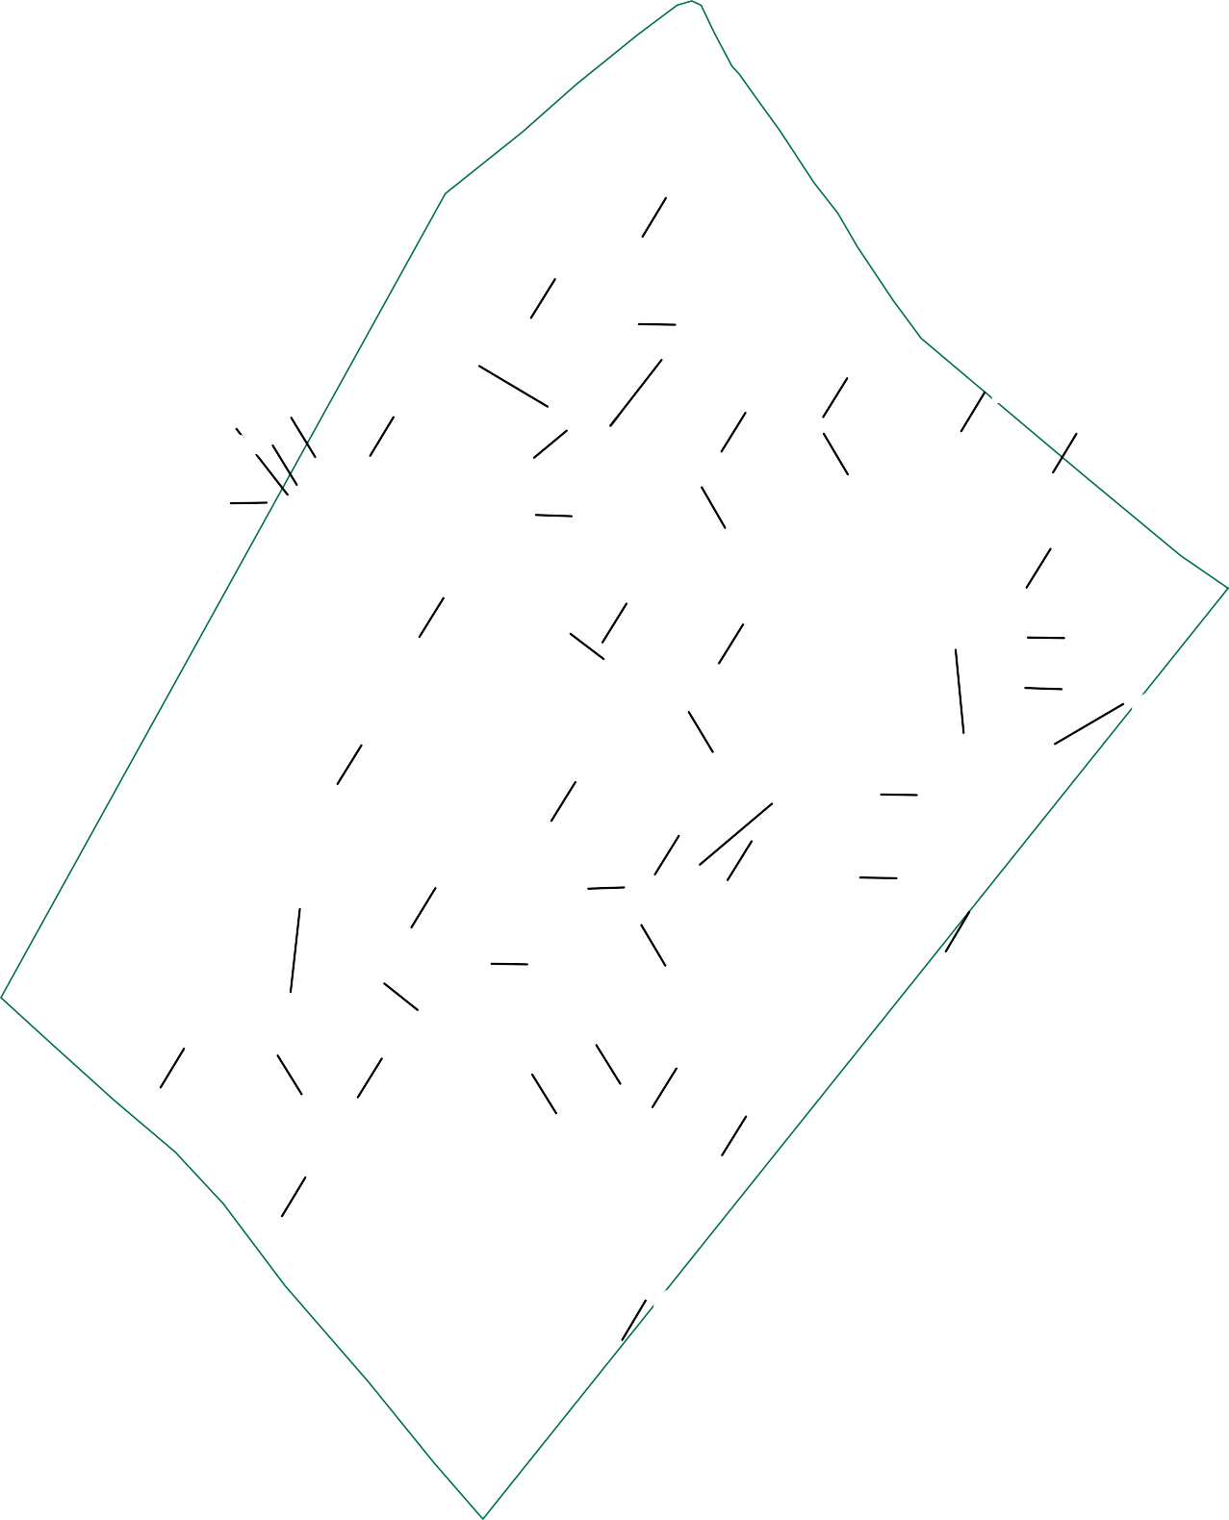

Finds distribution plot of Metal Detecting Survey
0 100 m
Date: Revision Number:
Scale:
Illustrator:
Path:
09/12/2021
0
1:1000 at A3 RJH
S:\PROJECTS\232820\GIS\
FigsMXD\Geophysics
Figure 17

APPENDICES

Appendix 1: Gradiometer Survey Equipment and Data Processing Survey methods and equipment
The magnetic data for this project were acquired using a Bartington 601-2 dual magnetic gradiometer system. This instrument has two sensor assemblies fixed horizontally 1 m apart allowing two traverses to be recorded simultaneously. Each sensor contains two fluxgate magnetometers arranged vertically with a 1 m separation and measures the difference between the vertical components of the total magnetic field within each sensor array. This arrangement of magnetometers suppresses any diurnal or low frequency effects.

The gradiometers have an effective resolution of 0.03 nT over a ±100 nT range, and measurements from each sensor are logged at intervals of 0.25 m. All data are stored on an integrated data logger for subsequent post-processing and analysis.

Wessex Archaeology undertakes two types of magnetic surveys: scanning and detail. Both types depend upon the establishment of an accurate 20 m or 30 m site grid, which is achieved using a Leica Viva RTK GNSS instrument and then extended using tapes. The Leica Viva system receives corrections from a network of reference stations operated by the Ordnance Survey and Leica Geosystems, allowing positions to be determined with a precision of 0.02 m in real-time and therefore exceed the level of accuracy recommended by European Archaeologiae Consilium (Schmidt et al. 2015) for geophysical surveys.

Scanning surveys consist of recording data at 0.25 m intervals along transects spaced 10 m apart, acquiring a minimum of 80 data points per transect. Due to the relatively coarse transect interval, scanning surveys should only be expected to detect extended regions of archaeological anomalies, when there is a greater likelihood of distinguishing such responses from the background magnetic field.

The detailed surveys consist of 20 m x 20 m or 30 m x 30 m grids, and data are collected at 0.25 m intervals along traverses spaced 1m apart. These strategies give 1600 or 3600 measurements per 20 m or 30 m grid respectively and are the recommended methodologies for archaeological surveys of this type (Schmidt et al. 2015).

Data may be collected with a higher sample density where complex archaeological anomalies are encountered, to aid the detection and characterisation of small and ephemeral features. Data may be collected at up to 0.125 m intervals along traverses spaced up to 0.25 m apart, resulting in a maximum of 28800 readings per 30 m grid, exceeding that recommended by European Archaeologiae Consilium recommendations (Schmidt et al. 2015) for characterisation surveys.

Post-processing

The magnetic data collected during the detail survey are downloaded from the Bartington system for processing and analysis using both commercial and in-house software. This software allows for both the data and the images to be processed in order to enhance the results for analysis; however, it should be noted that minimal data processing is conducted so as not to distort the anomalies.

As the scanning data are not as closely distributed as with detailed survey, they are georeferenced using the GPS information and interpolated to highlight similar anomalies in adjacent transects. Directional trends may be removed before interpolation to produce more easily understood images.

Typical data and image processing steps may include:
- Destripe – Applying a zero-mean traverse in order to remove differences caused by directional effects inherent in the magnetometer;

- Destagger – Shifting each traverse longitudinally by a number of readings. This corrects for operator errors and is used to enhance linear features;

- Despike – Filtering isolated data points that exceed the mean by a specified amount to reduce the appearance of dominant anomalous readings (generally only used for earth resistance data)

Typical displays of the data used during processing and analysis:
- Greyscale – Presents the data in plan view using a greyscale to indicate the relative strength of the signal at each measurement point. These plots can be produced in colour to highlight certain features but generally greyscale plots are used during analysis of the data.

- XY Plot – Presents the data as a trace or graph line for each traverse. Each traverse is displaced down the image to produce a stacked profile effect. This type of image is useful as it shows the full range of individual anomalies. XY plots can be made available upon request.

Appendix 2: GPR Survey Equipment and Data Processing Survey Methods and Equipment
The ground penetrating radar (GPR) data were collected using a cart mounted shielded antennae with central frequencies suitable for the types of target being investigated. Lower frequency antennae are able to acquire data from deeper below the surface, whereas higher frequencies allow high resolution imaging of near-surface targets at the expense of deep penetration. The exact make and model of equipment varies.

The depth of penetration of GPR systems is determined by the central frequency of the antenna and the relative dielectric permittivity (RDP) of the material through which the GPR signal passes. In general, soils in floodplain settings may have a wide range of RDPs, although around 8 may be considered average, resulting in a maximum depth of penetration c. 2.5m with the GPR signal having a velocity of approximately 0.1m/ns.

The GPR beam is conical in shape, however, and whilst most of the energy is concentrated in the centre of the cone, the GPR signal illuminates a horizontal footprint, which becomes wider with increasing depth. At the maximum depth of the antenna, it becomes impossible to resolve any feature smaller than the horizontal footprint for the corresponding depth. The size of the footprint is dependent upon central frequency, and its size increases as the central frequency decreases.

The vertical resolution is similarly dependent upon the central frequency; for the 300MHz antenna, features of the order of 0.05m may be resolved vertically. Antennae with lower frequencies can therefore penetrate more deeply but are less resolute in both horizontal and vertical directions. Choice of antenna frequency is guided largely by the anticipated depth to the target and the required resolution.

GPR data for detailed surveys are collected along traverses of varying length separated by 0.5m with cross lines collected running perpendicular to these traverses at wider separations. The data sampling resolution is governed by the data logger and a minimum separation of 0.05m between traces is collected for all surveys.

Post-Processing
The radar data collected during the detail survey are downloaded from the GPR system for processing and analysis using commercial software (GPR Slice). This software allows for both the data and the images to be processed in order to enhance the results for analysis; however, it should be noted that minimal data processing is conducted so as not to distort the anomalies.

Typical data and image processing steps may include:
  - Gain – Amplifies GPR data based upon its position in the profile, which boosts the contrast between anomalies and background. A wobble correction is also applied during this step;
  - Background Filter - is used to remove banding noises that are seen across the radargrams
  - Bandpass – Removes GPR data lying outside a specified range, which removes high- and low-frequency noise.

Typical displays of the data used during processing and analysis:
  - Timeslice – Presents the data as a series of successive plan views of the variation of reflector energy from the surface to the deepest recorded response. The variation in amplitude is represented using a greyscale with black indicating high amplitude and white indicating low amplitude responses.

  - Radargram – Presents each radar profile in a vertical view with distance along the profile expressed along the x axis and depth along the y axis. The amplitude variation is expressed using a greyscale.

Appendix 3: Geophysical Interpretation
The interpretation methodology used by Wessex Archaeology separates the anomalies into four main categories: archaeological, modern, agricultural, and uncertain origin/geological.

The archaeological category is used for features when the form, nature and pattern of the anomaly are indicative of archaeological material. Further sources of information such as aerial photographs may also have been incorporated in providing the final interpretation. This category is further sub- divided into three groups, implying a decreasing level of confidence:

- Archaeology – used when there is a clear geophysical response and anthropogenic pattern.

- Possible archaeology – used for features which give a response, but which form no discernible pattern or trend.

The modern category is used for anomalies that are presumed to be relatively modern in date:
- Ferrous – used for responses caused by ferrous material. These anomalies are likely to be of modern origin.

- Modern service – used for responses considered relating to cables and pipes; most are composed of ferrous/ceramic material although services made from non-magnetic material can sometimes be observed in gradiometer data. GPR is also known to be very effective at locating buried utilities and they are often identifiable within the radargrams as strong hyperbolic reflectors.

The agricultural category is used for the following:
- Former field boundaries – used for ditch sections that correspond to the position of boundaries marked on earlier mapping.

- Ridge and furrow – used for broad and diffuse linear anomalies that are considered to indicate areas of former ridge and furrow.

- Ploughing – used for well-defined narrow linear responses, usually aligned parallel to existing field boundaries.

- Drainage – used to define the course of ceramic field drains that are visible in the data as a series of repeating bipolar (black and white) responses. These can sometimes repeat or ‘ring’ through GPR datasets, particularly if there are ploughing furrows on the surface

The uncertain origin/geological category is used for features when the form, nature and pattern of the anomaly are not sufficient to warrant a classification as an archaeological feature. This category is further sub-divided into:

- Increased magnetic response – used for areas dominated by indistinct anomalies in gradiometer data, which may have some archaeological potential.

- Trend – used for low amplitude or indistinct linear anomalies.

- Superficial geology – used for diffuse edged spreads considered to relate to shallow geological deposits. They can be distinguished as areas of positive, negative, or broad bipolar (positive and negative) anomalies. These can be distinguished as areas of high and/or low amplitude response in GPR data, but are commonly amorphous in form.

In addition, for the interpretation of GPR datasets two additional categories are also employed:

  - High Amplitude – used for features which give a notably high amplitude response but display no discernible pattern.
  - Low Amplitude – used for features which give a notably low amplitude response but display no discernible pattern.

Appendix 4: Trench and test pit summaries
NGR coordinates and OD heights taken at centre of each trench; depth bgl = below ground level

Trench No 30 |  | Length 11.50 m |  |  | Width 1.10 m | Depth 0.30 m
Context  Number | Fill Of/Filled  With |  | Interpretative  Category | Description |  |  | Depth BGL
3001 |  |  | Topsoil | Turf and topsoil. Mid greyish brown  sandy silt with rooting and turf. |  |  | 0.0
3002 |  |  | Alluvium | Mid yellowish brown sandy silt with  very occasional charcoal. |  |  | 0.2
3003 | 3004 |  | Cut of linear ditch running NE  - SW | Ditch is cut into alluvium 3002 and filled with similar alluvial material.  Parallel to 3005 to SE |  |  | 0.45
3004 | 3003 |  | Secondary fill | Secondary ditch fill. Gradual buildup of material within ditch cut. Mid yellowish brown slightly sandy  silt, occasional charcoal. |  |  | 0.2
3005 | 3006 |  | Cut of linear ditch running NE  - SW | Ditch is cut into alluvium 3002 and  filled with similar alluvial material. Parallel to 3003 to NW |  |  | 0.4
3006 | 3005 |  | Secondary fill | Secondary ditch fill. Gradual buildup of material within ditch cut. Mid yellowish brown slightly sandy  silt, occasional charcoal. |  |  | 0.2

Site Code:  232820 |  | Site Name:  Battle of Otterburn |  | Test Pit ID:  1
Length:  2.50 m |  | Width:  1.10 m |  | Depth:  1.20 m
Context Number | Description |  | Interpretation |  | Depth m  BGL | Depth m  aOD | Samples
101 | Dark greyish yellowish brown sandy  silt with rooting and turf |  | Turf and  topsoil |  | 0-0.15
102 | Mid yellowish brown sandy silt with  very occasional charcoal flecks and degraded sandstone fragments |  | Alluvium |  | 0.15-  1.2
103 | Mottled mid yellow and pale yellow  sand with occasional iron panning |  | Natural  substrate |  | 1.2+

Site Code:  232820 |  | Site Name:  Battle of Otterburn |  | Test Pit ID:  2
Length:  2.50 m |  | Width:  1.10 m |  | Depth:  1.20 m
Context Number | Description |  | Interpretation |  | Depth m  BGL | Depth m  aOD | Samples
201 | Dark greyish yellowish brown sandy  silt with rooting and turf |  | Turf and  topsoil |  | 0-0.15

202 | Mid yellowish brown sandy silt with very occasional charcoal flecks and  degraded sandstone fragments | Alluvium | 0.15-  1.10
203 | Mottled mid yellow and pale yellow  sand with occasional iron panning | Natural  substrate | 1.10+

Site Code:  232820 |  | Site Name:  Battle of Otterburn |  | Test Pit ID:  3
Length:  2.50 m |  | Width:  1.10 m |  | Depth:  1.20 m
Context Number | Description |  | Interpretation |  | Depth  m BGL | Depth  m aOD | Samples
301 | Dark greyish yellowish brown sandy  silt with rooting and turf |  | Turf and  topsoil |  | 0-0.15
302 | Mid yellowish brown sandy silt with  very occasional charcoal flecks and degraded sandstone fragments |  | Alluvium |  | 0.15-  1.00
303 | Mottled mid yellow and pale yellow  sand with occasional iron panning |  | Natural  substrate |  | 1.00 +

Site Code:  232820 |  | Site Name:  Battle of Otterburn |  | Test Pit ID:  4
Length:  2.50 m |  | Width:  1.10 m |  | Depth:  1.20 m
Context Number | Description |  | Interpretation |  | Depth m  BGL | Depth m  aOD | Samples
401 | Dark greyish yellowish brown sandy  silt with rooting and turf |  | Turf and  topsoil |  | 0-0.15
402 | Mid yellowish brown sandy silt with  very occasional charcoal flecks and degraded sandstone fragments |  | Alluvium |  | 0.15-  1.10
403 | Soft mid brownish grey fine clay with occasional mottling. Appears  waterlain |  | Soft grey clay palaeochannel  fill |  | 1.10 +

Site Code:  232820 |  | Site Name:  Battle of Otterburn |  | Test Pit ID:  5
Length:  3 m |  | Width:  1.10 m |  | Depth:  1.20 m
Context Number | Description |  | Interpretation |  | Depth  m BGL | Depth  m aOD | Samples
501 | Dark greyish yellowish brown sandy  silt with rooting and turf |  | Turf and  topsoil |  | 0 - 0.2

502 | Mid yellowish brown sandy silt with very occasional charcoal flecks and  degraded sandstone fragments | Alluvium | 0.2 - 1
503 | Soft mid brownish grey fine clay with  occasional mottling. Appears waterlain | Fill of possible palaeochannel | 1 +

Site Code:  232820 |  | Site Name:  Battle of Otterburn |  | Test Pit ID:  6
Length:  3 m |  | Width:  1.10 m |  | Depth:  1.20 m
Context Number | Description |  | Interpretation |  | Depth m  BGL | Depth m  aOD | Samples
601 | Dark greyish yellowish brown sandy |  | Turf and |  | 0.0 -
 | silt with rooting and turf |  | topsoil |  | 0.2
602 | Mid yellowish brown sandy silt with |  | Alluvium |  | 0.2 -
 | very occasional charcoal flecks and |  |  |  | 01.0
 | degraded sandstone fragments
603 | Soft mid brownish grey fine clay with |  | Fill of |  | 1.0 -
 | occasional mottling. Appears |  | palaeochannel |  | 1.1
 | waterlain
604 | Band of gravel within palaeochannel |  | Gravel band |  | 1.1 -
 | fill, sub rounded with course sand |  |  |  | 1.2
 | and pea grit matrix. Appears natural

Site Code:  232820 |  | Site Name:  Battle of Otterburn |  | Test Pit ID:  7
Length:  3 m |  | Width:  1.10 m |  | Depth:  1.20 m
Context Number | Description |  | Interpretation |  | Depth m  BGL | Depth m  aOD | Samples
701 | Dark greyish yellowish brown sandy |  | Turf and |  | 0.0 -
 | silt with rooting and turf |  | topsoil |  | 0.25
702 | Mid yellowish brown sandy silt with |  | Alluvium |  | 0.25 -
 | very occasional charcoal flecks and |  |  |  | 1
 | degraded sandstone fragments.
 | More mottled with pale yellow sand
 | towards base
703 | Soft mid brownish grey fine clay with |  | Palaeochannel |  | 1.0 - |  | <102> 1
 | occasional mottling. Appears |  | fill |  | 1.2 |  | small bag
 | waterlain

Site Code:  232820 | Site Name:  Battle of Otterburn | Test Pit ID:  8
Length:  2.50 m | Width:  1.10 m | Depth:  1.20 m

Context Number | Description | Interpretation | Depth m  BGL | Depth m  aOD | Samples
801 | Dark greyish yellowish brown sandy | Turf and | 0.0 -
 | silt with rooting and turf | topsoil | 0.25
802 | Mid yellowish brown sandy silt with | Alluvium | 0.25 -
 | very occasional charcoal flecks and |  | 1.1
 | degraded sandstone fragments
803 | Soft mid brownish grey fine clay with | Palaeochannel | 1.1 -
 | occasional mottling. Appears | fill | 1.2+
 | waterlain

Site Code:  232820 |  | Site Name:  Battle of Otterburn |  | Test Pit ID:  9
Length:  2.50 m |  | Width:  1.10 m |  | Depth:  0.90 m
Context Number | Description |  | Interpretation |  | Depth m  BGL | Depth m  aOD | Samples
901 | Dark greyish yellowish brown sandy  silt with rooting and turf |  | Turf and  topsoil |  | 0 -  0.25
902 | Mid yellowish brown sandy silt with very occasional charcoal flecks and degraded sandstone fragments.  More compact than pits to north |  | Older alluvium and natural mix |  | 0.25 -  0.7
903 | Mottled mid yellow and pale yellow  sand with occasional iron panning |  | Natural  substrate |  | 0.7 +

Site Code:  232820 |  | Site Name:  Battle of Otterburn |  | Test Pit ID:  10
Length:  2 m |  | Width:  1.10 m |  | Depth:  0.80 m
Context Number | Description |  | Interpretation |  | Depth m  BGL | Depth m  aOD | Samples
1001 | Dark greyish yellowish brown sandy  silt with rooting and turf |  | Turf and  topsoil |  | 0 -  0.25
1002 | Mid yellowish brown sandy silt with very occasional charcoal flecks and degraded sandstone fragments.  More compact than pits to north |  | Harder alluvium and natural |  | 0.25 -  0.6
1003 | Mottled mid yellow and pale yellow  sand and gravel with occasional iron panning |  | Natural substrate |  | 0.6 +

Site Code:  232820 | Site Name:  Battle of Otterburn | Test Pit ID:  11
Length:  1.50 m | Width:  1.10 m | Depth:  0.40 m

Context Number | Description | Interpretation | Depth m  BGL | Depth m  aOD | Samples
1101 | Dark greyish yellowish brown sandy  silt with rooting and turf | Turf and  topsoil | 0 -  0.25
1102 | Mid yellowish brown sandy silt with very occasional charcoal flecks and degraded sandstone fragments.  More compact than in pits 1-8 to  north | Alluvium | 0.25 -  0.4
1103 | Mottled mid yellow and pale yellow sand and gravel with occasional iron  panning | Natural substrate | 0.4+

Site Code:  232820 |  | Site Name:  Battle of Otterburn |  | Test Pit ID:  12
Length:  1.50 m |  | Width:  1.10 m |  | Depth:  0.30 m
Context Number | Description |  | Interpretation |  | Depth  m BGL | Depth  m aOD | Samples
1201 | Dark greyish yellowish brown sandy  silt with rooting and turf |  | Turf and  topsoil |  | 0 -  0.25
1202 | Mottled mid yellow and pale yellow sand and gravel with occasional iron  panning |  | Natural substrate |  | 0.25 +

Site Code:  232820 |  | Site Name:  Battle of Otterburn |  | Test Pit ID:  13
Length:  3 m |  | Width:  1.10 m |  | Depth:  0.55 m
Context Number | Description |  | Interpretation |  | Depth  m BGL | Depth  m aOD | Samples
1301 | Dark greyish yellowish brown sandy  silt with rooting and turf |  | Turf and  topsoil |  | 0 - 0.2
1302 | Mid yellowish brown sandy silt with  very occasional charcoal flecks |  | Alluvium |  | 0.2 -  0.55
1303 | Mottled mid yellow/greyish brown  and pale yellow sands and gravels |  | Natural gravel  and sand |  | 0.55 +

Site Code:  232820 |  | Site Name:  Battle of Otterburn |  | Test Pit ID:  14
Length:  2.50 m |  | Width:  1.10 m |  | Depth:  0.55 m
Context Number | Description |  | Interpretation |  | Depth m  BGL | Depth m  aOD | Samples

1401 | Dark greyish yellowish brown sandy  silt with rooting and turf | Turf and  topsoil | 0 -  0.25
1402 | Mid yellowish brown sandy silt with  very occasional charcoal flecks | Alluvium | 0.25 -  0.55
1403 | Mottled mid yellow/greyish brown  and pale yellow sands and gravels | Natural sand  and gravel | 0.55 +

Site Code:  232820 |  | Site Name:  Battle of Otterburn |  | Test Pit ID:  15
Length:  2 m |  | Width:  1.10 m |  | Depth:  0.60 m
Context Number | Description |  | Interpretation |  | Depth  m BGL | Depth  m aOD | Samples
1501 | Dark greyish yellowish brown sandy  silt with rooting and turf |  | Turf and  topsoil |  | 0 -  0.25
1502 | Mid yellowish brown sandy silt with  very occasional charcoal flecks |  | Alluvium |  | 0.25 -  0.6
1503 | Mottled mid yellow/greyish brown  and pale yellow sands and gravels |  | Natural sand  and gravel |  | 0.6 +

Site Code:  232820 |  | Site Name:  Battle of Otterburn |  | Test Pit ID:  16
Length:  2.50 m |  | Width:  1.10 m |  | Depth:  0.90 m
Context Number | Description |  | Interpretation |  | Depth  m BGL | Depth  m aOD | Samples
1601 | Dark greyish yellowish brown sandy  silt with rooting and turf |  | Turf and  topsoil |  | 0 -  0.25
1602 | Mid yellowish brown sandy silt with  very occasional charcoal flecks |  | Alluvium |  | 0.25 -  0.6
1603 | Mottled mid yellow/greyish brown  and pale yellow sands and gravels |  | Mixed sands  and gravels |  | 0.6 +

Site Code:  232820 |  | Site Name:  Battle of Otterburn |  | Test Pit ID:  17
Length:  2.50 m |  | Width:  1.10 m |  | Depth:  0.85 m
Context Number | Description |  | Interpretation |  | Depth  m BGL | Depth  m aOD | Samples
1701 | Dark greyish yellowish brown sandy  silt with rooting and turf |  | Turf and  topsoil |  | 0 -  0.25
1702 | Mid yellowish brown sandy silt with  very occasional charcoal flecks |  | Alluvium |  | 0.25 -  0.85
1703 | Mottled mid yellow/greyish brown  and pale yellow sands and gravels |  | Natural sands  and gravels |  | 0.85 +

Site Code:  232820 |  | Site Name:  Battle of Otterburn |  | Test Pit ID:  18
Length:  2 m |  | Width:  1.10 m |  | Depth:  0.75 m
Context Number | Description |  | Interpretation |  | Depth  m BGL | Depth  m aOD | Samples
1801 | Dark greyish yellowish brown sandy  silt with rooting and turf |  | Turf and  topsoil |  | 0 - 0.3
1802 | Mid yellowish brown sandy silt with  very occasional charcoal flecks |  | Alluvium and  sand mix |  | 0.3 -  0.75
1803 | Mottled mid yellow/greyish brown  and pale yellow sands and gravels |  | Natural sands  and gravels |  | 0.75 +

Site Code:  232820 |  | Site Name:  Battle of Otterburn |  | Test Pit ID:  19
Length:  2.50 m |  | Width:  1.10 m |  | Depth:  0.55 m
Context Number | Description |  | Interpretation |  | Depth  m BGL | Depth  m aOD | Samples
1901 | Dark greyish yellowish brown sandy  silt with rooting and turf |  | Turf and  topsoil |  | 0 -  0.25
1902 | Mid yellowish brown sandy silt with  very occasional charcoal flecks |  | Alluvium |  | 0.25 -  0.55
1903 | Mottled mid yellow/greyish brown  and pale yellow sands and gravels |  | Natural sands  and gravels |  | 0.55 +

Site Code:  232820 |  | Site Name:  Battle of Otterburn |  | Test Pit ID:  20
Length:  2.50 m |  | Width:  1.10 m |  | Depth:  0.70 m
Context Number | Description |  | Interpretation |  | Depth  m BGL | Depth  m aOD | Samples
2001 | Dark greyish yellowish brown sandy  silt with rooting and turf |  | Turf and  topsoil |  | 0 -  0.25
2002 | Mid yellowish brown sandy silt with  very occasional charcoal flecks |  | Alluvium |  | 0.25 -  0.7
2003 | Mottled mid yellow/greyish brown  and pale yellow sands and gravels |  | Natural sands  and gravels |  | 0.7 +

Site Code:  232820 |  | Site Name:  Battle of Otterburn |  | Test Pit ID:  21
Length:  2.50 m |  | Width:  1.10 m |  | Depth:
Context Number | Description |  | Interpretation |  | Depth  m BGL | Depth  m aOD | Samples
2101 | Dark greyish yellowish brown sandy  silt with rooting and turf |  | Turf and  topsoil |  | 0 -  0.25
2102 | Mid yellowish brown sandy silt with  very occasional charcoal flecks |  | Alluvium |  | 0.25 -  0.5
2103 | Banded mid yellowish brown sandy silt and mid brownish yellow sand |  | Mixed alluvial and sand deposit- multiple flooding  deposits? |  | 0.5 - 1
2104 | Mid greyish brown silty clay with  occasional charcoal flecks |  | Palaeochannel  fill |  | 1+

Site Code:  232820 |  | Site Name:  Battle of Otterburn |  | Test Pit ID:  22
Length:  2.50 m |  | Width:  1.10 m |  | Depth:  1.20 m
Context Number | Description |  | Interpretation |  | Depth m  BGL | Depth m  aOD | Samples
2201 | Dark greyish yellowish brown sandy  silt with rooting and turf |  | Turf and  topsoil |  | 0 -  0.25
2202 | Mid yellowish brown sandy silt with  very occasional charcoal flecks |  | Alluvium |  | 0.25 -  0.5
2203 | Banded mid yellowish brown sandy silt and mid brownish yellow sand |  | Mixed alluvial and sand deposit- multiple flooding  deposits? |  | 0.5 -  0.9
2204 | Mid greyish brown silty clay with  occasional charcoal flecks |  | Palaeochannel  fill |  | 0.9 +

Site Code:  232820 |  | Site Name:  Battle of Otterburn |  | Test Pit ID:  23
Length:  2.50 m |  | Width:  1.10 m |  | Depth:  0.80 m
Context Number | Description |  | Interpretation |  | Depth  m BGL | Depth  m aOD | Samples
2301 | Dark greyish yellowish brown sandy  silt with rooting and turf |  | Turf and  topsoil |  | 0 -  0.15
2302 | Mid yellowish brown sandy silt with  very occasional charcoal flecks |  | Alluvium |  | 0.15 -  0.4
2303 | Banded mid yellowish brown sandy silt and mid brownish yellow sand |  | Alluvium and  sand mix- flood deposit? |  | 0.4 -  0.65
2304 | Mid greyish brown silty clay with  occasional charcoal flecks |  | Palaeochannel  fill |  | 0.65 + |  | <101> 20  litres

Site Code:  232820 |  | Site Name:  Battle of Otterburn |  | Test Pit ID:  24
Length:  2.50 m |  | Width:  1.10 m |  | Depth:  1.20 m
Context Number | Description |  | Interpretation |  | Depth  m BGL | Depth  m aOD | Samples
2401 |  |  | Turf and  topsoil |  | 0 -  0.25
2402 | Mid yellowish brown sandy silt with  very occasional charcoal flecks |  | Alluvium |  | 0.25 -  0.4
2403 | Banded mid yellowish brown sandy silt and mid brownish yellow sand |  | Alluvium and sand mix-  flood deposit? |  | 0.4 - 1
2404 | Mid grey and mid brown mottled silty  clay |  | Palaeochannel  fill |  | 1.00 +

Site Code:  232820 |  | Site Name:  Battle of Otterburn |  | Test Pit ID:  25
Length:  2.50 m |  | Width:  1.10 m |  | Depth:  1.20 m
Context Number | Description |  | Interpretation |  | Depth m  BGL | Depth m  aOD | Samples
2501 | Dark greyish yellowish brown sandy  silt with rooting and turf |  | Turf and  topsoil |  | 0 -  0.15
2502 | Mid yellowish brown sandy silt with  very occasional charcoal flecks |  | Alluvium |  | 0.15 -  0.4
2503 | Banded mid yellowish brown sandy silt and mid brownish yellow sand |  | Sand and  alluvium mixture |  | 0.4 -  0.8
2504 | Mid greyish brown silty clay with  occasional charcoal flecks |  | Palaeochannel  fill |  | 0.8 +

Site Code:  232820 |  | Site Name:  Battle of Otterburn |  | Test Pit ID:  26
Length:  2.50 m |  | Width:  1.10 m |  | Depth:  0.60 m
Context Number | Description |  | Interpretation |  | Depth  m BGL | Depth  m aOD | Samples
2601 | Dark greyish yellowish brown sandy  silt with rooting and turf |  | Turf and  topsoil |  | 0 -  0.15
2602 | Mid yellowish brown sandy silt with  very occasional charcoal flecks |  | Alluvium |  | 0.15 -  0.4
2603 | Mottled mid yellow/greyish brown  and pale yellow sands and gravels |  | Natural sands  and gravels |  | 0.4 +


Battle of Otterburn, Otterburn, Northumberland Detailed Gradiometer Survey Report

Appendix 5: Assessment of the environmental evidence
Table 4: Assessment of the environmental evidence

Test Pit | Feature Type | Context | Sample Code | Sample vol. (l) | Flot vol. (ml) | Bioturbation proxies | Charcoal  >2mm (ml) | Charcoal | Waterlogged vegetative parts | Waterlogged plant remains | Invertebrates | Preservation | Other
7 | Palaeochannel | 703 | 232820  _102 | 0.1 | 100 | n/a | - | - | A** (woody frags.), Alnus glutinosa twigs and stemwood/  branchwood + bark | Carex sp. seed C | Daphnia ephippia A, caddis fly (Trichoptera) larval cases A, beetles C | Good | -
23 | Palaeochannel | 2304 | 232820  _101 | 15 | 20 | 5%, B | Trace | Calluna vulgaris tp. stems A*,  Fraxinus excelsior | - | - | - | Mixed | Coal A*,  clinker/cinder A*, fragmented
Scale of abundance: C = <5, B = 5–10, A = 10–30, A* = 30–100, A** = 100–500, A*** = >500; Bioturbation proxies: Roots (%), Uncharred seeds (scale of abundance)

Battle of Otterburn, Otterbur
Detailed Gradiom

Appendix 6: Oasis record

Otterburn – John Sadler’s Account of the Battle

Act4

Death on St Oswin's Eve

The Battle of Otterburn, 5 (or 19) August 1388

The old song of 'Chevy-Chase' is the favourite ballad of the common people of England, and Ben Jonson used to say he had rather have been the author of it than of all his works. Sir Philip Sidney, in his discourse of Poetry [ The Defence of Poesie], speaks of it in the following words: 'I never heard the old song of Percy and Douglas that I found not my heart more moved than with a trumpet; and yet it is sung by some blind crowder with no rougher voice than rude style, which being so evil apparelled in the dust and cobweb of that uncivil age, what would it work trimmed in the gorgeous eloquence of Pindar?' For my own part, I am so professed an admirer of this antiquated song, that I shall give my reader a critique upon it without any further apology for so doing.
-Joseph Addison¹

The Ballad of Chevy Chase (see Appendix 1) and the Battle of Otterburn, far more so than his other fights, were what really gave his legend its first major boost. Losing doesn't necessarily damage your mythic status, but a big part of the Hotspur saga rests on this minor and otherwise unimportant fight. What is it about Otterburn? Thanks to Froissart and poetic tradition, the battle has become synonymous with chivalry, Douglas dies a hero's death, most definitely Kalas thanatos; Leonidas couldn't have done it better and Hotspur, as even his enemies acknowledged, fought like Hector. To lose the fight in such circumstances was no disgrace, half of history's enduring legends champion the losers - Thermopylae, Watling Street, Hastings, Roncesvalles and all the way to the Alamo and Gloucester Hill.

On a rather wild and windy day in August 1988 and on the actual site (depending on whose account you believe), I was part of a team who'd organised a 600th anniversary re-enactment of the Battle of Otterburn. No high summer heat for us. To add spice, and highly likely real bloodshed, the MoD had furnished the day with a company each of English and Scottish junior leaders, trainee NCOs with a cadre of instructors. Thank goodness the weapons were wooden, as the Scots took the whole business very seriously and if anyone doubted they'd won first time around, now it would be definite. It wasn't any wild melee but well­ drilled and coordinated fury, with proper NCOs bellowing themselves hoarse and urging their charges on to closer drill and even more focused blood lust. In both they succeeded admirably and we actual reenactors in proper harness with nearly real weapons were glad of our armour.

Ground
One day somebody will write a definitive account of the battle and much good work is being done, at the time of writing, by the Northumberland National Park Authority, Revitalising Redesdale, and the UK Battlefield Trust.² Otterburn field poses several problems which historians have struggled with and generally failed to resolve. Our main primary source is Jean Froissart, one of our main authorities for the 'chivalric revival' of the fourteenth century and he did travel widely across both England and Scotland. That said, he's a dreadful gossip and serial name dropper. Nonetheless, Hotspur owes him a good deal even if a lot of it is spin.

Of Otterburn Froissart says: 'Of all the battles and encounterings that I have made mention of heretofore in all this history, great or small, this battle that I treat of now was one of the sorest and best foughten without cowardice or faint hearts'.³ Yet the various descriptions are often sketchy and regularly contradict each other. These will be investigated thoroughly and conclusions offered. At first glance the ground appears straightforward though at least one credible writer, Charles Wesencraft, believes the battle was fought not at Otterburn but Elsdon and that the error is due to Froissart's confusion and cavalier approach to detail.⁴ In terms of modern sources, Andrew Boardman and Pete Armstrong are broadly in agreement with the views presented here.⁵ What can be added is an attempt to reconcile several of the anomalies in a way which may make sense.

George Ridpath, a comprehensive and redoubtable early complier (1787), gives extraordinarily little detail and relies on Percy's Reliques.6 He affirms the fighting began at evening, continued under moonlight and lists casualties on both sides. Irritatingly, he says nothing about ground.⁷ White (1857) gives a far fuller account of the terrain. He describes the Scottish force as passing the 'tower' (Otterburn Castle, now the Towers Hotel), and taking up position on 'the eminence north-west of Hott-Wood above Greenchesters - this forms a kind of promontory, jutting out to the south-west from the high land behind'. He goes on to suggest that 'Hott' comes from 'Holt' indicating that the rise was previously wooded.

There is no compelling reason to argue with this and the 1:25,000 OS Map clearly supports White - the high ground is called the Holt still and Greenchesters Camp crowns the crest. He gives the distance from the Tower as a 1½ miles
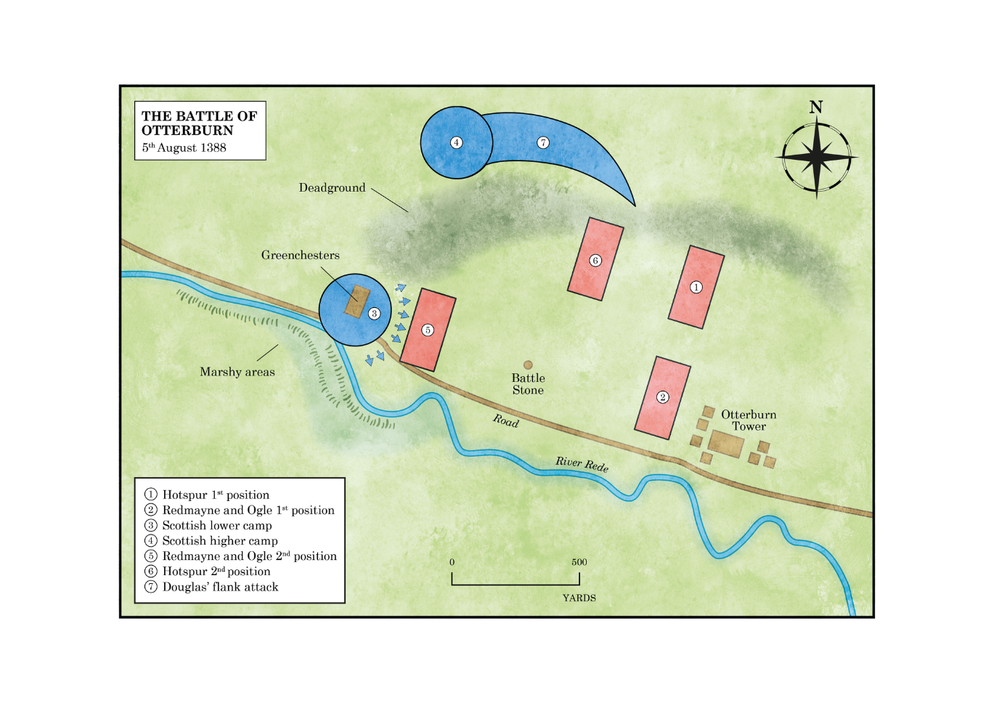

(2.4km) and this is also correct. He goes on to say the Scots made camp here on this commanding rise which gave them the necessary 'long view' to warn of any approach by English forces. Based on Inherent Military Probability (IMP) this makes sound sense.⁹ The Scots wouldn't establish their main position on the low-lying, wet ground directly below them towards the Rede. They would see that as a natural trap if they were attacked (as indeed it became for those stuck there). White does confirm that pilfered beasts with the bouches inutiles ('useless mouths') were sent into the wet bottom.

White also argues that the vicinity was dotted with scrubby trees and bushes, birch, alder, and hazel. This seems not unreasonable given botanical evidence from nearby Chattlehope Spout which he alludes to. He gives the date of the battle as 19 August and goes on to state that having failed in their efforts against the Tower the Scots dug in, throwing up earthworks on the north flank of the higher camp (this is unlikely as the ditches belong to the Iron Age site) and creating field defences, abbatis, to secure the lower enclosure, which is much more likely. White then goes on to assert that the Scots would have had few if any wheeled carts, relying instead on their hardy ponies, 'hobbyies' - this ties in with established principles of hobiler warfare, avoiding slow-moving baggage trains and using lances to prod recalcitrant beasts. Cattle were valuable booty, the profit element, and this was important.

White does suggest that this minor or lower camp extended across both sides of the Newcastle road, from where Greenchesters farm now stands down to the river.¹¹² Again, this conforms to Inherent Military Probability, no commander would want to leave a handy gap through which an enemy might infiltrate and turn his flank. He makes the point that the 'servants' would be hardy skirmishers, able to hold their ground at least for a while against men-at-arms until they could be reinforced. This turned out to be wrong, but the principle was sound.

Next, White covers the English approach to contact, coming over from Elsdon, swinging down past Davyshiels to reach Otterburn. He gives a highly accurate estimation of the view from the Scottish camp on the Holt and he's confident both sides fought on foot. However, he's also adamant that Hotspur told off a detachment led by Umfraville and Redmayne to skirt around the north flank to cut off any line of retreat.¹² The main body would then barrel along the road to attack the Scottish camp
.
Owing to the existing scrub and woodland, together with fading light, White suggests it would be unlikely that Hotspur had seen Greenchesters but had assumed the Scots were all encamped on the lower ground. Clearly, he was determined to attack and hadn't spent time in reconnaissance. Then, he has Percy attacking the camp defended by the auxiliaries. ¹³ For a while the defenders, protected by their improvised field works, hold out as Douglas feeds in infantry support to bolster the line. Meanwhile, the Scottish earl leads his main strike force north­ east, making full use of the contours and masking woods to deliver his own flank manoeuvre.

White credits Umfraville with a rather tortuous route, effectively passing Douglas by moving further north and attacking the newly dug entrenchments. Realising he's missed the bus, he abandons scrapping with those few reservists guarding the main Scottish camp and attempts to re-join the fight below but ends up colliding with the right flank of Percy's Brigade, just adding to the confusion. This account, as detailed as it is and correct in its analysis of ground, has influenced many if not most who've written about the battle since (including the author in my publication Battle for Northumbria (Newcastle upon Tyne, Bridge Studios, 1988)). Ramsay (1892) places the whole battle 1½ miles (2.4km) east of the (now) agreed site: Burne, Boardman, Armstrong, and I all disagree with this.

Bates (1895) gives a fairly sketchy account, describes the Scottish camp as surrounded by marshes with an entrance facing east along the line of the Newcastle road; armed camp followers form a first line of defence. He says nothing about any English flanking attack.15 Sitwell (1925) just says: 'The Scots made themselves bowers of trees and branches in a strong position surrounded by marshes, the entrance towards Newcastle was occupied by varlets & foragers ... the cattle could graze between the two camps'.¹⁶ Sitwell, who'd been a serving soldier, maintains the English battered their way into the camp which exposed them even more to Douglas' flank assault. He has Redmayne running from the fight pursued and captured by Lindsay, who is himself taken by the Prince Bishop.¹⁷
Redoubtable Colonel A.H. Burne (1952) was the first since White to have a serious look.¹⁸ He points out that the present road, the turnpike (A696) follows the line of the old medieval way. He rightly points out that the Scots defensive position covers the 'pass' between the river and rising ground north. He identifies two key problems: 1. Location of the Scottish camp; and 2. Flank marches by both armies. Burne argues that the English flank attack struck out northwards from the right of Hotspur's army in a wide flanking movement which today would take Umfraville past Otterburn Hall as far as Hopefoot (the way they'd just come), westwards, skirting Blakeman's Law to attack along a north-south axis, hitting the north flank of the higher camp. Burne projects the line of Douglas' own flank attack as an inside track, west to east around Greenchesters, parallel with Otterburn Hall.
The colonel had walked the ground and is confident Douglas was able to strike, initially undetected, against the right flank of Hotspur's main brigade at a point close to the current marker. Burne admits he struggled to work out what then happened to Umfraville, or how these two flanking manoeuvres failed to collide.¹⁹ He rejects any notion that Umfraville attacked on the left and not on the right - he feels the river prevents this.
This is a touch of deus ex machine and might be suspected that Burne was adapting the possibilities to suit his own hypothesis. He rejects Greenchesters as any site for a second camp on the basis it's too ancient, but this is not a reasonable hypothesis. It is difficult to disagree with so respected an authority, but Burne's vision is wrong. The idea of two large bodies of armoured men passing each other without noticing, even allowing for poor light and scrub/tree cover just doesn't add up. If Umfraville had to march back up the Davyshiels Road then strike out cross country, that's over 3 miles (4.8km) in distance. Yet, if he'd tried a tighter angle, he'd have smacked into Douglas.

Macdonald (2000) specifies the date as 5 August and he says that Percy sent Redmayne and Ogle off on a flanking manoeuvre but omits to specify which flank, the implication being this was a northwards move and the camp they attacked being that at Greenchesters.²⁰ He airily dismisses the idea of night fighting. He does credit Redmayne and Ogle with 'success on another part of the field' and of capturing Lindsay. This really doesn't add much. Nor does Moffatt's account (2002) which contains a rather bare and vague summary.
Boardman considers the battle in considerable detail and carefully analyses both ground and sources; he gives the date as 19 August. He points out that the area generally agreed upon was known on early maps as Battle Riggs. ²¹ He further observes that the line of the river is an important constraint and narrows the area available to the combatants. Now he says, quite rightly, that Froissart asserts the castle 'stood in the marsh'.²² This is a different marsh to that at Greenchesters or, more likely at the time, a continuous belt of low-lying alluvial bog. Boardman asserts, and Colonel Burne would have approved, that it was this very marsh which had partly frustrated Douglas' attempts to take the Tower which is after all built close to the confluence of the Otter Burn and Rede and none of this can be criticised. He confidently accepts the idea of two Scottish encampments one on higher, another on lower and that the defence of one could be supported by reserves from the other.

Boardman cites Oman and his analysis of Scottish fourteenth-century tactics, based on 'King Robert's Testament'.²³ This is important because it strongly implies, as the accounts seem to support, that the Scots were not relying just on defence. This was a clever diversion to pin the English while Douglas circled their flank. Boardman is adamant that Redmayne and Ogle attacked the lower camp by the river. He goes on to suggest that light from cooking fires would have alerted Hotspur to the reality of two enemy camps and he intended to strike at the upper base with the bulk of his forces, having divined that the lower camp was not his prime target.²⁴
Boardman is confident (and the author concurs) that Redmayne's success outpaced Hotspur's own advance. Bearing in mind the scrubby, wooded nature of the ground and failing light, this is understandable ('time spent in reconnaissance is never wasted'). He didn't know, could not see, exactly where the main camp stood. Despite being taken by surprise, Douglas' men formed up, as they'd been schooled to do and carried out their own flanking tactics, knowing exactly the ground over which they'd advance. He does say Redmayne's force remained mounted, but this unlikely. He dismisses the idea of a separate flanking move to the north led by Umfraville, which seems correct.

The author's previous account in Border Fury (Cambridge, Pearsons, 2004) is broadly consistent with Boardman, except it being more likely that Redmayne's Brigade attacked dismounted; wet ground and field obstacles would have frustrated any attempt at a mounted charge. Whether, having beaten up the camp, the English on this flank mounted up for the pursuit could, however, be a strong possibility. Armstrong (2006) takes a similar line.

If you approach Elsdon from the south along the straight-as-a-die road past Harwood, coming up from Cambo, you reach the high ground of Steng's Cross, the tarmac then winding and curving down towards the settlement. Directly in front you, angular and uncompromising against a grey winter's sky, is the sinister shape of the gibbet. This significantly postdates the bad old days of the reivers and was erected as late as 1791, built to cage the mortal remains of William Winter who'd been hanged at the Westgate in Newcastle.
By this date Elsdon was already ancient, the traditional town of turbulent Redesdale - the name's derived from the old English 'Elli's Valley'. Below the castle is a well-restored Vicar's Pele, an impressive tower house, deluxe by border standards, much extended and given a less military makeover in the nineteenth century. St Cuthbert's is a charming and surprisingly large church, an early foundation and one of the resting places for St Cuthbert's coffin on its extended travels. It was rebuilt in the later medieval period and there's some suggestion it might have been trashed by the Scottish army prior to the Battle of Otterburn in 1388.

What most would say about Otterburn itself is that a road and, if they notice, a river run through it. It has a distinctly unloved look with the MoD camp lying behind. Nonetheless, the current Otterburn Towers Hotel, mainly c. 1830, stands on the site of the original Umfraville castle, though no visible traces endure. The later Otterburn Hall c. 1870) was built for Lord James Douglas who was apparently gifted the site in recompense for the death of his ancestor in 1388 (see Map 2).²⁶ For a detailed examination of the primary sources, please refer to Appendix 3.

The Battle
Though not a major fight, the very intensity of the battle and the balladry this inspired guaranteed its lasting fame (see Appendix 1). And though he lost, Hotspur's legend began to flourish. Froissart lets us know that while Harry might have been beaten, his ransom (7,000 marks) was soon raised and paid over. Hotspur suffered no fallout from the defeat. How then do we summarise the facts as they appear to us and reconcile the various anomalies? We can accept the facts of the Scottish invasion as the sources broadly agree and that there was some skirmishing outside the walls of Newcastle near the extended timber outer barbican or barrier; whether knightly pennons changed hands is open to speculation. What we can accept is that Percy, realising he was facing far fewer numbers than he anticipated, decided to seize the initiative, which the Scots had so far monopolised, and go after them.

That Percy's force at about 6,000-7,000 was substantively larger seems reasonable. On that afternoon, to cover 32 miles (51km) given that most would be mounted on hobbies and travelling at about 7 to 8mph probably means they could have covered the distance in perhaps five to six hours. If they marched at noon that means they could be approaching Otterburn by late afternoon/ early evening, the hour of Vespers, plenty of time to deliver a knockout blow in daylight given dusk would have been at about 2100 hours.

To risk an immediate assault and avoid leaguering for the night made tactical sense. The Scots, being outnumbered, would, in all probability, have used the cover of darkness to clear off, content with keeping their loot intact. Given how far the beasts had been driven and at a rapid pace, they had probably needed to rest before going on to make that long climb to the border, so hanging on at Otterburn and pummelling the Tower didn't appear to entail much risk as the speed of Hotspur's reaction was partly unanticipated.

Let's also assume Douglas and March were, in part, surprised to find themselves under attack, their dispositions were still sound. The livestock was guarded by the ad hoc defences of the lower camp and the watchers could be relied upon to give a decent account of themselves; holding out long enough to be reinforced. Douglas had clearly trained his men-at-arms in the flanking manoeuvre they'd execute if attacked frontally. Walking the ground confirms the feasibility of this and we know the scrub and tree cover was denser at the time. Hotspur was relying on speed and dash rather than careful reconnaissance and he'd be aware of the risk that entailed.

Hotspur's plan to divide his forces does make sense if we accept he knew the location of the Scots' lower camp but not that of their main fighting base. What developed were almost two separate battles. Redmayne and Ogle performed their allotted task admirably and beat up the Scots guarding the camp; even reinforcements of men-at-arms couldn't finally stem the rot. Fatally, however, the flank attack developed into a wild pursuit, and they were unable to come to Hotspur's aid. As Percy hesitated, and this would be necessary to marshal his men for the second prong of his assault, Douglas gained the respite he needed. If, as has been suggested, Hotspur commanded up to 7,000 men and that these were mounted, his column in line of march would have stretched back for up to 8 miles (13km) and taken a deal of time and sweat to deploy for the attack. We are ready to surmise that a large part of his strength never in fact engaged.
As the column came north from Elsdon, they'd know the enemy was close, both sides would. Much has been said of the Scots being surprised but both sides would have had their prickers ranging. What the English would notice would be the absence of livestock and only the mournful dirge of curlews punctuating summer's evening. The Scots would have lifted whatever they could and whatever locals had failed to spirit away or conceal and that creates a feeling of unnatural calm. This was experienced in Northumberland again as recently as 2001 when foot and mouth disease resulted in mass culling and emptied fields. A rural landscape suddenly cleared of livestock is uncanny, and the extent of this is not realised until it happens. It feels like a harbinger.
At what point did the fighters dismount? We think Hotspur dismounted his men as he prepared to deploy. This would take time. We don't think Douglas mounted for his flank attack; the Scots tradition was to fight on foot in dense, packed spear phalanxes - the schlitron. That short distance over difficult ground must imply the Scots came down on foot, already marshalled into battalions so they could deliver their own counterattack while maintaining an element of surprise and with it tactical initiative.
At first the English were caught off guard but soon rallied and were able to hold their ground. The fight degenerated into stalemate in which the English possibly still had an advantage in numbers, though they'd be bone-weary after their exhausting yomp while Douglas' men were fit and rested. Both sides had reason to feel confident in their officers and neither at this stage could claim any morale advantage.
If the Earl of Douglas had been following Robert the Bruce's example he'd have done what the great man did at Bannockburn and kept one battalion in reserve to deal a decisive blow. We're thinking that is what Douglas did in fact do; his attack was no berserker rush but a sound and well-executed strike against Percy's extreme right flank which was effectively in the air. Clearly, the earl led from the front, and it cost him his life, but he died unrecognised, so his men didn't lose heart. This whole tactic was a well-rehearsed manoeuvre and his charge the signal for a renewed effort along the line with serial bruisers like Swinton showing the way. It worked.
We look at plans of troop deployments and moves on maps, but we must always bear in mind that while careful cartography and writer's hindsight appear to make sense of the whole thing, it was never like that on the day. Medieval commanders had no means of controlling a fight once it began other than by flags or messenger. 'No plan ever survives contact with the enemy' is a sound military maxim and the face of battle changes everything. It's also very ugly and confused.
Finally, after much hard fighting, Percy's line faltered and then broke, knots of fighters spilling untidily in the gathering dusk. If we assume the English reached the battlefield at about 1800 hours and were attacking on their left by 1830 with Douglas' counter punch ramming home at about 1900-1930 hours that's over an hour of decent daylight to win the day. We don't think the battle was, at any salient point, fought by moonlight but the pursuit would have been.
So, on the English left, Redmayne and Ogle pelted after their beaten opponents, losing all contact with Hotspur on their right and playing no further significant role in the overall decision. They cheered after the fleeing Scots, jubilantly relieving them of anything that was worth nicking or perhaps re-nicking. On Hotspur's right it is presumed there was no rout and that while many men were captured, a large part of Percy's 'tail' would have got off in good order and retreated towards Elsdon, harried all the way but still in fighting trim.
How do we explain the apparent interment of so many, presumably English dead, at Elsdon? Bodies were buried where they fell not carted for several miles. We're going to get even more heroic in our assumptions suggest that this came about because of a negotiated truce. These were not uncommon and while it cannot be proved, it is a tantalising possibility. After the battle, the Scots remained in possession of the field, but they may have agreed to allow English survivors access to the ground to remove their dead and inter them elsewhere. Now, we don't even know who the dead of Elsdon are. It was thought at the time they had to be casualties and while this makes every good sense, we'll know nothing more until, or indeed if, further forensic archaeological work is undertaken to open and investigate the supposed mass grave.
What does the Battle of Otterburn tell us about Hotspur as a commander? Winners are usually labelled as decisive; losers are plain impetuous. Harry Percy lost and is invariably described as rash and impetuous. His decision to attack at night or at least evening is routinely cited as evidence of folly. This isn't necessarily so. Having tracked the Scots and regained, for the first time in that campaign, a measure of tactical initiative, he really had no choice but to press this advantage or see it vanish. Besides, if he did attack at Vespers, he had well over two hours of daylight, medieval battles rarely lasted that long.
Hotspur had never led a sizeable field force into battle, medieval commanders didn't like battles, they were too unpredictable, impossible to control, and failure meant catastrophe. Percy had made his formidable reputation as a leader of light cavalry, hobiler warfare, now perfected by both sides on the Border Marches. Success, as he'd demonstrated, demanded dash and vigour. He had plenty of both. It took nerve. He had that, and it took fine judgement, luck helped as well. Trying to translate hobiler tactics onto a larger battlefield was tricky, different dynamics applied as command and control was far, far more difficult.
A key element in conventional combat was, as ever, intelligence gleaned through sound reconnaissance. This was lacking and proved a serious flaw; he would be attacking while not knowing exactly where his main enemy was stationed and the clear potential of dead ground which Douglas had previously spotted. We could say the Scots won because their close knowledge of the ground was superior.
Another serious failing on Percy's part was his inability to coordinate the two pincers of his assault. Redmayne and Ogle did well at the outset, achieved their key tactical objectives but seemingly had no orders or possibly just couldn't control their men when it came to reforming. Whatever the reason, he lost perhaps a third or more of his force who, had they been able to support his wing, might well have tilted the balance and it does seem to have been a fine balance. What we can say is that Hotspur gambled, he took a significant risk and he lost. History tends to be hard on losers. Yet his contemporaries didn't seem to blame him.
An even more famous loser, American Confederate General Robert E. Lee, noted that: 'there is always hazard in military movements, but we must decide between the positive loss of inaction and the risk of action'. James Wolfe, a posthumous winner, said very much the same: 'In war something must be left to chance and fortune, seeing that it is in its nature hazardous and an option of difficulties'. Hotspur, had he left us any written testimonial, would doubtless have concurred.

The Elsdon Burials
One of the most tantalizing aspects of the battle, which I referred to earlier are the presumed remains of those found beneath the floors of St Cuthbert's Church in Elsdon in the nineteenth century. These interments were known about by 1810 but no full excavation took place until 1877 when floor levels within the nave and transepts were being dug out and re-laid. A local doctor, E.C. Robertson, attended the site after remains had been discovered and wrote up his findings.27. Workmen confirmed they'd uncovered a total of996 bodies from what appeared to be a single mass burial, overlaid with many others from a mix of later periods. Robertson noted that the wall of the nave (c. 1400) had been built over part of the mass grave and therefore, he guessed, had to predate re-building - the fifteenth-century church replaced a smaller predecessor.
Robertson judged that the remains were all male and relatively young. On one skull he found evidence of healed battle injury. On the basis of this he came to the conclusion that these were English casualties from the Battle of Otterburn. This was supported but the fact that no females seemed to lie among them and the presumed age range ruled out plague or any other natural cause, besides no record of an outbreak of disease exists. How fascinating it would be to exhume some of these bones and have them analysed using modern scientific methods.

Otterburn – Elsdon Burials : The Berwick Naturalists Society

On the Skeletons exhumed at Elsdon, and their probable connection with the Battle of Otterburn.
By Dr EDWARD C. ROBERTSON, Otterburn.
IN the course of the restoration of St. Cuthbert's Church at Elsdon in the year 1877, it was found necessary to dig down and alter very considerably the levels of the different parts of the flooring of the church. Such was the accumulation of soil within the building, that the bases of the pillars were nearly covered and out of sight. The flooring was damp, and a disagreeable musty odour pervaded the church, In reducing the levels to their present state, it was necessary to remove in the Nave some 4 feet in depth of soil, and in the Transepts and Chancel about 2 1/2 feet. In the Nave the soil was removed completely with all remains contained in it down to the subsoil; in the other parts of the church, about one half of the soil was left. The removing of the earth brought to view an immense collection of skeletons, in every quarter of the edifice. The labourers who removed the earth, kept count of the number of skulls they carted into the pits dug in the churchyard to receive the bones, and they reported that 996 whole skulls were re-interred, besides a large number mutilated in the course of the removal. I may fairly estimate that the remains of nearly 1200 of the former chief inhabitants of the district were thus disturbed and removed from their silent beds, whilst probably 300 or 400 are left still peacefully reposing in hallowed ground. The skeletons bore every indication of having been much disturbed by the interment of those more recently buried. No doubt the intra-mural interments had taken place during hundreds of years, the last having occurred some 80 years ago and thus the bones of the earlier deceased had been frequently put out of place to make room for their successors. We thus frequently found skulls lying together in heaps of 3 and 4 in one spot. No remains other than bones were found, with the exception of a very few modern coffin handles, with a little decayed wood, and in one instance a small quantity of flaxen hair. The only sign of warfare and deadly strife I observed upon the bones so brought to light was upon one skull found in Hedley's Porch, which had during life been cleft open, but the hardy Borderer had recovered from the deadly wound, and very probably had lived for many years after its infliction. I picked up several bones of evident antiquity, which showed that their unfortunate possessors had been severe sufferers from rheumatic diseases, the hip joints being distorted and the leg bones immensely enlarged by ossific deposit. Some of the thigh bones in the Chancel were of great length and straightness. I estimated that their owners must have been from 6ft. 4in, to 6ft. 6in. in height. Whilst examining the excavations within the church, I was astonished to find that the north wall of the Nave was very shallow in its foundation, shallower than the south Nave and Transepts' walls, and that the north Nave wall was built over and upon skeletons, These bodies were lying E. and W. , and were completely under the wall of the church. I dug very carefully and with difficulty under the foundation of this north wall, and found the skeletons so laid, that the head of one was lying between the knees of its fellow. I examined under the deeper foundations of the corresponding south Nave wall, and also under those of the Transepts and Chancel, but under none of them did I discover any bones. In Hodgson's History of Northumberland, in describing Elsdon Church, the Historian of the 7 parishes writes, In removing a great accumulation of earth, against the north wall of the church, some short time before our visit here, in Sept., 1810, the bones of 100 or more (we have since been told only about 30) persons were discovered in double rows, with the skulls of one row within the thigh bones of the other, packed, as the labourers said, in the smallest possible compass." These skeletons mentioned by Hodgson had been discovered outside the church exactly opposite the wall, under which I traced bodies buried in exactly the same manner. Within the Nave it was impossible to determine how the bodies had been buried, but on examination of the bodies, I came to the conviction, that they were mainly the remains of men, and chiefly of young and middle aged men. From the close packing of the skeletons, I think it may be inferred that these dead men had been buried at one time and in all probability were the remains of men slain in battle. From the facts I have just brought before the Club, viz., that the foundations of that one wall, under which human skeletons were found, were shallower than the other foundations of the church, it seems to me fair to infer i) That the bodies so found were buried before the Nave was built, ii) That the bodies had only shortly before the erection of the wall been consigned to the earth ; and that it was to avoid the disturbance of these closely packed and not yet decomposed bodies, that the foundations of the church were in that part not so deeply laid, as in the rest of the church.

If I am correct in my inferences, and we can by its architecture discover when the church was built, we shall have a clue as to when these bones lived, moved, and had their being, Hodgson judges from its architecture that the church belongs to the period immediately after Richard ll., or very early in the fifteenth century, Richard being deposed in 1399, Mr Wilson the well-known ecclesiastical architect and author of " Churches of Lindisfarne," to whose enlightened taste we owe the conservative restoration of this fine old parish church, also assigns the erection of this edifice to about the same period. No doubt a much older and probably smaller church had existed at Elsdon for many centuries —small remains of it are to be found in the west part of the church in the round Norman pilasters, and in the small roundheaded windows, but the edifice as it at present stands, dates back undoubtedly to about the year 1400. Now in the autumn, About the Lammase Cycle, when husbonds wynn ther haye " of the year 1388, there was fought 3 miles distant from Elsdon, the famous Battle of Otterburn, where there was slain a large number of knights and men of high degree. The great Scottish leader fell in the combat, and his dead body was with those of Sir Robert Hart and Sir Simon Glendinning carried away long 40 miles to Melrose for burial. No historian tells us what became of the corpses of men nearly equally distinguished, who fell in the fray, but the ballad in a touching stanza tells us,
Then one the morne they made them beeres,
Of byrch and haysell graye ;
Many a widowe with wepyng teyres,
Ther makes they fette awaye."
The probability seems strong, that the bodies of the glorious dead, lying on their rustic biers, were carried to the parish church for interment with all solemn rites, in the consecrated ground, whilst the bodies of the meaner soldiers found a grave where they fell. There is no account extant of any battle about that period, except the battle of Otterburn, having occurred near Elsdon, which could have produced so many bodies " in one red burial blent," as those mentioned by Hodgson as discovered outside the church at Elsdon and to which must be added the skeletons I found extending under the walls, and probably within the Nave of the old Border church. We thus find ourselves arriving at the conclusion, that the mouldering bones I have been dilating upon are the remains of those warriors true, who in the autumn of 1388 met in deadly warfare on the now peaceful slopes of Otterburn, and whose heroic deeds are handed down to all generations in that chiefest of ballads—which will live as long as the English language endures—" The Battle of Otterburne."

We are grateful to Mr J.T. Angus his contribution on this point.
National Army Museum (1995). "Battlefield Register Report: Otterburn 1388." from http://www.english-heritage.org.uk/caring/listing/what-can-we-protect/battlefields/.
Ibid. Quoting Froissart, Jean Chronicles. Selected, edited and translated by Geoffrey Brereton (Penguin Books, 1968) pp335-48.
Produced by Revitalising Redesdale Landscape Partnership https://www.revitalisingredesdale.org.uk/projects/lost-redesdale-revealing-the-hidden-landscape/redesdale-lidarlandscapes/
A comprehensive discussion of the nature of territorial units is given in the Elsdon Village Atlas, Chapter 3. The Archaeological Practice Ltd., (2004), Historic Village Atlas 5: Elsdon. Northumberland National Park Authority. And for manorial documents the Manorial Documents Register Project is particularly valuable https://www.northumberlandarchives.com/manorial-documents-register-project/ ³ Ibid. p.35
R. Young et al., An Archaeological Research Framework. Northumberland National Park, p.241 ⁵ T Partida, 'Drawing the Lines: A GIS Study of Enclosure in Northamptonshire', PhD, Huddersfield (2014) pp.29-30
DT 164/4 M
Hodgson in 1827 states that ‘Troughen Ward comprises that part of the parish of Elsdon which lies on the west side of the river Rede’. John Hodgson, A History of Northumberland in Three Parts, Part II. Vol. I., Newcastle Upon Tyne, (1827) p.132
Garretshiels has historically had variant spelling, typically Garretshield, but for consistency and to avoid confusion the modern spelling of Garretshiels has been adopted within the text except where quoting from an historic source. However, in the Appendix the spelling of the original documents has been retained.
3590/40
https://maps.nls.uk/os/county-series/dates-england-and-wales.html
Partida, 2014. pp.37-66
For a full discussion of the Tithe Commutation Act and tithe apportionments and maps see, Roger J. P. Kain & R.R. Oliver, The Tithe Maps of England and Wales: A Cartographic Analysis and County by County Catalogue, Cambridge, (1995)
Ibid. p.359
Dates for the fourteenth century settlements, with the exception of Dargues, are from A. Mawer, The PlaceNames of Northumberland and Durham, Cambridge, (1920); Dargues has been identified as the modern name for Smallburn by I. Roberts A. Rushworth, R. Carlton, (2005), Droving in Northumberland National Park: An Historical and Archaeological background. The Archaeological Practice Ltd. p.25, which is in turn identified as Smaleburne by Hodgson and dated to 1385 ; all the sixteenth century settlements are from Hodgson, (1827); for the eighteenth century from map sources: West and East Otterburn QRD 003; Dunns and Low Garretshiels ZCL B 337. The locations of Heatherwick, Allen’s Close and Overacres are taken from the 1731 enclosure map of Elsdon Common, but as they lie outside of the study area the earliest date they are recorded has not been researched.
ZCL B 337. The map is undated but marks the ‘Turnpike Road’ established in 1776, and also shows many of the same features as the 1779 map of Garretshiels and Greenchesters Farms. It has therefore been dated here as c.1779.
M. Gelling, Place-Names in the Landscape, London, (2000) p.196
The classification of ridge and furrow was undertaken by Glenn Foard
Redesdale Lidar Landscapes Project Report. Unpublished report for Revitalising Redesdale Landscape Partnership and Northumberland National Park Authority.
This was an additional process to the data produced for the Redesdale Lidar Landscapes Project Report and was provided by Ed Hudspeth (GIS Officer, Northumberland National Park Authority).
Tim Gates pers. comm. We are grateful to Tim Gates for drawing our attention to these issues and identifying several relevant articles which discuss these issues. These are considered further in ‘Recommendations’.
A. Young, A Six months tour through the north of England, (1771)
Ibid, p.63
Young et al., p.289
ZCL B 337 Undated but c.1779
Not to be confused with the farm also called the Bog lying some 800m to the north-east of Old Town. See Figure 3.
D. Hall, The Open Fields of England, (2014) p.298
Hodgson, (1827) p.27
https://www.revitalisingredesdale.org.uk/projects/lost-redesdale-revealing-the-hidden-landscape/redesdalelidar-landscapes/ ²⁹ Hodgson, (1827) p.107
(A) ZWN/A3 [Act], QRD 3 [Award and Map]; W. E. Tate, A Domesday of English Enclosure Acts and Awards, Reading, (1978) p.201
Hodgson, (1827) p.134
Ibid. p.112
Craster H. H. E., A History of Northumberland: The Parish of Corbridge, Newcastle Upon Tyne, (1914) pp.117 & 139 ³⁴ Hall, (2014) p.295
O XXV 2
Mawer, (1920), pp.98-99
Ibid. p.178
Hodgson, (1827) p.110
Dunns and Low Garretshiels ZCL B 337, West and East Otterburn QRD 003.
SANT/PLA/03/01/01/01
OS 34/364
Hodgson, (1827) p.137
Ibid. p.75
ZCL B 337
Hodgson, (1827) p.71
Ibid. p.146
Ibid. p.147
Mawer, (1920) p.178
Richard Carlton Ian Roberts, Alan Rushworth, Drove Roads of Northumberland, Stroud, (2010) p.24; Mawer, (1920) p.176
Richard Carlton, pers. comm.
Hodgson, (1827) p.134; ZCL B 337
Young et al., pp.288-289
ZCLB 337 or 3590/40
Hall, (2014) p.6
T Partida et al., An Atlas of Northamptonshire: The Medieval and Early-Modern Landscape, Oxford, (2012) pp.53-58
Called Watling Street on all historic maps of the region.
Henry MacLauchlan, A Survey of Watling Street, London, (1852) pp.28-33
Richard Oram, 'Trackless, impenetrable and underdeveloped? Roads, colonization and environmental transformation in the Anglo-Scottish border zone, c.1100 to c.1300', in Valerie Allen and Ruth Evans (eds.), Roadworks: Medieval Britain, medieval roads, (Manchester, 2016), pp. 309-310 ⁵⁹ Ibid. p.313
The Archaeological Practice Ltd., (2004) p.58 ⁶¹ Ibid. p.34
Hodgson, (1827), p.161. But ‘Rede’ may also derive from ‘red’ as reference to soil colour, and the river is named Red Water on the 1779 estate map of Garretshiels (3590/40), or to a clearing, or possibly reeds, see Mawer, (1920) p.164
Hodgson, (1827) pp.70-71
The river Rede and lesser water courses and streams are shown. The pale blue lines are from the Ordnance Survey, the solid lines are modern data and the pecked lines have been digitised from the 1st Edition 1:10560 scale mapping to indicate where channels differ or those that were already former channels by c.1880. The line of the river as given by Armstrong is overlaid in darker blue.
James Anderson, 'The Piercebridge Formula in the North-east of England: an assessment and alternative method of supply to the Roman army', PhD, Newcastle (1991) pp.158-177 ⁶⁶ Ibid. p.297
Hall, (2014); Glenn Foard et al., Rockingham Forest: An Atlas of the Medieval and Early-Modern Landscape, Northampton, (2009); Partida et al., (2012)
Piers Dixon, 'Field-Systems, Rig and Other Cultivation Remains in Scotland: The Field Evidence', in S. Foster and T. C. Smout (ed.), The History of Soils and Field Systems, (Aberdeen, 1994),
Piers Dixon, 'The Deserted Medieval Villages of North Northumberland', Cardiff (1984)

